SUB: Progressive Activities at Institutions of All Religions in India to mitigate Communal Clashes and other problems/issues related to religious harmony

\*\*No Response Required\*\*

Sun, Apr 17th, 2016

To

1. Hon’ble PM of India
2. To whoever else it may concern,

Dear Respected Sir/Madam,

Namaskar! My earnest thanks to Central government for striving to develop India on par with developed nations. I appreciate Honble PM of India for ‘Gram Uday say Bharat Uday’ initiative which tries to iron out some of the differences among Indian peoples living in villages.

All Indians are same people ripped apart by various discriminatory ideologies like caste, religion, language, race, tribe, NGO, region, gender (women, LGBT), nationality etc. It causes me great anguish to see majority of Indian youth wasting their Youthful energies (aggressiveness, determination, health, will-power, intelligence etc.) especially in states like Kerala, AP, Telangana, Tamil Nadu, West Bengal, NE India , JK (Non-locals too) etc.

Only when all Intellectuals (of all discriminatory ideologies) align towards the same ultimate goal of India’s Vikas (Progress/Development) ONLY then there will be peace, progress, prosperity and happiness in India. I understand there are many Government efforts to set course for Indian Youth and most of the eminent Indian leaders (including President of India) are admonishing Indian Peoples to be pluralistic.

However, would just schemes/policies and nice words by Political leaders work on the minds of Indian Peoples who are so divided?

In this letter, please find an answer for your review that I was bestowed with (probably by divine intervention) when I visited a Mosque in Santa Clara, CA, USA (www.mcabayarea.org) on Friday Apr 15th 2016.

The Khutbah (in English) at the Mosque (of MCA) was so pure, logical, scientific and straight-forward. I felt like why Indian Mosques (and even Hindu Dharma Temples) are not able to deliver Khutbahs (Pravachans) like those at that particular mosque. (Also, there were no Loud Speakers sending sound kilometers way onto surrounding roads and buildings)

At the entrance of the Mosque, I saw a big notice board and below it there were many pamphlets (leaflets, brochures, newsletters etc.) aimed at raising awareness of Muslims visiting the Mosque for prayers. The notice board & the stand below had many pamphlets related to children’s education, adult’s education (including IT), newsletters etc. I never saw a progressive activity/feature/provision at any Hindu Temple or Church I visited in Bay Area, CA, USA.

In this letter, please find attached one such particular leaflet (scanned below and presented on Page 3).

I can only pray and hope that Indian Mosques/Temples are also as progressive as the MCA Mosque in Santa Clara (Bay Area, CA, USA) truly concerned about the wellbeing of worshippers and communities where they exist.

Though Indian Government is secular, I humbly request authorities to motivate Indian Islamic Clergy to visit the Mosque of MCA Bay Area, CA, USA and other Progressive mosques in USA. Not only Indian Islamic Clergy, but also members of other Indian religious NGOs (Hindu, Buddh, Sikh etc.) may visit big religious institutions (of Christianity and Islam) in big cities of USA to see how progressive they are.

On such visits, hope they understand various activities happening in those Islamic mosques or Christian Churches ….May be they could collect few Khutbahs and Sermons too for their review. I am confident that with an open mind and pure heart, Indian religious NGOs will find at least some activities, Khutbahs/Sermons useful to mitigate the problems/issues created by all religions in India for Indian Governments (Center/state) and innocent Indian peoples.

Indian Intelligence too may research American Mosques & Churches and may directly provide you with information of what might work in India at alleviating communal clashes (problems/issues) in communities and channelize the Youth energies towards Vikas (Progress/Development) of India.

Since it is in my own personal interest if not anyone else’s grievance that all Indian Citizens raise their awareness and align themselves towards the progress (Vikas) of India, I am submitting this grievance presenting my thoughts on the subject.

What I wrote is from/related to my own research and experiences. Please kindly forgive me if I said anything incorrect and wrong. Due to time constraints, please kindly forgive my English mistakes too.

Satyameva Jayathe,

Kal Gandikota

Note: I am not affiliated with any political party, any religion, media, NGO, business or any Government institution. I am an ordinary disabled Indian Citizen. I am not paid to write this letter and I am not seeking favors. Only if necessary, Copy to

1. Hon’ble President of India
2. Hon’ble Vice President of India
3. Whoever else it may concern

\*\*No Response Required\*\*



Figure 1: Leaflet Page 1

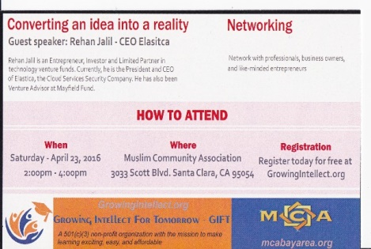

Figure 2: Leaflet Side 2