TABLE A1

Parameters Of generators

|  |  |  |  |
| --- | --- | --- | --- |
| *Name* | *buses* | *Rated capacity/MVA* | *Pss or not* |
| *G1* | 1 | 5500 | Y |
| *G2* | 4 | 2200 | Y |
| *G3* | 11 | 200 | Y |
| *G4* | 27 | 2700 | Y |
| *G5* | 25 | 5000 | Y |
| *G6* | 26 | 5600 | Y |
| *G7* | 24 | 5000 | Y |

TABLE A2

Parameters Of lines

|  |  |  |  |  |  |  |
| --- | --- | --- | --- | --- | --- | --- |
| *Number* | *From bus* | *To bus* | *R/Ω/km* | *X/ H/km* | *B/F/km* | *length/km* |
| *1* | *1* | *2* | *0* | *0.9337* | *0* | *167.00* |
| *2* | *3* | *2* | *0.01273* | *0.9337* | *1.3e-8* | *155.00* |
| *3* | *4* | *3* | *0* | *0.9337* | *0* | *167.00* |
| *4* | *2* | *5* | *0.00424* | *0.3864* | *3.9e-8* | *279.00* |
| *5* | *5* | *6* | *0.00210* | *0.1556* | *7.8e-8* | *236.00* |
| *6* | *6* | *7* | *0.00424* | *0.3864* | *3.9e-8* | *271.00* |
| *7* | *7* | *8* | *0* | *0* | *1.3e-4* | *224.45* |
| *8* | *9* | *5* | *0* | *0* | *1.3e-4* | *108.82* |
| *9* | *12* | *9* | *0.00424* | *0.3864* | *3.9e-8* | *218.00* |
| *10* | *10* | *9* | *0.01273* | *0.9337* | *1.3e-8* | *104.00* |
| *11* | *11* | *10* | *0* | *0.9337* | *0* | *167.00* |
| *12* | *13* | *12* | *0.00424* | *0.3864* | *3.9e-8* | *118.00* |
| *13* | *27* | *13* | *0* | *0.9337* | *0* | *167.00* |
| *14* | *6* | *28* | *0.00424* | *0.3864* | *3.9e-8* | *195.00* |
| *15* | *28* | *14* | *0.01273* | *0.9337* | *1.3e-8* | *117.00* |
| *16* | *14* | *15* | *0* | *0* | *2.6e-4* | *224.45* |
| *17* | *28* | *17* | *0.00636* | *0.4668* | *2.6e-8* | *252.00* |
| *18* | *16* | *17* | *0.00636* | *0.4668* | *2.6e-8* | *219.00* |
| *19* | *18* | *16* | *0.00424* | *0.3864* | *3.9e-8* | *260.00* |
| *20* | *25* | *18* | *0* | *0.9337* | *0* | *167.00* |
| *21* | *19* | *15* | *0.01273* | *0.9337* | *1.3e-8* | *247.00* |
| *22* | *20* | *19* | *0.01273* | *0.9337* | *1.3e-8* | *180.00* |
| *23* | *21* | *20* | *0.00424* | *0.3864* | *3.9e-8* | *450.00* |
| *24* | *24* | *21* | *0* | *0.9337* | *0* | *167.00* |
| *25* | *23* | *19* | *0.01273* | *0.9337* | *1.3e-8* | *60.00* |
| *26* | *20* | *23* | *0.00636* | *0.4668* | *2.6e-8* | *169.00* |
| *27* | *23* | *17* | *0.00424* | *0.3864* | *3.9e-8* | *379.00* |
| *28* | *22* | *23* | *0* | *0* | *1.3e-4* | *255.06* |
| *29* | *26* | *22* | *0* | *0.9337* | *0* | *167.00* |
| *30* | *8* | *16* | *0* | *0* | *1.3e-4* | *231.25* |
|  |  |  |  |  |  |  |

TABLE A3

Parameters Of transformers

|  |  |  |  |  |
| --- | --- | --- | --- | --- |
| *Name* | *buses* | *Rated capacity /MVA* | *Rato/%* | *Xs/%* |
| *T1* | 1-2 | 5500 | 100 | 6 |
| *T2* | 3-4 | 2200 | 100.6036 | 3 |
| *T3* | 11-10 | 200 | 100 | 3 |
| *T4* | 27-13 | 2700 | 99.6016 | 3 |
| *T5* | 25-18 | 5000 | 98.7167 | 6 |
| *T6* | 26-22 | 5600 | 98.4252 | 6 |
| *T7* | 24-21 | 5600 | 99.108 | 6 |

TABLE A4

Parameters Of loads

|  |  |  |
| --- | --- | --- |
| *Bus no.* | *P/MW* | *Q/MW* |
| *1* | 275 | 0 |
| *2* | 22 | 660 |
| *3* | 22 | 660 |
| *4* | 110 | 0 |
| *5* | 66 | 1980 |
| *6* | 44 | 1320 |
| *8* | 33 | 990 |
| *9* | 11 | 330 |
| *11* | 10 | 0 |
| *12* | 11 | 330 |
| *13* | 22 | 660 |
| *14* | 22 | 660 |
| *16* | 8000 | 3000 |
| *17* | 6000 | 3000 |
| *20* | 33 | 990 |
| *21* | 11 | 330 |
| *22* | 55 | 1650 |
| *24* | 280 | 0 |
| *25* | 250 | 0 |
| *26* | 250 | 0 |
| *27* | 135 | 0 |
| *28* | 44 | 1320 |

TABLE A5

coupling relationship between all nodes

|  |  |  |  |  |  |  |  |  |  |  |  |  |  |  |  |  |  |  |  |  |  |  |  |  |  |  |  |  |
| --- | --- | --- | --- | --- | --- | --- | --- | --- | --- | --- | --- | --- | --- | --- | --- | --- | --- | --- | --- | --- | --- | --- | --- | --- | --- | --- | --- | --- |
| *node* | *1* | *2* | *3* | *4* | *5* | *6* | *7* | *8* | *9* | *10* | *11* | *12* | *13* | *14* | *15* | *16* | *17* | *18* | *19* | *20* | *21* | *22* | *23* | *24* | *25* | *26* | *27* | *28* |
| *1* | 0.43 | 0 | 0 | 0 | 0 | 0 | 0 | 0 | 0 | 0 | 0 | 0 | 0 | 0 | 0 | 0 | 0 | 0 | 0 | 0 | 0 | 0 | 0 | 0 | 0 | 0 | 0 | 0 |
| *2* | -3.1e4 | 3.1 e4 | 200 | -200 | 0 | 0 | 0 | 0 | 0 | 0 | 0 | 0 | 0 | 0 | 0 | 0 | 0 | 0 | 0 | 0 | 0 | 0 | 0 | 0 | 0 | 0 | 0 | 0 |
| *3* | 0 | 0 | -101 | 100 | 0 | 0 | 0 | 0 | 0 | 0 | 0 | 0 | 0 | 0 | 0 | 0 | 0 | 0 | 0 | 0 | 0 | 0 | 0 | 0 | 0 | 0 | 0 | 0 |
| *4* | 0 | 0 | 0 | -17.9 | 0 | 0 | 0 | 0 | 0 | 0 | 0 | 0 | 0 | 0 | 0 | 0 | 0 | 0 | 0 | 0 | 0 | 0 | 0 | 0 | 0 | 0 | 0 | 0 |
| *5* | -1.21 | 1.21 | 8e-3 | -0.08 | -1.21 | 0 | 0 | 0 | 2.5e3 | -5.5 | 5.5 | -5.7e2 | -4.8 | 0 | 0 | 0 | 0 | 0 | 0 | 0 | 0 | 0 | 0 | 0 | 0 | 0 | 4.8 | 0 |
| *6* | 1 | -1 | -6e-3 | 0.006 | 1 | 236 | 0 | 0 | -2.1e3 | 4.5 | -4.5 | 4.7e2 | 4 | 0 | 0 | 0 | 0 | 0 | 0 | 0 | 0 | 0 | 0 | 0 | 0 | 0 | -4 | 0 |
| *7* | -3.4e-5 | 3.4e-5 | 2.2e-7 | -2.2 e-7 | -3.4 e-5 | -0.8 | 1.118 | 0 | 0.07 | -1.4e-4 | 1.5e-4 | -1.6e-2 | -1.3e4 | 0 | 0 | 0 | 0 | 0 | 0 | 0 | 0 | 0 | 0 | 0 | 0 | 0 | 1.4e-4 | 0 |
| *8* | -3.5e-5 | 3.5e-5 | 2.3e-7 | -2.3e-7 | -3.5e-5 | -0.84 | 1.16 | -1.16 | 0.07 | -1.6e-4 | 1.6e-4 | -1.7e-2 | -1.4e-4 | 0 | 0 | 0 | 0 | 0 | 0 | 0 | 0 | 0 | 0 | 0 | 0 | 0 | 1.4e-4 | 0 |
| *9* | 0 | 0 | 0 | 0 | 0 | 0 | 0 | 0 | 2.5e3 | -5.5 | 5.5 | -5.7e2 | -4.8 | 0 | 0 | 0 | 0 | 0 | 0 | 0 | 0 | 0 | 0 | 0 | 0 | 0 | 4.8 | 0 |
| *10* | 0 | 0 | 0 | 0 | 0 | 0 | 0 | 0 | 0 | -1.2e2 | 1.2e2 | 0 | 0 | 0 | 0 | 0 | 0 | 0 | 0 | 0 | 0 | 0 | 0 | 0 | 0 | 0 | 0 | 0 |
| *11* | 0 | 0 | 0 | 0 | 0 | 0 | 0 | 0 | 0 | 0 | 42 | 0 | 0 | 0 | 0 | 0 | 0 | 0 | 0 | 0 | 0 | 0 | 0 | 0 | 0 | 0 | 0 | 0 |
| *12* | 0 | 0 | 0 | 0 | 0 | 0 | 0 | 0 | 0 | 57 | -57 | 6e2 | 50 | 0 | 0 | 0 | 0 | 0 | 0 | 0 | 0 | 0 | 0 | 0 | 0 | 0 | -50 | 0 |
| *13* | 0 | 0 | 0 | 0 | 0 | 0 | 0 | 0 | 0 | 0 | 0 | 0 | -1.2e2 | 0 | 0 | 0 | 0 | 0 | 0 | 0 | 0 | 0 | 0 | 0 | 0 | 0 | 1.2e2 | 0 |
| *14* | 1.1e-4 | -1.1e-4 | -7e-7 | 7.1-7 | 1.1e-4 | 2.6 | 0 | 0 | -0.2 | 5e-4 | -5e-3 | 5e-2 | 4.4e-4 | 1.2 | 0 | 0 | 0 | 0 | 0 | 0 | 0 | 0 | 0 | 0 | 0 | 0 | -4.4e-4 | -2.6 |
| *15* | -0.2 | 0.2 | 1.2e-3 | -1.3e-3 | -0.2 | -4.6e3 | 0 | 0 | 4e2 | -0.89 | 0.89 | -92. | -0.78 | -2.1e3 | 2.1e3 | 0 | 0 | 0 | 4.1e3 | -3.9e3 | -8.7 | 69 | 0.7 | 8.7 | 0 | -69 | 0.78 | 4.6e3 |
| *16* | 0 | 0 | 0 | 0 | 0 | 0 | 0 | 0 | 0 | 0 | 0 | 0 | 0 | 0 | 0 | 1.8e3 | 0 | 6.9 | 0 | 0 | 0 | 0 | 0 | 0 | -6.9 | 0 | 0 | 0 |
| *17* | 0.05 | -0.05 | -3e-4 | 3e-4 | 0.05 | 1.e3 | 0 | 0 | -111 | 0.2 | -0.2 | 25 | 0.2 | 0 | 0 | -98 | 1.2e4 | -0.4 | 0 | -0.03 | -7.e-5 | 3.4 | 0.03 | 7e-5 | 0.38 | -3.4 | -0.21 | -1.2e3 |
| *18* | 0 | 0 | 0 | 0 | 0 | 0 | 0 | 0 | 0 | 0 | 0 | 0 | 0 | 0 | 0 | 0 | 0 | -119 | 0 | 0 | 0 | 0 | 0 | 0 | 119 | 0 | 0 | 0 |
| *19* | 0 | 0 | 0 | 0 | 0 | 0 | 0 | 0 | 0 | 0 | 0 | 0 | 0 | 0 | 0 | 0 | 0 | 0 | -6e5 | 5e5 | 121 | -968 | -9.7 | -121 | 0 | 968 | 0 | 0 |
| *20* | 0 | 0 | 0 | 0 | 0 | 0 | 0 | 0 | 0 | 0 | 0 | 0 | 0 | 0 | 0 | 0 | 0 | 0 | 0 | 2e5 | 45 | 0 | 0 | -45 | 0 | 0 | 0 | 0 |
| *21* | 0 | 0 | 0 | 0 | 0 | 0 | 0 | 0 | 0 | 0 | 0 | 0 | 0 | 0 | 0 | 0 | 0 | 0 | 0 | 0 | -111 | 0 | 0 | 111 | 0 | 0 | 0 | 0 |
| *22* | 0 | 0 | 0 | 0 | 0 | 0 | 0 | 0 | 0 | 0 | 0 | 0 | 0 | 0 | 0 | 0 | 0 | 0 | 0 | 2e-16 | 5e-19 | -120 | -2e-16 | -8e-19 | 0 | 120 | 0 | 0 |
| *23* | 0 | 0 | 0 | 0 | 0 | 0 | 0 | 0 | 0 | 0 | 0 | 0 | 0 | 0 | 0 | 0 | 0 | 0 | 0 | 1.2 | 3e-3 | -121 | -1.21 | -3e-3 | 0 | 121 | 0 | 0 |
| *24* | 0 | 0 | 0 | 0 | 0 | 0 | 0 | 0 | 0 | 0 | 0 | 0 | 0 | 0 | 0 | 0 | 0 | 0 | 0 | 0 | 0 | 0 | 0 | 1.2 | 0 | 0 | 0 | 0 |
| *25* | 0 | 0 | 0 | 0 | 0 | 0 | 0 | 0 | 0 | 0 | 0 | 0 | 0 | 0 | 0 | 0 | 0 | 0 | 0 | 0 | 0 | 0 | 0 | 0 | 97 | 0 | 0 | 0 |
| *26* | 0 | 0 | 0 | 0 | 0 | 0 | 0 | 0 | 0 | 0 | 0 | 0 | 0 | 0 | 0 | 0 | 0 | 0 | 0 | 0 | 0 | 0 | 0 | 0 | 0 | 44 | 0 | 0 |
| *27* | 0 | 0 | 0 | 0 | 0 | 0 | 0 | 0 | 0 | 0 | 0 | 0 | 0 | 0 | 0 | 0 | 0 | 0 | 0 | 0 | 0 | 0 | 0 | 0 | 0 | 0 | 26 | 0 |
| *28* | -1.3 | 1.3 | 8e-3 | -8e-3 | -1.3 | -3e5 | 0 | 0 | 2.6e4 | -5.8 | 5.8 | -6018 | -5.1 | 0 | 0 | 0 | 0 | 0 | 0 | 0 | 0 | 0 | 0 | 0 | 0 | 0 | 5.1 | 3e5 |

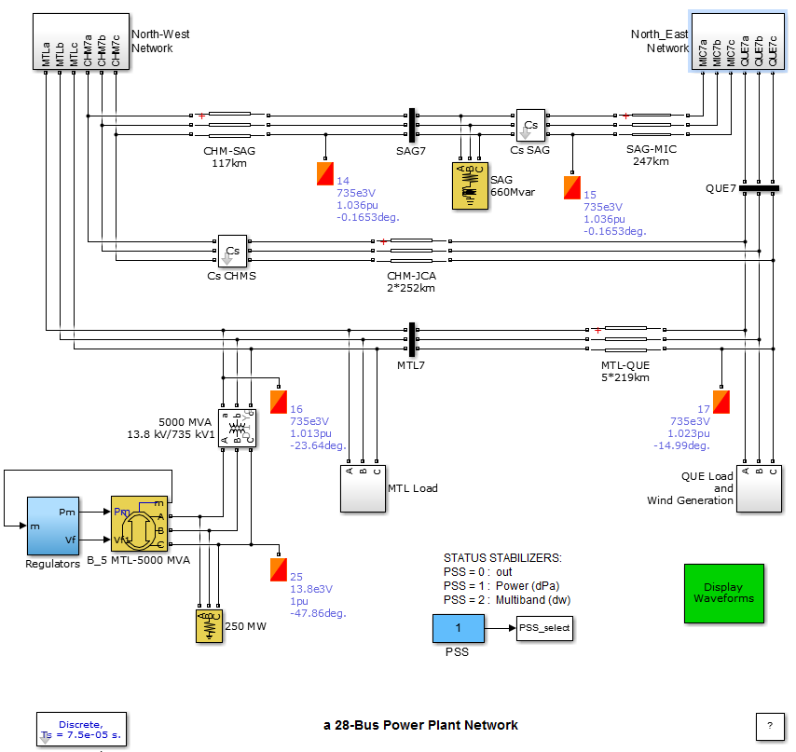

Fig. A1 SIMULATION model