**Live @:** [**http://orfe.princeton.edu/courses/orf467/live**](http://orfe.princeton.edu/courses/orf467/live)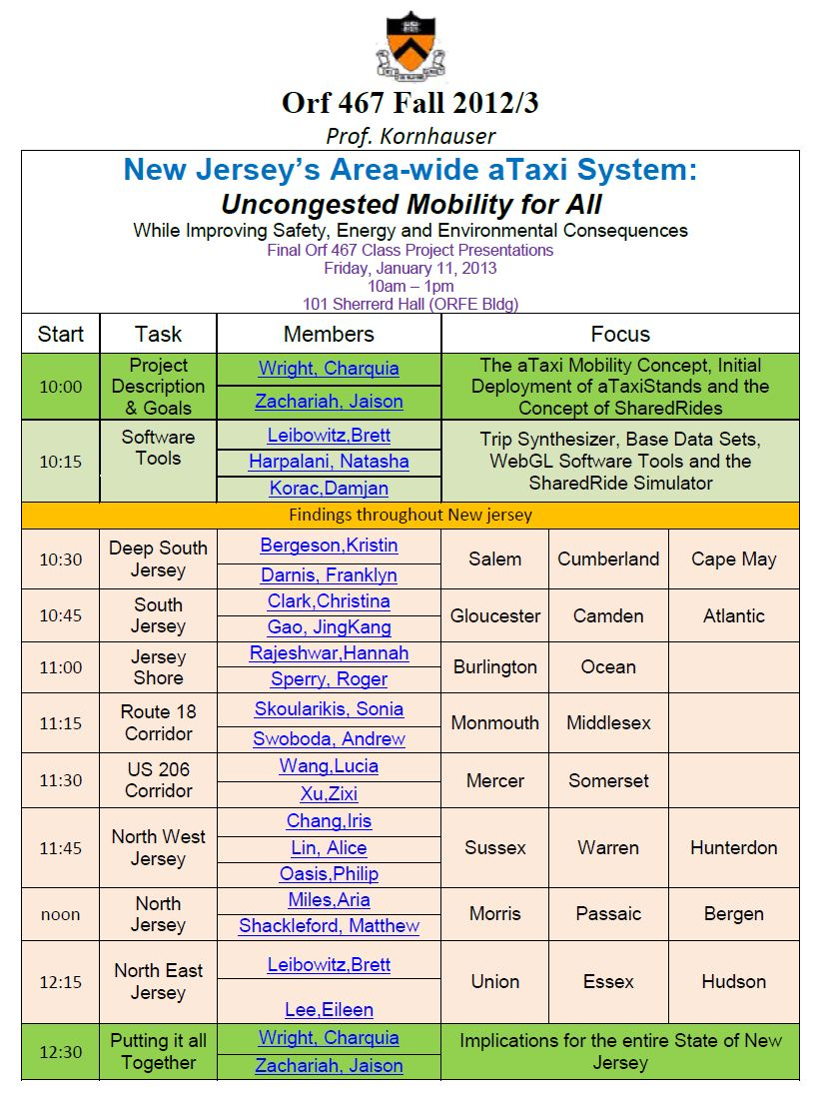

**Live @:** [**http://orfe.princeton.edu/courses/orf467/live**](http://orfe.princeton.edu/courses/orf467/live)

**Live @:** [**http://orfe.princeton.edu/courses/orf467/live**](http://orfe.princeton.edu/courses/orf467/live)



|  |  |  |  |
| --- | --- | --- | --- |
| ***Special Seminar***  **Simulation and Animation Tools**  **for the**  **Design and Operations Planning**  **of**  **Automated Transit Networks**  **(ATNs: PRTs and aTaxis)**  ***by***  **Prof. Dr. Ingmar Andreasson**  **Royal Institute of Technology (KTH)**  **Stockholm, Sweden**  Friday, January 11, 2013 1pm – 2pm 101 Sherrerd Hall (ORFE Bldg) | | | |
| 1:00 | Special Seminar | **Prof. Dr. Ingmar Andreasson**  **Royal Institute of Technology (KTH)**  **Stockholm, Sweden** | **Simulation and Animation Tools for the**  **Design and Operations Planning of**  **Automated Transit Networks**  **(ATNs: PRTs and aTaxis)** |