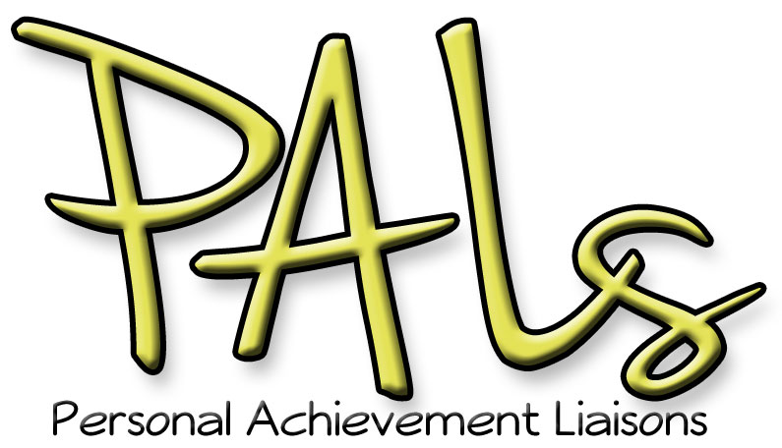

**Why do I want a PALs Mug?**With the PAL’s Mug you and your mentee can get together for a free, friendly, cup of coffee, tea, or soda.

**How does the program work?**   
You and your mentee will go to Outtakes together and the cashier will scan your mugs. As long as **both** mugs are presented together, the coffee, tea, or soda is on Student Engagement’s tab!

* You will be given a receipt for $0.00. Keep the receipt with you when you get your coffee/tea/soda in case any of the Outtakes staff is unfamiliar with the new program.
* Coffee and tea are available at Outtakes. Until the soda fountain is installed in Outtakes, please use the fountain to the right of Chopp’d for soda.

Student Engagement will be billed monthly for PALs program beverages. Since this is a new program, we will check with you periodically to find out how the program is working for you.

Thank you for being PALs mentor!

**Mentor Mugs FAQs**

**Q.** Can I get anything to drink with my mentor mug?

**A.** Coffee and Tea from Outtakes and soda from the fountain machine near Chopp’d are free when you use your Mentor Mug and meet your mentee.

**Q.** Can I (or my mentee) get free drinks all the time?

**A.** Only when **actively** engaged in first-semester mentoring **with** your mentee.

**Q.** Can I (or my mentee) get free drinks by myself?

**A.** You and your mentee must be together, as beverages are only free when both mugs are presented together.

**Q.** Do I have to return my mug at the end of the semester?

**A.** The mug is yours to keep as a thank you for being a PALs mentor! You will not be entitled to free fill-ups however, unless you are actively mentoring a new student in their first semester, and you are there together. This program is intended to support your mentoring activities during the one semester, PALs mentoring program.

**Q.** What if I maintain a relationship with my PALs mentee past the first semester? Can I continue to get free drinks?

**A.** We would be thrilled if you continued to connect with your PALs mentee and we hope your relationship continues. However, in order to ensure continued funding for the program we ask you to refrain from using the PALs Mentor Mug when you are not with a first-semester mentee.