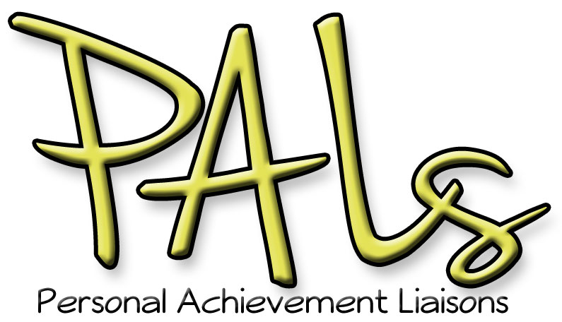

Welcome Reception and Inaugural Meeting

December 11th, 2012  
3:00-4:30 pm  
Campus Center 375

**Please join us for our welcome reception and inaugural meeting and receive your:**

* **Mentor Handbook** with resources and campus policies
* sample “welcome e-mails” to send to your mentees
* academic schedule with mentoring touch-points highlighted
* official **PALs Mug,** and instructions for getting it filled

Thank you for being a PALs mentor!