IEEE 1394

[](http://upload.wikimedia.org/wikipedia/commons/a/a5/Firewire_Logo.png)

The 6-conductor and 4-conductor alpha FireWire 400 connectors

[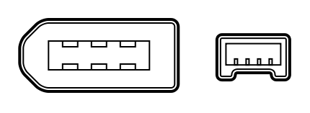](http://upload.wikimedia.org/wikipedia/commons/c/c5/FireWire-46_Diagram.svg)

A 6-conductor FireWire 400 alpha connector

[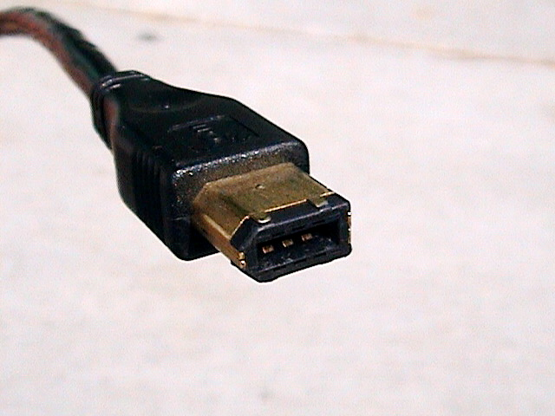](http://upload.wikimedia.org/wikipedia/commons/a/a6/Firewire6-pin.jpg)

9-pin FireWire 800 connector

[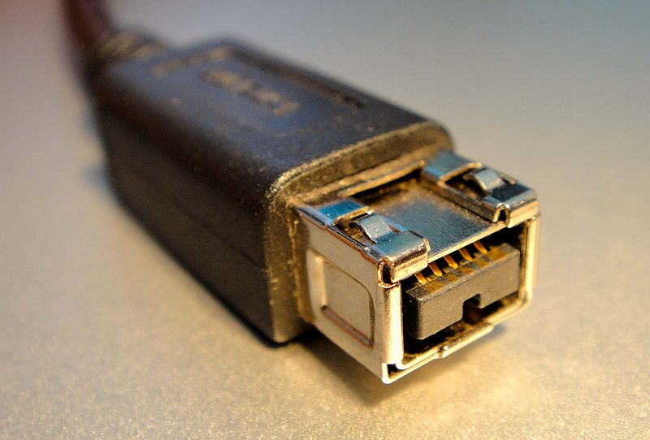](http://upload.wikimedia.org/wikipedia/commons/f/fe/FireWire800_Stecker.jpeg)

4-conductor (left) and 6-conductor (right) FireWire 400 alpha connectors

[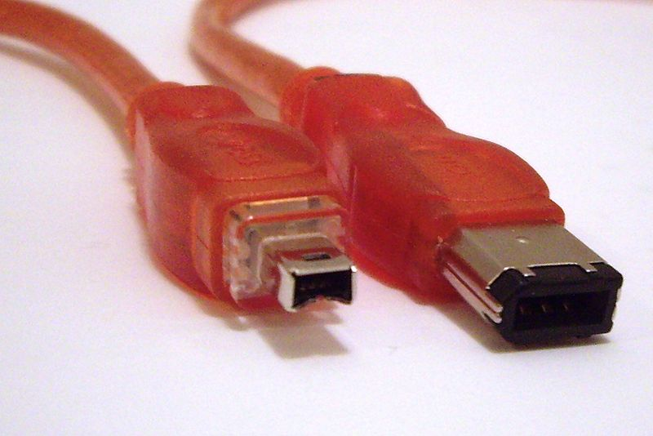](http://upload.wikimedia.org/wikipedia/commons/f/f7/FireWire_cables.jpg)

Thunderbolt and Thunderbolt 2 to Firewire adapter

