***The World of Pre-Health Living-Learning Community***

Designed for students interested in majoring in the physical sciences, particularly those desiring a pre-health academic career (medical, dental, nursing, veterinary, etc.). Freshmen only.

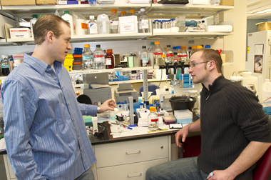 

**University at Albany Living-Learning Communities**: ***Students who live together, take 2 or more theme-related classes each semester, and desire to be engaged in and out of the classroom.***

The University at Albany is pleased to offer Living-Learning Communities (L-LCs) to our incoming freshmen. L-LCs provide students with the opportunity to meet like-minded students, live in the same residence hall, take classes with students who share similar academic goals, and meet faculty and upper class students who study in the field.

**Some of the things you will do as a member of *The World of Pre-Health***

* Live on State Quad with other students interested in pre-health academic majors and careers in the health care field
* Take some classes with other L-LC students:
  + Fall L-LC classes: ABIO 120 (General Biology I), AENG 240 (Growing up in America); Spring L-LC classes: ABIO 121 (General Biology II)
* Meet with the Pre-Health Advisor to discuss plans for careers in health-related fields
* Meet faculty and graduate students in biology, chemistry, and physics and learn about their research and specialties
* Learn about and meet representatives from the pre-health– related student clubs
* Attend guest speaker lectures on topics and skills to help you get ready for graduate school and understand scientific research
* Meet with faculty and practitioners to learn about different careers for science majors
* Develop and participate in community service projects which reflect your interest in this field
* Actively participate in the L-LC events offered throughout the academic year



“The best thing about being a part of a L-LC at UAlbany was living with other people who shared my interests and being able to work outside of class on homework together.”

~L-LC student, Class of 2014

**Responsibilities of being in a Living-Learning Community:**

* Students must register for the L-LC classes. While there may be extenuating circumstances, students are not expected to drop their L-LC classes. Students are encouraged to work closely with their advisor on their academic schedules.
* Students participate in programming with the L-LC designed to explore the topic or theme. These often include meetings with faculty members and guest speakers, occasionally eating meals with the professors, and meeting with upper class students who share the interest or major (usually through a variety of student clubs and organizations).
* Students in each L-LC are expected to participate in the out-of-class programs.
* Each L-LC is expected to participate in at least one community service project each semester.

  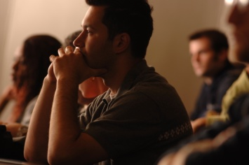

**How do I apply / join?**

* **Students apply for L-LCs when they pay their housing deposit and apply for housing.**
* When registering for housing, students must note their interest in the appropriate L-LC(s). Students can designate both a first choice and second choice option.
* L-LCs will be filled on a first come, first serve basis. Applicants will be notified by July 1st if they have been accepted into the L-LC. Once the L-LC is filled, students will be placed on a waiting list and notified if space becomes available.
* For students requesting a roommate: BOTH students MUST also apply for the same L-LC.
* For students requesting a L-LC that is geared for a particular major: you (and, if applicable, your roommate) must be interested in pursuing that major. The Department of Residential Life and your Academic Advisor will be working together to ensure both your housing and your academic/class schedule support the L-LC programming.
* All students (including those accepted into an L-LC) will be notified of their room and roommate assignments by the first week of August.
* Questions about the various L-LCs can be directed to [studentengagement@albany.edu](mailto:studentengagement@albany.edu). Questions about housing and housing/roommate assignments can be directed to the Department of Residential Life at [reslife@uamail.albany.edu](mailto:_______@uamail.albany.edu).



“The comfort level that was created by those seamless interactions with the upper-class students and me built a very solid foundation for the students to excel as the semester went forward.”

~Prof. Joe Sheehan, L-LC professor