***The World of Sustainability and the Environment***

Designed for students from any major interested in the environment.

Freshmen only.

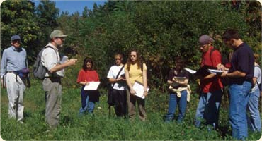  [](http://www.albany.edu/gogreen/recycling-scorecard.shtml)

**University at Albany Living-Learning Communities**: ***Students who live together, take 2 or more theme-related classes each semester, and desire to be engaged in and out of the classroom.***

The University at Albany is pleased to offer Living-Learning Communities (L-LCs) to our incoming freshmen. L-LCs provide students with the opportunity to meet like-minded students, live in the same residence hall, take classes with students who share similar academic goals, and meet faculty and upper class students who study in the field.

**Some of the things you will do as a member of *The World of Sustainability*:**

* Live on Indian Quad with other students interested in sustainability. Students will take classes designed to increase their knowledge on sustainability topics like biodiversity, climate change, urban sprawl, and local/organic food
* Take some classes with other L-LC students:
  + Fall L-LC classes: UFSP100 (Freshman seminar in Sustainability) and AENV 105 (Introduction to Environmental Science); Spring L-LC classes: AATM 102 (Science and Major Environmental Issues) and APLN 220 (Introductory Urban Planning)
* Have lunch with your UFSP 100 professor to discuss class assignments and related topics
* Meet members of University at Albany Sustainability Council, Net Impact, Campus Greens, NYPIRG, UAlbany Students for Sustainability
* Work with UAlbany’s Director of Sustainability to develop and implement student-based sustainability initiatives for the UAlbany campus
* Attend guest lectures and meet leaders and students from other schools making a difference in such areas as biodiversity conservation, natural resources management, and sustainable agriculture
* Learn about the impact of food production on the environment
* Actively participate in the L-LC events offered throughout the academic year

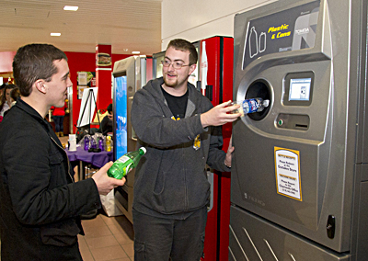

“This was a great program to start off my college experience. Having some of the same professors and classes meant we could study together in the Residence Hall.”

~ LLC students, Class of 2014

**Responsibilities of being in a Living-Learning Community:**

* Students must register for the L-LC classes. While there may be extenuating circumstances, students are not expected to drop their L-LC classes. Students are encouraged to work closely with their advisor on their academic schedules.
* Students participate in programming with the L-LC designed to explore the topic or theme. These often include meetings with faculty members and guest speakers, occasionally eating meals with the professors, and meeting with upper class students who share the interest or major (usually through a variety of student clubs and organizations).
* Students in each L-LC are expected to participate in the out-of-class programs.
* Each L-LC is expected to participate in at least one community service project each semester.

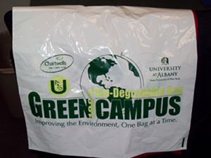 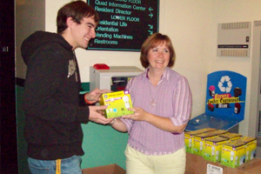 

**How do I apply / join?**

* **Students apply for L-LCs when they pay their housing deposit and apply for housing.**
* When registering for housing, students must note their interest in the appropriate L-LC(s). Students can designate both a first choice and second choice option.
* L-LCs will be filled on a first come, first serve basis. Applicants will be notified by July 1st if they have been accepted into the L-LC. Once the L-LC is filled, students will be placed on a waiting list and notified if space becomes available.
* For students requesting a roommate: BOTH students MUST also apply for the same L-LC.
* For students requesting a L-LC that is geared for a particular major: you (and, if applicable, your roommate) must be interested in pursuing that major. The Department of Residential Life and your Academic Advisor will be working together to ensure both your housing and your academic/class schedule support the L-LC programming.
* All students (including those accepted into an L-LC) will be notified of their room and roommate assignments by the first week of August.
* Questions about the various L-LCs can be directed to [studentengagement@albany.edu](mailto:studentengagement@albany.edu) . Questions about housing and housing/roommate assignments can be directed to the Department of Residential Life at [reslife@uamail.albany.edu](mailto:_______@uamail.albany.edu).



“Working with the L-LC students was a real joy. They have enthusiasm and passion for being at UAlbany and are very open to ideas from professors and the upper-class mentors.”

~Prof. Joe Sheehan, LLC Professor