# Paper 1

Hello world :)

Here is an example citation [@example]. Here is an example abbreviation: .

Here is an example table.

Here is an example plot.

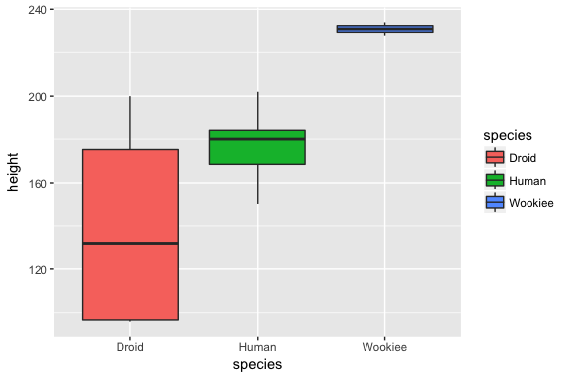

Starwars distribution of heights by species