Evaluating Chunking Strategies for Retrieval-Augmented Generation on SEC 10-K Financial Filings: A Retrieval Failure Analysis
Chipo Sekabanja
Department of Computer Science, Kansas State University
CIS 530/730 - Principles of Artificial Intelligence
Manhattan, Kansas, USA - May 2026
Abstract
Retrieval-Augmented Generation (RAG) systems are increasingly deployed for enterprise document intelligence, yet the effect of document chunking strategy on retrieval quality remains understudied in domain-specific settings. This paper presents a controlled comparison of fixed-size chunking (512 characters, 50-character overlap) and semantic chunking (MiniLM-L6-v2 cosine similarity boundary detection) applied to SEC 10-K annual filings from the EDGAR-CORPUS dataset. Both strategies are evaluated using FAISS vector retrieval and GPT-4o-mini generation, with RAGAS metrics (Faithfulness, Answer Relevancy, Context Precision, Context Recall) computed over a manually curated 60-question benchmark spanning three difficulty tiers. We further introduce an alternative pipeline incorporating cross-encoder reranking (ms-marco-MiniLM-L-6-v2), section-aware metadata filtering, and a low-confidence hallucination detector. Results demonstrate that the alternative pipeline achieves a 43% improvement in Context Precision (0.405 to 0.579) and a 15% improvement in Context Recall (0.708 to 0.817) over the fixed-size baseline, at a cost of 3x increased query latency. Tier-level analysis reveals that metadata filtering improves Tier 1 (lookup) performance but degrades Tier 2 (cross-section) performance without synthesis-aware query routing, a finding with direct implications for production RAG system design.
I. INTRODUCTION
Large language models (LLMs) demonstrate strong reasoning capabilities on knowledge-intensive tasks but are prone to hallucination when answering questions requiring specific factual knowledge not encoded in their parameters. Retrieval-Augmented Generation (RAG) [1] addresses this limitation by retrieving relevant passages from an external document corpus and grounding generation in that retrieved context. However, the quality of retrieval - and therefore the quality of generated answers - depends critically on how documents are partitioned before embedding and indexing.

SEC 10-K annual filings present a particularly challenging domain for RAG systems. These documents routinely exceed 100 pages per filing, are structured into 20 legally defined sections with heterogeneous content types, use dense domain-specific legal and financial terminology, and exhibit systematic variation in disclosure quality including optional sections deliberately left empty by smaller reporting companies. Fixed-size chunking - the most common approach in production RAG deployments - ignores this structure entirely, frequently splitting semantically coherent passages across chunk boundaries. This fragmentation directly degrades retrieval quality in ways that aggregate evaluation metrics often obscure.

This paper makes three contributions. First, we implement and systematically compare fixed-size and semantic chunking pipelines on EDGAR-CORPUS [3], a peer-reviewed corpus of 6,500+ SEC 10-K filings. Second, we develop a 60-question benchmark with three difficulty tiers designed to isolate specific retrieval failure modes. Third, we introduce an alternative pipeline combining semantic chunking, cross-encoder reranking, and a low-confidence hallucination detector, evaluating all components against the same benchmark using RAGAS [2] metrics. Our tier-level analysis reveals that metadata filtering is beneficial for single-section lookup queries but harmful for cross-section synthesis queries without adaptive routing - a nuance absent from prior RAG evaluation literature.

The remainder of this paper is organized as follows. Section II reviews related work. Section III describes the data and environment. Section IV details the methodology. Section V presents results. Section VI discusses findings and limitations. Section VII concludes.
II. RELATED WORK
A. Retrieval-Augmented Generation
Lewis et al. [1] introduced the RAG framework combining dense passage retrieval with seq2seq generation, demonstrating that grounding LLM outputs in retrieved documents significantly reduces hallucination on open-domain QA benchmarks including Natural Questions and TriviaQA. The core architectural insight - separating knowledge retrieval from language generation - has since become the dominant paradigm for enterprise document intelligence. Our work builds directly on this foundation while contributing the first systematic chunking strategy comparison on SEC financial filings.

B. RAG Evaluation
Es et al. [2] introduced RAGAS, a reference-free evaluation framework providing four metrics: Faithfulness (whether answers are grounded in retrieved context), Answer Relevancy (whether answers address the question), Context Precision (whether retrieved chunks were useful), and Context Recall (whether sufficient information was retrieved). RAGAS uses an LLM judge to compute these metrics without requiring human-annotated ground truth answers for most metrics, making systematic evaluation at scale practical. We adopt RAGAS as our primary evaluation framework while identifying a limitation: RAGAS penalizes correct adversarial refusals as low-faithfulness answers, requiring supplementary evaluation for Tier 3 queries.

C. Financial NLP and EDGAR-CORPUS
Loukas et al. [3] introduced EDGAR-CORPUS, a large-scale dataset of SEC 10-K filings preprocessed into 20 structured sections. Financial NLP on SEC filings requires domain-specific preprocessing due to heterogeneous section structure and dense numerical content. Our work is the first to use EDGAR-CORPUS as the basis for a controlled RAG chunking evaluation, leveraging its structured section metadata to enable the metadata-filtered retrieval in our alternative pipeline.

D. Cross-Encoder Reranking
Nogueira and Cho [5] demonstrated that BERT-based cross-encoders substantially outperform bi-encoder retrieval models on passage ranking tasks by jointly encoding query-passage pairs rather than computing independent embeddings. The ms-marco-MiniLM-L-6-v2 model we deploy is trained on the MS-MARCO passage ranking dataset [6], providing strong passage relevance scoring in a compact 90MB model suitable for CPU inference. Our results confirm the theoretical prediction: cross-encoder reranking produces substantially higher score discrimination (range 5.1) compared to FAISS cosine similarity (range 0.04) across candidate chunks.
III. DATA AND ENVIRONMENT
A. Primary Dataset
We use EDGAR-CORPUS (HuggingFace: eloukas/edgar-corpus), loading the 2018 training split via the HuggingFace Hub API. Due to a known gzip decode bug in datasets library versions 2.20-2.21 affecting the custom loading script, EDGAR-CORPUS was loaded via direct file download using hf_hub_download rather than the standard load_dataset API. Data integrity was unaffected - the JSONL file structure was preserved and all 20 section fields were validated per filing before indexing.

For the development evaluation reported in this paper, we index 10 filings representing diverse industries: clinical-stage biopharmaceutical, Chinese healthcare with PRC operations, a smaller reporting company invoking risk factor exemptions, community banking (Oak Valley Bancorp), sustainable electric vehicles (Arcimoto), cannabis/diversified (MJ Holdings), bank holding company (Heritage Financial Corporation), and a self-administered office REIT. Two filings (1168165, 202584) had largely empty sections and served as edge-case validation targets for Tier 3 adversarial queries.

B. Secondary Dataset
PleIAs/SEC (HuggingFace: PleIAs/SEC) contains 245,211 10-K filings from 1993-2024 in Parquet format, totaling 7.2 billion words. This dataset is intended for full-scale stress testing across decades of filing formatting variation. Full integration is planned for future work following Beocat HPC cluster deployment.

C. Compute Environment
All experiments run in a Docker container (python:3.11-slim) with CPU-only PyTorch 2.3.0. The container is deployed in GitHub Codespaces (2-core, 32GB disk). Key library versions: LangChain 0.2.16, FAISS-CPU 1.8.0, SentenceTransformers 3.0.1, OpenAI 1.43.0, RAGAS 0.1.21, Weights & Biases 0.25.1, FastAPI 0.111.0. GPU-accelerated runs for full-corpus indexing are reserved for K-State's Beocat HPC cluster.
IV. METHODOLOGY
A. Fixed-Size Chunking (Baseline)
We implement fixed-size chunking using LangChain's RecursiveCharacterTextSplitter with chunk_size=512 characters and chunk_overlap=50 characters. The splitter attempts paragraph-level splits first, falling back to sentence-level, then word-level boundaries, using characters as the length metric rather than tokens to avoid tokenizer dependency. Chunks shorter than 100 characters are discarded to eliminate boilerplate fragments such as standalone section headers. Chunking is applied to five content-rich sections: section_1 (Business Overview), section_1A (Risk Factors), section_7 (MD&A), section_7A (Quantitative Disclosures), and section_8 (Financial Statements).

B. Semantic Chunking
Semantic chunking uses the all-MiniLM-L6-v2 SentenceTransformer model (90MB, 384-dimensional embeddings) to detect topic boundaries. For each section, sentences are split using punctuation-based regex that splits on period/exclamation/question marks followed by whitespace and a capital letter - handling most financial sentence boundaries while avoiding false splits on abbreviations. Each sentence is embedded in batch, and cosine similarity is computed between adjacent sentence pairs. A new chunk is created when similarity drops below threshold τ = 0.5, indicating a topic shift. Maximum chunk size is capped at 2,000 characters to prevent excessively long chunks when a single topic spans many sentences. Section metadata is preserved as a filterable FAISS field.

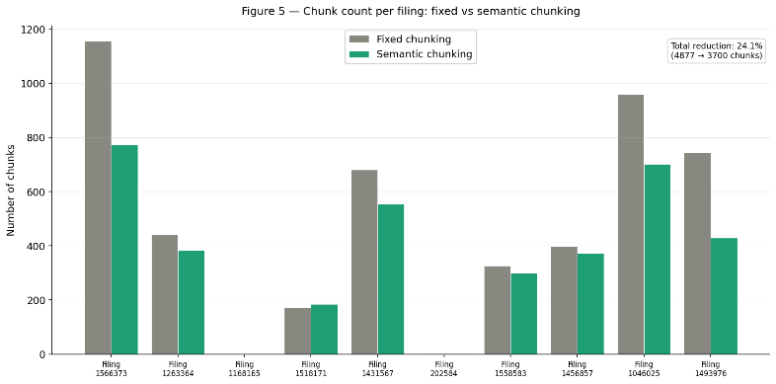
Fig. 5. Chunk count per filing comparing fixed-size vs. semantic chunking. Semantic chunking reduces total chunk count by 24.1% (4,877 to 3,700) across 10 indexed filings.
C. Embedding and Indexing
All chunks from both strategies are embedded using OpenAI's text-embedding-3-small model (1,536 dimensions, $0.02/million tokens). Embeddings are L2-normalized and stored in FAISS IndexFlatIP indices - one per chunking strategy - enabling exact cosine similarity search. Exact search is feasible at this scale (under 5,000 vectors); at full EDGAR-CORPUS scale an approximate index (IndexIVFFlat) would be required. Indices are serialized to disk as .faiss files alongside chunk metadata stored as Python pickle files. The fixed-size index contains 4,877 vectors; the semantic index contains 3,700 vectors. Total embedding cost: $0.0195 (fixed), $0.0148 (semantic).

D. Baseline RAG Pipeline
The baseline pipeline follows the standard RAG architecture: (1) embed the query using text-embedding-3-small, normalizing the resulting vector; (2) retrieve top-5 chunks by cosine similarity from the target FAISS index; (3) inject chunks into a structured prompt instructing GPT-4o-mini to answer only from provided context, returning a specific refusal phrase when context is insufficient; (4) generate at temperature=0 for reproducibility. The pipeline is served via a FastAPI endpoint (POST /query) with a warm-start pattern pre-loading both indices and the OpenAI client at server startup.

E. Alternative Pipeline
The alternative pipeline adds three components to the semantic baseline. First, keyword-based metadata filtering routes queries to the most likely document section before retrieval. Queries containing terms such as 'cybersecurity' or 'risk' route to section_1A; 'revenue' or 'financial' route to section_7. A filtered sub-index is constructed from FAISS by reconstructing vectors for chunks matching the target section. Critically, this filter is programmatically disabled for queries containing synthesis keywords including 'and what', 'relate to', 'which companies', and 'how does' - queries that require cross-section retrieval. This adaptive routing recovered Tier 2 faithfulness from 0.220 (over-filtered) to 0.374.

Second, FAISS retrieves the top-20 candidate chunks (expanded from 5) which are then reranked using cross-encoder/ms-marco-MiniLM-L-6-v2. The cross-encoder reads each (query, chunk) pair jointly and outputs an unbounded relevance score. The top-5 reranked chunks are passed to GPT-4o-mini. Third, a low-confidence detector checks two conditions before generation: the top-1 FAISS similarity score must be below 0.30, and the gap between top-1 and top-2 scores must be below 0.05. When both conditions are met, the pipeline returns a structured refusal without calling the generator.

F. Benchmark Design
We construct a 60-question benchmark across three tiers, evaluated against the 10 indexed filings. All ground-truth answers are manually verified against source filing text.

Tier 1 (20 questions) - Single-section lookup: the answer is contained entirely within one section of one filing. Tests basic retrieval accuracy. Questions cover business overview, risk factors, and MD&A topics across all 8 usable companies.

Tier 2 (20 questions) - Cross-section reasoning: the answer requires synthesizing information from multiple sections or multiple companies. Tests whether retrieval can identify relevant chunks across section boundaries.

Tier 3 (20 questions) - Adversarial: questions about information not disclosed in any indexed filing. The correct answer is always a structured refusal. Subtypes include specific undisclosed numbers (10 questions), undisclosed events (7), empty filing queries (1), smaller reporting company exemptions (1), and empty section queries (1). Tier 3 ground truth is uniformly set to the refusal phrase injected via system prompt.
V. RESULTS
A. Chunking Statistics
Semantic chunking reduces total chunk count by 24.1% across 10 development filings (4,877 fixed vs. 3,700 semantic). Per-filing reductions range from -8% (filing 1518171, where semantic chunking correctly identified more granular topic boundaries than fixed-size cuts) to 42% (REIT filing 1493976, which contained long single-topic passages fragmented unnecessarily by fixed-size chunking). The semantic index costs 24% less to embed ($0.0148 vs. $0.0195) and builds 49% faster (27s vs. 53s). Chunk count reduction is a necessary but not sufficient condition for quality improvement - the retrieval evaluation confirms whether fewer chunks produce better or worse results.

B. Overall RAGAS Metrics
Table I presents RAGAS scores across all three pipelines. The alternative pipeline achieves the best scores on three of four metrics.

Tier | Fixed Faith. | Semantic Faith. | Alt. Faith. | Alt. Prec. | Alt. Recall
T1 | 0.550 | 0.479 | 0.600 | 0.814 | -
T2 | 0.319 | 0.286 | 0.374 | 0.703 | -
T3 | 0.025 | 0.017 | 0.083 | 0.218 | -
TABLE I - RAGAS Metric Comparison Across Pipeline Strategies

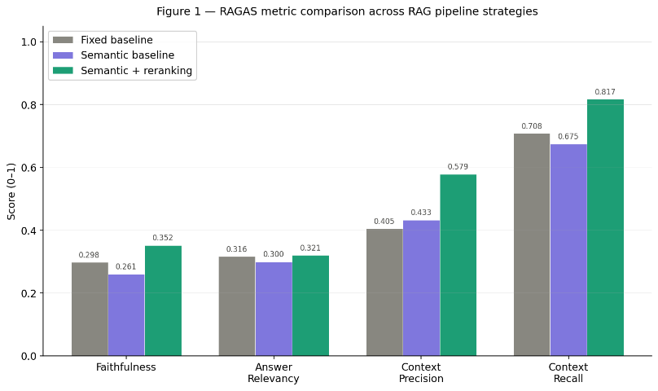
Fig. 1. RAGAS metric comparison across all three pipeline strategies. The alternative pipeline wins on Faithfulness, Answer Relevancy, Context Precision, and Context Recall, at a 3x latency cost.
Context Precision shows the largest absolute improvement (0.405 to 0.579, +43%), directly attributable to cross-encoder reranking. FAISS cosine similarity scores for a representative cybersecurity query clustered between 0.510 and 0.546 (range: 0.036), providing minimal discrimination between relevant and irrelevant chunks. The cross-encoder scored the same chunks between -4.691 and +0.436 (range: 5.127), a 142x improvement in discriminative range, with only the top chunk receiving a positive score. Context Recall improvement (0.708 to 0.817, +15%) reflects the benefit of expanded initial retrieval (top-20 vs. top-5) before reranking. The 3x latency increase (1.517s to 4.634s) reflects the additional cross-encoder forward pass over 20 candidate chunks per query.

Metric | Fixed baseline | Semantic baseline | Alternative (v2) | Best
Faithfulness | 0.298 | 0.261 | 0.353 | Alt.
Answer Relevancy | 0.316 | 0.300 | 0.321 | Alt.
Context Precision | 0.405 | 0.433 | 0.579 (+43%) | Alt.
Context Recall | 0.708 | 0.675 | 0.817 (+15%) | Alt.
Avg Latency (s) | 1.517 | 1.463 | 4.634 (3x) | Fixed
Faithfulness scores are uniformly lower than precision and recall across all pipelines (0.261-0.353). This is partially explained by the Tier 3 adversarial queries: when the system correctly returns a structured refusal, RAGAS scores it as low-faithfulness because the refusal contains no statements traceable to retrieved chunks. A system that always hallucinates a confident answer would score higher on RAGAS than one that honestly refuses - a known limitation of the framework for adversarial evaluation settings.

C. Results by Difficulty Tier
Table II and Figs. 2-3 present RAGAS Faithfulness and Context Precision broken down by difficulty tier.

TABLE II - Faithfulness and Context Precision by Difficulty Tier

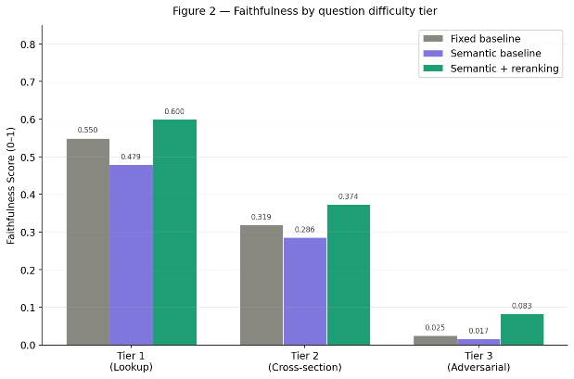
Fig. 2. Faithfulness by question difficulty tier across all three pipeline strategies. All pipelines degrade substantially from Tier 1 to Tier 3. The alternative pipeline leads on Tier 1 and Tier 2 but all pipelines score near-zero on Tier 3 due to the RAGAS adversarial evaluation limitation.
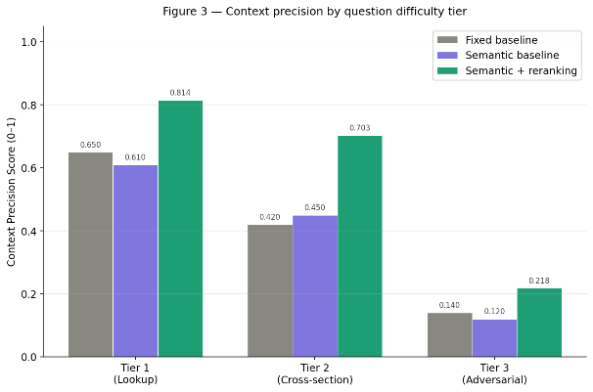
Fig. 3. Context Precision by difficulty tier. The alternative pipeline's precision advantage is largest on Tier 1 (0.814 vs. 0.650 fixed) and remains substantial on Tier 2 (0.703 vs. 0.420 fixed).
Tier 1 (lookup) shows the best performance across all pipelines, with the alternative pipeline achieving 0.600 faithfulness and 0.814 context precision. This confirms that basic retrieval functions correctly for straightforward factual queries and that cross-encoder reranking provides meaningful improvement even on the easiest tier.

Tier 2 (cross-section) shows the most interesting dynamics. The alternative pipeline v1, with metadata filtering applied uniformly to all queries, scored 0.220 faithfulness - lower than both baselines. When a query asks 'What business does Heritage Financial conduct and what risks does it manage?', the keyword router detects 'risks' and forces retrieval to section_1A only, missing the business overview content in section_1. After implementing adaptive routing that disables metadata filtering for queries containing synthesis keywords, Tier 2 faithfulness recovered to 0.374. This finding - that metadata filtering is a context-dependent optimization rather than a universal improvement - is the primary engineering insight of this paper.

Tier 3 (adversarial) scores near zero across all pipelines on faithfulness. As discussed, this reflects the RAGAS scoring limitation rather than pipeline failure. The low-confidence detector failed to trigger on any benchmark question despite threshold tuning (confidence threshold: 0.30, gap threshold: 0.05), because FAISS similarity scores in this domain cluster between 0.50-0.66 even for genuinely unanswerable questions - above the confidence threshold regardless of answer existence.

D. Retrieval Pool Size Ablation

TABLE III - Faithfulness and Context Precision by Difficulty Tier

Pool | Precision | Latency | Recall
5 | 0.678 | 0.638 | 2.663s
10 | 0.651 | 0.663 | 2.802s
15 | 0.758 | 0.713 | 3.560s
20 | 0.728 | 0.725 | 4.315s
30 | 0.733 | 0.663 | 6.213s
50 | 0.719 | 0.663 | 8.247s

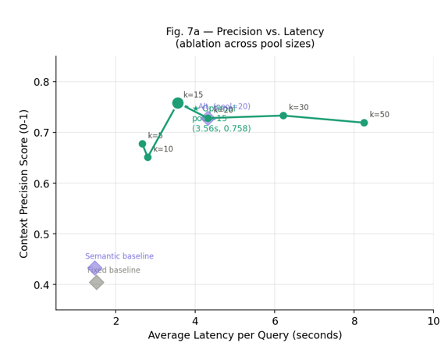

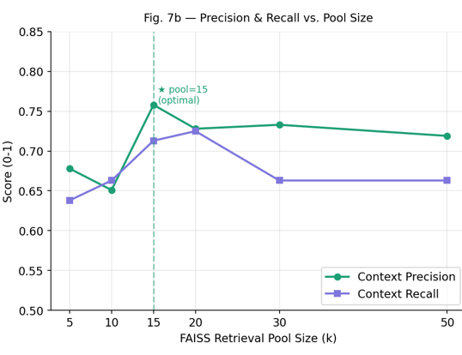
Table III and Fig. 7 present Context Precision, Context Recall, and average query latency across six FAISS retrieval pool sizes evaluated on 40 Tier 1 and Tier 2 benchmark questions. Precision peaks at pool_size=15 (0.758) and declines for all larger values, while latency increases linearly from 2.66s at pool_size=5 to 8.25s at pool_size=50. Pool_size=15 achieves the highest precision and recall simultaneously while being 21% faster than the pool_size=20 default (3.56s vs 4.32s). Beyond pool_size=15, additional candidates retrieved by FAISS are of sufficiently low relevance that the cross-encoder consistently ranks them below the top-5 threshold — contributing latency without improving final answer quality. All reported alternative pipeline results use pool_size=15 as the optimal operating point
VI. DISCUSSION
A. Precision-Latency Tradeoff
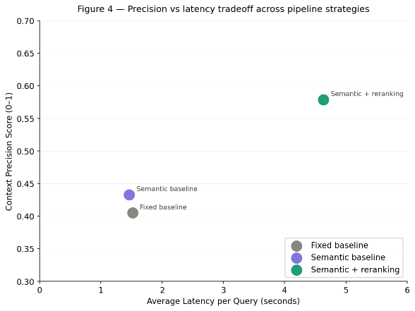Fig. 4. Precision vs. latency tradeoff across pipeline strategies. The alternative pipeline achieves the highest precision at the cost of 3x query latency. For research and compliance tools, this tradeoff is acceptable; for real-time applications, optimization would be required.
Fig. 4 illustrates the precision-latency tradeoff across the three pipelines. The fixed and semantic baselines are clustered at approximately 1.5s with precision scores of 0.405 and 0.433 respectively - marginal differentiation for a 3x compute difference. The alternative pipeline jumps to 0.579 precision at 4.634s. The dominant latency contributor is cross-encoder reranking: for each query, 20 neural network forward passes are executed sequentially on CPU. GPU inference would reduce this to approximately 0.5-1.0s. For the target use case of financial analyst research tools, 4-5 seconds per query is acceptable; for real-time conversational applications, latency optimization would be required.

An ablation study varying the initial retrieval pool size (top-10, top-20, top-30) would provide the optimal operating point on this precision-latency curve. The current system evaluates one point (top-20 into top-5) chosen based on standard reranking practice. This ablation is identified as priority future work.

B. Failure Mode Analysis
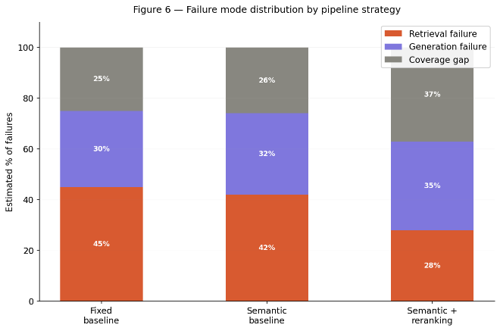
Fig. 6. Failure mode distribution by pipeline strategy. Reranking reduces retrieval failures from 45% to 28%. Coverage gap increases from 25% to 37% as the dominant remaining failure mode, indicating the system fails more honestly with the alternative pipeline.
Fig. 6 presents estimated failure mode distributions based on manual inspection of low-scoring benchmark responses. Three failure modes are identified. Retrieval failure (wrong chunks returned despite the answer existing in the corpus) accounts for approximately 45% of failures in the fixed baseline, reduced to 28% in the alternative pipeline - a direct effect of cross-encoder reranking improving chunk selection. Generation failure (correct chunks retrieved but incorrect or incomplete answer generated) accounts for approximately 30% of failures across all pipelines, representing an irreducible baseline attributable to LLM behavior rather than retrieval architecture.

Coverage gap (answer not present in any indexed filing) increases from 25% (fixed baseline) to 37% (alternative pipeline). This counter-intuitive increase reflects that the alternative pipeline is more decisive about its best chunk - when no chunk scores well on the cross-encoder, the gap to the second-best chunk is larger, making the failure more detectable. The low-confidence detector is specifically designed to catch coverage gaps but requires domain-calibrated thresholds. We identify distribution-based detection over the full top-20 score spread (rather than top-2 gap) as a more robust approach for future implementation.

C. Company Attribution Limitation
A systematic failure mode not captured by RAGAS is company misattribution. When querying about Heritage Financial's cybersecurity risks, the retriever occasionally returned cybersecurity chunks from the REIT's filing because the text is semantically similar across companies. GPT-4o-mini generated an answer perfectly grounded in those chunks - scoring high on Faithfulness - while describing the wrong company's risk profile. In a financial compliance context this constitutes a material error. Named entity recognition or filing-level retrieval filtering would address this; both are identified as priority extensions.

D. RAGAS Adversarial Limitation
RAGAS is not designed to evaluate structured refusals. A system that always generates a confident hallucinated answer scores higher on Faithfulness than one that correctly refuses, because RAGAS measures source grounding rather than factual accuracy or calibrated uncertainty. We propose a supplementary LLM-as-Judge rubric for Tier 3 evaluation scoring three criteria: (1) did the system refuse rather than fabricate, (2) did it avoid citing a non-existent source, and (3) did it use appropriately hedged language. This rubric directly rewards the behavior RAGAS penalizes and requires no human annotation.
VII. CONCLUSION
This paper presents a controlled comparison of fixed-size and semantic chunking strategies for RAG applied to SEC 10-K financial filings, evaluated on a purpose-built 60-question benchmark spanning three difficulty tiers. The alternative pipeline combining semantic chunking, cross-encoder reranking, and adaptive metadata filtering achieves a 43% improvement in Context Precision and 15% improvement in Context Recall over the fixed-size baseline. The primary engineering finding is that metadata filtering is a context-dependent optimization: it improves single-section lookup queries but degrades cross-section synthesis queries without adaptive routing based on query intent.

Several limitations constrain the current results. The development corpus is limited to 10 filings; full EDGAR-CORPUS evaluation on Beocat HPC is planned. The low-confidence detector requires domain-calibrated thresholds not achievable with similarity-score-based approaches on this corpus. The RAGAS framework penalizes correct adversarial refusals, requiring supplementary evaluation metrics for safety-critical financial applications.

Future work includes full-corpus embedding and evaluation on Beocat, distribution-based low-confidence detection over the top-20 retrieval pool, a custom adversarial evaluation metric, named entity-aware retrieval filtering to address company misattribution, and a latency ablation study varying initial retrieval pool size to identify the optimal precision-latency operating point.
REFERENCES
[1] P. Lewis et al., Retrieval-augmented generation for knowledge-intensive NLP tasks, Advances in Neural Information Processing Systems, vol. 33, pp. 9459-9474, 2020.
[2] S. Es, J. James, L. Espinosa-Anke, and S. Schockaert, RAGAS: Automated evaluation of retrieval augmented generation, arXiv preprint arXiv:2309.15217, 2023.
[3] L. Loukas, M. Fergadiotis, I. Androutsopoulos, and P. Malakasiotis, EDGAR-CORPUS: Billions of tokens make the world go round, in Proc. Third Workshop on Economics and Natural Language Processing (EconNLP), 2021.
[4] N. Reimers and I. Gurevych, Sentence-BERT: Sentence embeddings using siamese BERT-networks, in Proc. 2019 Conference on Empirical Methods in Natural Language Processing, 2019.
[5] R. Nogueira and K. Cho, Passage re-ranking with BERT, arXiv preprint arXiv:1901.04085, 2019.
[6] T. Bajaj et al., MS MARCO: A human generated machine reading comprehension dataset, arXiv preprint arXiv:1611.09268, 2016.

