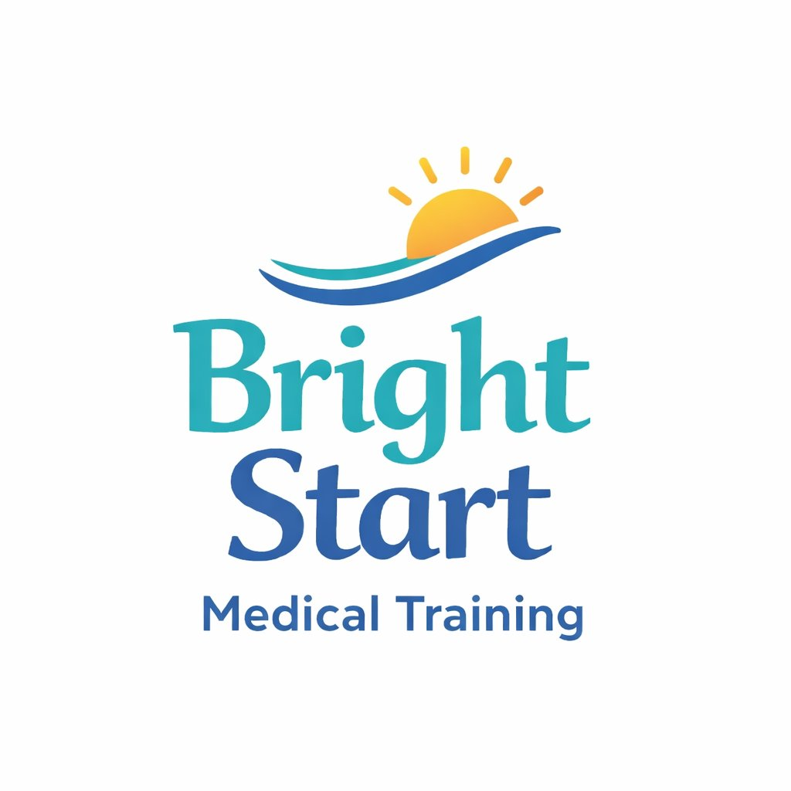
BRIGHT START MEDICAL TRAINING
3301 Green Street, Claymont, DE 19703 · 302-307-3939 · info@brightstart-training.com · brightstart-training.com

Application for Admission — Home Health Aide (HHA) Training Program
Complete this application and return it with the documents listed below. Admission requirements and the application process are described in Sections 4–6 of the School Catalogue. Submitting an application does not guarantee admission.

APPLICANT INFORMATION
Full Legal Name:

  Date of Birth:
  Phone Number:

Email Address:

Street Address:

  City / State:
  ZIP Code:

EMERGENCY CONTACT
  Contact Name:
  Phone Number:

PROGRAM
Home Health Aide (HHA) Training Program — 76 hours (60 classroom/laboratory + 16 supervised practical (clinical) training). Classes meet Monday–Friday, 8:30 AM – 3:00 PM.

  Preferred Cohort Start Date:
  Alternate Start Date:

ENTRANCE REQUIREMENTS
Check each statement that applies to you:
☐ I am at least 18 years of age.
☐ I have a high school diploma or GED.
☐ I have a valid government-issued photo ID.
☐ I consent to a criminal background check through the Delaware Criminal Justice Information System (DELJIS).
☐ I consent to a drug screening.
DOCUMENTS TO SUBMIT WITH THIS APPLICATION
☐ Copy of government-issued photo ID
☐ Proof of high school diploma or GED
☐ $100.00 non-refundable registration fee (applied to the total program cost of $1,785.00)
☐ Optional: transcripts or certificates for prior training, if requesting transfer credit (Catalogue Section 37)
APPLICANT CERTIFICATION
By signing below, I certify that the information in this application is true and complete, and that I have received the Bright Start Medical Training School Catalogue. I understand that admission may be conditionally accepted pending background check results, that a criminal history is reviewed on a case-by-case basis, and that I may not begin supervised practical training until a satisfactory result is confirmed. I also understand that completion of this program does not result in a state certification or registry listing.

  Applicant Signature
  Date:
  Program Director — George Frankel
  Date:

Bright Start Medical Training admits students without discrimination based on race, color, religion, sex, national origin, age, disability, or political affiliation. Applicants who need an accommodation may contact the school at 302-307-3939 or info@brightstart-training.com.
FOR SCHOOL USE ONLY
  Date Received:
  Registration Fee Received:

☐ ID Verified ☐ Diploma / GED Verified ☐ Background Check Cleared ☐ Drug Screen Cleared
Decision: ☐ Accepted ☐ Conditionally Accepted ☐ Denied
  Cohort Assigned:
  School Official / Date:

