REFLEX
Delivery Synchronization Platform
Project & Technical Documentation
Near-Real-time delivery status visibility for small urban retailers in Kenya

Version 1.0
Prepared for: Reflex — The Readiness Sprint
Date: September 2026

Table of Contents
1. Introduction 3
2. System Overview 3
3. System Architecture 4
4. Data Model (Entity-Relationship Diagram) 6
5. Order Lifecycle & State Diagram 7
6. End-to-End Process Flow 7
7. API Documentation 8
8. User Interface 9
9. Testing Strategy 11
10. Security Considerations 11
11. Known Limitations & Trade-offs 12
12. Future Roadmap 12
13. Team & Project Management 13
14. Recommended Tools for Ongoing Documentation 14
Appendix A — Original Architecture Reference Poster 15
Appendix B — How to Run the Project Locally 15

1. Introduction

1.1 Purpose of this Document
This document describes the design, architecture, and implementation of Reflex, a delivery-synchronization platform built during a five-day "Readiness Sprint." It is written for future contributors, reviewers, and evaluators who need to understand how the system works, why specific decisions were made, and what would need to change before the platform could move from prototype to production.
The document follows the KISS principle (Keep It Simple, Straightforward): every diagram is a real rendered image rather than raw diagram code, every section explains one idea at a time, and technical depth is layered so a reader can stop at whichever level of detail they need.

1.2 Problem Statement
Small urban retailers in Kenya (electronics shops, pharmacies, boutiques) currently coordinate deliveries informally — usually over WhatsApp or phone calls between the shop, a boda-boda rider, and the customer. This creates three recurring problems:
- No single, trusted record of where an order is in its journey.
- No proof that a delivery was actually received by the correct customer.
- No visibility for the retailer once the parcel leaves the shop.

1.3 Proposed Solution
Reflex replaces the informal WhatsApp thread with a single shared ledger. A retailer logs a delivery once; a dispatcher assigns it to a rider; the rider updates its status as it moves; and a customer-specific OTP adds a verification step before an order can be marked as delivered. In the current MVP, it demonstrates the verification workflow but is not yet independent proof of delivery because the code is displayed in the interface rather than privately sent to the customer. All three personas view the same live state instead of separate, conflicting stories.

1.4 Scope of the Current Build
The current build is a functional MVP (Minimum Viable Product) developed to prove the delivery workflow end-to-end. It intentionally excludes production concerns such as persistent storage, authentication, and SMS delivery — these are documented as future work in Section 12.

2. System Overview
Reflex connects three personas into one synchronized delivery ledger:
Persona | Role | Typical Device
Retailer Staff | Logs delivery requests for customers | Shop tablet or desktop
Dispatcher | Assigns logged orders to an available rider | Control cockpit monitor
Field Rider | Picks up the parcel and confirms delivery via OTP | Budget Android smartphone

2.1 Order Status Flow (at a glance)
Every order moves through exactly four states, in one direction only:
PENDING_DISPATCH → ASSIGNED → PICKED_UP → DELIVERED
The backend — not the interface — enforces this order, so no user can skip or reverse a stage (see Section 5).

2.2 Technology Stack
Layer | Technology | Notes
Backend | Python 3.12 + Flask | Lightweight REST API server
Frontend | HTML, CSS, vanilla JavaScript | No framework; three persona views in one page
Data storage | In-memory Python dictionaries | Reset on restart — MVP only, see Section 11
Verification | 4-digit OTP per order | Cryptographically generated with Python's secrets module
Sync method | HTTP polling every 4 seconds | Simple to implement; trade-off explained in Section 11
Cross-origin support | flask-cors | Allows the browser dashboard to call the API

3. System Architecture
Reflex is built as a modular monolith: one deployable application, cleanly divided into layers by responsibility. This keeps the MVP simple to build and explain while leaving each layer free to be replaced later without rewriting the others.

3.1 Layered Architecture Diagram
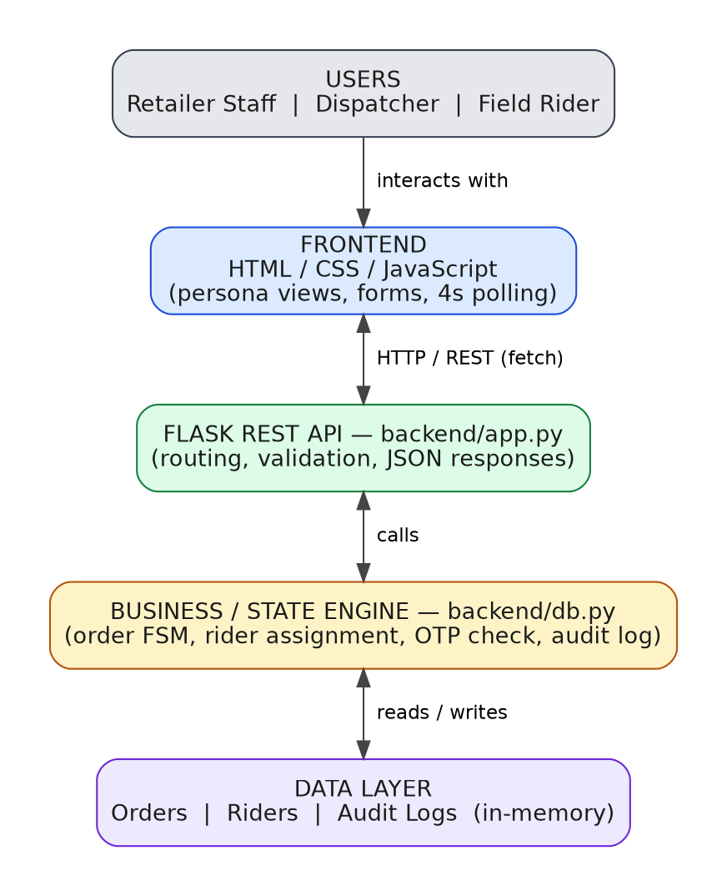
Figure 1 — Reflex layered architecture: users, frontend, API, business logic, and data.

3.2 Layer Responsibilities

Frontend (frontend/static/)
- Renders the three persona views (Retailer, Dispatcher, Rider) from one HTML page.
- Collects form input and calls the REST API using fetch().
- Polls the backend every 4 seconds to refresh on-screen state.
- Never decides whether a status transition is valid — that belongs to the backend.

API layer (backend/app.py)
- Exposes REST endpoints grouped by persona (retailer, dispatcher, rider, system).
- Validates every incoming request before it reaches business logic.
- Translates business-logic results into JSON responses with correct HTTP status codes.

Business / state engine (backend/db.py)
- Owns the order state machine and every guarded transition.
- Generates and verifies the OTP for each order.
- Assigns and releases riders, and writes every event to the audit trail.

Data layer
- Three in-memory tables: Orders, Riders, and Audit Logs.
- Suitable for a demo; not durable — see Section 11 for the production direction.

3.3 Guiding Principles
- Backend owns the state — the frontend only displays and requests changes.
- Keep the MVP small — only what is needed to prove the workflow is included.
- Validate at the source of truth — rules live in the backend, not just the UI.
- Design for extension — each layer can be replaced without rewriting the others.
- Document the real system — this document reflects what is implemented, not just what was planned.

4. Data Model (Entity-Relationship Diagram)
The MVP stores three record types in memory. The diagram below shows their fields and how they relate; the relationships are enforced in code rather than by a database engine.
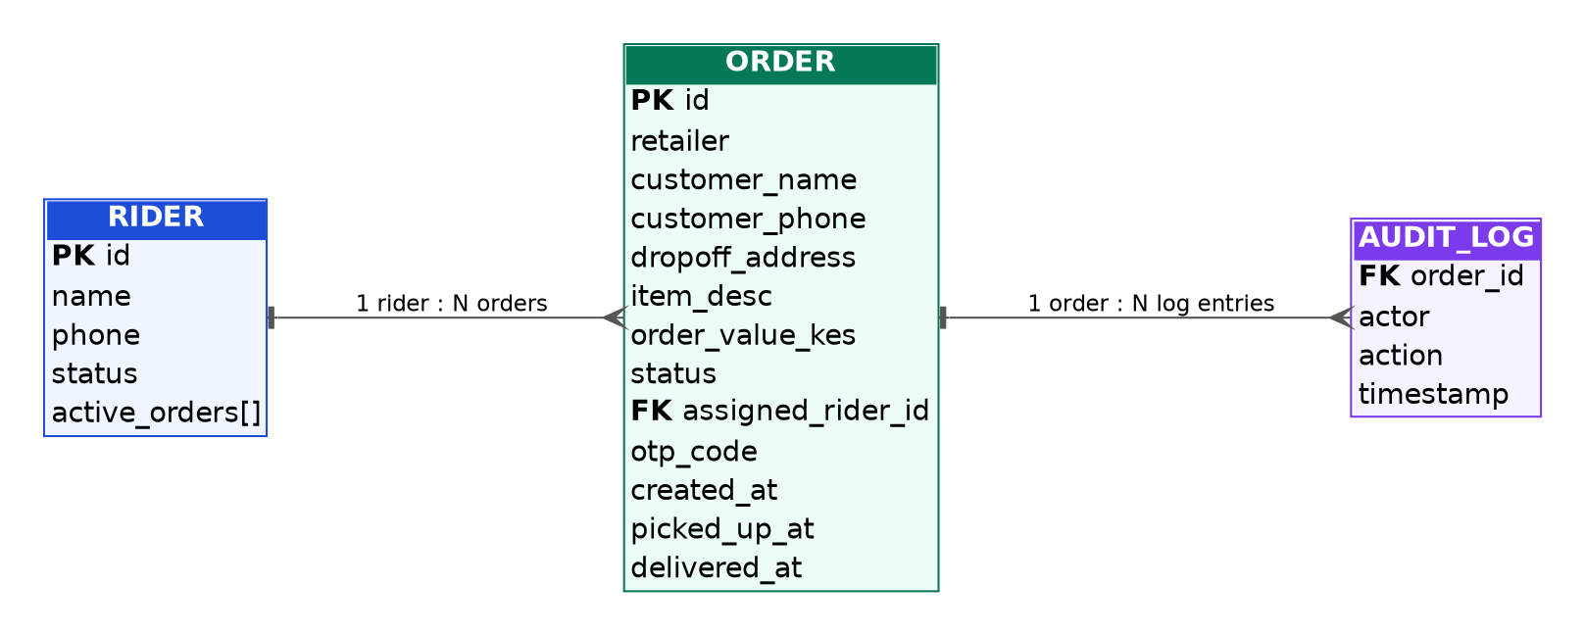
Figure 2 — Entity-Relationship Diagram: Rider, Order, and Audit_Log.

4.1 Entity Notes

Rider
Represents a field rider. status is either AVAILABLE or BUSY; active_orders lists the order IDs currently assigned to that rider (capped at one in the current dispatch rule).

Order
The central record of the system. Carries the full delivery detail, its current status, the generated otp_code, and three timestamps (created, picked up, delivered) that together form a timeline for each delivery.

Audit_Log
An append-style list of every meaningful event against an order — creation, assignment, pickup, failed OTP attempts, and successful delivery — each stamped with the actor and the time it happened.
Audit events are available through the tracking API and are also visible in the deployed dashboard through an AUDIT TRAIL section on order cards. The log is append-style by application convention, not immutable by storage design.

5. Order Lifecycle & State Diagram
The backend treats the order status as a finite state machine. A transition is only accepted if the order is currently in the exact state that transition expects; anything else is rejected with a clear error message.
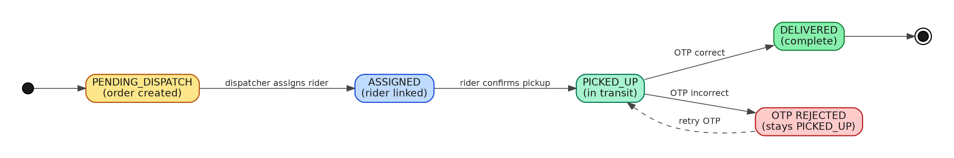
Figure 3 — Order state diagram, including the OTP retry loop.

5.1 Transition Rules
From | To | Trigger | Guard
(new) | PENDING_DISPATCH | Retailer submits an order | All required fields validated
PENDING_DISPATCH | ASSIGNED | Dispatcher assigns a rider | Rider must be AVAILABLE
ASSIGNED | PICKED_UP | Rider confirms pickup | Must be the rider it was assigned to
PICKED_UP | DELIVERED | Rider submits correct OTP | OTP must match exactly
PICKED_UP | PICKED_UP | Rider submits wrong OTP | Attempt is logged, order stays put

6. End-to-End Process Flow
The flowchart below shows the same lifecycle as a swimlane diagram, making clear which actions belong to which persona and which belong to the system itself.
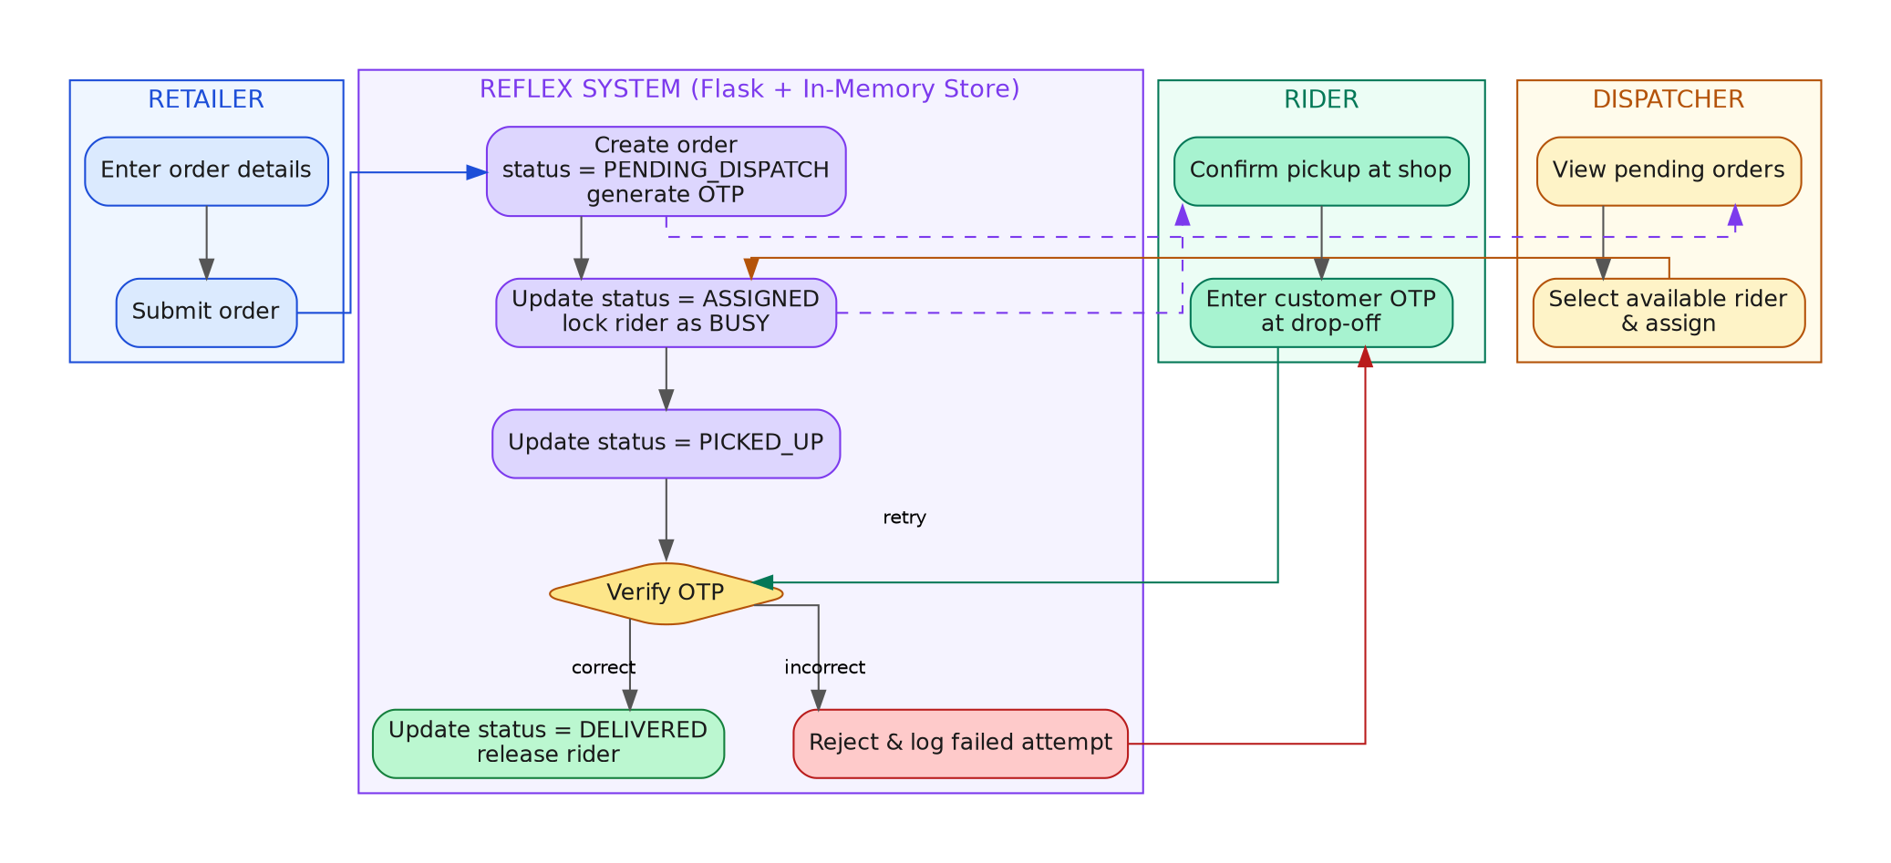
Figure 4 — Swimlane flow across Retailer, Reflex System, Rider, and Dispatcher.

6.1 Narrative Walkthrough
- Retailer enters the customer's name, phone, address, and item details, then submits the order.
- Reflex creates the order in PENDING_DISPATCH and generates a secure 4-digit OTP.
- Dispatcher sees the order in the unassigned queue and assigns it to an available rider.
- Reflex marks the order ASSIGNED and marks the selected rider as BUSY in the current in-memory state and records the assigned order in the rider’s active order list.
- The current data layer prevents sequential reassignment of the same order and rejects assignment to a rider already marked BUSY, but it does not enforce an atomic concurrency lock.
- Rider collects the parcel from the shop and confirms pickup; Reflex marks it PICKED_UP.
- At the doorstep, the rider asks the customer for their OTP and enters it into the app.
- Reflex checks the OTP: a match marks the order DELIVERED and frees the rider; a mismatch is rejected and logged, and the rider can retry.

7. API Documentation
All endpoints are served from the single Flask application and return JSON with a success boolean plus either the requested data or an error message.

7.1 Endpoint Reference
Endpoint | Method | Persona | Purpose
/ | GET | Everyone | Serves the live dashboard HTML
/api/orders | GET | Retailer | Lists all orders, optionally filtered by status
/api/orders | POST | Retailer | Creates a new delivery request
/api/orders/<id>/tracking | GET | Retailer | Returns order status, rider, and audit trail
/api/dispatch/unassigned | GET | Dispatcher | Returns unassigned orders and available riders
/api/dispatch/assign | POST | Dispatcher | Assigns a rider to an order
/api/riders/<id>/tasks | GET | Rider | Returns tasks assigned to a specific rider
/api/riders/pickup | POST | Rider | Confirms parcel pickup at the shop
/api/riders/deliver | POST | Rider | Submits the customer OTP to complete delivery
/api/system/reset | POST | Demo tool | Resets all data to a clean seed state

7.2 Request Flow (Sequence Diagram)
The sequence below traces a single action — a rider tapping "Verify & Deliver" — from click to updated screen.
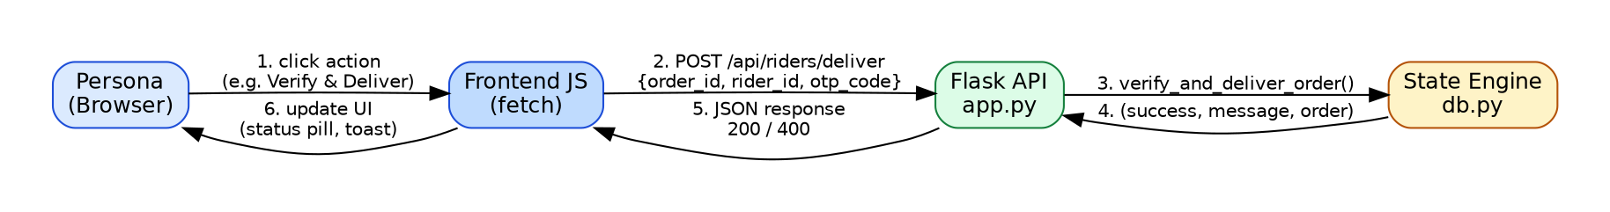
Figure 5 — Sequence diagram for a rider delivery request.

7.3 Validation Rules
- Customer name must include at least two names (first and last).
- Phone number must be exactly 10 numeric digits.
- Delivery address must be at least 5 characters.
- Item description must be at least 3 characters.
- A rider already BUSY cannot be assigned a second order.
- Every rejected action returns success: false with a human-readable error and the correct HTTP status code (400 or 404).

8. User Interface
The current dashboard presents the Retailer, Dispatcher, and Rider panels together in one unified three-persona view. Each panel reads from the same backend state, with the frontend polling the API every four seconds for updates. Screens below were captured from the running application.

8.1 Dashboard Header
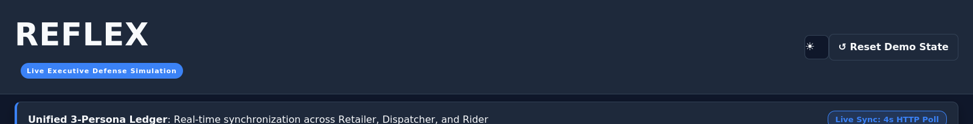
Figure 6 — Header bar with theme toggle, demo reset control, and the live sync indicator.

8.2 Retailer Panel
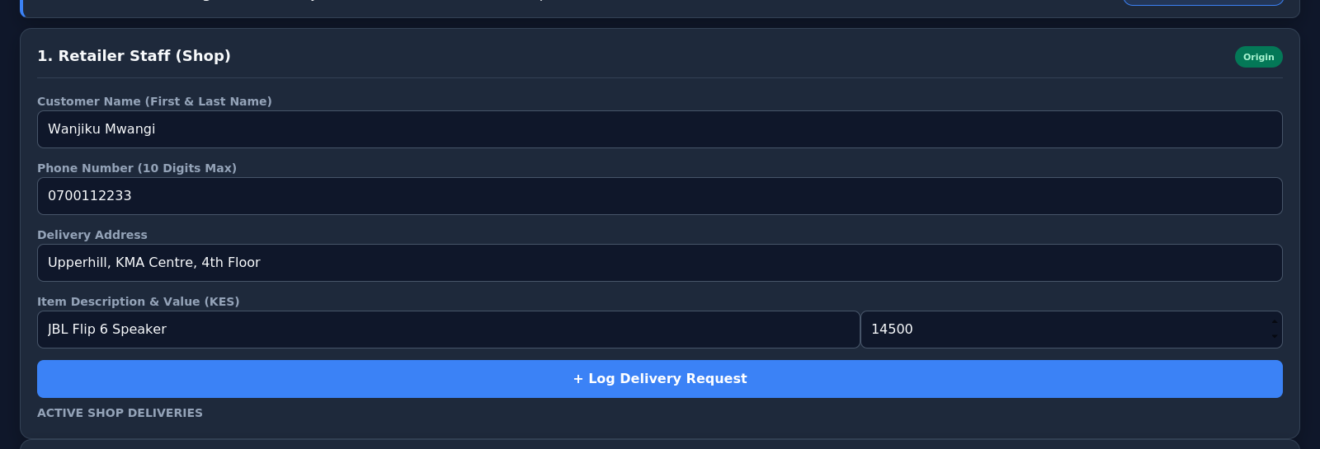
Figure 7 — Retailer Staff panel: new-order form with inline validation hints.

8.3 Dispatcher Panel
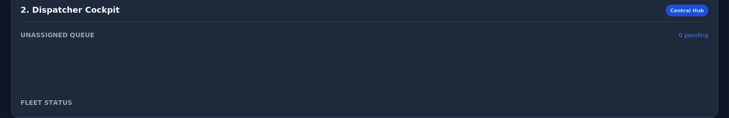
Figure 8 — Dispatcher Cockpit: unassigned queue and fleet status.

8.4 Rider Panel
Figure 9 — Field Rider panel, styled as a mobile phone frame with the rider selector.
Note: these captures were rendered with a lightweight compatibility engine used for automated documentation, which lays the three panels out in a single column and does not execute background data refresh. In a modern browser (Chrome, Edge, Firefox, Safari) the same page renders as a live three-column dashboard that updates every 4 seconds — shown in the layout reference in Figure 1 of the Appendix.

9. Testing Strategy
An automated suite (tests/test_reflex.py) exercises the backend directly through Flask's test client, covering both the happy path and the guard conditions that keep delivery state consistent.
# | Test | What it proves
1 | test_01_create_delivery_order | A valid order is created with status PENDING_DISPATCH and a 4-digit OTP
2 | test_02_dispatcher_unassigned_queue | New orders appear in the dispatcher's unassigned queue
3 | test_03_dispatcher_assign_order | Assigning a valid rider moves an order to ASSIGNED
4 | test_04_duplicate_assignment_guard | An already-assigned order cannot be assigned again
5 | test_05_rider_pickup_flow | The assigned rider can move the order to PICKED_UP
6 | test_06_invalid_otp_rejection | A wrong OTP is rejected and the order stays PICKED_UP
7 | test_07_valid_otp_delivery_success | The correct OTP marks the order DELIVERED and frees the rider
8 | test_08_order_tracking_audit_trail | The tracking endpoint returns the delivered order together with multiple audit entries from its lifecycle.
9 | test_09_busy_rider_assignment_blocked | A BUSY rider cannot receive a second order
10 | test_10_phone_validation_max_10_digits | Phone numbers outside the 10-digit rule are rejected
11 | test_11_customer_name_min_names | A single-word customer name is rejected

9.1 Manual Checks
Two edge cases sit outside the automated suite and were verified by hand:
- Attempting pickup before an order has been assigned is rejected.
- Attempting delivery before an order has been picked up is rejected.

10. Security Considerations

10.1 Protections already in place
- Backend-side validation of every state transition (the UI cannot force an invalid one).
- OTP verification before any order can be marked delivered.
- Rider and order identity checks before pickup or delivery actions are accepted.
- Cryptographically generated OTPs (Python's secrets module, not random).
- Failed OTP attempts are written to the audit trail rather than silently discarded.

10.2 Not yet implemented (by design, for this sprint)
- User authentication and role-based access control.
- HTTPS / transport encryption.
- Real SMS delivery of the OTP to the customer.
- Rate limiting on API endpoints.
- Encryption of sensitive fields at rest.
These gaps are deliberate MVP boundaries, not oversights, and are carried forward into the roadmap in Section 12.

11. Known Limitations & Trade-offs
The team recorded every significant trade-off during the build, together with the reasoning for accepting it and what would change with more time. A condensed summary:
Decision | Chosen approach | Why | Future direction
Data storage | In-memory dictionaries | Zero setup for every teammate during the sprint | Persistent database (PostgreSQL/MySQL)
Dispatch | Manual, by a human dispatcher | Avoids GPS/routing complexity for an MVP | Automated assignment by location and load
Delivery proof | 4-digit OTP | Simple and lightweight to implement and demo | SMS-delivered OTP, unseen by the rider
Synchronization | HTTP polling (4s) | No persistent connection or extra infrastructure | WebSockets or Server-Sent Events
Concurrency guard | Sequential status check | No parallel write path in a single-process demo | Atomic conditional update
Authentication | None — trusted single operator | Kept sprint focus on the delivery workflow itself | Full auth + role-based access control
Frontend | Plain HTML/CSS/JS | No build step or learning cost for a 5-day sprint | Component framework once screen count grows

The full reasoning behind each item — including the specific defects found and fixed during development — is preserved in docs/TRADE_OFF_LOG.md in the project repository.

12. Future Roadmap
The current architecture was deliberately kept simple enough to extend without rewriting the core business logic. A possible production direction:
- Replace the in-memory store with a persistent relational database.
- Introduce authentication and role-based access control for each persona.
- Send the OTP to the customer by SMS instead of displaying it in the UI.
- Move from HTTP polling to WebSockets or Server-Sent Events for instant updates.
- Add GPS-based, automated rider assignment.
- Add photo proof-of-delivery alongside the OTP.
- Introduce mobile applications for riders in place of a mobile browser view.
- Add analytics and reporting for retailers and operations managers.

13. Team & Project Management
Reflex was developed by a five-person cross-functional pod using an Agile Scrum approach, with each member owning a distinct area of the codebase.
Member | Role | Owned files | Responsibility
Member 1 | Backend Core, Data Engine & QA | backend/db.py, tests/test_reflex.py | State machine, OTP generation, concurrency guards, automated tests
Member 2 | Backend API & Integration | backend/app.py | REST routes, request validation, JSON responses, error handling
Member 3 | Frontend UI & Interaction | frontend/static/index.html | Unified three-persona dashboard, forms, polling logic
Member 4 | Frontend Styling & Theming | frontend/static/styles.css | CSS grid layout, dark/light themes, status badges, mobile frame
Member 5 | Technical Docs & Architecture | docs/ARCHITECTURE.md, docs/TRADE_OFF_LOG.md | Architecture spec, trade-off log, presentation preparation

13.1 Scrum Flow
Product Goal → Sprint Planning → Task Breakdown → Parallel Development → Integration → Testing → Demo → Review / Retrospective

13.2 Definition of Done
- The code works and the API returns the expected response.
- Invalid actions are handled gracefully, not silently.
- The feature is integrated with the rest of the system.
- Relevant automated tests pass.
- Documentation reflects the actual implementation, not the original plan.

14. Recommended Tools for Ongoing Documentation
This document was produced as a static Word file. For a project that keeps evolving, the following tools are worth considering, matched to the kind of documentation they suit best. None are required — they are recommendations for whoever maintains this project next.

14.1 Living / collaborative documentation
- Notion — flexible pages and databases; good for architecture notes, meeting logs, and onboarding guides that change often.
- Confluence (Atlassian) — pairs naturally with Jira for teams already using Atlassian tools; strong page hierarchy and permissions.
- GitBook — clean, versioned documentation sites generated straight from Markdown, good for public-facing docs.

14.2 Diagrams
- draw.io / diagrams.net — free, works inside browsers or as a desktop app, exports clean PNG/SVG; well suited to architecture and flow diagrams like the ones in this document.
- Lucidchart — collaborative diagramming with ERD-specific shape libraries and direct database import for ERDs.
- Excalidraw — quick, hand-drawn-style diagrams for lightweight sketches during design discussions.

14.3 API documentation
- Swagger / OpenAPI + Swagger UI — generates interactive, testable API documentation directly from an OpenAPI spec; the endpoint table in Section 7 could become a living spec.
- Postman — API collections that double as documentation and a manual testing tool; can publish a read-only documentation page per collection.

14.4 Code-adjacent documentation
- MkDocs (with the Material theme) or Docusaurus — turns Markdown files already in the repository into a searchable documentation website, deployable alongside the code.
- Read the Docs — free hosting for MkDocs/Sphinx sites, rebuilt automatically from the repository.

14.5 Suggested approach for this project
Given the project's size, the simplest sustainable setup is: keep architecture and trade-off notes as Markdown files in docs/ (as already started), diagram in draw.io and export PNGs into the same folder, and publish the whole docs/ folder with MkDocs once the codebase grows beyond a single sprint. This keeps documentation next to the code it describes and avoids maintaining two separate sources of truth.

Appendix A — Original Architecture Reference Poster
The single-page reference below was produced during the sprint and summarizes the architecture, ERD, flowcharts, sequence diagram, and state diagram together for quick reference.
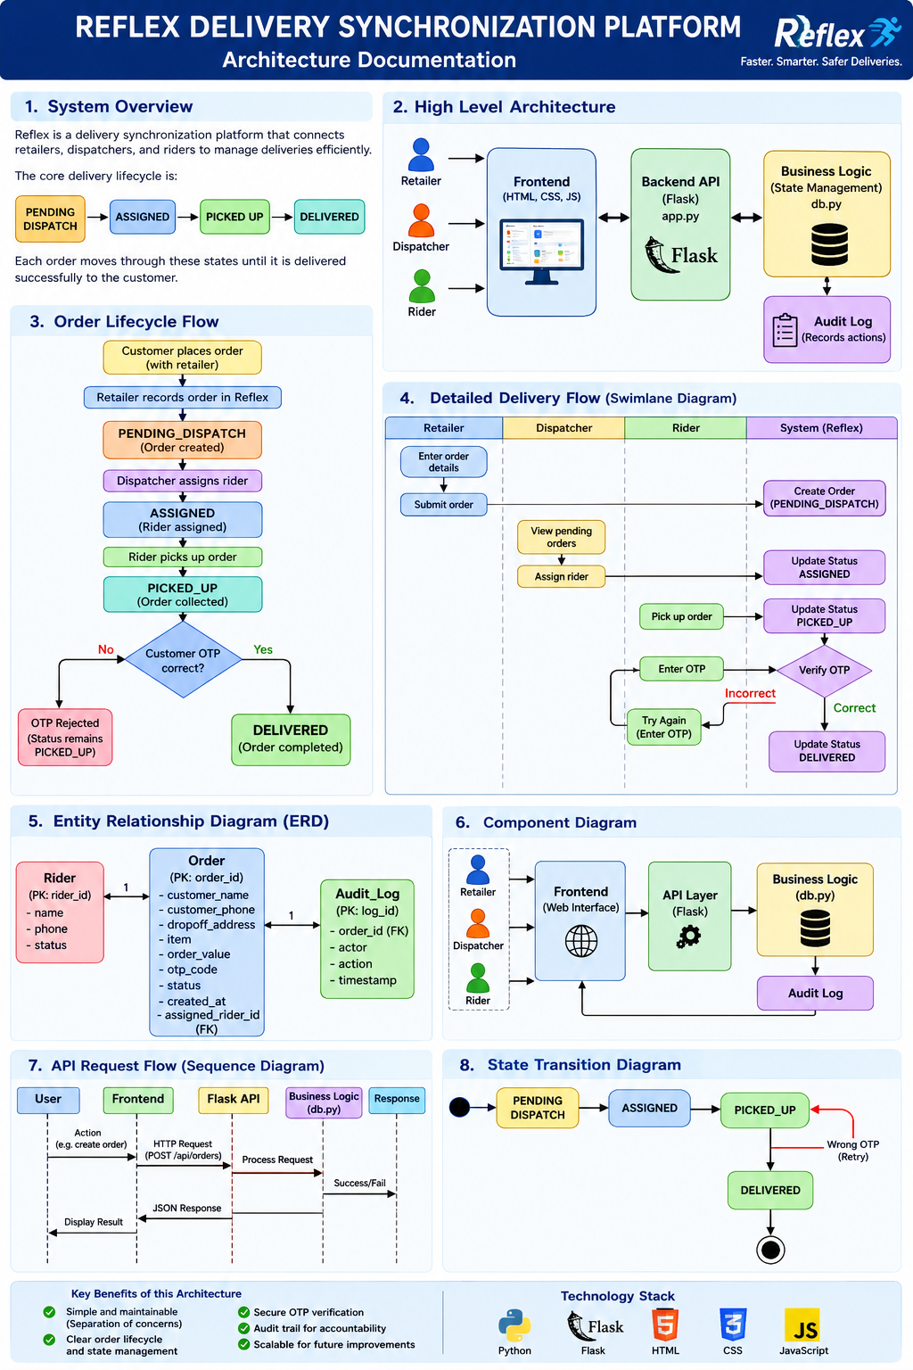
Figure A1 — Original architecture reference poster (docs/architecture-diagram.png).

Appendix B — How to Run the Project Locally
1. Install dependencies:
pip install -r requirements.txt
2. Start the server:
python backend/app.py
3. Open the dashboard at http://127.0.0.1:5050
4. Run the automated tests:
python tests/test_reflex.py

