

University of Ruhuna
Bachelor of Information and Communication
Technology Degree

Advanced Database Management Systems ICT3222
Mini Project – Final Report
Group – 08
TG/2022/1354 - L.M.C Wijesinghe
TG/2022/1342 - J.M.P.B.W Jayasundara
TG/2022/1352 - W.I.D Wijesinghe
TG/2022/1369 - H.K.D Randika
TG/2022/1373 - M.M Shasan

Introduction
The database is intended to support the lifecycle of a loan: application and assessment, approval, disbursement, scheduled repayment, payment processing, maturity and delinquency monitoring, recovery, and audit. MySQL tables store the operational records. Functions calculate repayment and risk values. Triggers validate selected loan/payment inputs and record changes. Procedures carry out transaction-oriented operations, scheduled events automate an overdue check, views expose work queues and summaries, and roles grant different levels of access.

Backend Solution

EER Diagram
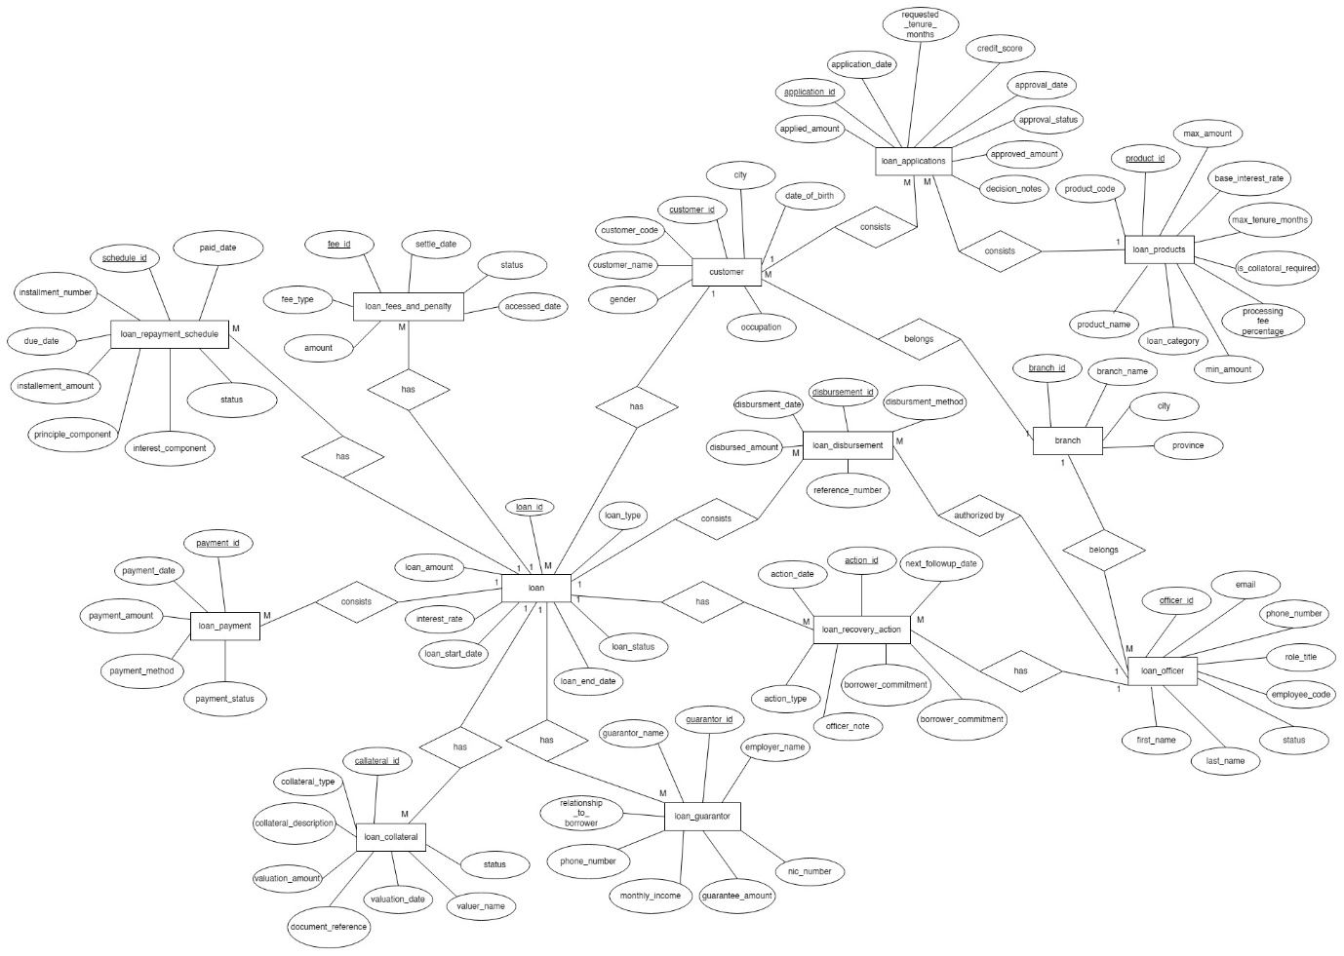

Relational Mapping
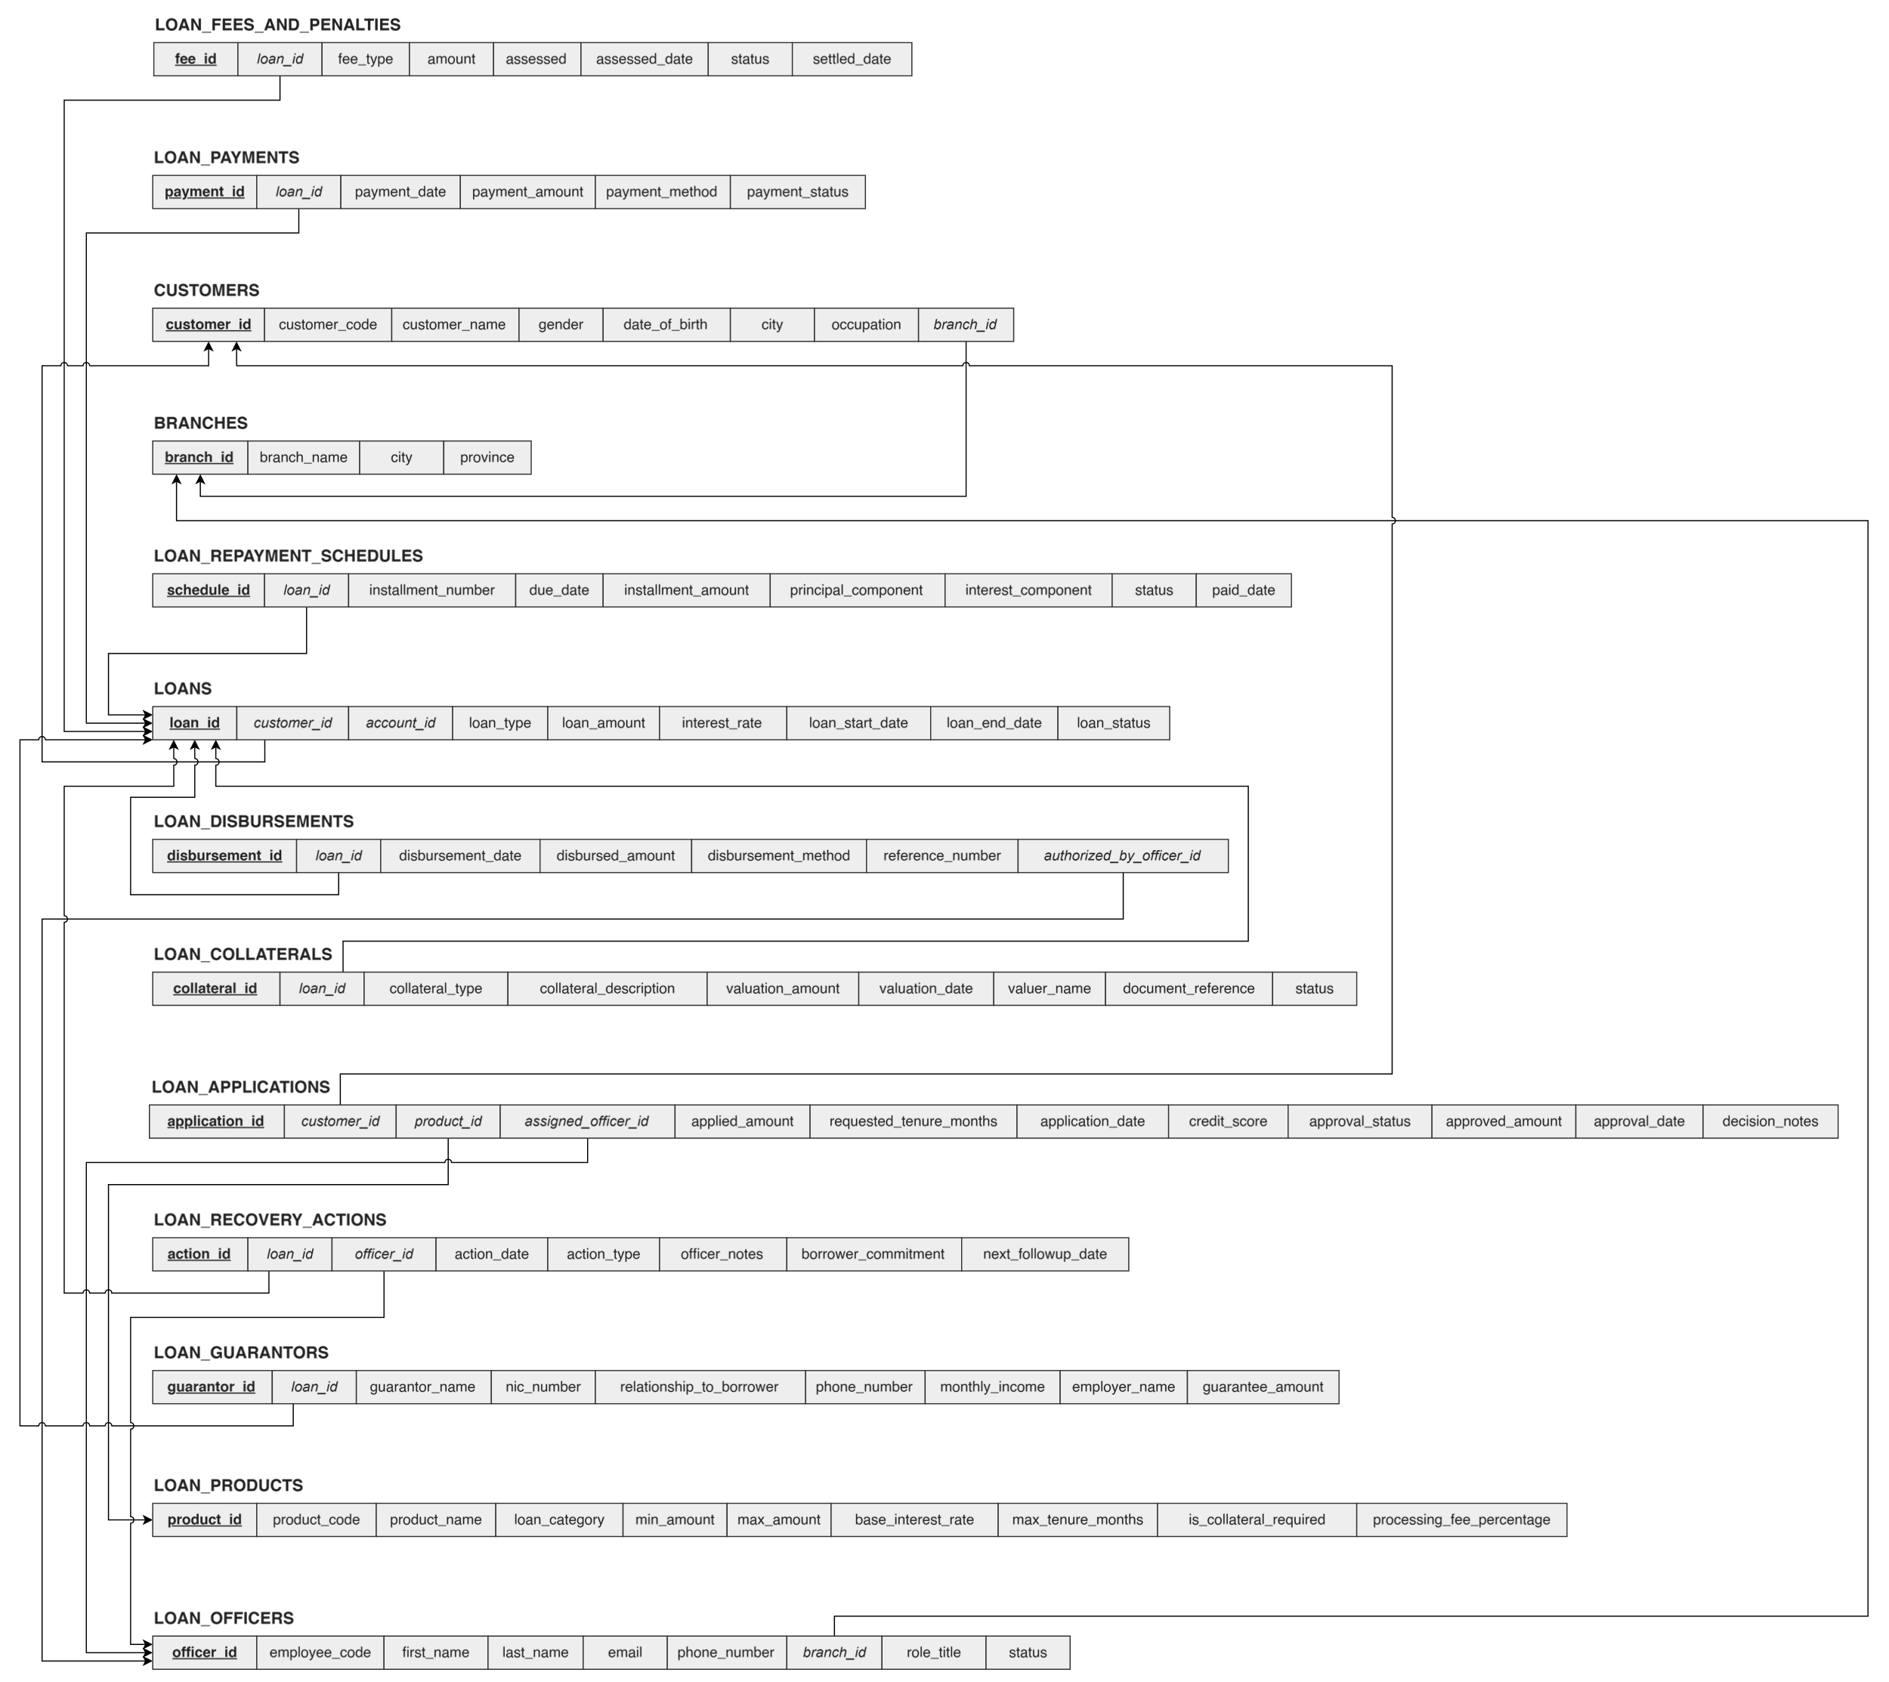

Table Structure

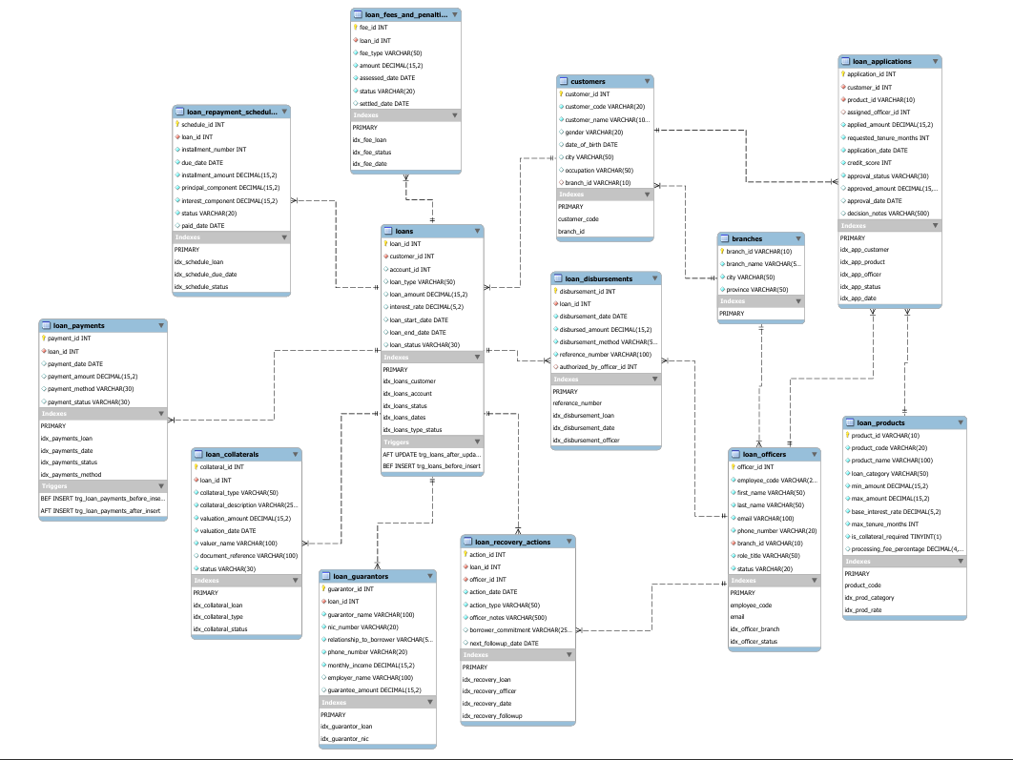

Architecture of the Backend

