**JAVA – EXTERNAL LEARNING 1**

**CHIRAN JEEVI**

**2019103013**

1) Write a method that returns the longest common prefix of two strings. For example, the longest common prefix of **amplifier** and **amplitude** is **ampl**.

The method is: **static** String prefix(String s1, String s2)

If the two strings don’t have a common prefix, the method returns an empty string. Write a **main** method that prompts the user to enter two strings and displays their longest common prefix.

**One.java**

import java.util.Scanner;

public class One {

    public static String prefix (String *s1*, String *s2*) {

*int* i, j;

        String res = "";

        String bigsString, smallsString, temp;

*boolean* prefixAvailable;

        if (*s1*.length() > *s2*.length()) {

            bigsString = *s1*;

            smallsString = *s2*;

        }

        else {

            bigsString = *s2*;

            smallsString = *s1*;

        }

        prefixAvailable = false;

        for (i=0; i<smallsString.length(); i++) {

            temp = smallsString.substring(0, i+1);

            if (bigsString.contains(temp)) {

                prefixAvailable = true;

                res = temp;

            }

        }

        if (prefixAvailable)

            return res;

        else

            return "";

    }

    public static *void* main(String[] *args*)

    {

        Scanner input = new Scanner(System.in);

        String s1, s2;

        String result = new String();

        System.out.print("\n Enter 1st string: ");

        s1 = input.nextLine();

        System.out.print(" Enter 2nd string: ");

        s2 = input.nextLine();

        result = prefix(s1, s2);

        System.out.println("\n Longest Common Prefix = " + result + "\n");

        input.close();

    }

}

OUTPUT:

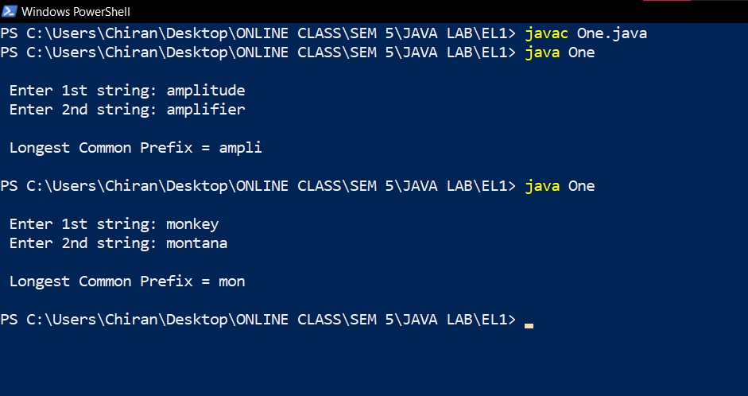

2) Write a program that prompts the user to enter aadhar number in the format DDDD DDDD DDDD, where D is a digit. The program displays **Valid** for a correct aadhar number and **Invalid** otherwise.

**Two.java**

import java.util.Scanner;

public class Two {

    public static *void* main(String[] *args*)

    {

        Scanner input = new Scanner(System.in);

        String entry;

*int* i, j;

*boolean* itsaNum = true, itsaBlank = true;

        System.out.print("\n Enter Aadhaar Number: ");

        entry = input.nextLine();

        if (entry.length() == 14) {

            for (i=0; i<14; i++)

            {

                if (i==4 || i==9) {

                    if ( entry.charAt(i)!=' ' )

                        itsaBlank = false;

                }

                else

                    if ( !digit(entry.charAt(i)) )

                        itsaNum = false;

            }

            if (itsaNum && itsaBlank)

                System.out.println("\n  VALID\n");

            else

                System.out.println("\n  INVALID\n");

        }

        else

            System.out.println("\n  INVALID \n");

    }

    public static *boolean* digit (*char* *c*) {

        if (*c*>='0' && *c*<='9')

            return true;

        return false;

    }

}

OUTPUT:

