**JAVA – WEEK 3**

**CONSTRUCTORS & CLASSES**

**CHIRAN JEEVI**

**2019103013**

**LEVEL-1**

1. Define a class called with data members : numerator(int) and denominator(int). The member methods are constructor with two arguments of type integer, default constructor in which always denominator is initialised with value 1, set and get methods, void display to print the details of the object Rational. Create a Test class to create objects of Rational and invoke the methods. Validate the input in the set methods.

**CODE:**

**Rational.java**

public class Rational

{

*int* num;

*int* denom;

    //DEFAULT CONSTRUCTOR

    public Rational () {

        denom = 1;

    }

    //PARAMETERIZED CONSTRUCTOR

    public Rational (*int* *n*, *int* *d*) {

        num = *n*;

        denom = *d*;

    }

    //GET METHODS: only return type

    public *int* getNum () {

        return num;

    }

    public *int* getDenom () {

        return denom;

    }

    //SET METHODS: only parameter, NO return

    public *void* setNum (*int* *n*) {

        num = *n*;

    }

    public *void* setDenom (*int* *d*) {

        denom = *d*;

    }

    //DISPLAY

    public *void* display () {

        System.out.println(" Numerator = " + num + " Denominator = " + denom);

    }

}

**TestRational.java**

import java.util.*;

public class TestRational

{

    public static *void* main(String[] *args*)

    {

        Scanner input = new Scanner(System.in);

*int* n, d;

        System.out.print("\n Enter Numerator   : ");

        n = input.nextInt();

        System.out.print(" Enter Denominator : ");

        d = input.nextInt();

        Rational r1 = new Rational();

        Rational r2 = new Rational(n,d);

        System.out.println();

        r1.display();

        r2.display();

        System.out.println();

        System.out.println(" r2.getNum() = " + r2.getNum() + "\n r2.getDenom = " + r2.getDenom());

        r1.setNum(89);

        r1.setDenom(34);

        System.out.println("\n New r1 after setting num & denom : ");

        r1.display();

        System.out.println();

        input.close();

    }

}

OUTPUT:

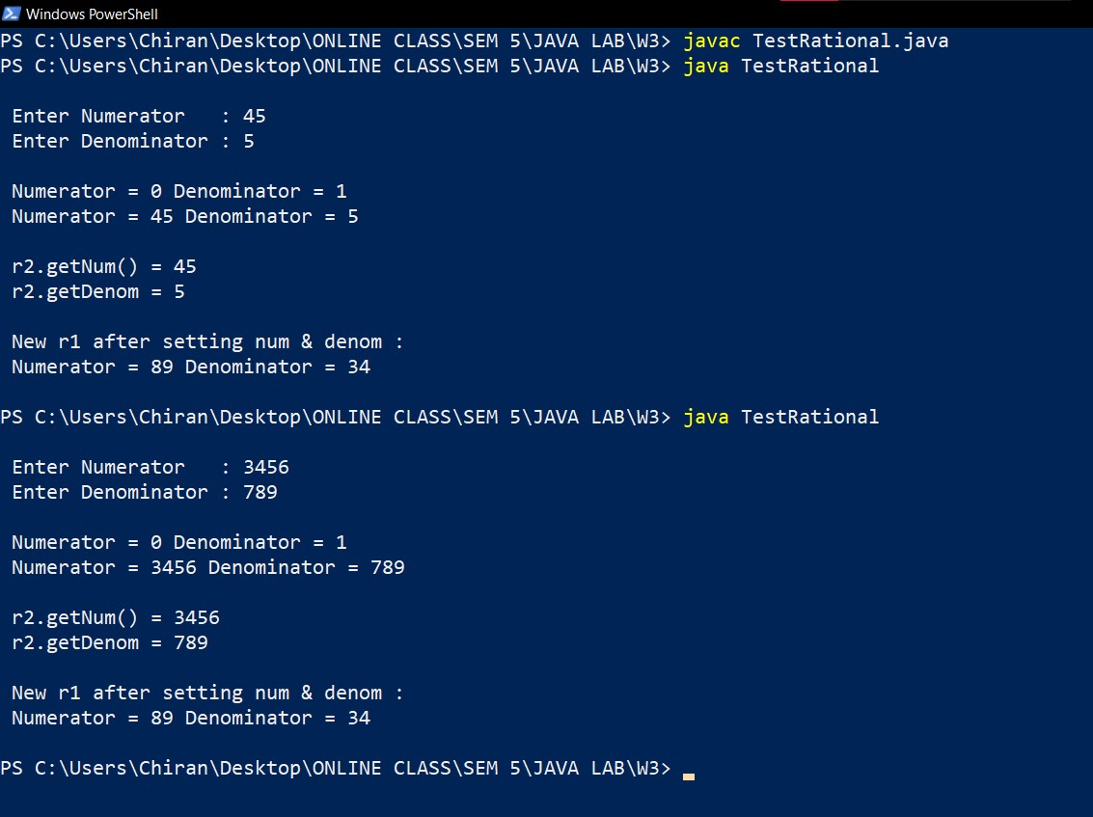

1. Define a class called Employee with datamembers: empid(int), firstname(String), lastname(String), salary(double). The salary is initialised with value of 1000 while declaring. The member methods are:

Employee()

Employee (int id, String fn, String ln)

setEmpid(int)

setFirstName(String)

setLastName(String)

int getEmpid()

String getFirstName()

String getLastName( )

double getSalary()

void display() – call the get methods to print the instance fields using this reference

String toString()

Validate the inputs in set methods.

Create a test class to create objects and test the methods

**Employee.java**

import java.util.*;

public class Employee

{

*int* empid;

    String firstname, lastname;

*double* salary = 1000;

    //int count=0;

    //int [] eidArr = new int[20];

*int* totalEmployees=0;

    public Employee () {

        empid = 0;

        firstname = null;

        lastname  = null;

        totalEmployees++;

    }

    public Employee (*int* *id*, String *fn*, String *ln*, *double* *sal*)

    {

        setEmpid(*id*);

        setFirstname(*fn*);

        setLastname(*ln*);

        setSalary(*sal*);

        totalEmployees++;

    }

    //SET

    public *void* setEmpid (*int* *id*) {

    if (*id*>0) {

        empid = *id*;

    }

        else

            System.out.println("\n invalid Employee Id");

    }

    public *void* setFirstname (String *fn*) {

        if (*fn*!=null)

            firstname = String.valueOf(*fn*);

        else

            System.out.println("\n invalid firstname");

    }

    public *void* setLastname (String *ln*) {

        if (*ln*!=null)

            lastname  = String.valueOf(*ln*);

        else

            System.out.println("\n invalid lastname");

    }

    public *void* setSalary (*double* *sal*) {

        if (*sal*>0)

            salary = *sal*;

        else

            System.out.println("\n invalid salary");

    }

    //GET

    public *int* getEmpid () {

        return empid;

    }

    public String getFirstname () {

        return firstname;

    }

    public String getLastname () {

        return lastname;

    }

    public *double* getSalary () {

        return salary;

    }

    public *void* display ()

    {

        System.out.println(" Eid: " + empid);

        System.out.println(" Name: " + firstname + " " + lastname);

        System.out.println(" Salary: " + salary);

    }

    public String toString () {

        return String.format(" Name of Employee: %s %s, Employee ID: %d, Salary: %.2f", firstname, lastname, empid, salary);

    }

}

**TestEmployee.java**

import java.util.Scanner;

public class TestEmployee

{

    public static *void* main(String[] *args*)

    {

        Scanner input = new Scanner(System.in);

*int* eid;

        String fname = new String(), lname = new String();

*double* sal;

        System.out.println("\n Enter Employee Details: ");

        System.out.print("Employee ID : ");

        eid = input.nextInt();

        input.nextLine();

        System.out.print("First Name  : ");

        fname = input.nextLine();

        System.out.print("Last Name   : ");

        lname = input.nextLine();

        System.out.print("Salary      : ");

        sal = input.nextDouble();

        System.out.println("\n\n Running Default Employee constructor: ");

        Employee e1 = new Employee();

        e1.display();

        System.out.println("\n\n Running Parameterized Constructor with Entered data:");

        Employee e2 = new Employee(eid, fname, lname, sal);

        e2.display();

        Employee e3 = new Employee();

        e3.setEmpid(99);

        e3.setFirstname("Tom");

        e3.setLastname("Cruise");

        e3.setSalary(8500.56);

        String e3Deets = e3.toString();

        System.out.println("\n\n E3 Details: ");

        System.out.println(e3Deets + "\n");

        input.close();

    }

}

OUTPUT:

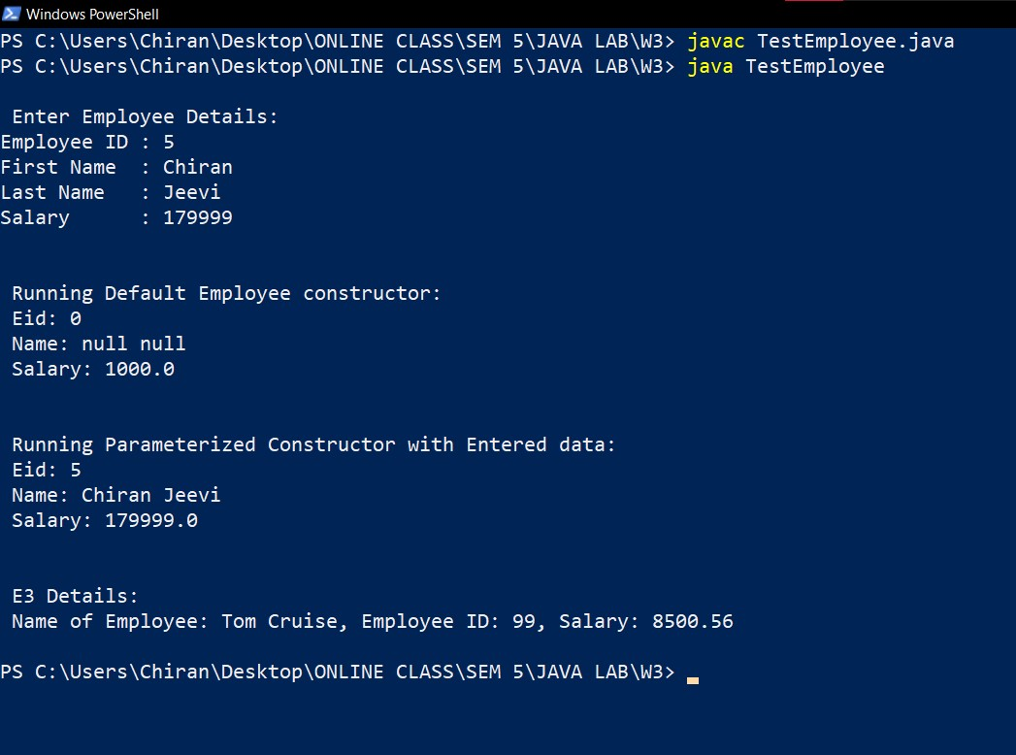

**LEVEL-2**

1. Define a class called Book with data members: title(String), authorName(String), year of publication(int) and price(double). The methods are: default constructor, constructor with four arguments, void display() that prints the details of Book object using Sytem.out.printf.

Define a test class in which an array of Book Objects are created and the details of Book Object printed. The size of the array has to be obtained from the user.

**Book.java**

public class Book

{

    String title = new String();

    String author = new String();

*int* yearOfPublication;

*double* price;

    public Book ()

    {

        title = null;

        author = null;

        yearOfPublication = 0;

        price = 500.00;

    }

    public Book (String *book*, String *writer*, *int* *year*, *double* *cost*)

    {

        setTitle ( *book*);

        setAuthor ( *writer*);

        setYearOfPublication ( *year*);

        setPrice ( *cost*);

    }

    public *void* setTitle (String *book*) {

        if (*book*!=null)

            title = String.valueOf(*book*);

        else

            title = null;

    }

    public *void* setAuthor (String *writer*)

    {

        if (*writer*!=null)

            author = String.valueOf(*writer*);

        else

            author = null;

    }

    public *void* setYearOfPublication (*int* *year*) {

        if (*year*>0)

            yearOfPublication = *year*;

        else

            yearOfPublication = 0;

    }

    public *void* setPrice (*double* *cost*) {

        if (*cost*>0)

            price = *cost*;

        else

            price = 0;

    }

    public *void* display ()

    {

        System.out.println(" Book Details: ");

        System.out.printf("Title: %s \nAuthor: %s \nYear Of Publication: %d \nPrice: %.2f\n \n", title, author, yearOfPublication, price);

    }

}

**TestBook.java**

import java.util.Scanner;

public class TestBook

{

    public static *void* main(String[] *args*)

    {

        Scanner input = new Scanner(System.in);

*int* i, n;

        System.out.print("\n Enter the Total Number of Books: ");

        n = input.nextInt();

        Book [] library = new Book[n];

        for (i=0; i<n; i++)

        {

            input.nextLine();

            String book, writer;

*int* year;

*double* cost;

            System.out.println("\n Enter Book #" + (i+1) + " Details: (Enter 'nil' if the book deets are unknown)");

            System.out.print("Title: ");

            book = input.nextLine();

            if (book.equals("nil"))

            {

                //CALLS DEFAULT CONSTRUCTOR

                library[i] = new Book();

                continue;

            }

            System.out.print("Author: ");

            writer = input.nextLine();

            System.out.print("Year of Publication: ");

            year =  input.nextInt();

            System.out.print("Price: ");

            cost = input.nextDouble();

            library[i] = new Book(book, writer, year, cost);

        }

        System.out.println("\n");

        System.out.println(" PRINTING ALL THE BOOKS IN LIBRARY: \n\n");

        for (i=0; i<n; i++)

        {

            library[i].display();

        }

        input.close();

    }

}

**OUTPUT:**

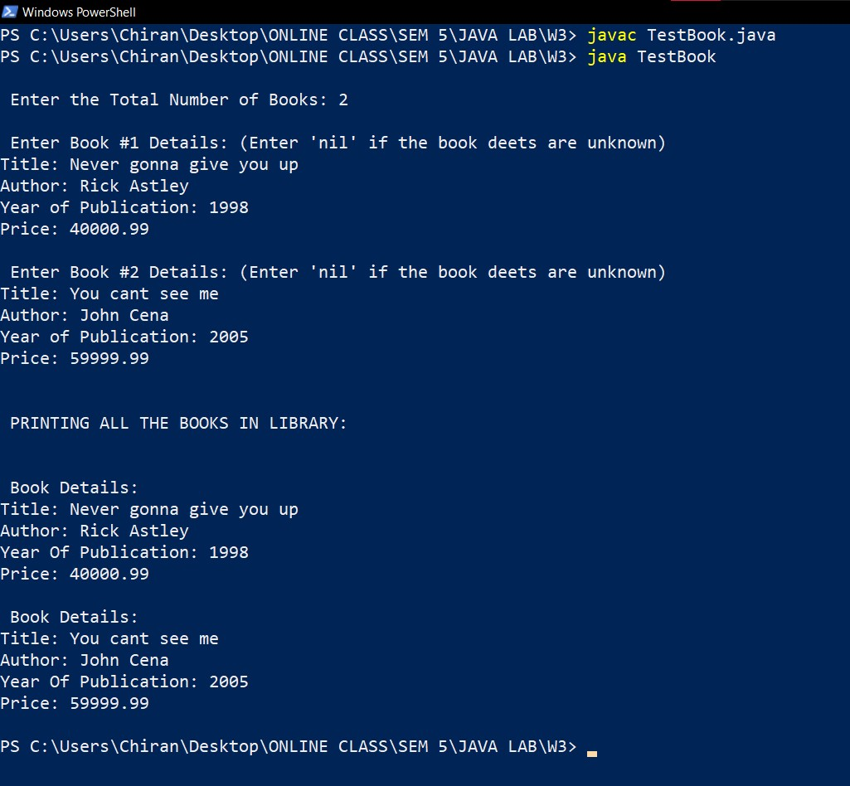

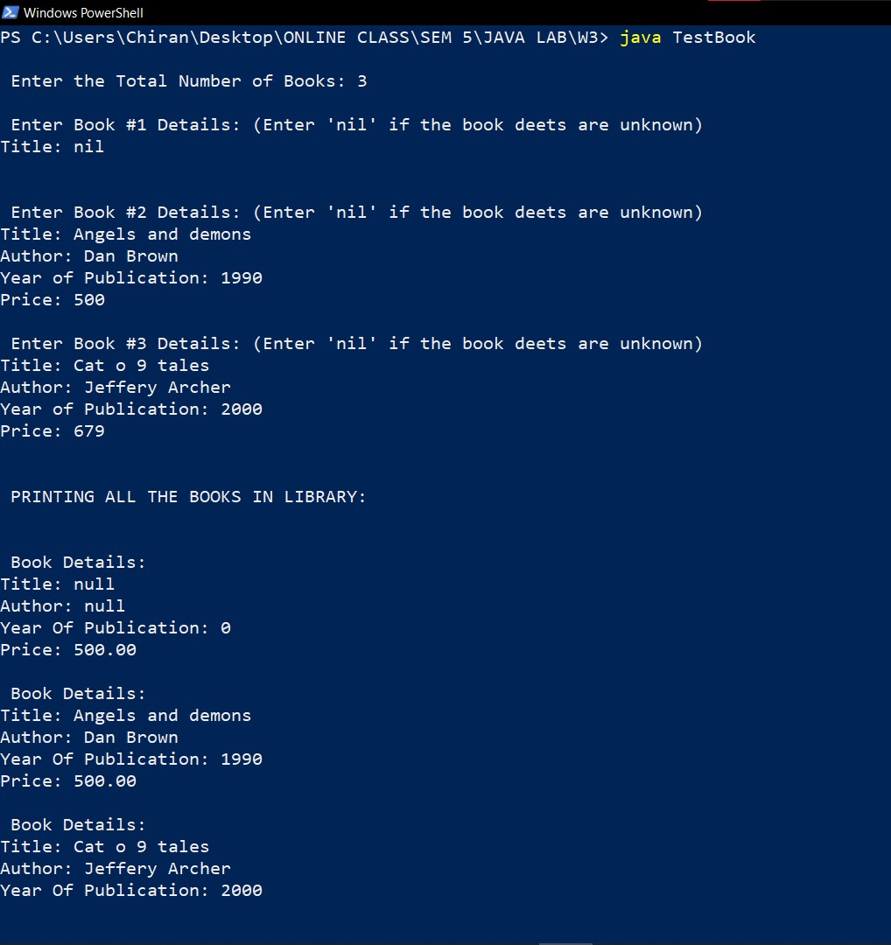

**LEVEL-3**

1. Define a method void increment(int val) for the class Rational that increments the numerator and denominator by the val. Print the details of Rational object before and after calling of increment. (2)

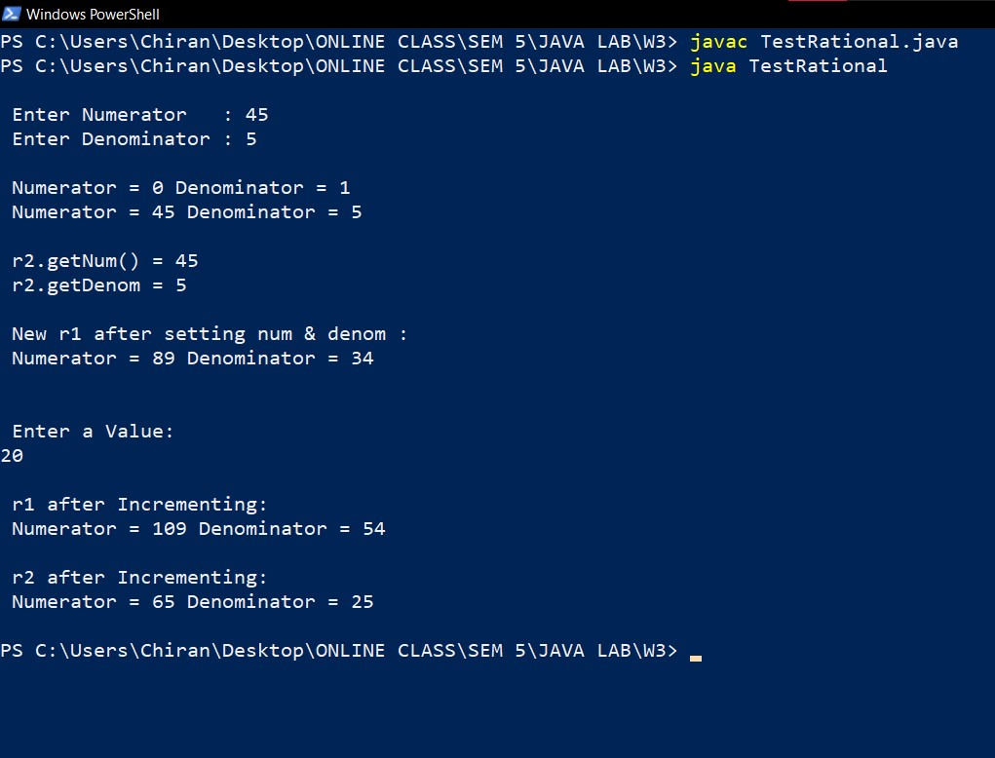

2. Define a method double calculateBonus(double intRate) in class Employee that calculates the bonus (bonus = salary * intRate) when it is called by the object of Employee. (1)

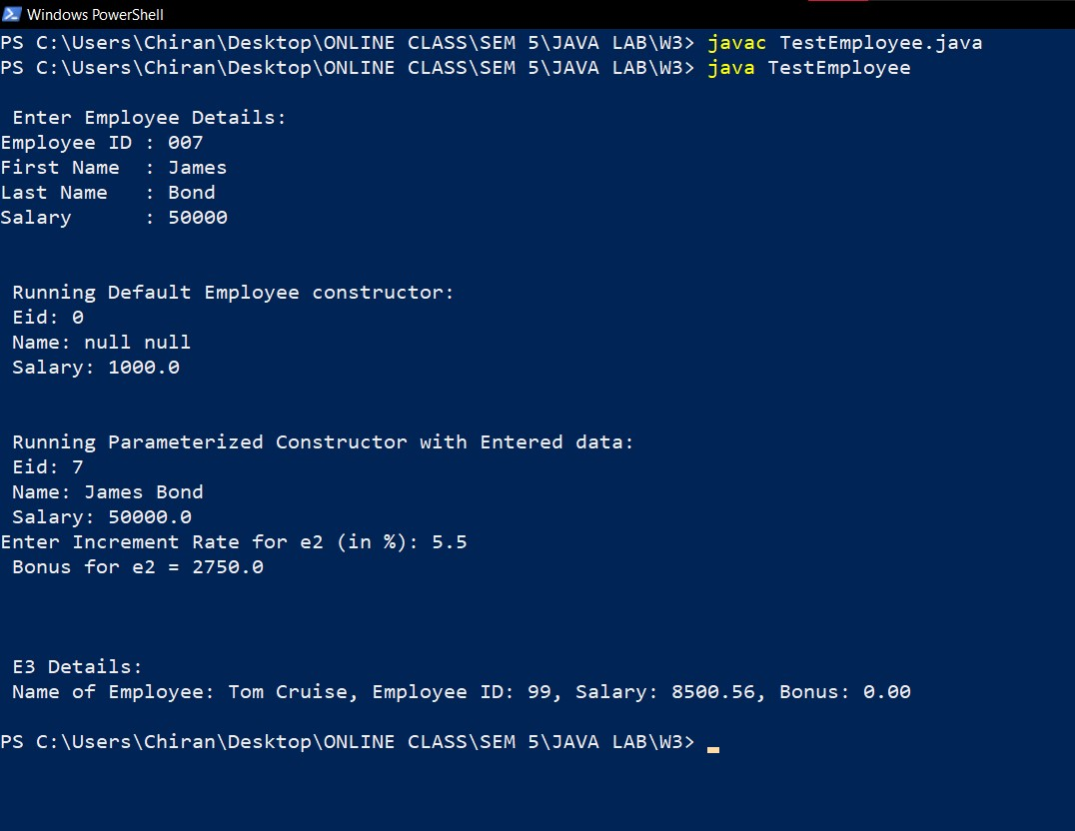

3. Define method Boolean checkDup(Book []) that checks whether duplicate details of book exist in the array of Book.

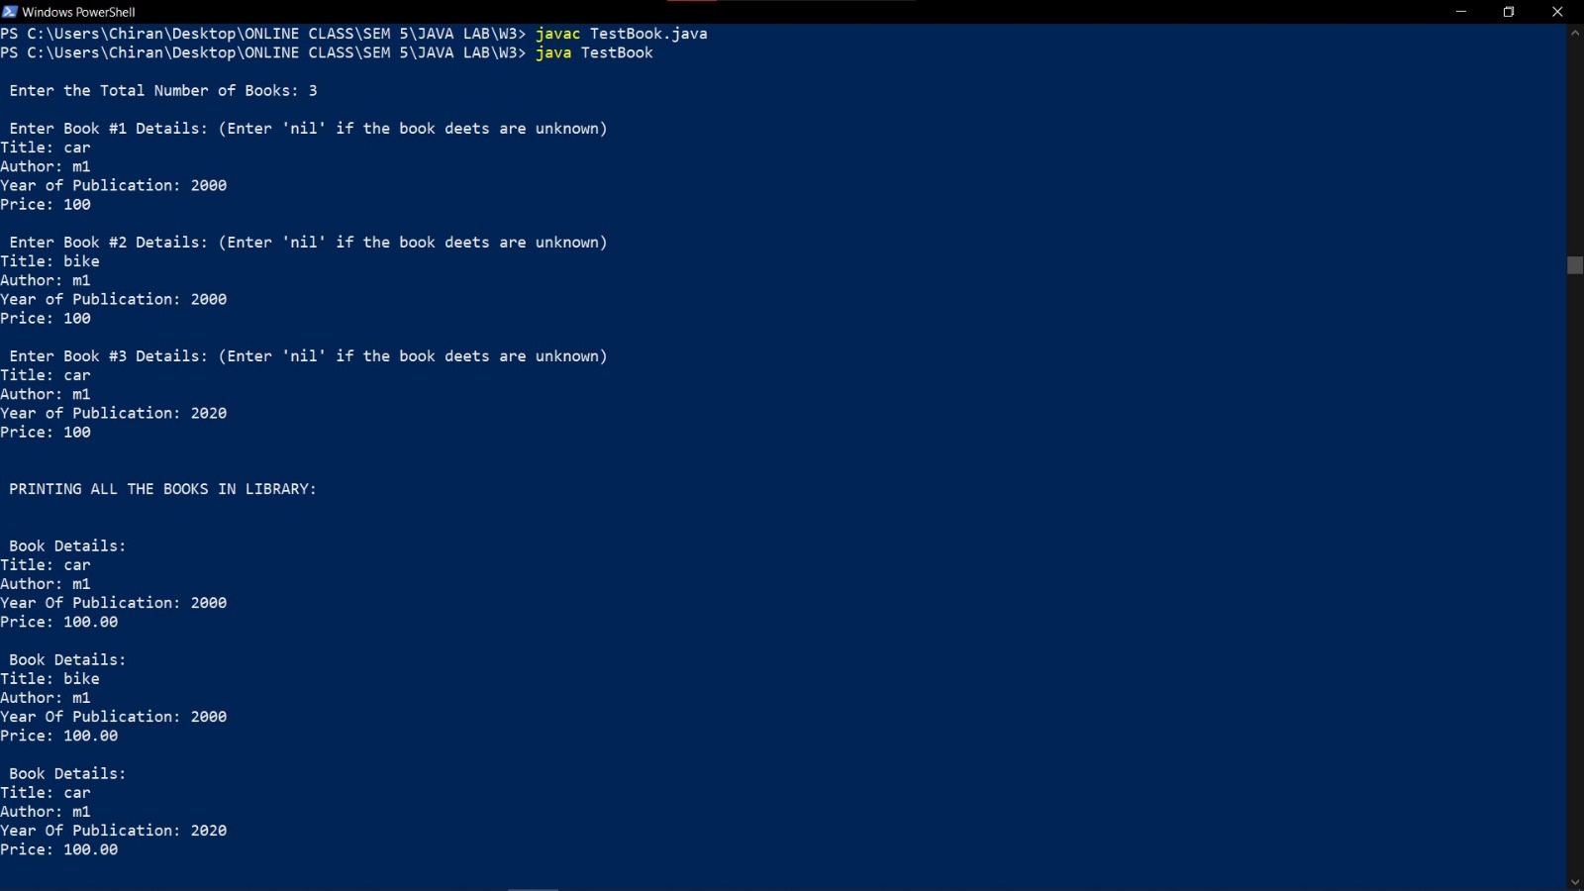

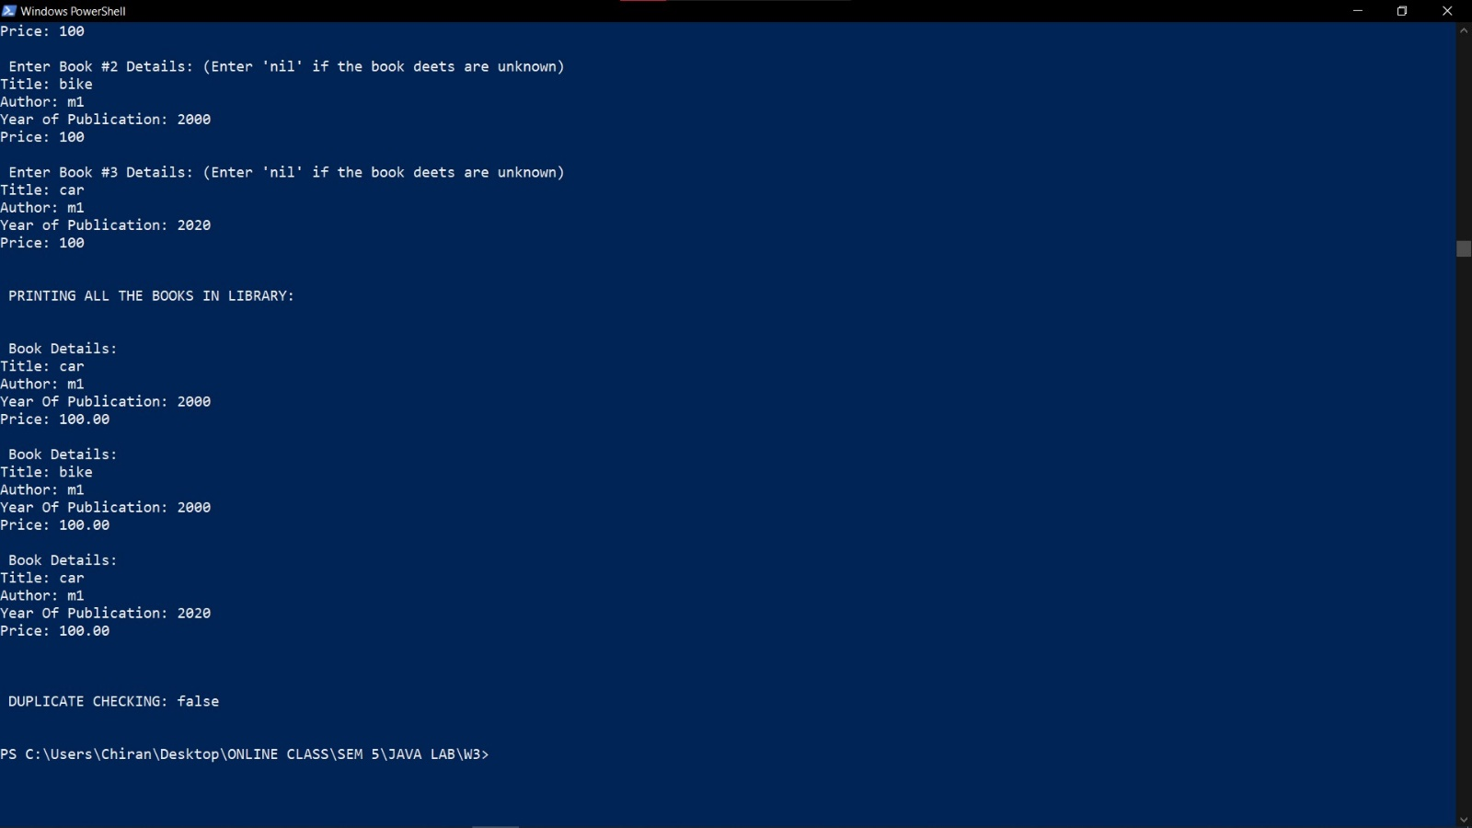

|  |  |
| --- | --- |
|  | **Marks** |
| **Preparatory Exercises** |  |
| **Observation** |  |
| **Spot** |  |
| **Total** |  |