**JAVA – WEEK 4**

**CLASSES AND OBJECTS**

**CHIRAN JEEVI**

**2019103013**

**LEVEL-1**

1) With respect to class Employee : include static variable bonusrate (float), count(int) to keep track of objects created, Static method void modifyInterestRate(float val). Member method: double calculateBonus() that finds the bonus of the Employee object. In the display(), print the number of objects created.Write a driver program to test the static, member method and explore static method can access instance variable or invoke instance method.

**Employee.java**

import java.util.*;

public class Employee

{

*int* empid;

    String firstname =  new String();

    String lastname = new String();

*double* salary = 1000;

*double* bonus;

    static *int* count=0;

    static *float* bonusrate = 0.5f;

    public Employee () {

        empid = 0;

        firstname = null;

        lastname  = null;

        count++;

    }

    public Employee (*int* *id*, String *fn*, String *ln*, *double* *sal*)

    {

        setEmpid(*id*);

        setFirstname(*fn*);

        setLastname(*ln*);

        setSalary(*sal*);

        count++;

    }

    //SET

    public *void* setEmpid (*int* *id*)

    {

    if (*id*>0) {

        empid = *id*;

    }

        else

            System.out.println("\n invalid Employee Id");

    }

    public *void* setFirstname (String *fn*)

    {

        if (*fn*!=null)

            firstname = String.valueOf(*fn*);

        else

            System.out.println("\n invalid firstname");

    }

    public *void* setLastname (String *ln*)

    {

        if (*ln*!=null)

            lastname  = String.valueOf(*ln*);

        else

            System.out.println("\n invalid lastname");

    }

    public *void* setSalary (*double* *sal*)

    {

        if (*sal*>0)

            salary = *sal*;

        else

            System.out.println("\n invalid salary");

    }

    //GET

    public *int* getEmpid () {

        return empid;

    }

    public String getFirstname () {

        return firstname;

    }

    public String getLastname () {

        return lastname;

    }

    public *double* getSalary () {

        return salary;

    }

    public *int* getTotalEmployeeCount () {

        return count;

    }

    //CALCULATE BONUS

    public *double* calculateBonus () {

        bonus = (salary*bonusrate)/100;

        return (bonus);

    }

    public String toString () {

        return String.format(" Name of Employee: %s %s, Employee ID: %d, Salary: %.2f, Bonus: %.2f", firstname, lastname, empid, salary, bonus);

    }

    //MODIFY BONUSRATE

    public static *void* modifyBonusRate (*float* *val*)

    {

        bonusrate = *val*;

    }

    public static *void* display (Employee [] *list*, *int* *c*)

    {

        System.out.println("\n Total Number of Employees = " + Employee.count);

        for (*int* i=0; i<*c*; i++)

        {

            System.out.println(" Eid: " + *list*[i].empid);

            System.out.println(" Name: " + *list*[i].firstname + " " + *list*[i].lastname);

            System.out.println(" Salary: " + *list*[i].salary + "\n");

        }

    }

}

**TestEmp.java**

import java.util.Scanner;

public class TestEmp

{

    public static *void* main(String[] *args*)

    {

        Scanner input = new Scanner(System.in);

        final *int* MAX = 10;

*int* n;

        System.out.println("\n Enter 999 in Employee id to quit input intake\n");

*int* eid, i=0, x, j;

*double* sal, intRate, bonusCash;

        String fname = new String(), lname = new String();

        Employee [] list = new Employee[MAX];

        while (true)

        {

            System.out.println("\n Enter Employee Details: ");

            System.out.print("Employee ID : ");

            eid = input.nextInt();

            input.nextLine();

            if (eid==999)

                break;

            System.out.print("First Name  : ");

            fname = input.nextLine();

            System.out.print("Last Name   : ");

            lname = input.nextLine();

            System.out.print("Salary      : ");

            sal = input.nextDouble();

            list[i] = new Employee(eid, fname, lname, sal);

            i++;

        }

        System.out.println("\n\n Running Default Employee constructor: ");

        Employee e1 = new Employee();

        System.out.println(e1.toString());

        //INVOKING STATIC METHOD

        if (i>0)

            Employee.display(list, (i));

        System.out.print("\n Enter any Employee id : ");

        x = input.nextInt();

        System.out.print(" Name of Employee = ");

        //ACCESSING STATIC VARIABLE

        for (j=0; j<i; j++)

        {

            if (list[j].empid == x){

                //ACCESSING INSTANCE VARIABLE

                System.out.println(" " + list[j].firstname + " " + list[j].lastname + " ");

            }

        }

        System.out.println("\n The current BonusRate = " + Employee.bonusrate);

        System.out.print(" Do You want to change it? (y/n): ");

*char* c = input.next().charAt(0);

        if (c=='y')

        {

            System.out.print(" Enter new BonusRate: ");

*float* br = input.nextFloat();

            //ACCESSING INSTANCE METHOD

            System.out.println("\n Old Bonus Amount for Employee ID " + list[0].empid + " = " + list[0].calculateBonus() );

            //ACCESSING STATIC METHOD

            Employee.modifyBonusRate(br);

            System.out.println("\n New BonusRate = " + Employee.bonusrate + "\n");

            //ACCESSING INSTANCE METHOD

            System.out.println(" New Bonus Amount for Employee ID " + list[0].empid + " = " + list[0].calculateBonus());

        }

    }

}

**OUTPUT:**

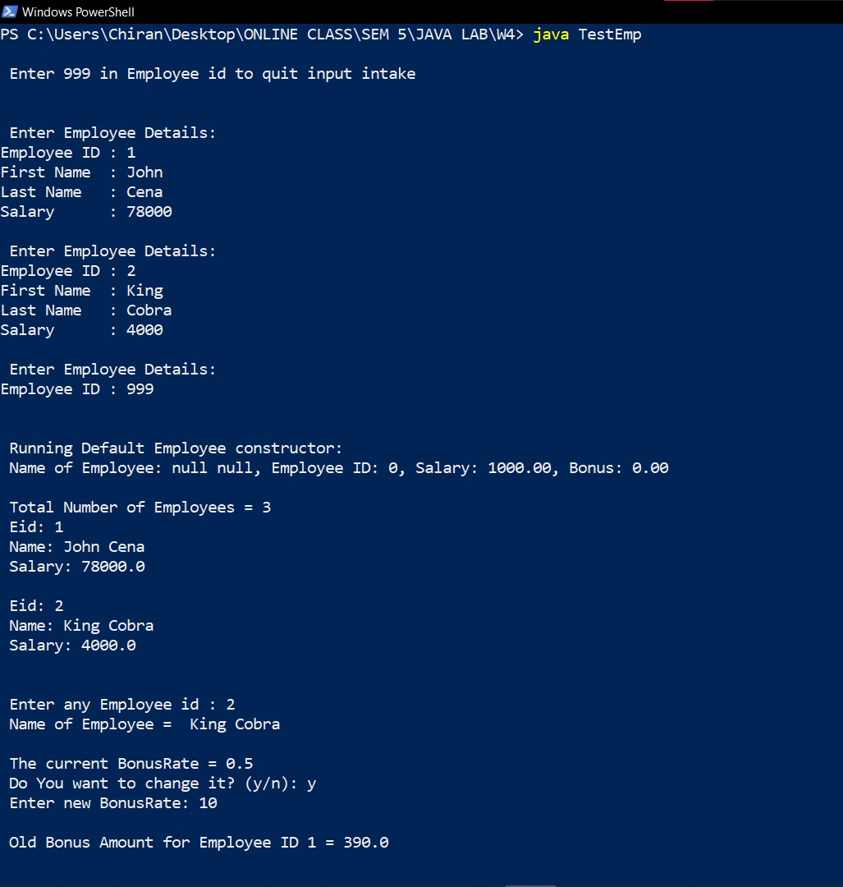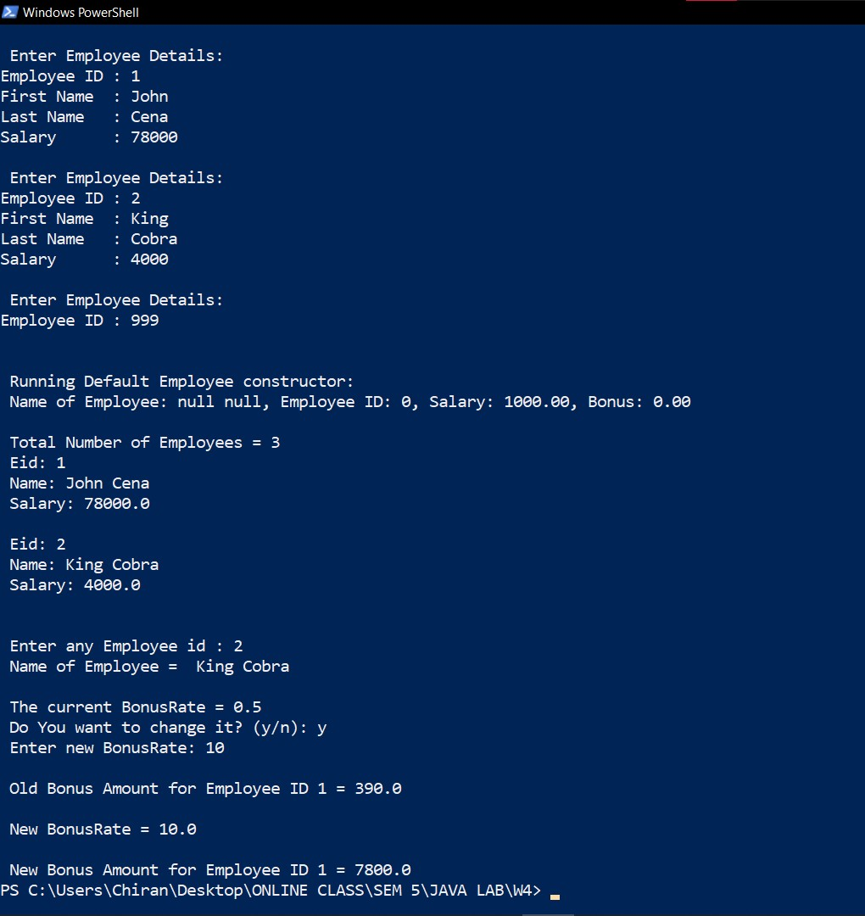

2) Define class Librarymember with members: accno(int), accName(String), deposit(double), noofbooks(int) and methods are: void issue(int val) increments the noofbooks by the val value and void return(int n) decrements the number of books by n. Define static variable :static final float fine =1.50; Include float calculatefine(int noofDays) that will calculate the fine amount to be paid for number of days beyond the due date

**Librarymember.java**

public class Librarymember

{

*int* accno;

    String accName = new String();

*double* deposit;

*int* noofbooks;

    static *int* totalBooksInLib=0;

    static final *float* fine = 1.50f;

*int* dueDays = 20;

*int* x=100;  //for default accNo

    public Librarymember ()

    {

        accno = x++;

        accName = null;

        deposit = 0;

        noofbooks = 0;

    }

    public Librarymember (*int* *an*, String *name*, *double* *d*, *int* *books*)

    {

        accno = *an*;

        accName = *name*;

        deposit = *d*;

        issueBooks(*books*);

    }

    public *void* issueBooks (*int* *val*)

    {

        noofbooks += *val*;

        totalBooksInLib += *val*;

    }

    public *void* returnBooks (*int* *val*)

    {

        if (noofbooks<*val*)

            System.out.println(" Returned book count is greater");

        else

        {

            noofbooks -= *val*;

            totalBooksInLib -= *val*;

            System.out.println(" " + *val* + " books returned! \t Remaining Books issued to Account = " + noofbooks);

        }

    }

    public *float* calculateFine (*int* *noofDays*)

    {

        if (*noofDays*>dueDays)

            return ( (*noofDays*-dueDays)*fine );

        else

        {

            System.out.println("\n No need to Pay any Fine! ");

            return 0;

        }

    }

}

**TestLibmem.java**

import java.util.Scanner;

public class TestLibmem

{

    public static *void* main(String[] *args*)

    {

        Scanner input =  new Scanner(System.in);

*int* i, n;

        System.out.print("\n Enter Library Members Count: ");

        n = input.nextInt();

        Librarymember memberz[] = new Librarymember[10];

        System.out.printf("\n Enter %d Member Details (000 when Acc Deets are unknown) \n", n);

        for (i=0; i<n; i++)

        {

*int* an, books;

            String name;

*double* d;

            System.out.print("\n Account Number: ");

            an = input.nextInt();

            if (an == 000)

            {

                //default constructor

                memberz[i] = new Librarymember();

                continue;

            }

            input.nextLine();

            System.out.print(" Member Name : ");

            name = input.nextLine();

            System.out.print(" Deposit Amount : ");

            d = input.nextDouble();

            System.out.print(" Books issued : ");

            books = input.nextInt();

            memberz[i] = new Librarymember(an, name, d, books);

        }

        System.out.print("\n Do you want to return any books? (y/n): ");

*char* c = input.next().charAt(0);

        if (c=='y')

        {

            System.out.print(" Account No: ");

*int* an = input.nextInt();

            System.out.print(" Number of Books Returning: ");

*int* retBook = input.nextInt();

            for (i=0; i<n; i++)

            {

                if (memberz[i].accno == an)

                {

                    memberz[i].returnBooks(retBook);

                }

            }

        }

        System.out.print("\n Do you want to check Fine Amount? (y/n): ");

        c = input.next().charAt(0);

        if (c=='y')

        {

            System.out.print(" Account No: ");

*int* an = input.nextInt();

            System.out.print(" Enter Total Days from Initial Issued Date : ");

*int* days = input.nextInt();

            for (i=0; i<n; i++)

            {

                if (memberz[i].accno == an)

                {

*float* fineAmt = memberz[i].calculateFine(days);

                    if (fineAmt > 0)

                        System.out.println(" Fine Amount = " + fineAmt);

                }

            }

        }

    }

}

**OUTPUT:**

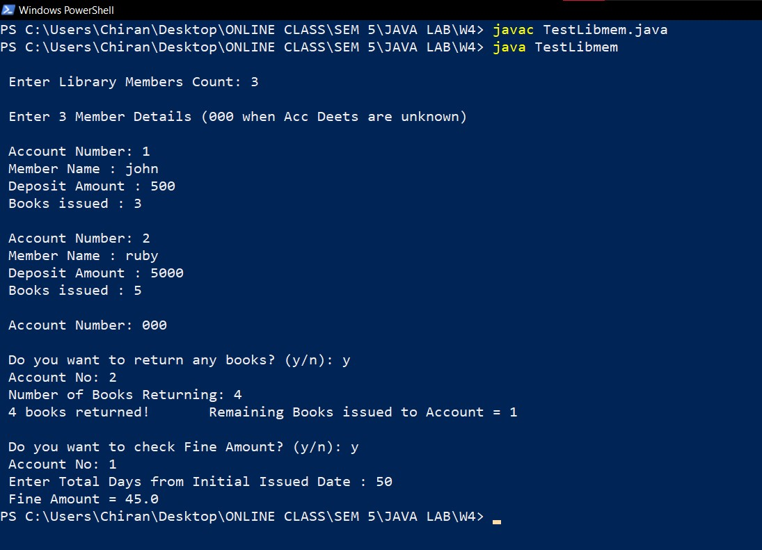

**LEVEL – 2**

1) Define class Course with members: courseName(String), courseInstructor(String), noofHours(int), noofCredits(int). The member functions are: default constructor, constructor with arguments, toString() to display the course details, get and set methods.

Include static variable : noofStudentsEnrolled(int)

Static method: void enroll(int n) will add up n students to the noofStudentsEnrolled

Static method: void drop(int n) will reduce n students from the noofStudentsEnrolled

In driver method create objects of Course and test all methods.

**CODE:**

**Course.java**

public class Course

{

    String courseName = new String();

    String courseInstructor = new String();

*int* noofHours;

*int* noofCredits;

    //STATIC VARIABLE

    static *int* noofStudentsEnrolled=0;

    public Course ()

    {

        courseName = null;

        courseInstructor = null;

        noofHours = noofCredits = 0;

        noofStudentsEnrolled++;

    }

    public Course (String *cn*, String *ci*, *int* *hours*, *int* *creds*)

    {

        setCourseName(*cn*);

        setCourseInstructor(*ci*);

        setHours(*hours*);

        setCredits(*creds*);

        noofStudentsEnrolled++;

    }

    //SET METHODS

    public *void* setCourseName (String *cn*)

    {

        if (*cn* != null)

            courseName = String.valueOf(*cn*);

    }

    public *void* setCourseInstructor (String *ci*)

    {

        if (*ci* != null)

            courseInstructor = String.valueOf(*ci*);

    }

    public *void* setHours (*int* *hours*)

    {

        if (*hours*>0)

            noofHours = *hours*;

    }

    public *void* setCredits (*int* *creds*)

    {

        if (*creds*>0)

            noofCredits = *creds*;

    }

    //GET METHODS

    public String getCourseName ()

    {

        return courseName;

    }

    public String getCourseInstructor ()

    {

        return courseInstructor;

    }

    public *int* getHours ()

    {

        return noofHours;

    }

    public *int* getCredits ()

    {

        return noofCredits;

    }

    //TO-STRING DISPLAY INFO

    public String toString ()

    {

        return String.format(" Course-Name: %s, Course-Instructor: %s, Duration: %d hours, Credits: %d", courseName, courseInstructor, noofHours, noofCredits);

    }

    //STATIC METHODS:

    public static *void* enroll (*int* *n*)

    {

        if (*n*>0)

            noofStudentsEnrolled += *n*;

        System.out.println("\n Total No. of Students Enrolled = " + noofStudentsEnrolled);

    }

    public static *void* drop (*int* *n*)

    {

        if (*n*<noofStudentsEnrolled)

            noofStudentsEnrolled -= *n*;

        System.out.println("\n Total No. of Students Enrolled = " + noofStudentsEnrolled);

    }

}

**TestCourse.java**

import java.sql.ClientInfoStatus;

import java.util.Scanner;

public class TestCourse

{

    public static *void* main(String[] *args*)

    {

        Scanner input = new Scanner(System.in);

*int* i, n;

        System.out.print("\n Enter Courses Entry (000 for No Details):  ");

        n = input.nextInt();

        Course cList [] = new Course[n];

        for (i=0; i<n; i++)

        {

            input.nextLine();

            String cn = new String();

            String ci = new String();

*int* hours, creds;

            System.out.print("\nCourse Name: ");

            cn = input.nextLine();

            if (cn.equals("000") == true)

            {

                cList[i] = new Course();

                continue;

            }

            System.out.print("Course Instructor: ");

            ci = input.nextLine();

            System.out.print("Duration: ");

            hours = input.nextInt();

            System.out.print("Credits: ");

            creds = input.nextInt();

            cList[i] = new Course(cn, ci, hours, creds);

        }

        enrollForCourse();

        dropFromCourse();

        displayCourses(cList, n);

        input.close();

    }

    public static *void* enrollForCourse ()

    {

        Scanner input = new Scanner(System.in);

        System.out.println("\n Total No. of Students Enrolled = " + Course.noofStudentsEnrolled);

        System.out.print(" Do you want to Initiate Enrollment? (y/n): ");

*char* c = input.next().charAt(0);

        if (c=='y')

        {

            System.out.print(" Enter No of Students: ");

*int* num = input.nextInt();

            Course.enroll(num);

        }

    }

    public static *void* dropFromCourse ()

    {

        Scanner input = new Scanner(System.in);

        System.out.println("\n Total No. of Students Enrolled = " + Course.noofStudentsEnrolled);

        System.out.print(" Do you want to Initiate Dropout? (y/n): ");

*char* c = input.next().charAt(0);

        if (c=='y')

        {

            System.out.print(" Enter No of Students: ");

*int* num = input.nextInt();

            Course.drop(num);

        }

    }

    public static *void* displayCourses (Course *cList*[], *int* *n*)

    {

*int* i;

        String res = new String();

        System.out.println("\n LIST OF ALL COURSES & ITS DETAILS \n");

        for (i=0; i<*n*; i++)

        {

            res = *cList*[i].toString();

            System.out.println(res);

        }

        System.out.println();

    }

}

**OUTPUT:**

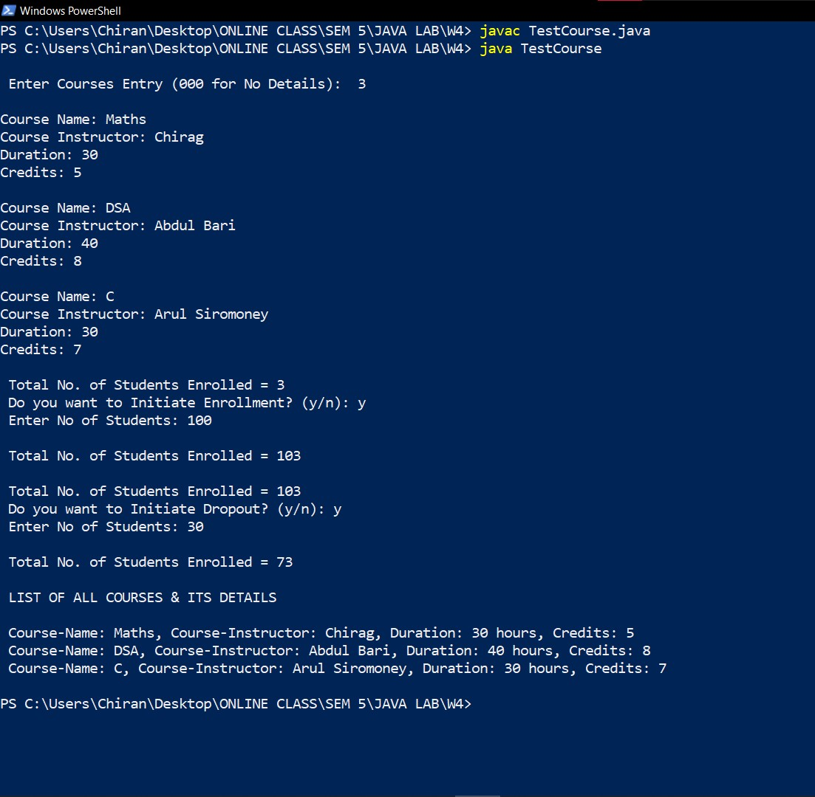

**LEVEL – 3**

1. Create class called Gradebook, create an array of Course, initialse and print the details of the Course.

**Course.java**

public class Course

{

    String courseName = new String();

    String courseInstructor = new String();

*int* noofHours;

*int* noofCredits;

    //STATIC VARIABLE

    static *int* noofStudentsEnrolled=0;

    public Course ()

    {

        courseName = null;

        courseInstructor = null;

        noofHours = noofCredits = 0;

        noofStudentsEnrolled++;

    }

    public Course (String *cn*, String *ci*, *int* *hours*, *int* *creds*)

    {

        setCourseName(*cn*);

        setCourseInstructor(*ci*);

        setHours(*hours*);

        setCredits(*creds*);

        noofStudentsEnrolled++;

    }

    //SET METHODS

    public *void* setCourseName (String *cn*)

    {

        if (*cn* != null)

            courseName = String.valueOf(*cn*);

    }

    public *void* setCourseInstructor (String *ci*)

    {

        if (*ci* != null)

            courseInstructor = String.valueOf(*ci*);

    }

    public *void* setHours (*int* *hours*)

    {

        if (*hours*>0)

            noofHours = *hours*;

    }

    public *void* setCredits (*int* *creds*)

    {

        if (*creds*>0)

            noofCredits = *creds*;

    }

    //GET METHODS

    public String getCourseName ()

    {

        return courseName;

    }

    public String getCourseInstructor ()

    {

        return courseInstructor;

    }

    public *int* getHours ()

    {

        return noofHours;

    }

    public *int* getCredits ()

    {

        return noofCredits;

    }

    //TO-STRING DISPLAY INFO

    public String toString ()

    {

        return String.format(" Course-Name: %s, Course-Instructor: %s, Duration: %d hours, Credits: %d", courseName, courseInstructor, noofHours, noofCredits);

    }

    //STATIC METHODS:

    public static *void* enroll (*int* *n*)

    {

        if (*n*>0)

            noofStudentsEnrolled += *n*;

        System.out.println("\n Total No. of Students Enrolled = " + noofStudentsEnrolled);

    }

    public static *void* drop (*int* *n*)

    {

        if (*n*<noofStudentsEnrolled)

            noofStudentsEnrolled -= *n*;

        System.out.println("\n Total No. of Students Enrolled = " + noofStudentsEnrolled);

    }

}

**Gradebook.java**

import java.util.Scanner;

public class Gradebook

{

    public static *void* main(String[] *args*)

    {

        Scanner input = new Scanner (System.in);

*int* i, n;

        System.out.print("\n Enter Courses Entry:  ");

        n = input.nextInt();

        Course cList2 [] = new Course[n];

        for (i=0; i<n; i++)

        {

            input.nextLine();

            String cn = new String();

            String ci = new String();

*int* hours, creds;

            System.out.print("\nCourse Name: ");

            cn = input.nextLine();

            System.out.print("Course Instructor: ");

            ci = input.nextLine();

            System.out.print("Duration: ");

            hours = input.nextInt();

            System.out.print("Credits: ");

            creds = input.nextInt();

            cList2[i] = new Course(cn, ci, hours, creds);

        }

        displayAllCourses(cList2, n);

    }

    public static *void* displayAllCourses (Course *cList2*[], *int* *n*)

    {

*int* i;

        String res = new String();

        System.out.println("\n LIST OF ALL COURSES & ITS DETAILS \n");

        for (i=0; i<*n*; i++)

        {

            res = *cList2*[i].toString();

            System.out.println(res);

        }

        System.out.println();

    }

}

**OUTPUT:**

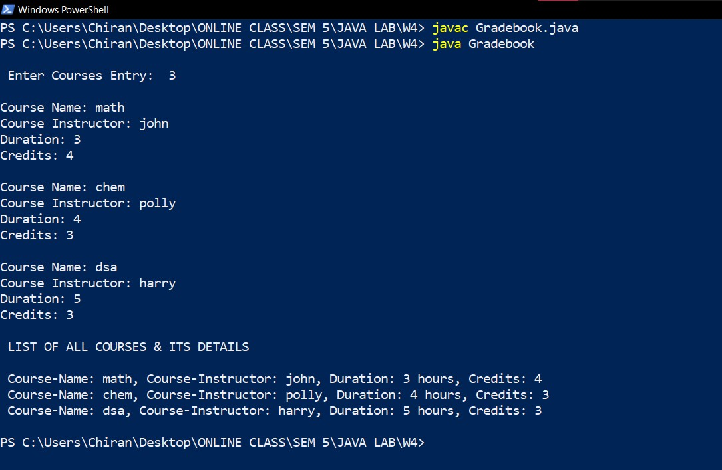

2) Define class called TestBook with static method: Book search(Book [], String title) which will return the searched Book object if it exists in the array of Book objects. In the TestBook class, create an array of Book Objects and invoke the search method. The Book details returned from the search must be printed and if the returned object is null print the “ “Book with title _________ is not found”

**Book.java**

public class Book

{

    String title = new String();

    String author = new String();

*int* yearOfPublication;

*double* price;

    public Book ()

    {

        title = null;

        author = null;

        yearOfPublication = 0;

        price = 500.00;

    }

    public Book (String *book*, String *writer*, *int* *year*, *double* *cost*)

    {

        setTitle ( *book*);

        setAuthor ( *writer*);

        setYearOfPublication ( *year*);

        setPrice ( *cost*);

    }

    public *void* setTitle (String *book*) {

        if (*book*!=null)

            title = String.valueOf(*book*);

        else

            title = null;

    }

    public *void* setAuthor (String *writer*)

    {

        if (*writer*!=null)

            author = String.valueOf(*writer*);

        else

            author = null;

    }

    public *void* setYearOfPublication (*int* *year*) {

        if (*year*>0)

            yearOfPublication = *year*;

        else

            yearOfPublication = 0;

    }

    public *void* setPrice (*double* *cost*) {

        if (*cost*>0)

            price = *cost*;

        else

            price = 0;

    }

    public *void* display ()

    {

        System.out.println(" Book Details: ");

        System.out.printf("Title: %s \nAuthor: %s \nYear Of Publication: %d \nPrice: %.2f\n \n", title, author, yearOfPublication, price);

    }

}

**TestBook.java**

import java.util.*;

public class TestBook

{

    public static *void* main(String[] *args*)

    {

        Scanner input = new Scanner(System.in);

*int* i, n;

        System.out.print("\n Enter the Total Number of Books: ");

        n = input.nextInt();

        Book [] objects = new Book[n];

        for (i=0; i<n; i++)

        {

            input.nextLine();

            String book = new String();

            String writer = new String();

*int* year;

*double* cost;

            System.out.println("\n Enter Book #" + (i+1) + " Details: ");

            System.out.print("Title: ");

            book = input.nextLine();

            System.out.print("Author: ");

            writer = input.nextLine();

            System.out.print("Year of Publication: ");

            year =  input.nextInt();

            System.out.print("Price: ");

            cost = input.nextDouble();

            objects[i] = new Book(book, writer, year, cost);

        }

        input.nextLine();

        System.out.print("\n Enter A Book Title to Search for: ");

        String name = input.nextLine();

        //input.nextLine();

        Book b = new Book();

        b = search(objects, name, n);

        if (b==null)

            System.out.println("\n Book with title _________ is not found \n");

        else

        {

            b.display();

        }

        input.close();

    }

    public static Book search (Book *lib*[], String *title*, *int* *n*)

    {

*int* i;

        for (i=0; i<*n*; i++)

        {

            if ( *title*.equals(*lib*[i].title) )

            {

                System.out.println();

                return *lib*[i];

            }

        }

        return null;

    }

}

**OUTPUT:**

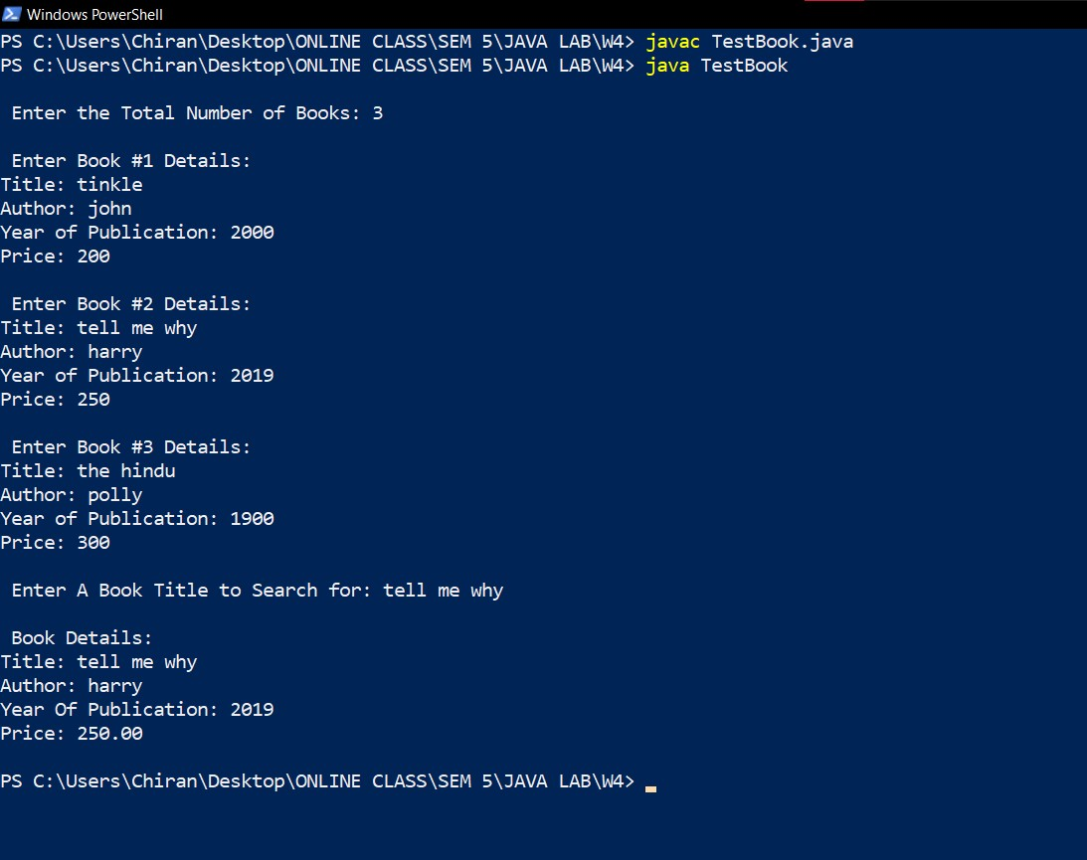

|  |  |
| --- | --- |
|  | **Marks** |
| **Preparatory Exercises** |  |
| **Observation** |  |
| **Spot** |  |
| **Total** |  |