DAY 2- Introduction to Version Control

CHIRAG YADAV

iOS Developer

After setting up Git, to the rest of the tasks.

1.Git Setup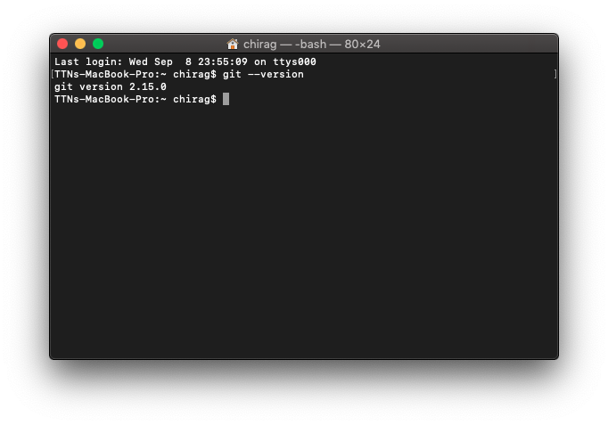

2.Initialize a Git Repository 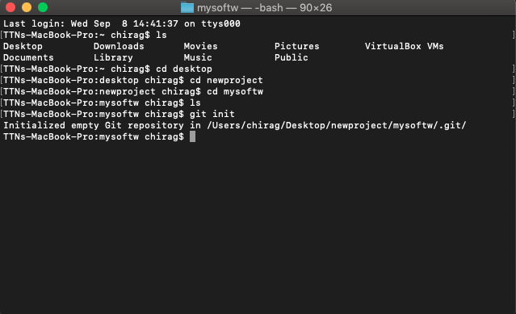

3.Add files to the repository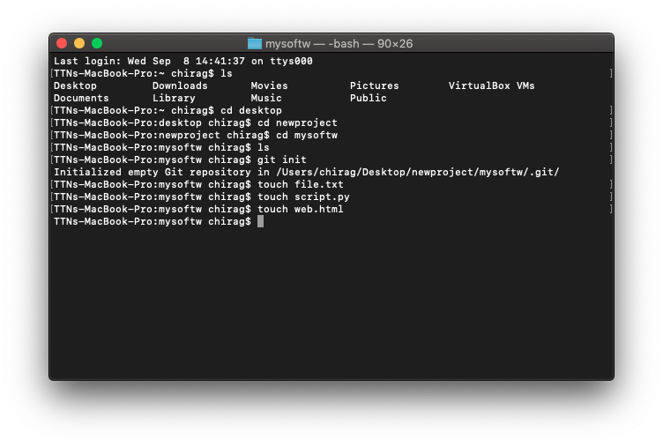

4.Unstage 1 file

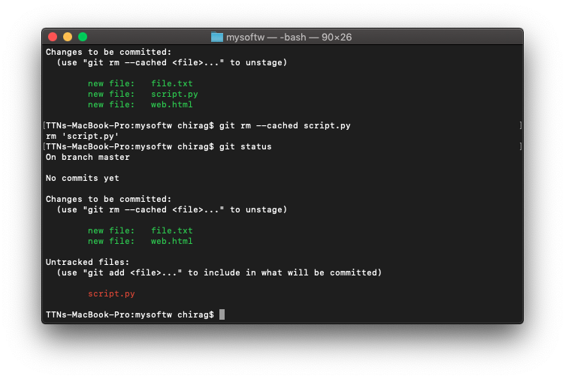

5.Commit the file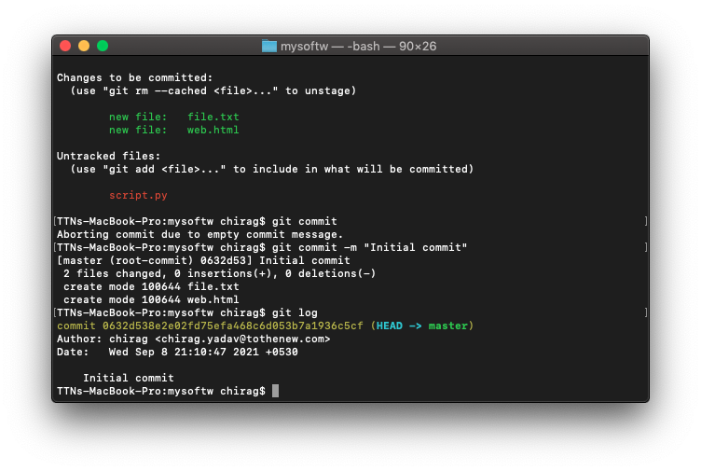

6.Add a remote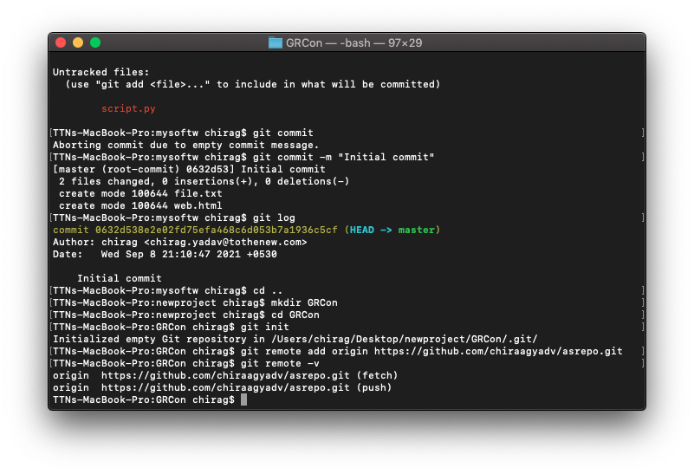

7.Undo changes to a particular file

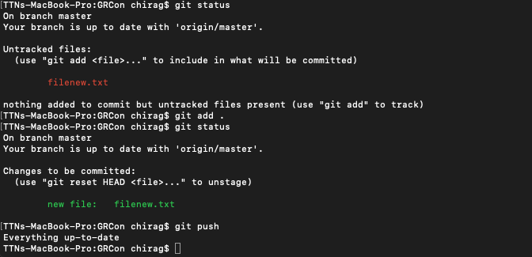

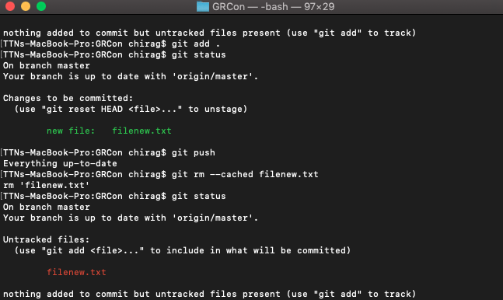

8.Push changes to Github.



9.Clone the repository.

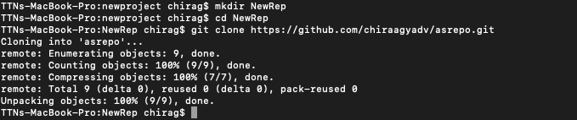

11.Check differences between a file and its staged version

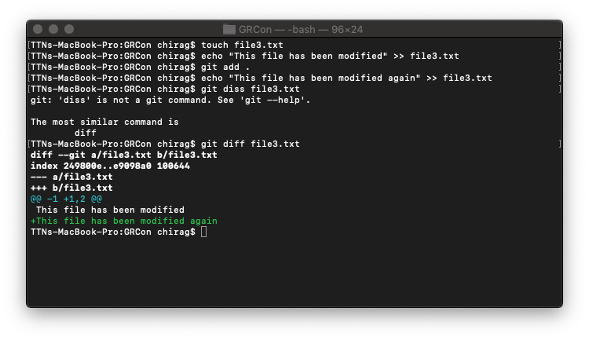

12.Ignore a few files to be checked in.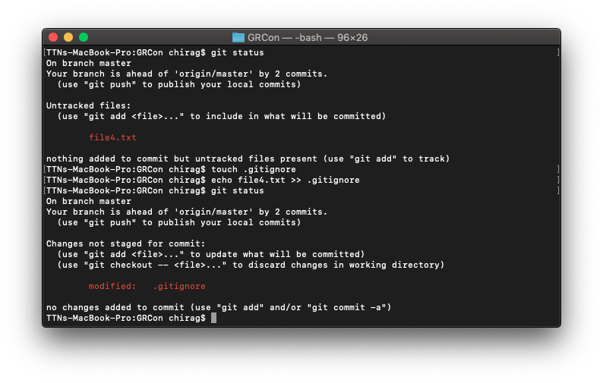

13.Create a new branch.

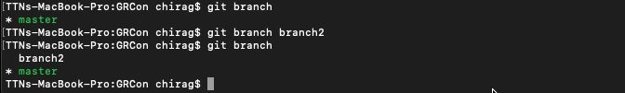

14.Diverge them with commits.

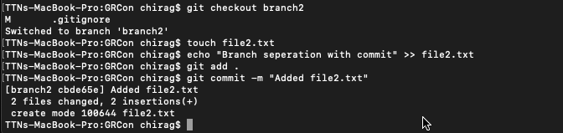

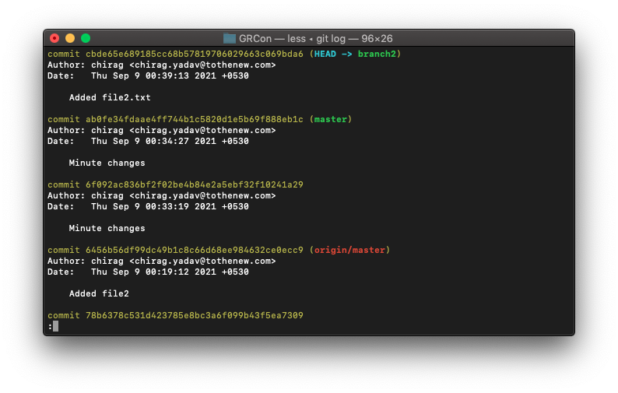

15.Edit the same file at the same line on both branches and commit.

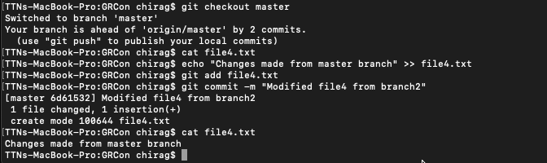

17.Stash the changes and pop them.

