C Programming Exercises
Name:
Roll No:
Instructions: Read the code, understand the logic, and write the output in the space provided. Check your answer with the Expected Output.

Exercise 1: Hello World Program
Problem: Write a C program to print "Hello, World!" on the screen.
Code:
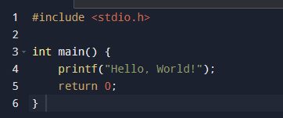

Explanation:
1. #include <stdio.h> includes the standard input/output library.
2. main() is the entry point of every C program.
3. printf() is used to display text on the console.
4. return 0; indicates successful program termination.
Your Output:
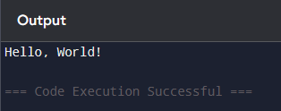
Expected Output:
Hello, World!

Exercise 2: Sum of Two Numbers
Problem: Write a C program to read two integers from the user and print their sum.
Code:
#include <stdio.h>
int main() {
int a, b, sum;
printf("Enter two numbers: ");
scanf("%d %d", &a, &b);
sum = a + b;
printf("Sum = %d", sum);
return 0;
}
Explanation:1. int a, b, sum; declares three integer variables.
2. scanf() reads user input. &a is the address of variable a.
3. sum = a + b; performs addition.
4. printf() displays the result using %d format specifier for integers.
Your Output:

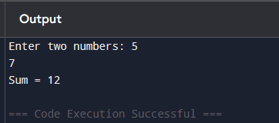

Expected Output:
Enter two numbers: 5 7
Sum = 12

Exercise 3: Check Even or Odd
Problem: Write a C program to check whether a given number is even or odd using if-else.
Code:
#include <stdio.h>
int main() {
int n;
printf("Enter a number: ");
scanf("%d", &n);
if (n % 2 == 0) {
printf("%d is Even", n);
} else {
printf("%d is Odd", n);
}
return 0;
}
Explanation:
1. The modulo operator % gives the remainder.
2. If n % 2 == 0, the number is perfectly divisible by 2, so it's Even.
3. Otherwise, the if-else branch prints Odd.
4. This introduces conditional control flow.
Your Output:
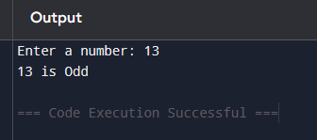

Expected Output:
Enter a number: 13
13 is Odd

Exercise 4: Factorial using For Loop
Problem: Write a C program to find the factorial of a number using a for loop.
Code:
#include <stdio.h>
int main() {
int n, i;
long fact = 1;
printf("Enter n: ");
scanf("%d", &n);
for(i = 1; i <= n; i++) {
fact = fact * i;
}
printf("Factorial of %d = %ld", n, fact);
return 0;
}
Explanation:
1. Factorial n! = 1 × 2 × 3 × ... × n
2. The for loop runs from i = 1 to n.
3. In each iteration, fact is multiplied by i.
4. long is used to store larger factorial values.
5. Example: 5! = 120

Your Output
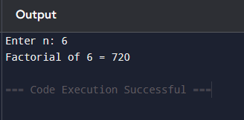
Expected Output:
Enter n: 5
Factorial of 5 = 120

Exercise 5: Sum of First N Natural Numbers
Problem: Write a C program to calculate the sum of first N natural numbers using a while loop.
Code:
#include <stdio.h>
int main() {
int n, i = 1, sum = 0;
printf("Enter N: ");
scanf("%d", &n);
while(i <= n) {
sum += i;
i++;
}
printf("Sum = %d", sum);
return 0;
}
Explanation:
1. We initialize sum = 0 and i = 1.
2. The while loop continues as long as i <= n.
3. sum += i is shorthand for sum = sum + i.
4. i++ increments the counter each iteration.
5. For N=10, the sum is 55.

Your Output:


Expected Output:
Enter N: 10
Sum = 55

Exercise 6: Multiplication Table - Nested Loop
Problem: Write a C program to print the multiplication table of a given number.
Code:
#include <stdio.h>
int main() {
int n, i;
printf("Enter a number: ");
scanf("%d", &n);
for(i = 1; i <= 10; i++) {
printf("%d x %d = %d\n", n, i, n * i);
}
return 0;
}
Explanation:
1. The for loop iterates 10 times, from i=1 to i=10.
2. In each iteration, n * i is calculated and printed.
3. \n creates a new line for each result.
4. This demonstrates a simple iterative loop in practice.

Your Output:
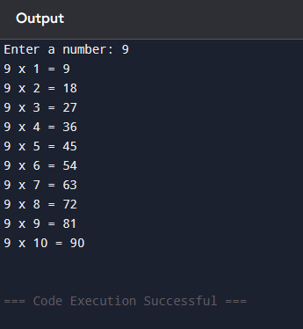

Expected Output:
Enter a number: 7
7 x 1 = 7
7 x 2 = 14
7 x 3 = 21
7 x 4 = 28
7 x 5 = 35
7 x 6 = 42
7 x 7 = 49
7 x 8 = 56
7 x 9 = 63
7 x 10 = 70

Exercise 7: Reverse a Number - While Loop
Problem: Write a C program to reverse the digits of a given integer.
Code:
#include <stdio.h>
int main() {
int n, rev = 0, digit;
printf("Enter a number: ");
scanf("%d", &n);
while(n > 0) {
digit = n % 10;
rev = rev * 10 + digit;
n = n / 10;
}
printf("Reversed = %d", rev);
return 0;
}
Explanation:
1. n % 10 extracts the last digit.
2. rev = rev * 10 + digit builds the reversed number.
3. n = n / 10 removes the last digit.
4. The loop continues until n becomes 0.
5. Example: 1234 -> 4321
Your Output:
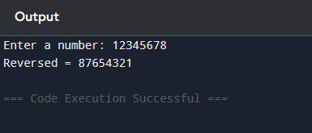

Expected Output:
Enter a number: 1234
Reversed = 4321

Exercise 8: Check Prime Number
Problem: Write a C program to check if a number is Prime using a for loop.
Code:
#include <stdio.h>
int main() {
int n, i, isPrime = 1;
printf("Enter n: ");
scanf("%d", &n);
if(n <= 1) {
isPrime = 0;
} else {
for(i = 2; i * i <= n; i++) {
if(n % i == 0) {
isPrime = 0;
break;
}
}
}
if(isPrime)
printf("%d is Prime", n);
else
printf("%d is Not Prime", n);
return 0;
}
Explanation:
1. A prime number is only divisible by 1 and itself.
2. We check divisors from 2 up to sqrt(n) (i*i <= n).
3. If any divisor is found, isPrime is set to 0 and we break.
4. The flag isPrime determines the final output.
Your Output:
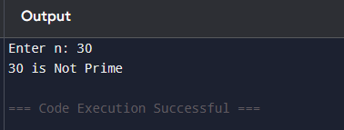

Expected Output:
Enter n: 29
29 is Prime

Exercise 9: Fibonacci Series using Recursion
Problem: Write a C program to print the Fibonacci series up to N terms using recursion.
Code:
#include <stdio.h>
int fib(int n) {
if(n <= 1)
return n;
return fib(n-1) + fib(n-2);
}
int main() {
int n, i;
printf("Enter number of terms: ");
scanf("%d", &n);
printf("Fibonacci Series: ");
for(i = 0; i < n; i++) {
printf("%d ", fib(i));
}
return 0;
}
Explanation:
1. Fibonacci: 0, 1, 1, 2, 3, 5, 8...
2. fib() is a recursive function that calls itself.
3. Base case: if n <= 1, return n.
4. Recursive case: fib(n-1) + fib(n-2).
5. main() calls fib() for each term from 0 to n-1.
Your Output:
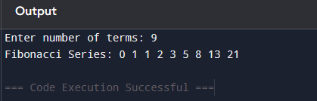

Expected Output:
Enter number of terms: 8
Fibonacci Series: 0 1 1 2 3 5 8 13

Exercise 10: GCD using Recursion - Euclidean Algorithm
Problem: Write a C program to find the GCD (Greatest Common Divisor) of two numbers using recursion.
Code:
#include <stdio.h>
int gcd(int a, int b) {
if(b == 0)
return a;
return gcd(b, a % b);
}
int main() {
int x, y;
printf("Enter two numbers: ");
scanf("%d %d", &x, &y);
printf("GCD of %d and %d = %d", x, y, gcd(x, y));
return 0;
}
Explanation:
1. This uses the Euclidean Algorithm recursively.
2. gcd(a, b) = gcd(b, a % b)
3. Base case: if b == 0, return a.
4. The function keeps calling itself with smaller values until b becomes 0.
5. Example: gcd(48, 18) = 6
Your Output:
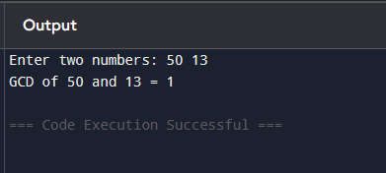

Expected Output:
Enter two numbers: 48 18
GCD of 48 and 18 = 6

