Activity Sheet 05 Start Date: 30/05/2026 End Date: 02/06/2026.
Topic: Searching [Easy + Medium Coding Questions]

AMRITA VISHWA VIDYAPEETHAM CHENNAI CAMPUS
Amrita School of Computing

Coding Practice

Activity Sheets

(For the Batch 2025-2029)

Name: PATHIPATI RUTHWIK Roll No.: CH.SC.U4CSE25230
Department: CSE

Activity Sheet 05 Start Date: 30/05/2026 End Date: 02/06/2026.
Topic: Searching [Easy + Medium Coding Questions]

Instructions
The Mock Test syllabus for CSE CT | CYS | AIE | RAI program is enclosed in the attached document for your reference.
Materials for the Mock Test [Must-DO Coding Questions] is provided in a link.
It is mandatory to upload the completed Activity sheets before the deadline in the MS-Form link shared by your class Advisor.
Activity Sheet: 01 - Coding Questions from Searching – Part 1 [Easy + Medium Questions]
Each Activity Sheets contains total of 20 Questions.
Platform: Any Online Compiler of your choice – GDB Compiler Language: C | C++ | JAVA | PYTHON
The Activity Sheet will have the coding Questions and the Test Case. Once executed in Online Compiler, take screen shot of the code and the output and paste it in the space provided in the activity sheet.
The Final Activity Sheet should be in PDF Format and the file name should be your roll number.

Course Instructors: CARE TEAM
Dr.R.Annamalai Assistant Professor (Sl.Grade) |CSE-AIE Dr.J.Umamageswaran Assistant Professor (Sr.Grade) | CSE-CT Ms.D. Sasikala Assistant Professor | CSE-AIE Mr.NirmalRaj Assistant Professor | CSE-CYS

Activity Sheet 05 Start Date: 30/05/2026 End Date: 02/06/2026.
Topic: Searching [Easy + Medium Coding Questions]

- Given an arr[] of elements of size n, return the largest element given in the array.
Examples:
Input: arr[] = [10, 20, 4]
Output: 20
Explanation: Among 10, 20 and 4, 20 is the largest.

Input: arr[] = [20, 10, 20, 4, 100]
Output: 100

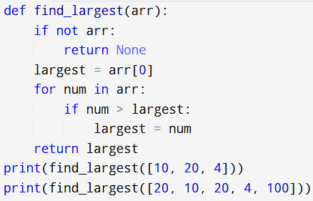
Activity Sheet 05 Start Date: 30/05/2026 End Date: 02/06/2026.
Topic: Searching [Easy + Medium Coding Questions]

Code:

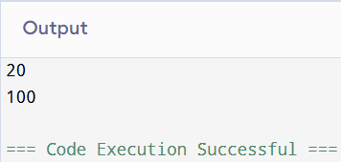
Activity Sheet 05 Start Date: 30/05/2026 End Date: 02/06/2026.
Topic: Searching [Easy + Medium Coding Questions]

Output:

Activity Sheet 05 Start Date: 30/05/2026 End Date: 02/06/2026.
Topic: Searching [Easy + Medium Coding Questions]

- You are given an array arr[] of size n - 1 that contains distinct integers in the range from 1 to n (inclusive). This array represents a permutation of the integers from 1 to n with one element missing. Your task is to identify and return the missing element.
Constraints:
1 ≤ arr.size() ≤ 106
1 ≤ arr[i] ≤ arr.size() + 1

Input: arr[] = [1, 2, 3, 5]
Output: 4
Explanation: All the numbers from 1 to 5 are present except 4.

Input: arr[] = [1] Output: 2
Explanation: Only 1 is present so the missing element is 2.

Input: arr[] = [8, 2, 4, 5, 3, 7, 1]
Output: 6
Explanation: All the numbers from 1 to 8 are present except 6.

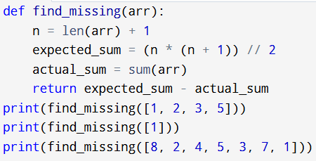
Activity Sheet 05 Start Date: 30/05/2026 End Date: 02/06/2026.
Topic: Searching [Easy + Medium Coding Questions]

Code:

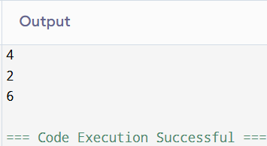
Activity Sheet 05 Start Date: 30/05/2026 End Date: 02/06/2026.
Topic: Searching [Easy + Medium Coding Questions]

Output

Activity Sheet 05 Start Date: 30/05/2026 End Date: 02/06/2026.
Topic: Searching [Easy + Medium Coding Questions]

- Given an array arr[] containing only non-negative integers, your task is to find a continuous subarray (a contiguous sequence of elements) whose sum equals a specified value target. You need to return the 1-based indices of the leftmost and rightmost elements of this subarray. You need to find the first subarray whose sum is equal to the target.
Note: If no such array is possible then, return [-1]. Constraints:
1 ≤ arr.size() ≤ 106
0 ≤ arr[i] ≤ 103
0 ≤ target ≤ 109

Input: arr[] = [1, 2, 3, 7, 5], target = 12
Output: [2, 4]
Explanation: The sum of elements from 2nd to 4th position is 12.
Input: arr[] = [5, 3, 4], target = 2
Output: [-1]
Explanation: There is no subarray with sum 2.

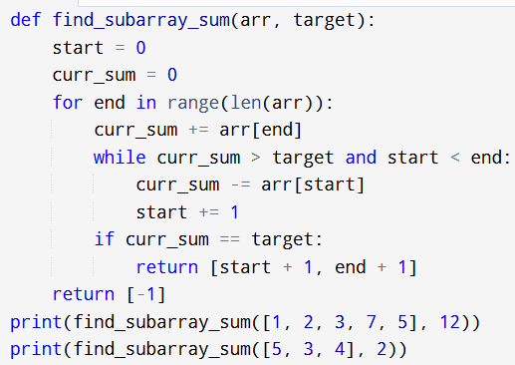
Activity Sheet 05 Start Date: 30/05/2026 End Date: 02/06/2026.
Topic: Searching [Easy + Medium Coding Questions]

Code:

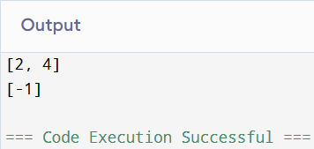
Activity Sheet 05 Start Date: 30/05/2026 End Date: 02/06/2026.
Topic: Searching [Easy + Medium Coding Questions]

Output

Activity Sheet 05 Start Date: 30/05/2026 End Date: 02/06/2026.
Topic: Searching [Easy + Medium Coding Questions]

- Given an array of positive integers arr[], return the second largest element from the array. If the second largest element doesn't exist then return -1.
Note: The second largest element should not be equal to the largest element.

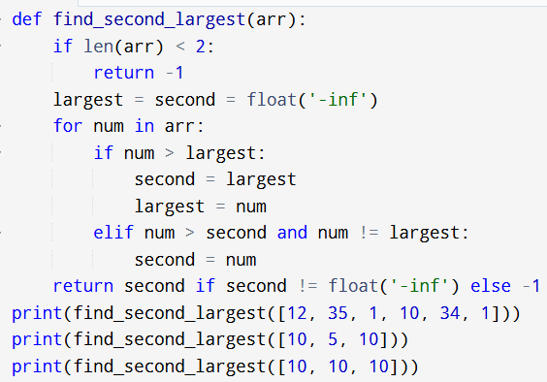
Activity Sheet 05 Start Date: 30/05/2026 End Date: 02/06/2026.
Topic: Searching [Easy + Medium Coding Questions]

Code:

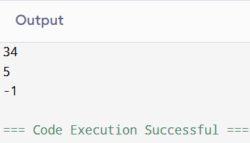
Activity Sheet 05 Start Date: 30/05/2026 End Date: 02/06/2026.
Topic: Searching [Easy + Medium Coding Questions]

Output

Activity Sheet 05 Start Date: 30/05/2026 End Date: 02/06/2026.
Topic: Searching [Easy + Medium Coding Questions]
- Given an array arr[]. Find the majority element in the array. If no majority element exists, return -1.

Constraints:
1 ≤ arr.size() ≤ 105
1 ≤ arr[i] ≤ 105

Note: A majority element in an array is an element that appears strictly more than arr.size()/2 times in the array. Input: arr[] = [1, 1, 2, 1, 3, 5, 1]
Output: 1
Explanation: Since, 1 is present more than 7/2 times, so it is the majority element.
Input: arr[] = [2, 13]
Output: -1
Explanation: Since, no element is present more than 2/2 times, so there is no majority element.

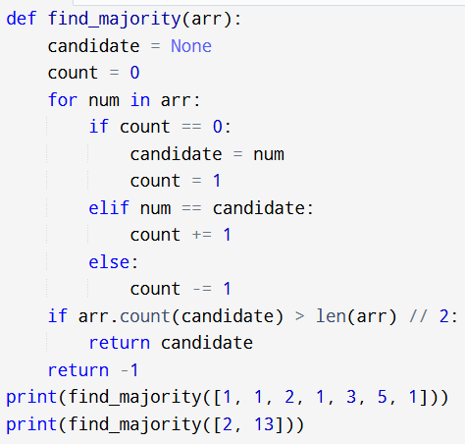
Activity Sheet 05 Start Date: 30/05/2026 End Date: 02/06/2026.
Topic: Searching [Easy + Medium Coding Questions]

Code:

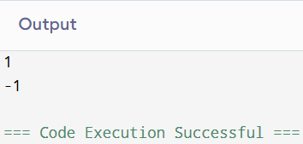
Activity Sheet 05 Start Date: 30/05/2026 End Date: 02/06/2026.
Topic: Searching [Easy + Medium Coding Questions]

Output

Activity Sheet 05 Start Date: 30/05/2026 End Date: 02/06/2026.
Topic: Searching [Easy + Medium Coding Questions]
- Given an integer array arr[] and an integer k, your task is to find and return the kth smallest element in the given array.
Constraints:
1 ≤ arr.size() ≤ 105
1 ≤ arr[i] ≤ 105
1 ≤ k ≤ arr.size()

Note: The kth smallest element is determined based on the sorted order of the array. Input: arr[] = [10, 5, 4, 3, 48, 6, 2, 33, 53, 10], k = 4
Output: 5
Explanation: 4th smallest element in the given array is 5.
Input: arr[] = [7, 10, 4, 3, 20, 15], k = 3
Output: 7
Explanation: 3rd smallest element in the given array is 7.

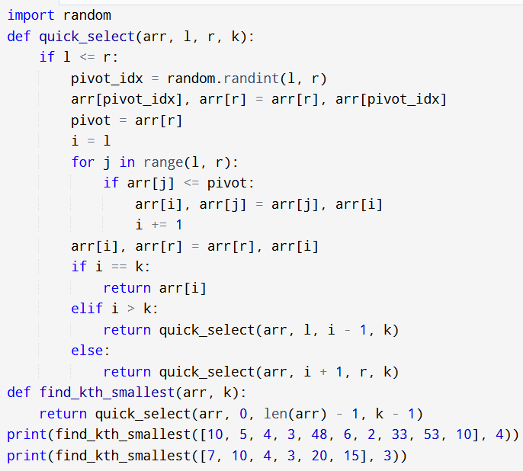
Activity Sheet 05 Start Date: 30/05/2026 End Date: 02/06/2026.
Topic: Searching [Easy + Medium Coding Questions]

Code:

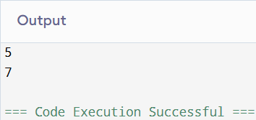
Activity Sheet 05 Start Date: 30/05/2026 End Date: 02/06/2026.
Topic: Searching [Easy + Medium Coding Questions]

Output

Activity Sheet 05 Start Date: 30/05/2026 End Date: 02/06/2026.
Topic: Searching [Easy + Medium Coding Questions]
- Given a sorted array and a number key, return whether the key is present in the array or not.
Constraints
1 <= T <= 100
1 <= n <= 104
-106 <= Ai <= 106
-106 <= key <= 106
Examples
Array: [1, 2, 3, 3, 3, 4, 4, 5]
Number: 2 Answer: true
Array: [1, 2, 3, 3, 3, 4, 4, 5]
Number: 6 Answer: false

Input Format
First-line contains an integer ‘T’ denoting the number of test cases. For each test case the input has two lines:
Two space-separated integers ‘n’ and 'key' denoting the length of the array and the number to be searched respectively. n space-separated integers denoting the elements of the array.

Output Format
T lines each contain true or false denoting the answer for each test case. Sample Input
2
8 2
1 2 3 3 3 4 4 5
8 6
1 2 3 3 3 4 4 5

Expected Output true
false

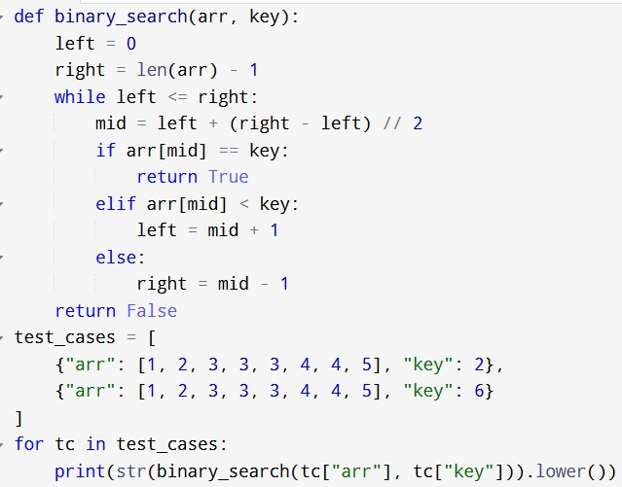
Activity Sheet 05 Start Date: 30/05/2026 End Date: 02/06/2026.
Topic: Searching [Easy + Medium Coding Questions]

Code:

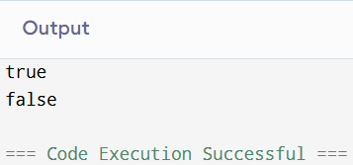
Activity Sheet 05 Start Date: 30/05/2026 End Date: 02/06/2026.
Topic: Searching [Easy + Medium Coding Questions]

Output

Activity Sheet 05 Start Date: 30/05/2026 End Date: 02/06/2026.
Topic: Searching [Easy + Medium Coding Questions]
- Given a sorted array and a number key, find the index of the first and last occurrence of the key in the array.
If the key is not present, return [-1, -1]. Constraints
1 <= T <= 100
1 <= n <= 104
-106 <= Ai <= 106
-106 <= key <= 106

Examples
Array: [1, 2, 3, 3, 3, 4, 4, 5]
Number: 3
Answer: [2, 4]
Array: [1, 2, 3, 3, 3, 4, 4, 5]
Number: 5
Answer: [7, 7]
Array: [1, 2, 3, 3, 3, 4, 4, 5]
Number: 6
Answer: [-1, -1]

Testing Input Format
First-line contains an integer ‘T’ denoting the number of test cases. For each test case the input has two lines:
Two space-separated integers ‘n’ and 'key' denoting the length of the array and the number to be searched respectively.
n space-separated integers denoting the elements of the array.
Output Format
T lines each contain two integers denoting the indices of the first and last occurrence of the key in the array for each test case.
Sample Input 2
8 3
1 2 3 3 3 4 4 5
8 6
1 2 3 3 3 4 4 5
Expected Output 2 4
-1 -1

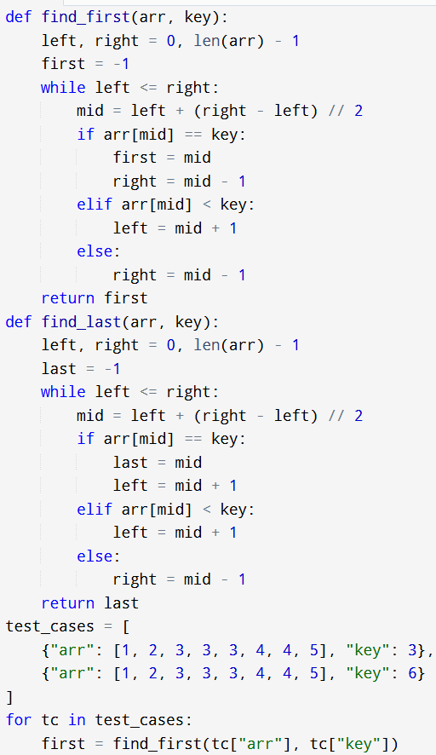
Activity Sheet 05 Start Date: 30/05/2026 End Date: 02/06/2026.
Topic: Searching [Easy + Medium Coding Questions]

Code:

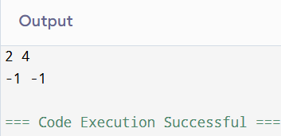
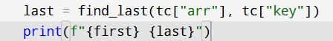
Activity Sheet 05 Start Date: 30/05/2026 End Date: 02/06/2026.
Topic: Searching [Easy + Medium Coding Questions]

Output

Activity Sheet 05 Start Date: 30/05/2026 End Date: 02/06/2026.
Topic: Searching [Easy + Medium Coding Questions]
- Given a sorted array of integers, find the number of negative numbers.

Constraints
1 <= T <= 100
1 <= n <= 104
-105 <= Ai <= 105
Examples
Array: [-5, -3, -2, 3, 4, 6, 7, 8]
Answer: 3
Array: [0, 1, 2, 3, 4, 6, 7, 8]
Answer: 0

Testing Input Format
The first line contains 'T' denoting the no. of test cases.
T lines each contain a number 'n' denoting the number of elements, followed by n space-separated numbers denoting the array elements.
Output Format
T lines each contain an integer denoting the number of negative numbers for that test case.
Sample Input 2
8 -5 -3 -2 3 4 6 7 8
8 0 1 2 3 4 6 7 8
Expected Output 3
0

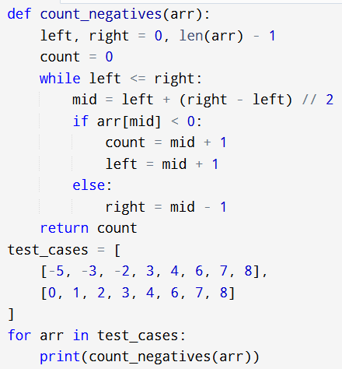
Activity Sheet 05 Start Date: 30/05/2026 End Date: 02/06/2026.
Topic: Searching [Easy + Medium Coding Questions]

Code:

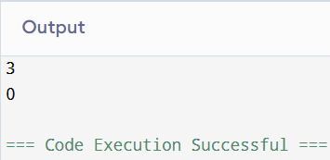
Activity Sheet 05 Start Date: 30/05/2026 End Date: 02/06/2026.
Topic: Searching [Easy + Medium Coding Questions]

Output

Activity Sheet 05 Start Date: 30/05/2026 End Date: 02/06/2026.
Topic: Searching [Easy + Medium Coding Questions]
- Given a sorted array and a number key, find the smallest array element which is greater than the key.
If the key is greater than or equal to the largest element then return the key itself. Constraints
1 <= T <= 100
1 <= n <= 104
-106 <= Ai <= 106
-106 <= key <= 106

Examples
Array: [1, 2, 3, 3, 4, 4, 8, 10]
Number: 4
Answer: 8
Array: [1, 2, 3, 3, 3, 4, 4, 5]
Number: 5
Answer: 5 (Largest Element)
Array: [1, 2, 3, 3, 3, 4, 4, 5]
Number: -5
Answer: 1
Testing Input Format
First-line contains an integer ‘T’ denoting the number of test cases. For each test case the input has two lines:
Two space-separated integers ‘n’ and 'key' denoting the length of the array and the number to be searched respectively.
n space-separated integers denoting the elements of the array. Output Format
T lines each contain the next greater element for each test case.
Sample Input 2
8 4
1 2 3 3 4 4 8 10
8 5
1 2 3 3 3 4 4 5
Expected Output 8
5

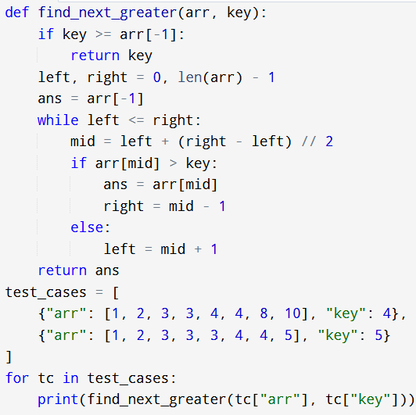
Activity Sheet 05 Start Date: 30/05/2026 End Date: 02/06/2026.
Topic: Searching [Easy + Medium Coding Questions]

Code:

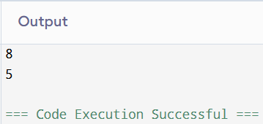
Activity Sheet 05 Start Date: 30/05/2026 End Date: 02/06/2026.
Topic: Searching [Easy + Medium Coding Questions]

Output

Activity Sheet 05 Start Date: 30/05/2026 End Date: 02/06/2026.
Topic: Searching [Easy + Medium Coding Questions]
- Given a sorted array containing distinct integers and a number 'key', find the index of the key in the array. If the key is not present, return the index at which it would be inserted considering that we need to maintain the sort order.

Constraints
1 <= T <= 100
1 <= n <= 104
-106 <= Ai <= 106
-106 <= key <= 106

Examples
Array: [1, 2, 3, 4, 5]
Number: 3
Answer: 2
Array: [1, 2, 3, 5]
Number: 4
Answer: 3
Array: [1, 2, 3, 4, 5]
Number: -100
Answer: 0
Array: [1, 2, 3, 4, 5]
Number: 6
Answer: 5

Testing Input Format
First-line contains an integer ‘T’ denoting the number of test cases. For each test case the input has two lines:
Two space-separated integers ‘n’ and 'key' denoting the length of the array and the number to be searched respectively.
n space-separated integers denoting the elements of the array. Output Format
T lines each contain the index of the first occurrence of the key in the array or the index to insert the number (if not present) for each test case.

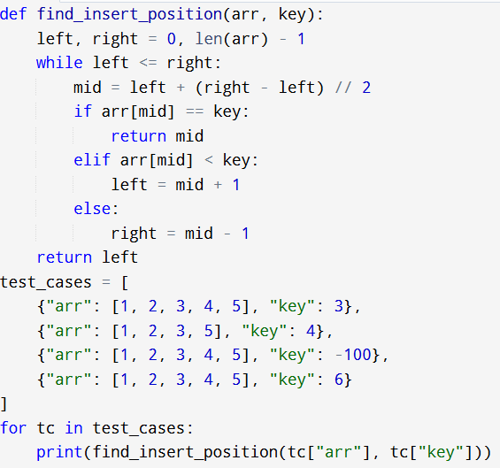
Activity Sheet 05 Start Date: 30/05/2026 End Date: 02/06/2026.
Topic: Searching [Easy + Medium Coding Questions]

Code:

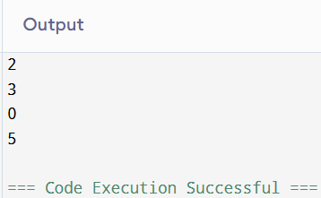
Activity Sheet 05 Start Date: 30/05/2026 End Date: 02/06/2026.
Topic: Searching [Easy + Medium Coding Questions]

Output

Activity Sheet 05 Start Date: 30/05/2026 End Date: 02/06/2026.
Topic: Searching [Easy + Medium Coding Questions]
- You are given a list of unique integers which are sorted but rotated at some pivot. You are also given a target value and you have to find its index in the list. If it is not present in the list, return -1.
Constraints
1 <= T <= 100
1 <= n <= 104
1 <= array elements <= 106
1 <= target <= 106
Example:
List: [4, 5, 6, 7, 1, 2, 3]
Target value: 6
Resultant index: 2

Testing Input Format
The first line contains 'T', denoting the number of test cases. Each test contains 3 lines:
a number 'n', denoting the number of elements.
n space-separated numbers denoting the array elements. the target value.
Output Format
T lines, each containing a number denoting the index of the target value. -1 if the target value is not present.

Sample Input 4
7
4 5 6 7 0 1 2
4
4
3 4 1 2
5
5
5 1 2 3 4
2
4
5 6 3 4
4
Expected Output 0
-1
2
3

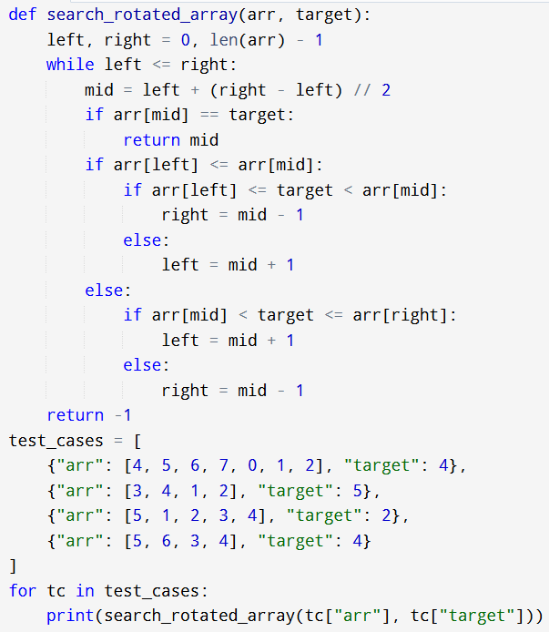
Activity Sheet 05 Start Date: 30/05/2026 End Date: 02/06/2026.
Topic: Searching [Easy + Medium Coding Questions]

Code:

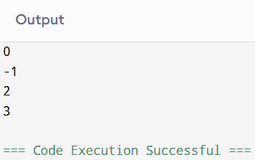
Activity Sheet 05 Start Date: 30/05/2026 End Date: 02/06/2026.
Topic: Searching [Easy + Medium Coding Questions]

Output

Activity Sheet 05 Start Date: 30/05/2026 End Date: 02/06/2026.
Topic: Searching [Easy + Medium Coding Questions]
- Given a sorted list of numbers in which all elements appear twice except one element that appears only once, find the number that appears only once.
Constraints
1 <= T <= 100
1 <= Size of array <= 20000
1 <= Elements in array <= 106
Example:
1, 1, 2, 3, 3, 4, 4
Here, ‘2’ appears once and all other elements appear twice.

findNonRepeatingElement([1, 1, 2, 3, 3, 4, 4]) => 2 Expected Time Complexity: O(log n)
Testing Input Format
The first line contains 'T', denoting the no. of test cases.

Each test case consists of two lines. The first contains a number 'n' denoting the number of elements. The second line has ‘n’ space-separated numbers denoting the elements.
Output Format
For each test case, a line containing the non-repeating number.

Sample Input 3
1
3
3
1 2 2
5
3 3 4 4 5
Expected Output 3
1
5

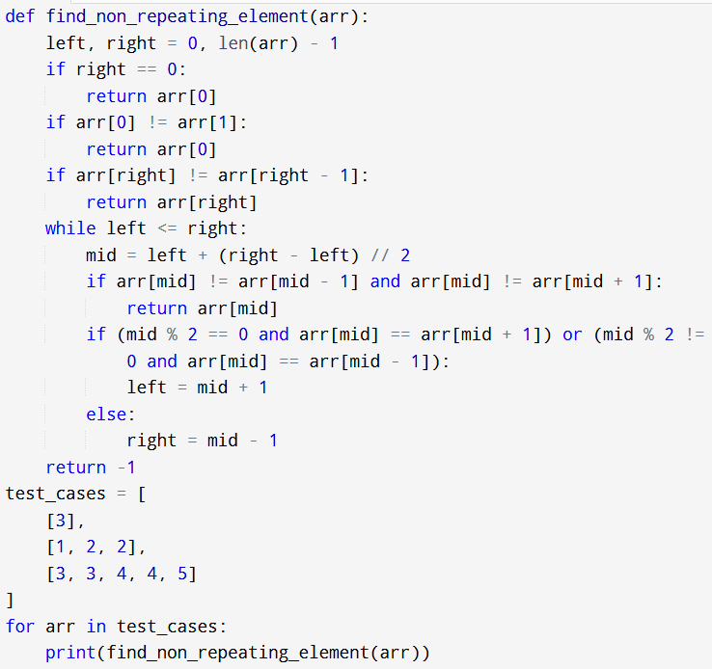
Activity Sheet 05 Start Date: 30/05/2026 End Date: 02/06/2026.
Topic: Searching [Easy + Medium Coding Questions]

Code:

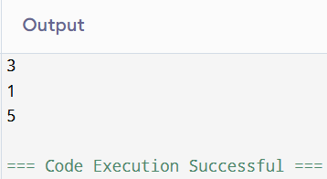
Activity Sheet 05 Start Date: 30/05/2026 End Date: 02/06/2026.
Topic: Searching [Easy + Medium Coding Questions]

Output

Activity Sheet 05 Start Date: 30/05/2026 End Date: 02/06/2026.
Topic: Searching [Easy + Medium Coding Questions]

- Given a matrix, check if the matrix contains a given key.

The matrix has the following properties:
Integer in each row is arranged in non-decreasing order from left to right.
The first integer in every row is greater than the last integer of the previous row.

Constraints
1 <= T <= 10
1 <= n,m <= 100
0 <= key <= 105
0 <= matrix[i][j] <= 105

Examples Matrix:
1 2 3
4 5 6
7 8 9
Key: 6 Answer: true Matrix:
1 2 3
4 5 6
7 8 9
10 11 12
Key: 15 Answer: false Testing Sample Input
The first line contains 'T' denoting the no. of test cases. For each test case:
The first line contains the numbers 'n' and 'm' denoting the number of rows and columns respectively followed by the key.
The next ‘n’ lines contain ‘m’ space-separated integers denoting elements of a 2-d matrix. Expected Output
T lines each contain true/false denoting the answer.

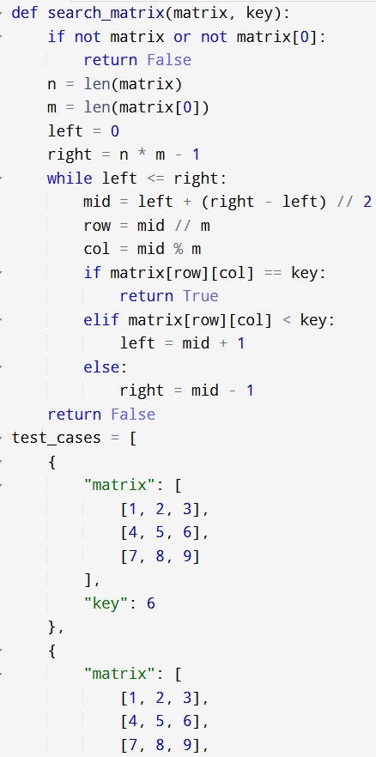
Activity Sheet 05 Start Date: 30/05/2026 End Date: 02/06/2026.
Topic: Searching [Easy + Medium Coding Questions]

Code:

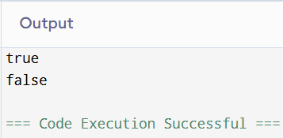
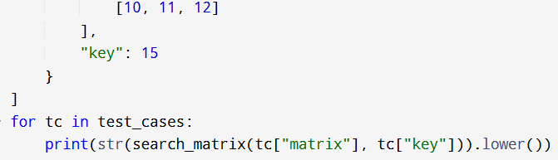
Activity Sheet 05 Start Date: 30/05/2026 End Date: 02/06/2026.
Topic: Searching [Easy + Medium Coding Questions]

Output

Activity Sheet 05 Start Date: 30/05/2026 End Date: 02/06/2026.
Topic: Searching [Easy + Medium Coding Questions]

- A peak element is an element strictly greater than its neighbors. Given an integer array arr[], find any peak element's index using binary search. If the array contains multiple peaks, return any one.
Constraints:
1 ≤ n ≤ 10³ | arr[-1] = arr[n] = -∞ | arr[i] ≠ arr[i+1] Example:
Input arr=[1,2,3,1]
Output 2

Input arr=[1,2,1,3,5,6,4]
Output 5 (or 1)

Input arr=[1] Output 0

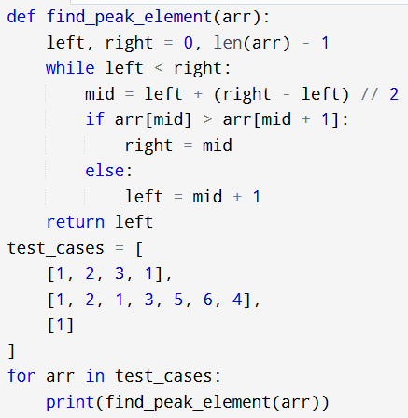
Activity Sheet 05 Start Date: 30/05/2026 End Date: 02/06/2026.
Topic: Searching [Easy + Medium Coding Questions]

Code:

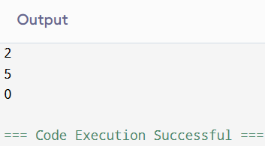
Activity Sheet 05 Start Date: 30/05/2026 End Date: 02/06/2026.
Topic: Searching [Easy + Medium Coding Questions]

Output

Activity Sheet 05 Start Date: 30/05/2026 End Date: 02/06/2026.
Topic: Searching [Easy + Medium Coding Questions]

- Given an array arr[] and a target, determine if there exist three elements that sum to the target. Return "YES" or "NO".
Constraints: 3 <= n <= 10^3 | -10^9 <= arr[i] <= 10^9 Input
arr=[1,4,45,6,10,8], target=22 Output
YES (4+10+8)
Input
arr=[1,2,4,3,6], target=10 Output
YES (1+3+6)

Input
arr=[1,2,3,4,5], target=100 Output
NO

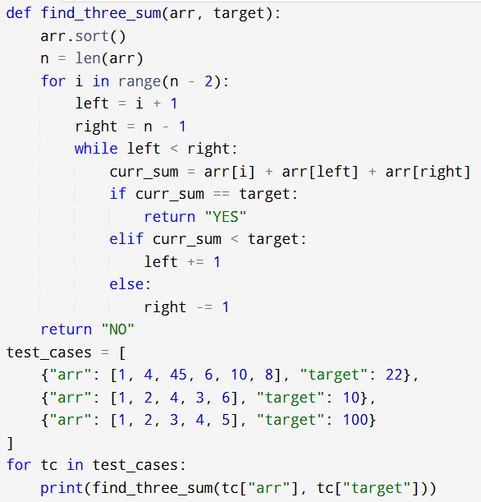
Activity Sheet 05 Start Date: 30/05/2026 End Date: 02/06/2026.
Topic: Searching [Easy + Medium Coding Questions]

Code:

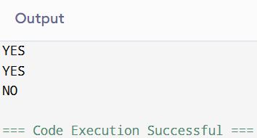
Activity Sheet 05 Start Date: 30/05/2026 End Date: 02/06/2026.
Topic: Searching [Easy + Medium Coding Questions]

Output

Activity Sheet 05 Start Date: 30/05/2026 End Date: 02/06/2026.
Topic: Searching [Easy + Medium Coding Questions]

- Given an m×n matrix where each row is sorted left-to-right and each column is sorted top-to-bottom, return true if the target exists, false otherwise.
Constraints:
1 ≤ m, n ≤ 300 | -10⁹ ≤ matrix[i][j], target ≤ 10⁹

Input:
matrix=[[1,4,7],[2,5,8],[3,6,9]], target=5
Output:
true
Input:
matrix=[[1,4,7],[2,5,8],[3,6,9]], target=10
Output: false

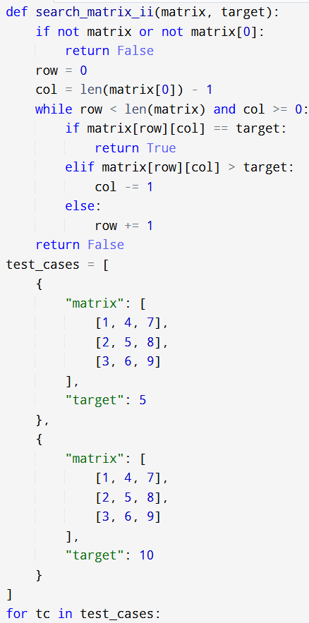
Activity Sheet 05 Start Date: 30/05/2026 End Date: 02/06/2026.
Topic: Searching [Easy + Medium Coding Questions]

Code:

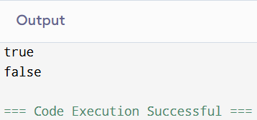
Activity Sheet 05 Start Date: 30/05/2026 End Date: 02/06/2026.
Topic: Searching [Easy + Medium Coding Questions]

Output

Activity Sheet 05 Start Date: 30/05/2026 End Date: 02/06/2026.
Topic: Searching [Easy + Medium Coding Questions]

- Given a sorted array arr[] and an integer x, find the number of occurrences of x in the array using binary search.

Constraints:
1 ≤ n ≤ 10⁵ | 1 ≤ arr[i] ≤ 10⁵

Input: arr=[1,1,2,2,2,3,4], x=2
Output:
3

Input: arr=[10,20,20,30,30,30], x=30
Output:
3

Input: arr=[5,5,5,5], x=9
Output: 0

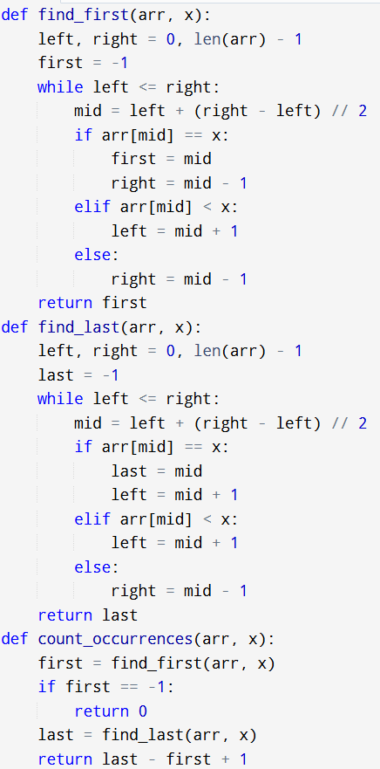
Activity Sheet 05 Start Date: 30/05/2026 End Date: 02/06/2026.
Topic: Searching [Easy + Medium Coding Questions]

Code:

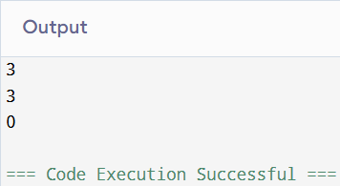
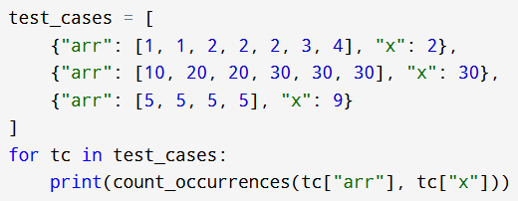
Activity Sheet 05 Start Date: 30/05/2026 End Date: 02/06/2026.
Topic: Searching [Easy + Medium Coding Questions]

Output

Activity Sheet 05 Start Date: 30/05/2026 End Date: 02/06/2026.
Topic: Searching [Easy + Medium Coding Questions]

- Find the Equilibrium Index
An equilibrium index i satisfies: sum of arr[0..i-1] == sum of arr[i+1..n-1]. Return the first such index. Return
-1 if none exists.
Note: Compute total sum first, then iterate updating left sum. Equilibrium when leftSum == totalSum - leftSum
- arr[i].

Constraints:
1 <= n <= 10^5 | -10^4 <= arr[i] <= 10^4
Input
arr=[-7,1,5,2,-4,3,0]
Output 3
Input arr=[1,2,3]
Output
-1

Input arr=[0] Output 0

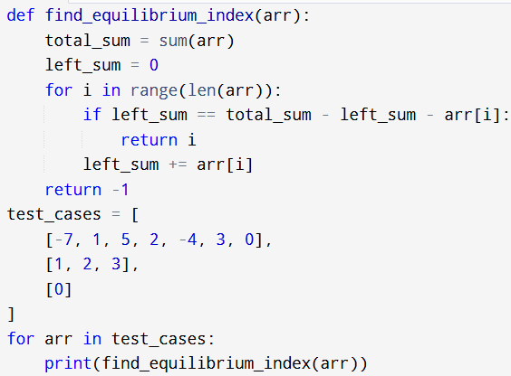
Activity Sheet 05 Start Date: 30/05/2026 End Date: 02/06/2026.
Topic: Searching [Easy + Medium Coding Questions]

Code:

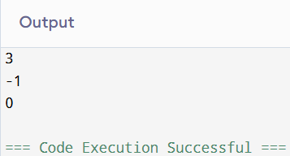
Activity Sheet 05 Start Date: 30/05/2026 End Date: 02/06/2026.
Topic: Searching [Easy + Medium Coding Questions]

Output

Activity Sheet 05 Start Date: 30/05/2026 End Date: 02/06/2026.
Topic: Searching [Easy + Medium Coding Questions]

- Count Pairs with Given Difference
Given an unsorted array arr[] and an integer diff, count the number of pairs (i, j) where i < j and arr[j] - arr[i]
== diff.
Note: Sort the array, then use binary search to find arr[i] + diff for each element. Constraints:
1 <= n <= 10^4 | 0 <= arr[i] <= 10^5 | 0 <= diff <= 10^5

Input
arr=[1,5,3,4,2], diff=3 Output
2 (pairs: (1,4) and (2,5))
Input
arr=[8,12,16,4,0,20], diff=4
Output 5

Input
arr=[1,1,1,1], diff=0 Output
6

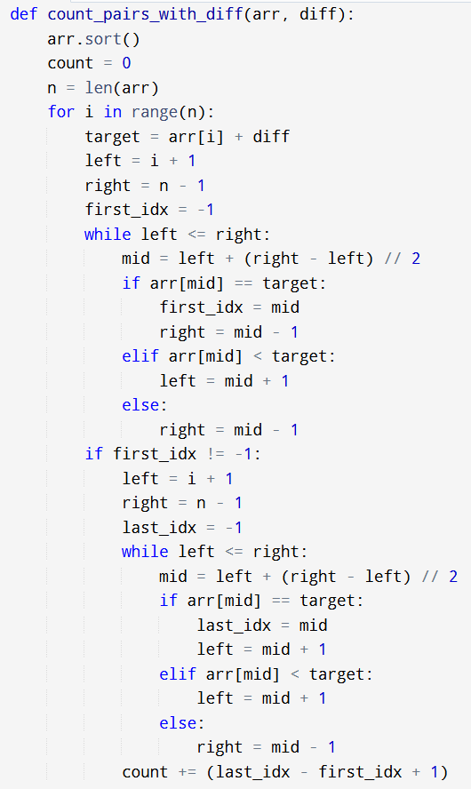
Activity Sheet 05 Start Date: 30/05/2026 End Date: 02/06/2026.
Topic: Searching [Easy + Medium Coding Questions]

Code:

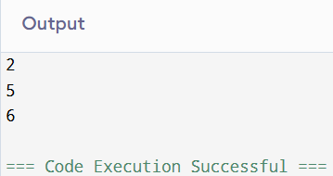
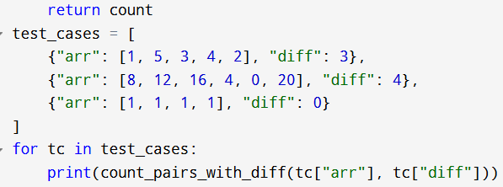
Activity Sheet 05 Start Date: 30/05/2026 End Date: 02/06/2026.
Topic: Searching [Easy + Medium Coding Questions]

Output

