Predicting Dementia Using Brain Scan Measurements and Patient Health Data: A Person-Wise Validated, Explainable Machine Learning Study on OASIS
Chirag Somkuwar
PRN 23070521042
Healthcare Analytics Mini Project (CA-III)
Symbiosis Institute of Technology, Nagpur
Nagpur, Maharashtra, India

Abstract—Dementia is usually screened with a brain scan or a memory test, yet the two sources are rarely modelled together and compared on equal terms. This paper builds a classifier that separates demented from nondemented older adults using seven inputs from the OASIS-2 longitudinal dataset: three brain scan measurements (eTIV, nWBV, ASF) and four patient details (age, sex, SES, MMSE). Logistic Regression, Random Forest and SVM are compared with 5-fold cross-validation that keeps every visit of a person in one fold, repeated over five seeds. A Random Forest using both kinds of data reaches a ROC-AUC of 0.793, against 0.639 for scan measurements alone and 0.742 for patient details alone. Logistic Regression is the strongest model on OASIS-2 (AUC 0.851) while the Random Forest is strongest on an independent OASIS-1 test set (AUC 0.938). SHAP values summed by data type attribute about 34% of the model’s influence to scan measurements and 66% to patient details. Keeping every visit of a person in the same fold avoids the leakage that a plain random split would allow. The model is deployed as a Streamlit dashboard. I compare protocols and headline numbers with four published OASIS studies and explain why my scores are lower.
Keywords—dementia, OASIS, MRI volumetrics, MMSE, Random Forest, SHAP, explainable AI, person-wise cross-validation

I. Introduction
Dementia slowly damages memory and thinking until daily life becomes hard. Doctors usually look at a brain scan or give a memory test such as the Mini-Mental State Examination (MMSE) [1], and they rate how severe it is with the Clinical Dementia Rating (CDR) [2]. These two kinds of evidence are often looked at separately. I wanted to know whether one model that sees both the scan measurements and the patient details can tell demented and nondemented people apart better, and which of the two it leans on more.
The Open Access Series of Imaging Studies (OASIS) is a popular public source for this kind of question [3], [4]. Many papers report accuracy above 90% on it [5], [6], [7], [8], but I found three reasons to be careful with those numbers. One is that OASIS-2 has several visits per person, so a normal random split can put the same person in both training and test data. Another is that scores closely tied to the label, mainly CDR, are often used as inputs. The last is that the contribution of each kind of data (scan or clinical) is rarely measured.
This project tries to deal with those problems using a small pipeline that is easy to follow. Its main points are:
- A person-wise validation protocol (all visits of one person stay together) that avoids the leakage a plain random split would allow, repeated over five seeds, with Logistic Regression, Random Forest and SVM compared under identical conditions.
- A modality-level explanation: SHAP influence is summed separately for the three scan measurements and the four patient details, giving a direct imaging-versus-clinical share.
- An external test on OASIS-1 and a deployed Streamlit dashboard that shows a SHAP chart for each person [9].
The rest of the paper goes in this order: related work (Section II), data (III), method and model design with equations (IV), setup and hyperparameters (V), results (VI), comparison with the benchmark papers (VII), limitations (VIII) and conclusion (IX).

II. Related Work and Benchmark Models
I use four published OASIS studies as benchmarks. Faouri et al. [5] worked on the same Kaggle copy of OASIS-2 [10]. They ran 112 experiments with seven classifiers (AdaBoost, Random Forest, kNN, SVM, Decision Tree, Naïve Bayes, Logistic Regression), changing the number of features with information gain and PCA and using 10-fold cross-validation. SVM and Naïve Bayes were the most stable, and AUC reached about 0.96 to 0.97 with all features. In their feature ranking CDR came first and MMSE second, far ahead of the rest.
Kubi and Nazir [6] used OASIS-2 with both tabular data and MRI slices. On the tabular data Gaussian Naïve Bayes was best after tuning (91.30% accuracy, 80/20 split), and on MRI slices DenseNet121 reached 90%. They also used SHAP and found that nWBV varied most in its impact across models. Dhariwal [7] treated every OASIS-2 visit as an independent row and trained XGBoost (learning rate 0.03, depth 3, subsample 0.9). It scored 97.33% accuracy and AUC 0.9706 on a stratified 20% hold-out, with CDR as the strongest predictor. Basheer et al. [8] proposed a modified capsule network on the 373 × 15 OASIS table and reported 92.39% accuracy.
Other recent OASIS studies compare standard classifiers in a similar way. Antor et al. [11] compared SVM, Logistic Regression, Decision Tree and Random Forest and reported SVM as the best. Alshamlan et al. [12] added feature selection to SVM, Random Forest and Logistic Regression, and Cabanillas-Carbonell and Zapata-Paulini [13] compared five models across both OASIS datasets. Mokadem et al. [14] found ensembles best among nine algorithms on neuropsychological data. Studies on community cohorts found that machine learning models performed about the same as logistic regression [15], [16], and one of them found that removing MRI markers did not significantly worsen the model [15].
On explainability, Haddada et al. [17] checked whether SHAP explanations agree with medical knowledge on OASIS-3. They found that clinical features beat FreeSurfer scan features, and that tree-based explanations for clinical features matched medical insight. Duah et al. [18] used SHAP in a longitudinal model on the same OASIS-2 data, and Kamalov et al. [19] proposed an explainable decision tree for OASIS; both are preprints. Reviews [20], [21] report that image-based models give promising results and that most data come from ADNI, and a recent survey focuses on interpretable diagnosis [22].
On validation, work on brain MRI shows how easily scores become optimistic. Yagis et al. [23] found that splitting scans into slices before cross-validation raised accuracy by about 30% on OASIS, and Rumala [24] reported that record-wise splits looked best in cross-validation on longitudinal MRI while subject-wise splits scored lowest, which points to leakage.
The headline numbers in the first four papers are high, but none of them describes splitting by person, and three of the four use CDR as an input. So my aim is not to beat their numbers. I want to see what is left when the evaluation is stricter and the score that defines the label is removed.

III. Dataset and Preprocessing

A. Datasets
OASIS-2 [3] is the training set. It has 150 people aged 60 to 98 with 373 visits in total, and every visit is labelled Demented, Nondemented or Converted (nondemented at first, demented later). OASIS-1 [4] is cross-sectional, and I use its 198 records of people aged 60 and above who have a CDR score as a second test set. I used the Kaggle copy of the CSV files while my OASIS access request was pending. The data files are not in the GitHub repository because of the OASIS access terms.

B. Features
The model uses seven features (Table I), split into two groups: three brain scan measurements from the OASIS image processing and four patient details. I left out Education because it means years of school in OASIS-2 but a 1 to 5 code in OASIS-1, so the two files cannot share it. I also did not use CDR as an input, since the demented label comes from it.
TABLE I
Input features used by the models
Group | Feature | Meaning
Imaging | eTIV | Estimated total intracranial volume (size of the skull cavity)
Imaging | nWBV | Normalised whole-brain volume (fraction of the cavity filled by brain)
Imaging | ASF | Atlas scaling factor, derived from eTIV
Clinical | Age | Age at the visit (60–98 years)
Clinical | Sex | Encoded M = 1, F = 0
Clinical | SES | Socioeconomic status, ordinal 1–5
Clinical | MMSE | Score on a 30-point memory test
Education and CDR are excluded (see text).

C. Label and cleaning
For OASIS-2 the label is binary, with Converted counted as Demented. That gives 190 nondemented and 183 demented visits (146 Demented plus 37 Converted), a 51% / 49% split, so I did no oversampling. SES is missing for 19 visits and MMSE for 2; I filled both with the median. For OASIS-1 the rule is CDR > 0 means demented, missing SES (18 records) takes the OASIS-2 median, and no other rows had to be dropped. The 198 records split into 100 demented and 98 nondemented. ASF and eTIV are almost exact inverses of each other (their product is nearly constant, median 1755.06), so the dashboard only asks for eTIV and works out ASF itself. Logistic Regression and SVM get standardised features:
$z = (x − μ)/σ$ (1)
where μ and σ come from the training folds only, so nothing leaks in from the validation fold. The Random Forest does not need scaling.

IV. Methodology and Model Architecture

A. Pipeline
Fig. 1 shows the whole workflow. It follows the seven steps of the project: explore and clean the data, split by person, compare three classifiers, compare imaging-only, clinical-only and combined inputs, explain the Random Forest with SHAP, test on OASIS-1, and deploy.
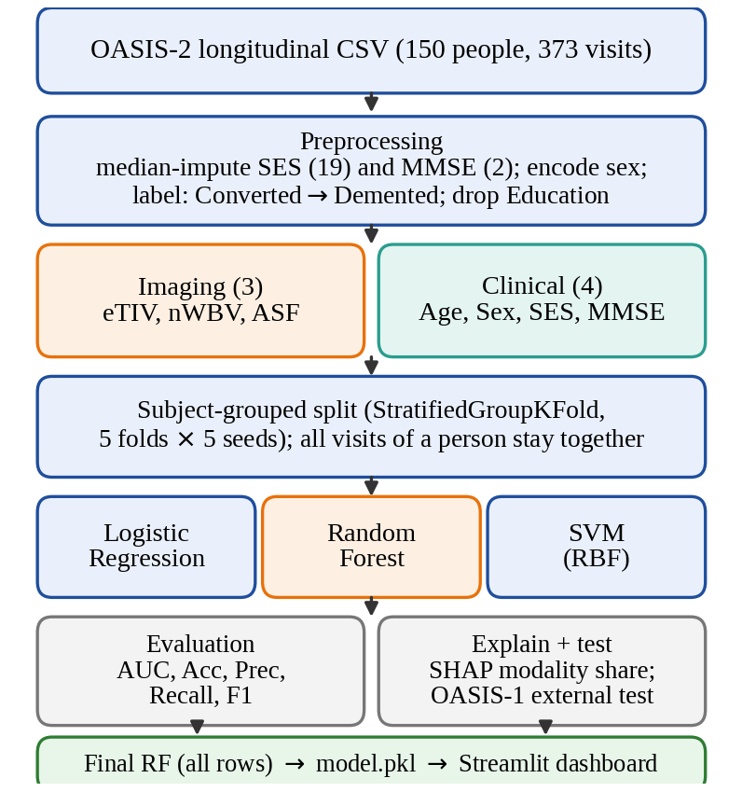
Fig. 1. End-to-end pipeline from the OASIS-2 file to the deployed dashboard. Orange marks the model carried forward to explanation, external testing and deployment.

B. Person-wise validation
Each visit i belongs to a person g(i). I use StratifiedGroupKFold with five shuffled folds and g = Subject ID, so every visit of a person lands in one fold and the class mix stays roughly equal across folds. The whole thing is repeated for seeds 0 to 4. For the three-model comparison I pool the out-of-fold probabilities, compute each metric once per seed at a threshold of 0.5, and average over seeds. For the imaging, clinical and combined comparison I take the mean of the five fold AUCs per seed and then average over seeds. The lowest and highest seed are kept as a rough measure of spread.

C. Classifiers
Logistic Regression [25] models the probability of dementia with a linear score and a sigmoid:
$p(y=1|x) = \frac{1}{1 + e^{−(w^{T}x + b)}}$ (2)
and is fitted by minimising the L2-regularised logistic loss, with y ∈ {−1, +1} in the loss:
$min \frac{1}{2}‖w‖{}^{2} + C\sum_{i=1}^{N}{log(1+e^{−y_{i}(w^{T}x_{i}+b)})}$ (3)
Random Forest [26] grows B = 200 decision trees, each on a bootstrap sample and with only m = ⌊√7⌋ = 2 randomly chosen features considered at every split (Fig. 2). A node t is split to maximise the drop in Gini impurity:
$G(t) = 1 − \sum_{k}{{p_{k}}^{2}}$ (4)
$ΔG = G(t) − \frac{n_{L}}{n}G(t_{L}) − \frac{n_{R}}{n}G(t_{R})$ (5)
where p_{k} is the share of class k in the node and n_{L}, n_{R} are the sizes of the child nodes. Trees are grown without a depth limit. The forest output is the average of the tree probabilities:
$p̂(x) = \frac{1}{B}\sum_{b=1}^{B}{p_{b}(x)}$ (6)
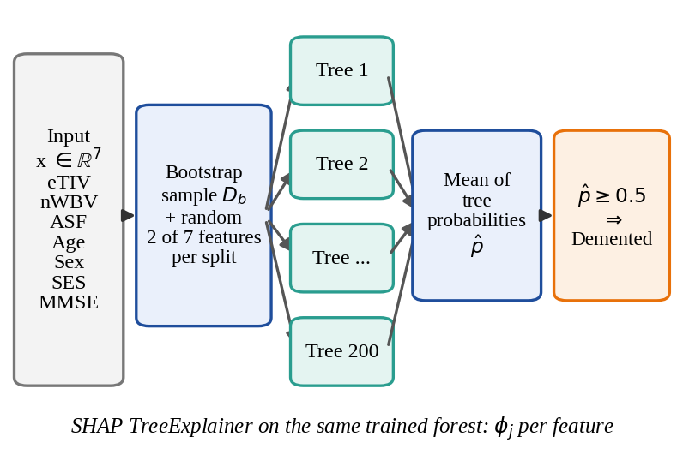
Fig. 2. Architecture of the final classifier. Seven inputs feed a 200-tree Random Forest; the averaged probability is thresholded at 0.5. SHAP is computed on the same trained forest.
Support Vector Machine [27] uses the radial basis function (RBF) kernel with γ = 1/(d·Var(X)), the ‘scale’ setting, where d = 7:
$K(x, x′) = exp(−γ‖x − x′‖{}^{2})$ (7)
$f(x) = \sum_{i}{α_{i}y_{i}K(x_{i}, x) + b}$ (8)
Because ROC-AUC needs scores, the decision value f is turned into a probability by Platt scaling [28], P(y=1|f) = 1/(1 + exp(Af + B)), fitted by internal cross-validation (probability = True).

D. Explainability with SHAP
The Random Forest is explained with SHAP [29], [30], which assigns each feature j its Shapley value [31] for a prediction f(x): its average marginal contribution over all subsets S of the feature set F,
$φ_{j} = \sum_{S⊆F∖\{j\}}{\frac{|S|!(|F|−|S|−1)!}{|F|!}[ f_{S∪\{j\}}(x) − f_{S}(x) ]}$ (9)
$f(x) = φ_{0} + \sum_{j=1}^{7}{φ_{j}(x)}$ (10)
The TreeExplainer algorithm computes these values exactly and efficiently for tree ensembles [30]; I take the values for the Demented class. For a modality M (imaging or clinical), the mean absolute SHAP value of each feature over N test visits is summed and expressed as a share of the total:
$I_{j} = \frac{1}{N}\sum_{i=1}^{N}{|φ_{j}(x_{i})|}$ (11)
$Share(M) = \frac{\sum_{j∈M}{I_{j}}}{\sum_{j=1}^{7}{I_{j}}} × 100\%$ (12)
This is repeated on five person-wise 80/20 splits (GroupShuffleSplit, seeds 0–4), and the mean and range of the shares are reported.

E. Evaluation metrics
With TP, FP, TN, FN the usual counts (Demented = positive), accuracy = (TP+TN)/(TP+TN+FP+FN) and precision = TP/(TP+FP). Recall and F1 are
$Recall = \frac{TP}{TP + FN}, F1 = \frac{2 · Precision · Recall}{Precision + Recall}$ (13)
The area under the ROC curve [32] is threshold-free and equals the probability that a randomly chosen demented visit receives a higher score than a randomly chosen nondemented one (ties count one half):
$AUC = Pr[ p̂(x^{+}) > p̂(x^{−}) ]$ (14)

F. External test and deployment
For the external test, each model is trained on all OASIS-2 rows and evaluated once on OASIS-1. The dashboard model is a 200-tree Random Forest trained on all 373 OASIS-2 rows and saved with the feature list, the training ranges and the ASF constant. The Streamlit app has three tabs (Predict, How the model works, Results and limits). The user moves sliders for eTIV, nWBV, age, sex, SES and MMSE, or loads one of three example people, and gets a risk estimate with a SHAP chart showing what pushed that prediction up or down. The explainer is cached, and scikit-learn is pinned to the version that made the model file so the pickle loads on the server.

V. Experimental Setup and Hyperparameters

A. Testing environment
I ran all experiments as Python scripts in Google Colab on a CPU; the data are tiny (373 rows, 7 features), so no GPU is needed. The tools are pandas and NumPy for data, scikit-learn 1.6.1 [25] for the models and validation, SHAP for explanations, matplotlib and seaborn for plots, joblib for saving the model, and Streamlit for the dashboard. The dashboard runs on Streamlit Community Cloud from the GitHub repository (the development container uses Python 3.11). The code is split into four scripts (preprocessing, model comparison, final model with SHAP, external test) plus the app.

B. Hyperparameters
Table II lists every setting the code fixes. Apart from the number of trees, I kept the scikit-learn defaults and did not run a grid or random search. That keeps the comparison simple, but it also means the scores are not tuned (see Section VIII).
TABLE II
Hyperparameters and protocol settings
Component | Setting
Logistic Regression | StandardScaler → L2 penalty, C = 1.0, lbfgs solver, max_iter = 100, random_state = 42
Random Forest | n_estimators = 200, criterion = gini, max_features = sqrt (2 of 7), max_depth = None, min_samples_split = 2, min_samples_leaf = 1, bootstrap = True; random_state = 42 (seed in the grouped-CV and SHAP runs)
SVM | StandardScaler → SVC, RBF kernel, C = 1.0, gamma = scale, probability = True, random_state = 42
Validation | StratifiedGroupKFold, 5 folds, shuffle = True, seeds 0–4, groups = Subject ID; threshold 0.5
SHAP runs | GroupShuffleSplit, test_size = 0.2, seeds 0–4; TreeExplainer on Demented-class output
Imputation | Median of SES and MMSE (OASIS-1 SES: OASIS-2 median)
All other parameters take scikit-learn 1.6.1 defaults.

VI. Results and Analysis

A. Comparison of the three classifiers
Table III gives the person-wise cross-validated results on OASIS-2, averaged over five seeds, and Fig. 3 shows the ROC curves for one seed. Logistic Regression is best on every metric. Its AUC of 0.851 is 0.065 above the Random Forest (0.786) and 0.070 above the SVM (0.781), and its seed range (0.843–0.858) does not overlap with theirs. The Random Forest and SVM are close to each other. My guess is that with only 150 people and one strong, roughly one-directional signal (MMSE), a regularised linear model has little to lose, while trees with no depth limit can fit noise specific to a person. Other cohorts also show logistic regression matching machine learning models [15], [16], but I did not test the reason here.
TABLE III
Person-wise 5-fold CV on OASIS-2 (mean of 5 seeds)
Model | Acc. | Prec. | Recall | F1 | AUC | AUC range
Logistic Reg. | 0.777 | 0.813 | 0.708 | 0.757 | 0.851 | 0.843–0.858
Random Forest | 0.729 | 0.739 | 0.692 | 0.714 | 0.786 | 0.770–0.811
SVM (RBF) | 0.726 | 0.740 | 0.682 | 0.709 | 0.781 | 0.764–0.796
Threshold 0.5; AUC range = lowest and highest of the five seeds.
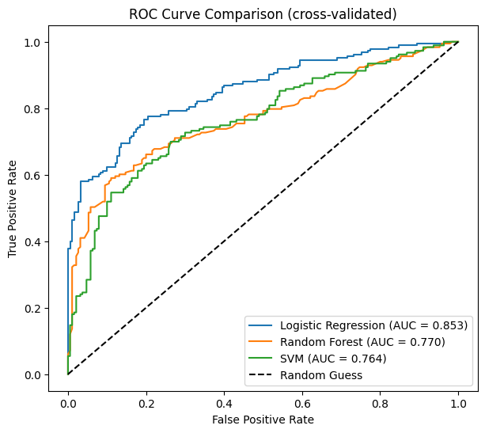
Fig. 3. Cross-validated ROC curves of the three classifiers on OASIS-2 (one seed; AUC 0.853, 0.770 and 0.764). The five-seed averages are in Table III.
Recall is the weakest metric for all three models (0.68 to 0.71). At a threshold of 0.5 they miss about three in ten demented visits, which would matter if this were used for screening. Precision is higher (0.74 to 0.81), so the models lean cautious rather than sensitive. Fig. 6(a) shows this for Logistic Regression: of the 183 demented visits it finds 130 and misses 53, and it wrongly flags 31 of the 190 nondemented visits. Lowering the threshold would be the obvious fix, and I list it as future work.

B. Imaging only, clinical only and combined
Table IV and Fig. 4 (left) compare the same Random Forest on three input sets. Scan measurements alone are weak (AUC 0.639), patient details alone do better (0.742), and the two together do best (0.793). Adding the scan measurements to the patient details gives a gain of 0.051 AUC. The lowest combined seed (0.777) is above the highest clinical-only seed (0.744), so the gain shows up in all five splits and is not down to one lucky partition. The scan side is weak partly because it is only three global volume summaries, not the images themselves, and reviews report better results for image-based models [20].
TABLE IV
Random Forest AUC by input set (grouped CV)
Input set | Mean AUC | Lowest seed | Highest seed
Imaging only (3) | 0.639 | 0.619 | 0.655
Clinical only (4) | 0.742 | 0.739 | 0.744
Combined (7) | 0.793 | 0.777 | 0.817

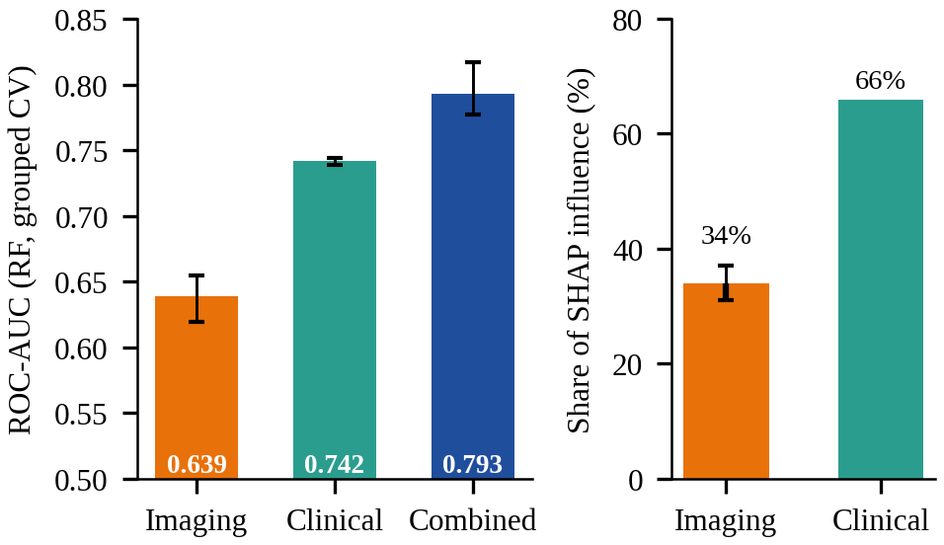
Fig. 4. Left: AUC by input set (whiskers = lowest and highest seed). Right: share of SHAP influence by data type (mean of five splits; imaging whisker 31%–37%).
The combined value here (0.793) is a little higher than the Random Forest value in Table III (0.786). The two analyses average AUC differently (mean of fold AUCs versus pooled out-of-fold scores) and the forest uses a different random seed. Both are person-wise and both give the same ordering.

C. What the model relies on
Fig. 5 is the SHAP summary of the Random Forest. MMSE has the largest influence in all five splits, and low scores push strongly towards Demented. nWBV comes next, and low brain volume also pushes towards Demented. Age, SES, ASF, eTIV and sex matter less. When I add the influence up by data type (Eqs. (11)–(12)), the three scan measurements carry 34% of the total on average (31% to 37% across splits) and the four patient details carry 66%. That matches Table IV: about two thirds of the signal is clinical, but the scan side still adds something measurable. Haddada et al. [17] likewise found clinical features stronger than scan features on OASIS-3. MMSE is closely tied to how the dementia label is assigned, so it is no surprise that it dominates. SHAP shows what the model used, not what causes dementia.
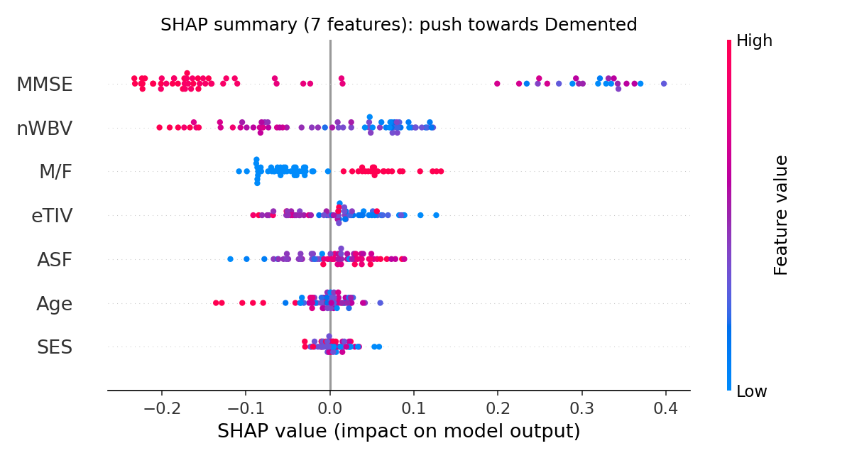
Fig. 5. SHAP summary of the Random Forest (each dot is one visit; colour = feature value; right = pushes towards Demented).

D. Why person-wise validation
I did not report a number for a plain random split. The reason to avoid one is clear, though. When one person’s visits fall on both sides of the split, the model can partly recognise that person from similar eTIV, nWBV and age at each visit instead of learning a general rule, and the score then looks better than it would on new people. This is the leakage problem described in [23], [24]. Person-wise validation removes this risk, which is why every result in this paper uses it. Measuring exactly how much a random split would inflate the scores is left for future work.

E. External test on OASIS-1
Table V shows models trained on OASIS-2 and tested once on OASIS-1. The ranking changes. The Random Forest is best (AUC 0.938, accuracy 0.874, recall 0.910), then Logistic Regression (0.896) and SVM (0.891). All three AUCs are higher than their OASIS-2 cross-validated values, but I would not read that as better generalisation. OASIS-1 uses a different label rule (CDR > 0), is cross-sectional, and was evaluated once with no repeated seeds or confidence intervals, and any of these could make the task easier. What the test does show is that a model trained on one cohort carries over to another with AUC near 0.9, and that no single model wins on both datasets. Fig. 6(b) shows the Random Forest result: it catches 91 of the 100 demented records and wrongly flags 16 of the 98 nondemented ones.
TABLE V
Trained on OASIS-2, tested on OASIS-1 (n = 198)
Model | Acc. | Prec. | Recall | F1 | AUC
Logistic Reg. | 0.808 | 0.816 | 0.800 | 0.808 | 0.896
Random Forest | 0.874 | 0.850 | 0.910 | 0.879 | 0.938
SVM (RBF) | 0.813 | 0.871 | 0.740 | 0.800 | 0.891

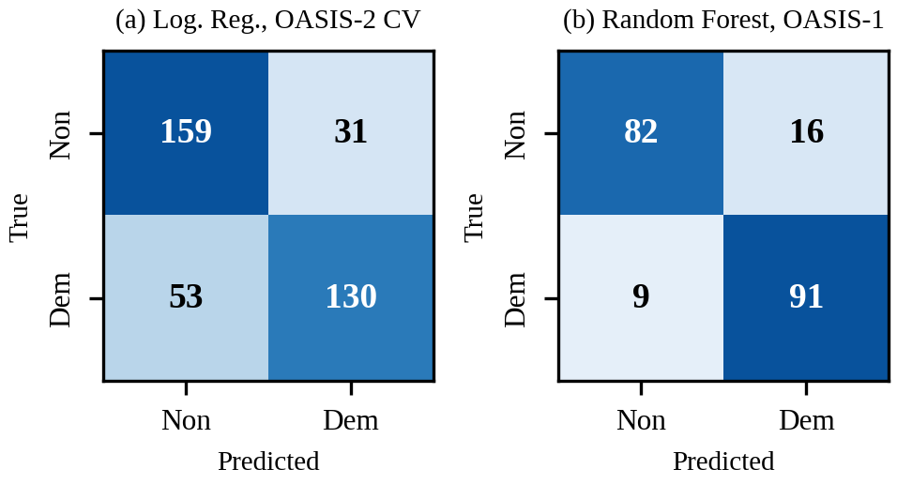
Fig. 6. Confusion matrices (Non = nondemented, Dem = demented). (a) Logistic Regression, pooled out-of-fold predictions on OASIS-2 (one seed). (b) Random Forest trained on OASIS-2 and tested on OASIS-1.

VII. Comparative Analysis with Benchmark Models
The three classifiers I use are standard benchmarks, and Faouri et al. [5] tested all of them on the same OASIS-2 table. Their AUCs (all features, 10-fold CV) are 0.885 for Logistic Regression, 0.901 for Random Forest and 0.960 for SVM. Mine under person-wise CV are 0.851, 0.786 and 0.781.
The gap is largest for the Random Forest and the SVM. I think three things explain much of it. One is CDR. In [5] it has an information gain of 0.724, more than twice that of MMSE and about ten times that of any other feature, and in [7] it is the strongest predictor. The OASIS group label is assigned from CDR, so a model that gets CDR as input is partly reading the answer. I left it out. Another is the split. The benchmarks do not describe splitting by person, and [7] states that each visit is treated as an independent row. Visits from the same person can then sit in both the training and test sets, which tends to make scores look better than they would on new people. The third is sample size. [6] works with 227 rows, oversamples the minority class at random and uses an 80/20 split, so the test set is only a few dozen rows and gives a noisy estimate. All of this fits with my lower numbers coming from a stricter evaluation, but it does not prove it, because I did not re-run the benchmark pipelines.
The model rankings differ too. Faouri et al. find SVM and Naïve Bayes the most stable and advise against ensembles. Kubi and Nazir find Gaussian Naïve Bayes best on tabular data, and Dhariwal picks gradient boosting. I find Logistic Regression best under person-wise CV and the Random Forest best on OASIS-1. Antor et al. [11] also report SVM as best, and Mokadem et al. [14] find ensembles best on neuropsychological data. What the studies agree on is that no single classifier wins on this small table, so how the validation is designed matters more than which algorithm is used. The deep models [6], [8] reach 90 to 92% accuracy but need images or a special capsule architecture and heavier training, and the DenseNet121 in [6] has a recall of only 0.60. Tree-based models are strong on medium-sized tabular data [33], but my 373 rows are far smaller, which may favour the linear model. My seven-feature Random Forest is small enough to train on a CPU in a notebook, reaches recall 0.91 on OASIS-1, and can be explained exactly.
TABLE VI
Benchmark studies and this work
Study | Data and validation | Best model | Best reported
[5] | OASIS-2 (Kaggle), 10-fold CV, CDR in inputs | NB / DT / SVM | AUC 0.967
[6] | OASIS-2, 227 rows, oversampling, 80/20, CDR in inputs | GNB; DenseNet121 (MRI) | Acc. 0.913; 0.90
[7] | OASIS-2 visits as rows, stratified 80/20, CDR in inputs | XGBoost | Acc. 0.973; AUC 0.971
[8] | OASIS 373 × 15 table, deep network | Modified CapsNet | Acc. 0.924
Ours | OASIS-2 person-wise 5-fold × 5 seeds, no CDR | Logistic Reg. | AUC 0.851; Acc. 0.777
Ours | Train OASIS-2, test OASIS-1, no CDR | Random Forest | AUC 0.938; Acc. 0.874

On explainability, [6] uses SHAP and finds nWBV the most variable contributor, while my model puts MMSE first and nWBV second. That is not surprising, since their feature set includes CDR and uses different models. What I add is summing SHAP by data type, which answers the question from Section I directly: about one third of the model’s influence comes from scan measurements and two thirds from patient details.

VIII. Discussion and Limitations
This study has limits that I should state plainly. The data are small (150 people aged 60 and above), so the seed ranges are wide, and the 0.793 versus 0.742 gap, although consistent, rests on few individuals. I did no hyperparameter search or probability calibration and fixed the threshold at 0.5, so recall is lower than it could be. Median imputation is simple and I did not compare a model-based imputer. OASIS-1 uses a different label rule and was evaluated once without confidence intervals. MMSE is closely tied to how the label is assigned, so the clinical share partly reflects the labelling process. SHAP explains the model, not the disease. Finally, the CSV came from Kaggle, and the benchmark numbers are taken from the published papers, not from re-running their code. The dashboard is a learning project, not a medical tool.

IX. Conclusion and Future Work
With person-wise validation, combining brain scan measurements with patient details predicted dementia status better than either alone (AUC 0.793 against 0.639 and 0.742). Logistic Regression was the strongest model on OASIS-2 (AUC 0.851) and the Random Forest on OASIS-1 (AUC 0.938). SHAP added up by data type shows that about two thirds of the prediction comes from patient details and one third from scan measurements, with MMSE and nWBV the top individual features. Splitting by person and leaving out CDR are likely reasons why published OASIS results look higher than mine, although I did not re-run those studies to confirm this.
For future work I would like to use more people and other datasets, tune the hyperparameters with nested person-wise cross-validation, calibrate the probabilities and lower the threshold to catch more demented cases, add confidence intervals for the external test, try extra scan measurements, and test on follow-up visits to predict conversion.

References
[1] M. F. Folstein, S. E. Folstein, and P. R. McHugh, “‘Mini-mental state’: A practical method for grading the cognitive state of patients for the clinician,” J. Psychiatr. Res., vol. 12, no. 3, pp. 189–198, 1975.
[2] J. C. Morris, “The Clinical Dementia Rating (CDR): Current version and scoring rules,” Neurology, vol. 43, no. 11, pp. 2412–2414, 1993.
[3] D. S. Marcus, A. F. Fotenos, J. G. Csernansky, J. C. Morris, and R. L. Buckner, “Open Access Series of Imaging Studies: Longitudinal MRI data in nondemented and demented older adults,” J. Cogn. Neurosci., vol. 22, no. 12, pp. 2677–2684, 2010.
[4] D. S. Marcus et al., “Open Access Series of Imaging Studies (OASIS): Cross-sectional MRI data in young, middle aged, nondemented, and demented older adults,” J. Cogn. Neurosci., vol. 19, no. 9, pp. 1498–1507, 2007.
[5] S. Faouri, M. AlBashayreh, and M. Azzeh, “Examining stability of machine learning methods for predicting dementia at early phases of the disease,” Decis. Sci. Lett., 2022, doi: 10.5267/dsl.2022.1.005.
[6] N. N. B. A. Kubi and S. Nazir, “Dementia prediction with multimodal clinical and imaging data,” Int. J. Inf. Technol., vol. 17, pp. 5–16, 2025, doi: 10.1007/s41870-024-02326-7.
[7] N. Dhariwal, “OASIS-SB: A sex-balanced, distribution-preserving, synthetic phenotypic dataset for bias-resilient clinical prediction,” Front. Comput. Neurosci., vol. 19, Art. no. 1744217, 2026, doi: 10.3389/fncom.2025.1744217.
[8] S. Basheer, S. Bhatia, and S. B. Sakri, “Computational modeling of dementia prediction using deep neural network: Analysis on OASIS dataset,” IEEE Access, vol. 9, pp. 42449–42462, 2021, doi: 10.1109/ACCESS.2021.3066213.
[9] C. Somkuwar, “Dementia-Risk-Predictor,” GitHub repository. [Online]. Available: https://github.com/chirag-2025/Dementia-Risk-Predictor (accessed Oct. 24, 2026).
[10] J. Boysen, “Magnetic resonance imaging comparisons of demented and nondemented adults,” Kaggle, 2017. [Online]. Available: https://www.kaggle.com/jboysen/mri-and-alzheimers
[11] M. B. Antor et al., “A comparative analysis of machine learning algorithms to predict Alzheimer’s disease,” J. Healthc. Eng., vol. 2021, Art. no. 9917919, 2021, doi: 10.1155/2021/9917919.
[12] H. Alshamlan, A. Alwassel, A. Banafa, and L. Alsaleem, “Improving Alzheimer’s disease prediction with different machine learning approaches and feature selection techniques,” Diagnostics, vol. 14, no. 19, Art. no. 2237, 2024, doi: 10.3390/diagnostics14192237.
[13] M. Cabanillas-Carbonell and J. Zapata-Paulini, “Evaluation of machine learning models for the prediction of Alzheimer’s: In search of the best performance,” Brain Behav. Immun. Health, Art. no. 100957, 2025, doi: 10.1016/j.bbih.2025.100957.
[14] Z. Mokadem, M. Djerioui, B. Attallah, and Y. Brik, “A comparison of machine learning algorithms for predicting Alzheimer’s disease using neuropsychological data,” Sci. Eng. Technol., vol. 5, no. 1, 2025, doi: 10.54327/set2025/v5.i1.182.
[15] E. L. Twait, C. L. Andaur Navarro, V. Gudnason, Y.-H. Hu, L. J. Launer, and M. I. Geerlings, “Dementia prediction in the general population using clinically accessible variables: A proof-of-concept study using machine learning. The AGES-Reykjavik study,” BMC Med. Inform. Decis. Mak., vol. 23, no. 1, Art. no. 168, 2023, doi: 10.1186/s12911-023-02244-x.
[16] J. Zhou et al., “Identifying dementia from cognitive footprints in hospital records among Chinese older adults: A machine-learning study,” Lancet Reg. Health West. Pac., vol. 46, Art. no. 101060, 2024, doi: 10.1016/j.lanwpc.2024.101060.
[17] K. Haddada, M. Ibn Khedher, O. Jemai, S. Iben Khedher, and M. El Yacoubi, “Assessing the interpretability of machine learning models in early detection of Alzheimer’s disease,” in Proc. 16th Int. Conf. Human System Interaction (HSI), Paris, France, 2024, pp. 1–6, doi: 10.1109/HSI61632.2024.10613551.
[18] G. Duah, E. Nyarko, J. Y. Effah, I. B. Numoah, and A. Lotsi, “Explainable longitudinal machine learning for dementia progression using cognitive and MRI biomarkers,” medRxiv, 2026, doi: 10.64898/2026.07.12.26357878.
[19] F. Kamalov, F. Thabtah, D. Peebles, and A. Ibrahim, “Selectively augmented decision tree for explainable dementia detection,” medRxiv, 2026, doi: 10.64898/2026.02.03.26345441.
[20] A. Javeed, A. L. Dallora, J. S. Berglund, A. Ali, L. Ali, and P. Anderberg, “Machine learning for dementia prediction: A systematic review and future research directions,” J. Med. Syst., vol. 47, Art. no. 17, 2023, doi: 10.1007/s10916-023-01906-7.
[21] G. Kantayeva, J. Lima, and A. I. Pereira, “Application of machine learning in dementia diagnosis: A systematic literature review,” Heliyon, vol. 9, no. 11, Art. no. e21626, 2023, doi: 10.1016/j.heliyon.2023.e21626.
[22] K. Haddada, M. Ibn Khedher, and O. Jemai, “A survey of early detection and interpretable diagnosis of Alzheimer’s disease,” Multimed. Tools Appl., vol. 84, no. 35, pp. 44033–44061, 2025.
[23] E. Yagis et al., “Effect of data leakage in brain MRI classification using 2D convolutional neural networks,” Sci. Rep., vol. 11, Art. no. 22544, 2021, doi: 10.1038/s41598-021-01681-w.
[24] D. J. Rumala, “How you split matters: Data leakage and subject characteristics studies in longitudinal brain MRI analysis,” in Proc. MICCAI Workshop on Fairness of AI in Medical Imaging (FAIMI). Cham, Switzerland: Springer, 2023, doi: 10.1007/978-3-031-45249-9_23.
[25] F. Pedregosa et al., “Scikit-learn: Machine learning in Python,” J. Mach. Learn. Res., vol. 12, pp. 2825–2830, 2011.
[26] L. Breiman, “Random forests,” Mach. Learn., vol. 45, no. 1, pp. 5–32, 2001.
[27] C. Cortes and V. Vapnik, “Support-vector networks,” Mach. Learn., vol. 20, no. 3, pp. 273–297, 1995.
[28] J. C. Platt, “Probabilistic outputs for support vector machines and comparisons to regularized likelihood methods,” in Advances in Large Margin Classifiers. Cambridge, MA, USA: MIT Press, 1999, pp. 61–74.
[29] S. M. Lundberg and S.-I. Lee, “A unified approach to interpreting model predictions,” in Proc. Adv. Neural Inf. Process. Syst. (NIPS), 2017, pp. 4765–4774.
[30] S. M. Lundberg et al., “From local explanations to global understanding with explainable AI for trees,” Nat. Mach. Intell., vol. 2, no. 1, pp. 56–67, 2020.
[31] L. S. Shapley, “A value for n-person games,” in Contributions to the Theory of Games, vol. II. Princeton, NJ, USA: Princeton Univ. Press, 1953, pp. 307–317.
[32] T. Fawcett, “An introduction to ROC analysis,” Pattern Recognit. Lett., vol. 27, no. 8, pp. 861–874, 2006.
[33] L. Grinsztajn, E. Oyallon, and G. Varoquaux, “Why do tree-based models still outperform deep learning on typical tabular data?,” in Adv. Neural Inf. Process. Syst. (NeurIPS), Datasets and Benchmarks Track, vol. 35, 2022.

