GreenSettle
Carbon credits for cloud workloads, settled after the run from measured energy
TODO: author name · student number · course · date

Contents
Open in Word and update fields to build the table of contents.

Abstract
GreenSettle schedules batch jobs into greener time slots and settles carbon credits after each job has run, from the energy that was actually measured. A worker on a laptop measures the CPU package energy of each job with LibreHardwareMonitor and attributes it by CPU time, with an uncertainty estimate. The server compares the job with the same job started at submission time, using actual grid data, propagates the measurement and intensity uncertainties into the saving, and pays a capped rebate only for the part of the saving that lies beyond k standard uncertainties (a dead zone). The grid, the forecast and the noise models are simulated. E3 (simulated grid and forecast, 10 % forecast error, z = 1): -12.3 % gCO2e per job with 6 h tolerance (mean wait 2.1 h), -24.0 % with 12 h; 15% and 6% of deferrals backfired. E4 (simulated 10 % noise): at k = 1 a rebate went to 14.9% of jobs with no real saving (k = 0: 50.4%), and to 71.5% / 99.2% of jobs with a true 20 % / 40 % saving. Gaming table (simulated): no ex-post job earned credits (lowest net 0.20 credits); the simplified ex-ante strawman paid 2 job(s) to run. E1 repeatability on the real laptop: PENDING (run on the laptop).
The contribution claimed is narrow: ex-post counterfactual settlement with propagated measurement uncertainty and a dead zone. Only a limited literature search was done; related work is incomplete.

1. Problem
TODO: quote the exact wording of Challenge 10 and Challenge 8 from the course brief here.
Carbon-aware computing moves flexible work to hours when the electricity grid is cleaner. Incentives for such behaviour are usually granted from forecasts and estimates made before the work runs. Two questions are rarely answered afterwards: did the job really use the energy that was assumed, and was the moment it ran really cleaner than running it immediately? If rewards are paid on estimates, measurement noise and forecast errors can earn credits for savings that never happened.
GreenSettle addresses this with three parts: measurement of each job's energy with an uncertainty (Phase 1), an append-only credit ledger with a settlement rule that only pays for savings beyond the noise (Phase 2), and a scheduler, API and worker that put both into a running system (Phase 3).

2. Related work (short)
Only a limited literature search was done; related work is incomplete. The references below were not re-checked against their sources and are marked [UNVERIFIED]; they must be verified before submission.
- Temporal workload shifting in the cloud: Wiesner et al., "Let's Wait Awhile: How Temporal Workload Shifting Can Reduce Carbon Emissions in the Cloud", Middleware 2021. [UNVERIFIED]
- Carbon-aware scheduling at datacenter scale: Radovanovic et al., "Carbon-Aware Computing for Datacenters", IEEE Transactions on Power Systems. [UNVERIFIED]
- Per-software carbon accounting: Green Software Foundation, Software Carbon Intensity (SCI) specification. [UNVERIFIED]
- Energy measurement with Intel RAPL: Khan et al., "RAPL in Action: Experiences in Using RAPL for Power Measurements", ACM TOMPECS 2018. [UNVERIFIED]
- Uncertainty propagation: JCGM 100:2008, Guide to the expression of uncertainty in measurement (GUM). [UNVERIFIED]
TODO, papers still to read:
- TODO: counterfactual baselines and additionality in carbon-offset markets.
- TODO: measurement and verification (M&V) protocols for energy savings (e.g. IPMVP).
- TODO: carbon-intensity forecasting accuracy (grid operators, Electricity Maps methodology).
- TODO: any prior work on settling scheduling incentives ex post with uncertainty (to test the novelty claim).

3. Design
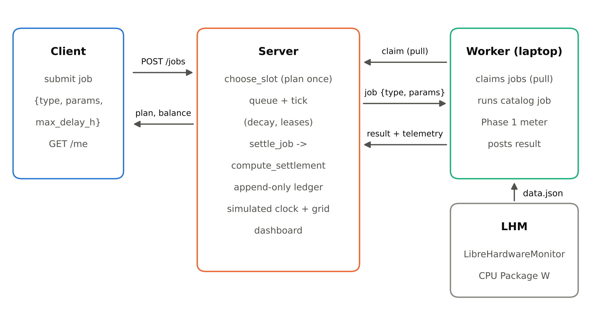
Figure 1: Architecture: the worker on the laptop pulls jobs; the server plans with choose_slot and settles measured energy into an append-only ledger.

3.1 Measurement (Phase 1)
The worker polls the CPU Package power from LibreHardwareMonitor about once per second and integrates it with the trapezoidal rule. Idle power is calibrated separately and subtracted; the remaining dynamic energy is attributed to the job by its share of busy CPU time (psutil, including child processes). The uncertainty combines sensor tolerance, sampling error, idle-baseline noise and attribution error in quadrature. The scope is the CPU package only.

3.2 Settlement (Phase 2)
compute_settlement (greensettle/settlement/rules.py) takes the job energy E ± dE, the counterfactual intensity i_submit (the same job started at submission, from actual grid data) and the intensity during the run i_run, each with an uncertainty:
fee = p · E · i_run (actual emissions)
saved = E · (i_submit − i_run)
saved_unc = √((dE·(i_submit − i_run))² + (E·u_submit)² + (E·u_run)²)
saving if saved − k·saved_unc > 0: rebate = min(ρ·p·(saved − k·saved_unc), γ·fee)
backfire elif −saved − k·saved_unc > 0: surcharge = σ·p·(−saved − k·saved_unc)
dead zone otherwise: no rebate, no surcharge
net = fee + surcharge − rebate

Because the rebate is at most γ·fee with γ < 1, a job with a positive fee always has a positive net cost, so running jobs cannot earn credits. Rebates are paid on the pessimistic saving, so a noise-sized saving earns nothing.
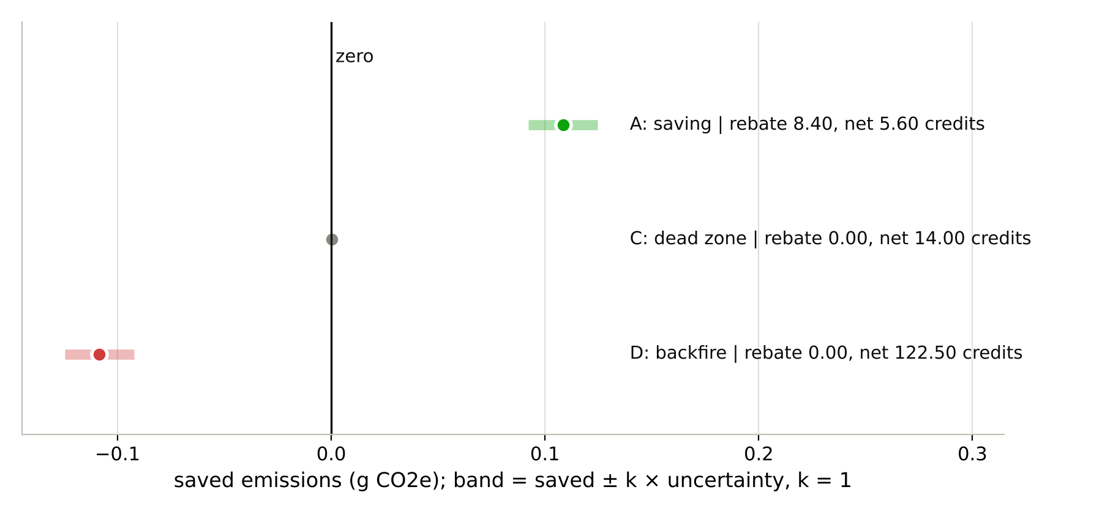
Figure 2: Dead zone: a rebate is paid only if the whole band lies above zero, and a backfire is declared only if it lies below zero (worked examples A, C, D, computed by compute_settlement).
The ledger is append-only (SQLite triggers block UPDATE and DELETE), stores integer micro-credits, rounds every amount against the user, applies a lazy half-life decay before each balance-changing write, and derives a tier (red, standard, green) from the balance after decay.

3.3 Scheduling (Phase 3)
choose_slot (greensettle/scheduler/slots.py) plans each job once at submission. It asks the forecast for every 30-minute start inside the user's wait window, picks the lowest forecast (earliest on ties), and defers only if the forecast saving exceeds defer_z combined forecast uncertainties; otherwise the job starts now. Ready jobs are dispatched by overdue first (a starvation guard), then tier priority, planned start and submission order, within global and per-tier concurrency limits. The server runs on a simulated clock so that a day of grid variation fits in a demonstration.

4. Implementation
- Python 3.11+, standard library plus psutil; FastAPI and uvicorn for the server; SQLite with versioned migrations (PRAGMA user_version).
- greensettle/agent: LibreHardwareMonitor client, meter, worker. greensettle/ledger: migrations, ledger, decay, allowance, settle_job, CLI. greensettle/scheduler: slots, planner, dispatch, queue. greensettle/server: API, clock, dashboard.
- The worker pulls work (POST /agent/claim) so the laptop can sit behind NAT; claims are atomic (BEGIN IMMEDIATE) and leased; an expired lease requeues a job once.
- A single-file dashboard (no external resources) shows the simulated grid, live power, the queue with candidate slots, settlements and balances.
- The test suite runs without hardware (mock sensor, fake clock); hardware tests are opt-in.

5. Security model
- Jobs are never commands: {job_type, params} from a fixed catalog with integer parameters in hard ranges. The worker re-validates and builds a fixed argv itself; no shell, no user strings reach a process; burn jobs are capped at 60 s for thermal safety.
- Authentication: per-user API keys (32 random bytes, shown once, stored as SHA-256); agent and admin tokens only from environment variables; constant-time comparison.
- Limits: queued jobs per user, request body size, strict request models that reject unknown fields, wrong types and NaN; error responses do not echo input.
- Network: binds to 127.0.0.1 unless told otherwise; remote use needs HTTPS or an SSH tunnel.
- Trust model: the server trusts the worker's energy numbers. Measurement attestation is out of scope; a dishonest worker could lie.

6. Experiments and results
E1 runs on the real laptop. E3, E4 and the gaming table are simulations: the grid curve, the forecast error and the measurement noise are simulated, and are labelled so below.

6.1 E1: measurement repeatability (real laptop)
E1: PENDING (run on the laptop). Command: python experiments/e1_repeatability.py --repeats 6 --seconds 20 --workers 1,4

6.2 E3: scheduling benefit (simulated)
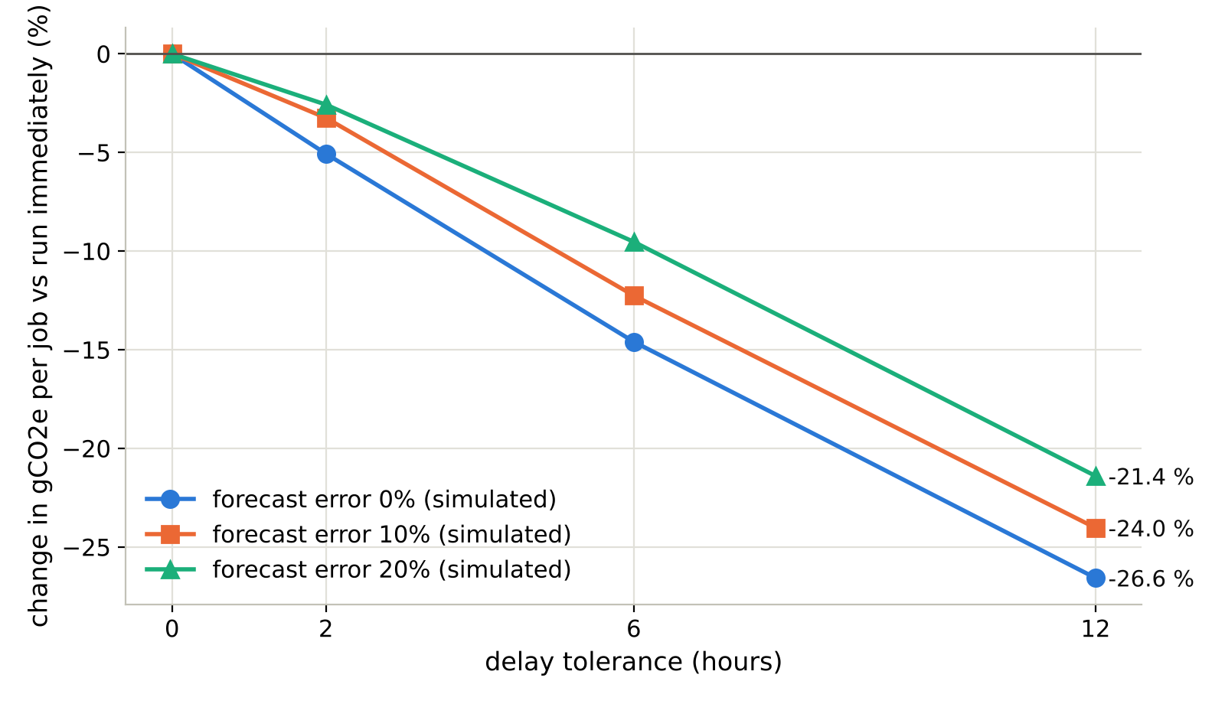
Figure 3: E3 (simulated grid and forecast): emissions per job relative to running immediately, choose_slot with defer_z = 1, 504 jobs over 7 days.
Table 1: E3 at 10 % simulated forecast error (full grid of settings in experiments/results/e3.csv).
delay (h) | defer_z | change vs immediate | mean wait (h) | deferred | deferrals backfired
2 | 0 | -3.3 % | 0.92 | 65% | 38%
2 | 1 | -3.3 % | 0.51 | 32% | 21%
2 | 2 | -2.3 % | 0.28 | 15% | 12%
6 | 0 | -11.3 % | 2.92 | 78% | 31%
6 | 1 | -12.3 % | 2.14 | 52% | 15%
6 | 2 | -11.7 % | 1.59 | 37% | 3%
12 | 0 | -23.6 % | 5.77 | 84% | 16%
12 | 1 | -24.0 % | 5.05 | 69% | 6%
12 | 2 | -23.4 % | 4.53 | 59% | 2%

E3 (simulated grid and forecast, 10 % forecast error, z = 1): -12.3 % gCO2e per job with 6 h tolerance (mean wait 2.1 h), -24.0 % with 12 h; 15% and 6% of deferrals backfired.

6.3 E4: dead-zone width (simulated)
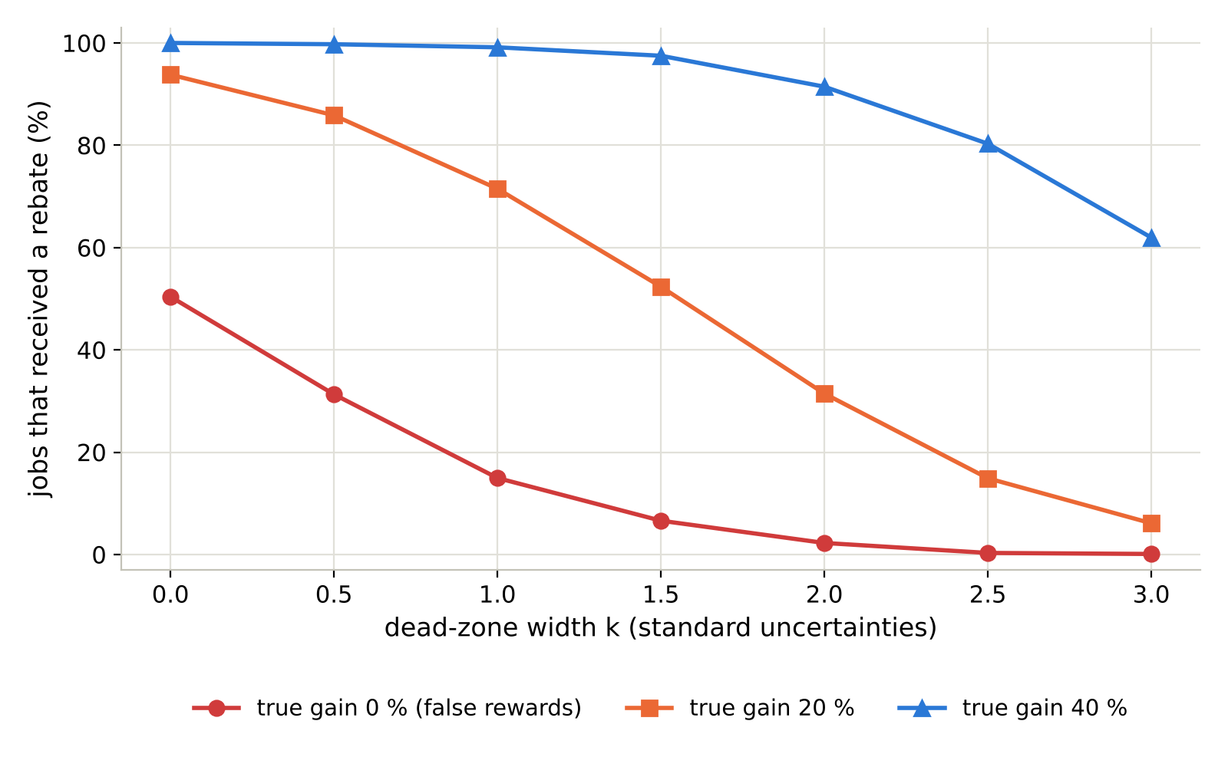
Figure 4: E4 (simulated 10 % measurement noise, 2000 jobs per point): a wider dead zone removes false rewards faster than deserved ones.
Table 2: E4: share of jobs that received a rebate, against k (simulated noise model).
k | false-reward rate (gain 0) | reward rate (gain 20 %) | reward rate (gain 40 %) | credits minted, gain 0
0 | 50.4% | 93.8% | 100.0% | 12442.4
0.5 | 31.3% | 85.9% | 99.8% | 6004.6
1 | 14.9% | 71.5% | 99.2% | 2530.1
1.5 | 6.6% | 52.3% | 97.5% | 894.8
2 | 2.2% | 31.4% | 91.5% | 205.0
2.5 | 0.3% | 14.9% | 80.3% | 27.7
3 | 0.1% | 6.1% | 62.0% | 4.8

E4 (simulated 10 % noise): at k = 1 a rebate went to 14.9% of jobs with no real saving (k = 0: 50.4%), and to 71.5% / 99.2% of jobs with a true 20 % / 40 % saving.

6.4 Gaming table (simulated)
Table 3: Gaming table: 200 simulated jobs per archetype; the ex-ante rule is a simplified strawman.
archetype | rule | mean net / job | share rebated | jobs with net < 0
honest_deferrer | ex-ante | 172.91 | 55.5% | 2
honest_deferrer | ex-post k=0 | 173.10 | 73.5% | 0
honest_deferrer | ex-post k=1 | 181.94 | 46.5% | 0
honest_deferrer | ex-post k=2 | 187.22 | 30.0% | 0
always_immediate | ex-ante | 217.50 | 0.0% | 0
always_immediate | ex-post k=0 | 217.00 | 0.0% | 0
always_immediate | ex-post k=1 | 217.00 | 0.0% | 0
always_immediate | ex-post k=2 | 217.00 | 0.0% | 0
junk_farmer | ex-ante | 0.96 | 55.5% | 0
junk_farmer | ex-post k=0 | 0.92 | 67.5% | 0
junk_farmer | ex-post k=1 | 0.97 | 42.5% | 0
junk_farmer | ex-post k=2 | 0.99 | 25.0% | 0
noise_chaser | ex-ante | 217.95 | 39.5% | 0
noise_chaser | ex-post k=0 | 205.63 | 49.5% | 0
noise_chaser | ex-post k=1 | 210.43 | 17.5% | 0
noise_chaser | ex-post k=2 | 211.53 | 1.5% | 0

Gaming table (simulated): no ex-post job earned credits (lowest net 0.20 credits); the simplified ex-ante strawman paid 2 job(s) to run.

7. Limitations
- CPU package energy only: RAM, display, storage and network are not measured; the laptop's memory and platform power sensors read 0 W.
- Attribution by CPU time ignores that P-core and E-core seconds cost different energy on this hybrid CPU.
- The server trusts worker measurements; there is no attestation.
- Jobs are planned once and never re-planned; one mean intensity is used per job.
- Failed jobs are not settled, so their energy is never billed.
- Overdue jobs skip tier priority; a job submitted with no wait window is overdue almost immediately.
- One laptop, one simulated grid, simulated forecast errors and noise; all parameters are placeholders (Table below). Only a limited literature search was done.

8. Placeholder parameters
None of these values was calibrated. Each is read from the code that uses it.
Table 4: Placeholder parameters (values read from the code).
parameter | value | defined in
Sensor tolerance | 5% of package energy | agent/meter.py MeterConfig
Attribution coefficients | base 0.05, k 0.2 | agent/meter.py MeterConfig
Intensity uncertainty | 10% relative (simulated curve) | intensity/provider.py SimulatedCurve
Forecast error model | 5% + 2% per hour of lead, max 40%, bias 0 | intensity/timeline.py ForecastErrorModel
Tier thresholds | red < 20, standard 20-100, green >= 100 credits; priority 0/1/2; max running 1/1/2 | ledger/config.py DEFAULT_TIERS
p (credits per g CO2e) | 1000 | settlement/rules.py SettlementParams
rho (rebate share) | 0.5 | settlement/rules.py SettlementParams
gamma (rebate cap / fee) | 0.6 | settlement/rules.py SettlementParams
k (dead-zone width) | 1 | settlement/rules.py SettlementParams
sigma (backfire surcharge) | 0 | settlement/rules.py SettlementParams
Decay half-life | 30 days | ledger/config.py LedgerConfig
Monthly allowance | 100 credits | ledger/config.py LedgerConfig

9. Conclusion
GreenSettle shows that carbon incentives for scheduled jobs can be settled after the run, from measured energy and actual grid data, with uncertainty carried through to the payment. In the simulations, scheduling within a wait window lowered emissions per job, the dead zone suppressed rewards for savings that were only noise, and no ex-post settlement ever paid a job to run. The real-hardware repeatability of the measurement (E1) and the calibration of every placeholder are the next steps.
E1 is PENDING (run on the laptop); this conclusion does not yet include real-laptop evidence.

Appendix A: Reproduce
python -m venv .venv && .venv\Scripts\Activate.ps1
pip install -r requirements.txt -r requirements-report.txt
python -m pytest # hardware tests skipped
python experiments/run_offline.py # worked examples, gaming table, E3, E4, SUMMARY.md
python -m greensettle.cli calibrate-idle --seconds 30 # on the laptop
python experiments/e1_repeatability.py --repeats 6 --seconds 20 --workers 1,4
python report/make_figures.py
python report/make_poster.py
python report/make_report.py

