Reference Check Analyzer
Technical Architecture
LangGraph-based pipeline, provider-agnostic LLM layer, real-time + batch execution, HTTP API.

1. Overview
The system is a LangGraph pipeline that automates comparing a candidate's claimed employment history against what their references actually say. It supports two reference input shapes (REF1: open-text transcript/email, REF2: structured yes/no verification form), runs in real time (single reference, or fan-out across a candidate's full reference list) or in bulk via a Batch API, and is exposed both as an importable Python package and as an HTTP service with a Streamlit front end.
Design principles that recur throughout the codebase:
- Deterministic comparison logic (diffing claimed vs. stated facts, scoring, routing) is plain Python, never left to an LLM to “judge” freely -- LLM calls are used only where free-text understanding is genuinely required (extraction, sentiment, summarization).
- Exactly one implementation of every piece of business logic. The batch pipeline and the HTTP API both call the same node classes as the interactive CLI demos -- nothing is reimplemented per execution path.
- Provider selection (which LLM backend) is a runtime configuration choice, never a code change.

2. System Architecture
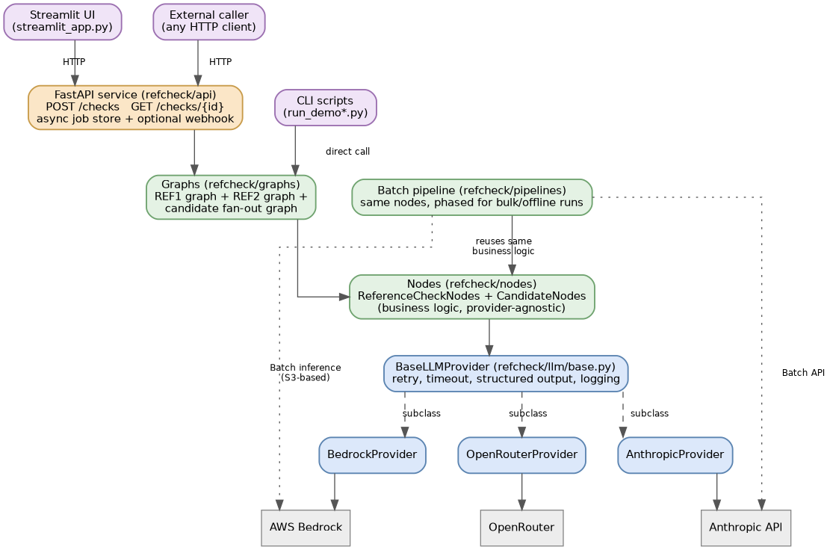
Figure 1. Component overview -- clients, API layer, core pipeline, and the provider abstraction.
Three ways into the pipeline (Streamlit UI and any external HTTP caller both go through the FastAPI service; CLI scripts call the graphs directly), one shared core (graphs -> nodes -> provider abstraction), and three interchangeable LLM backends behind a common interface.

3. Package Layout
refcheck/
config.py model-tier resolution (provider,tier)->model_id, every tunable setting
prompts.py every LLM system prompt
request_builders.py every (system, user_message) pair -- shared by real-time + batch
schemas.py Pydantic models, incl. REF1/REF2 type codes
validation.py input checks + prompt-injection pattern warnings
logging_config.py structured JSON logging + PII scrubbing

llm/
base.py BaseLLMProvider abstract class (shared retry/logging/output logic)
anthropic_provider.py / bedrock_provider.py / openrouter_provider.py
providers.py get_provider() factory, selected via LLM_PROVIDER env var
batch/
anthropic_batch.py Anthropic Message Batches API backend
bedrock_batch.py AWS Bedrock batch inference backend (S3-based)

nodes/
reference_nodes.py ReferenceCheckNodes -- REF1 + REF2 flow methods
candidate_nodes.py CandidateNodes -- dispatch, cross-check, aggregate

graphs/ reference_graph.py, candidate_graph.py (LangGraph StateGraphs)
pipelines/ batch_runner.py (bulk/offline, either batch backend)
data/ sample_data.py, sample_data_multi.py
api/ store.py, schemas.py, runner.py, main.py (FastAPI)

run_demo.py / run_demo_multi.py / run_batch_demo.py CLI entry points
streamlit_app.py web UI
tests/ unit tests, no API key needed

4. Reference Type Routing: REF1 / REF2
A reference's `type` field (REF_TYPE_OPEN_TEXT = "REF1", REF_TYPE_YES_NO = "REF2" in schemas.py) determines which of two compiled StateGraphs processes it. Both graphs are built from one shared ReferenceCheckNodes instance and converge on the same scoring, routing, and summary methods -- there is exactly one confidence-scoring implementation regardless of which reference type produced the input.
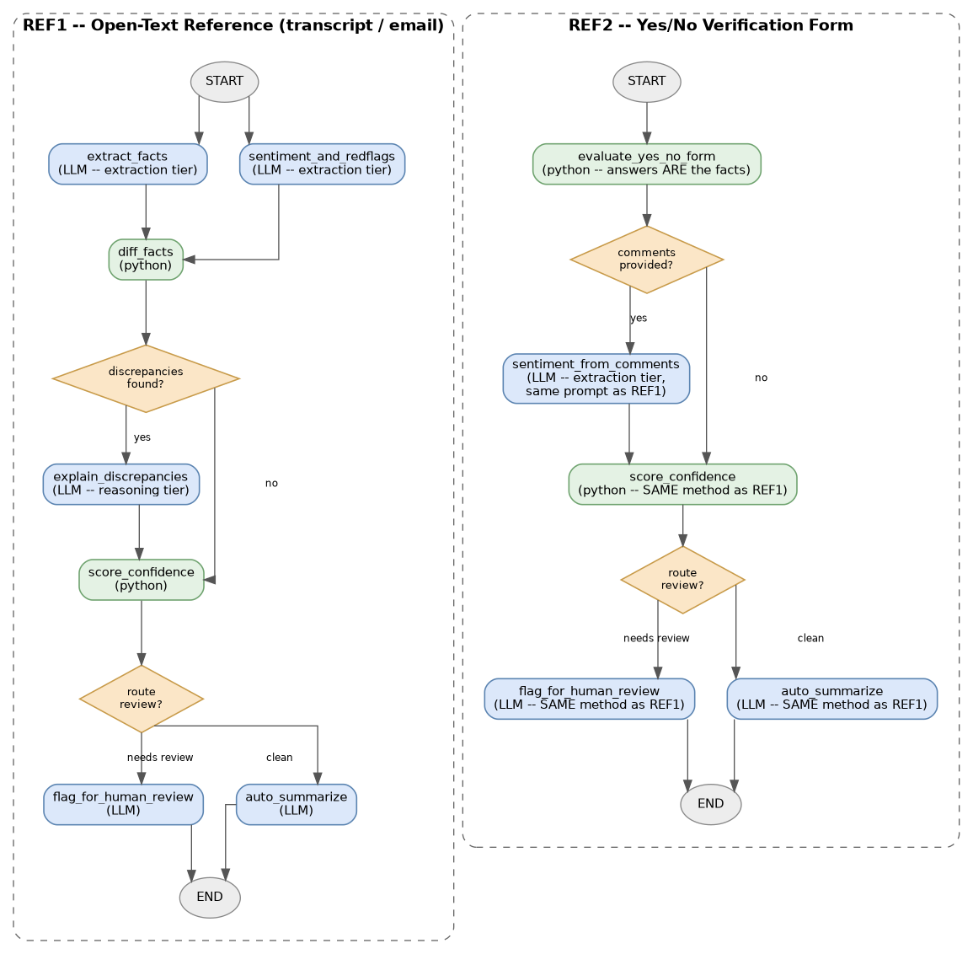
Figure 2. REF1 (open-text) and REF2 (yes/no form) single-reference graphs.

REF1 -- open text
- extract_facts (LLM, extraction tier) and sentiment_and_redflags (LLM, extraction tier) run in parallel.
- diff_facts (pure Python) compares extracted facts against the candidate's claims -- never an LLM freely judging similarity.
- explain_discrepancies (LLM, reasoning tier) only runs if diff_facts actually found something -- a conditional edge skips the call entirely on a clean match.

REF2 -- yes/no form
- No extraction step -- the form's answers ARE the facts. evaluate_yes_no_form (pure Python) builds discrepancies and red flags directly from the confirmed_title / confirmed_dates / confirmed_company / would_rehire / performance_concerns answers.
- sentiment_from_comments (LLM, extraction tier) only runs if the form has free-text comments, reusing the identical prompt REF1 uses for sentiment analysis.
Routing itself happens in exactly two places: graphs/candidate_graph.py:fan_out_references (builds the right payload per reference) and nodes/candidate_nodes.py:CandidateNodes.run_reference (invokes the matching compiled subgraph).

5. Candidate-Level Orchestration
A candidate can have any number of references, of either type or a mix. LangGraph's Send API fans out to one run_reference invocation per reference in parallel (capped by MAX_CONCURRENT_REFERENCES), then aggregates.
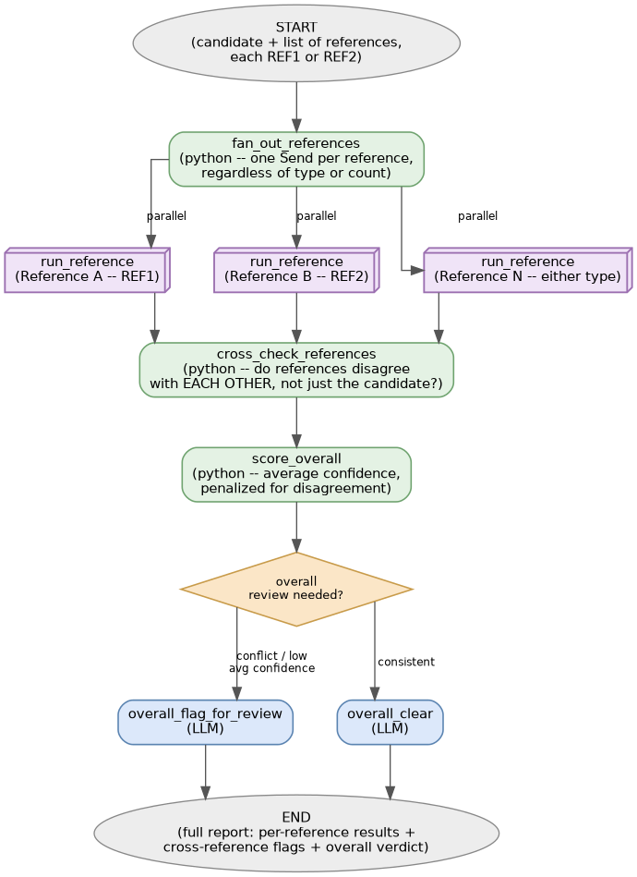
Figure 3. Fan-out across references, then cross-reference consistency check and overall scoring.
cross_check_references is the signal that per-reference scoring alone can't catch: it flags references disagreeing with EACH OTHER (e.g. conflicting performance ratings, mismatched company/title between two references), separately from any single reference's discrepancy against the candidate's own claims. score_overall averages per-reference confidence and applies an additional penalty for any such cross-reference disagreement.

6. Provider Abstraction and Model Tiering
llm/base.py:BaseLLMProvider implements retry/backoff (tenacity, exponential backoff on rate limits/timeouts/5xx), timeout handling, forced structured output via tool-calling, Pydantic schema validation of the result, and structured logging -- once. Each concrete provider (AnthropicProvider, BedrockProvider, OpenRouterProvider) implements exactly three methods: _execute (the API call), _extract_tool_input (pulling the result out of that provider's response shape), and _is_retryable_exception.
Model selection never hardcodes a model string. config.get_model(provider, tier) is the single resolution point, with an env var override (MODEL_<PROVIDER>_<TIER>) checked first:
Provider | Extraction tier (default) | Reasoning tier (default)
Anthropic (direct) | claude-haiku-4-5 | claude-sonnet-4-6
AWS Bedrock | anthropic.claude-haiku-4-5-v1:0 | anthropic.claude-sonnet-4-6-v1:0
OpenRouter | anthropic/claude-haiku-4.5 | anthropic/claude-sonnet-4.6

Switching the real-time provider is the LLM_PROVIDER environment variable; no code changes downstream of llm/providers.py:get_provider().

7. Batch Processing
pipelines/batch_runner.py runs the same business logic as the real-time graphs, restructured into 8 phases so every LLM call of the same kind -- across every candidate and reference in the run -- is submitted as one batch job instead of one call per reference. Deterministic phases (diff_facts, evaluate_yes_no_form, score_confidence, cross_check_references, score_overall, and all routing) call ReferenceCheckNodes(llm_provider=None) / CandidateNodes(llm_provider=None) directly -- the exact same methods the real-time graphs use, with no separate implementation.
Two selectable batch backends, chosen per run via a batch_provider argument (also config.get_model(batch_provider, tier) for tiering, same mechanism as real-time):
- Anthropic (llm/batch/anthropic_batch.py) -- inline request list, submit/poll/retrieve against the Message Batches API.
- Bedrock (llm/batch/bedrock_batch.py) -- structurally different: S3-based. Uploads a JSONL request file, calls CreateModelInvocationJob, polls the job resource, reads result JSONL back from S3. A Bedrock batch job runs against exactly one model, so this module transparently groups mixed-tier requests into one job per distinct model, hidden behind the same run_batch_sync() interface the Anthropic backend exposes.
Use case split: real-time graphs for anything a person is waiting on; batch for bulk/offline runs (e.g. an overnight queue) where the Batch API's own SLA (typically well under an hour, no hard guarantee) is acceptable, in exchange for roughly 50% lower cost.

8. HTTP API
refcheck/api/main.py exposes the real-time candidate graph over HTTP. Submission is asynchronous: the endpoint queues the work as a FastAPI BackgroundTask and returns a check_id immediately, since a check can involve several parallel LLM calls and take seconds to tens of seconds.
Method / Path | Purpose | Response
POST /api/v1/checks | Submit a candidate + references (REF1/REF2/mixed). Returns immediately; the actual run happens in the background. | 202 -> { check_id, status: "queued" }
GET /api/v1/checks/{check_id} | Poll for status and, once done, the full result. | { check_id, status, result, error }
GET /api/v1/schema | JSON schema for the request shapes -- lets a client discover REF1 vs REF2 field requirements dynamically. | ClaimedDetails / ReferenceInput / YesNoReferenceForm schemas
GET /health | Liveness check. | { status: "ok" }

Two ways to retrieve a result once submitted, usable independently or together:
- Pull -- poll GET /api/v1/checks/{check_id} until status is completed or failed.
- Push -- supply callback_url in the submit request; the full result is POSTed there as JSON when the check finishes (best-effort, logged on failure, not retried).
The job store (refcheck/api/store.py) is an in-memory dict behind a thread lock -- explicitly a demo-grade choice, documented as not durable across restarts and not shared across multiple worker processes. Its interface (create / get / mark_running / mark_completed / mark_failed) is small enough to back with Redis or a database without touching main.py or runner.py.

9. Client: Streamlit UI
streamlit_app.py builds a candidate + reference list interactively: a form for candidate/claimed details, then a per-reference form whose fields switch based on the REF1/REF2 radio selection (a text area for REF1, five yes/no dropdowns plus a comments box for REF2). On submit it POSTs to the API and polls (manual refresh button or an auto-refresh checkbox) until the result is ready, then renders per-reference discrepancies, red flags, and summaries, cross-reference flags, and the overall verdict.

10. Deployment
Dockerfile builds a single image capable of running any entry point (docker run <image> <script.py>); all three provider SDKs (anthropic, boto3, openai) are installed by default so switching LLM_PROVIDER never requires a rebuild. docker-compose.yml defines services for the API, the Streamlit UI (wired to the API automatically via API_BASE_URL), each CLI demo, both batch backends, and the test suite.
Every tunable setting -- provider selection, model IDs per tier, retry/timeout behavior, scoring thresholds and penalty weights, concurrency caps, input length limits, Bedrock batch S3/IAM configuration -- is an environment variable, documented in .env.example.

11. Testing
tests/ covers every pure-Python method/function directly -- diff_facts, evaluate_yes_no_form, score_confidence, cross_check_references, score_overall, all routing functions, config.get_model resolution, the provider factory, the batch custom_id convention, and the API's request validation/store wiring (with the actual LLM call monkeypatched out) -- all runnable via pytest tests/ -v with no API key or network access required.

12. Production-Readiness Notes

Implemented
- Retry/backoff, timeouts, and structured JSON logging with PII scrubbing on every LLM call, across all three providers and both batch backends.
- Input validation (length bounds) and non-blocking prompt-injection pattern detection before any text reaches an LLM call.
- Concurrency caps on reference fan-out; per-reference failure isolation (one bad reference is flagged for manual review rather than failing the whole candidate's run, in both real-time and batch).
- Optional prompt caching (off by default -- current prompts are below the practical cacheable minimum size).

Left as extension points
- Secrets management -- credentials currently come from environment variables; a production deployment should use a secrets manager.
- Job store durability and API authentication -- both called out explicitly above.
- True human-in-the-loop persistence -- a flagged case produces a summary today but does not pause the graph for a checkpointed reviewer decision; wiring a LangGraph checkpointer + interrupt() is the natural next step.
- Distributed tracing / per-candidate cost tracking beyond the existing structured logs.

