**Write SQL query to solve the problem given below:**

* There given a table named as product.
* The products are the computer components like keyboard, motherboard, monitor , speaker, etc..
* The product table contains attributes like product id, product name, price and product code.
* Example of such table is given below :

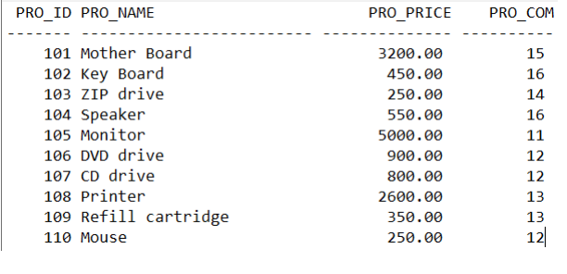

* Make sure to user right sql syntax to solve the query given below :
  + Write sql query to find the items whose prices are higher than or equal 250rs. Order the result by product price in descending, then product name in ascending. Return pro_name and pro_price.
  + Write a sql query to find the cheapest item. Return pro_name and pro_price.
  + Write the sql query to calculate the average price of the items for each company. Return average price and company code.
  + Write the sql query to find the average total for all the product mention in the table.

**Make sure to make your code clean neat.**

**ANSWER BELOW**

1. CREATE TABLE product
2. (

Product_ID INT PRIMARY KEY AUTO_INCREMENT,

Product_Name VARCHAR (20),

Product_Price DECIMAL (6,2) ***//(Here 6->Total digits both left & right to the decimal point & 2->Total digits right after decimal point. )***

Product_Code INT

);

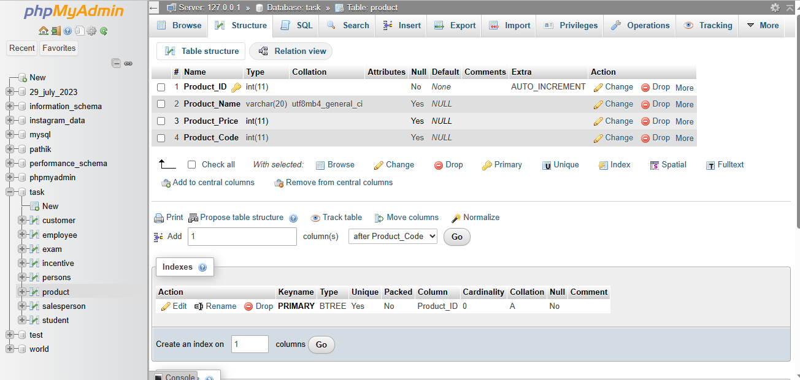

1. ALTER TABLE Persons AUTO_INCREMENT=101;
2. INSERT INTO product (Product_Name, Product_Price, Product_Code) VALUES ('Mother Board', '3200.00', '15'),('Key Board', '450.00', '16'), ('ZIP Drive', '250.00', '14'), ('Speaker', '550.00', '16'), ('Monitor', '5000.00', '11'), ('DVD Drive', '900.00', '12'), ('CD Drive', '800.00', '12'), ('Printer', '2600.00', '13'), ('Refill Cartridge', '350.00', '13'), ('Mouse', '250.00', '12');

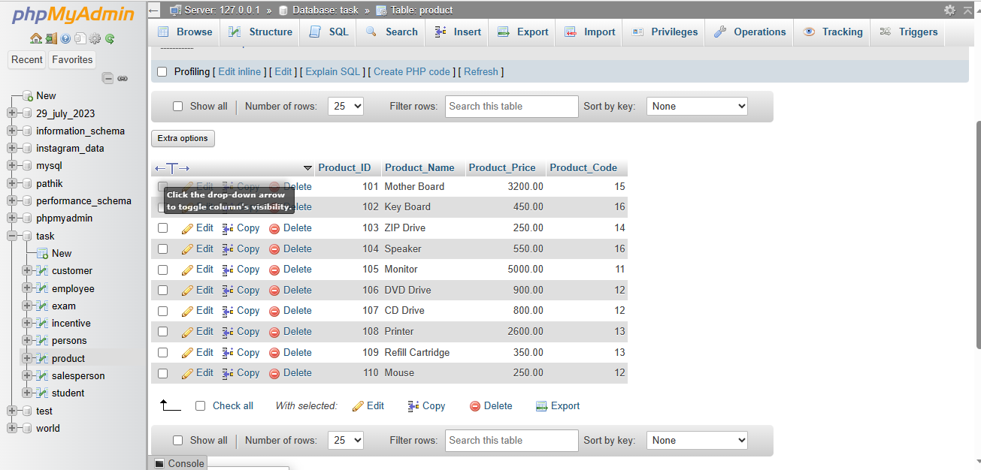

1. SELECT * FROM product WHERE Product_Price >=250;
2. SELECT Product_Name, Product_Price

FROM product

WHERE Product_Price >= 250.00

ORDER BY Product_Price DESC;

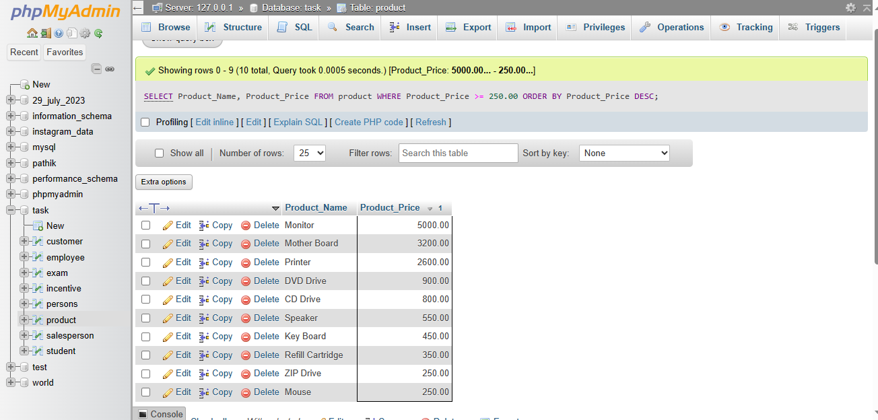

1. SELECT Product_Name, Product_Price

FROM product

ORDER BY Product_Price ASC

LIMIT 1;

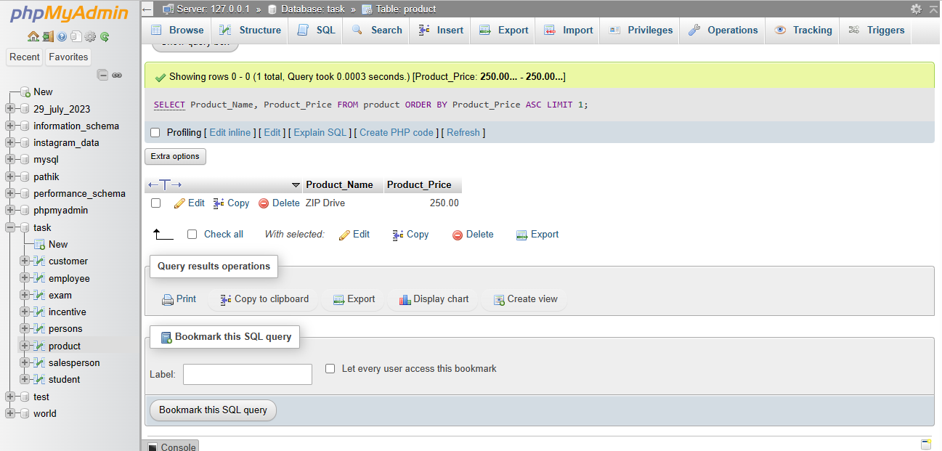

1. SELECT AVG(Product_Price) FROM product;

