**Report - Ankit Joshi(Manager)**

1. I helped in chart generation, Documentation, and work distribution.
2. Each team member has an equal contribution (meet expectation :0).
3. Below are the Query Plans and graphs for MySQL and PostgreSQL for both optimized and unoptimized Queries.
4. .SQL files are submitted separately.

For This project, every team member was involved in all the tasks (tuple generation and time calculation) so equal contribution

**Query performance results** (Query plans)–

1. List the name of the student with id equal to v1 (id).

* MySQL unoptimized

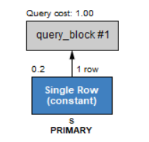

* 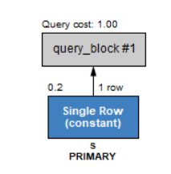MySQL optimized
* 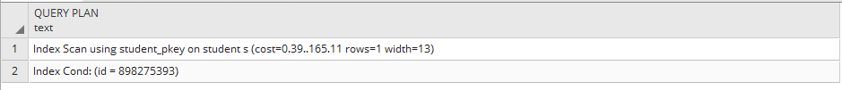PostgreSQL unoptimized
* PostgreSQL optimized

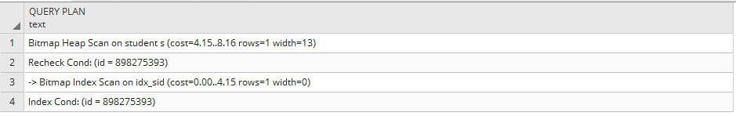

1. List the names of students with id in the range of v2 (id) to v3 (inclusive).

* MySQL unoptimized

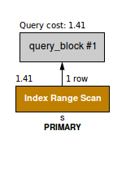

* 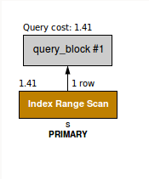MySQL optimized
* PostgreSQL unoptimized

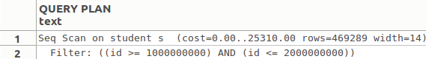

* PostgreSQL optimized

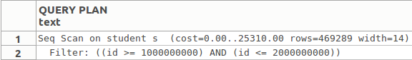

1. List the names of students who have taken course v4 (crsCode).

* MySQL unoptimized

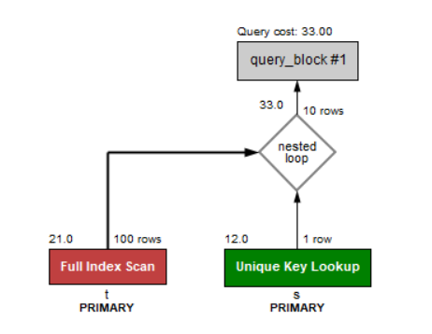

* MySQL optimized

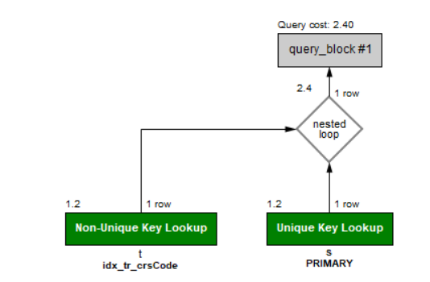

* PostgreSQL unoptimized

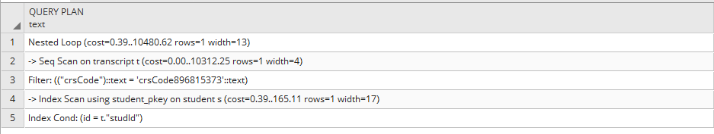

* PostgreSQL optimized

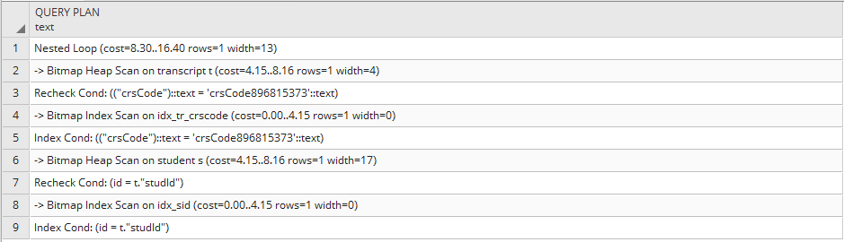

1. List the names of students who have taken a course taught by professor v5 (name).

* 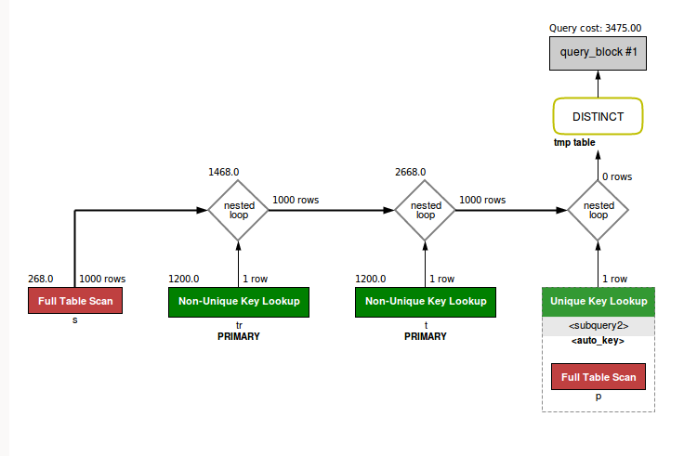MySQL unoptimized
* MySQL optimized

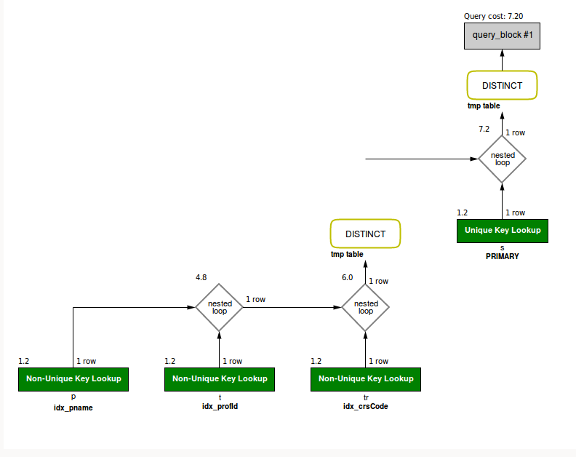

* PostgreSQL unoptimized

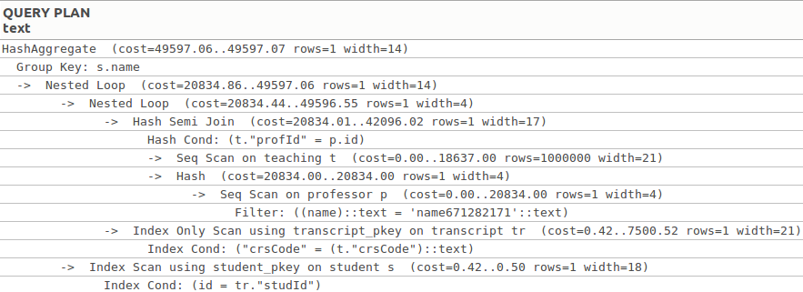

* 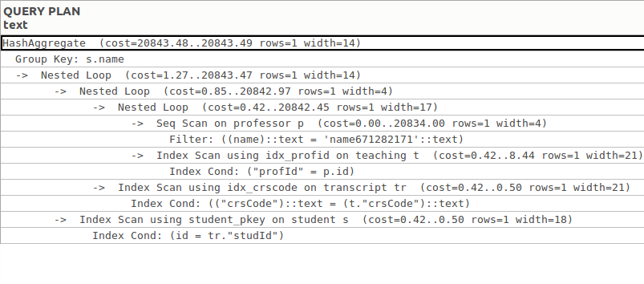PostgreSQL optimized

1. List the names of students who have taken a course from department v6 (deptId), but not v7.

* MySQL unoptimized

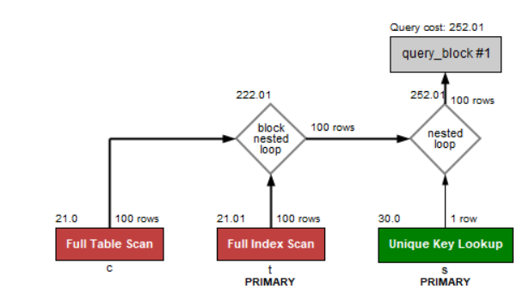

* 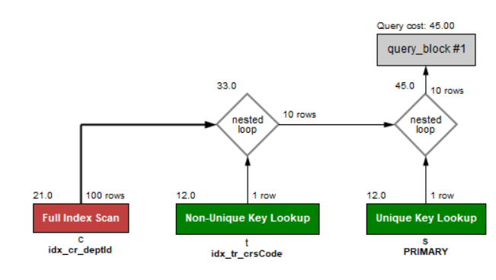MySQL optimized
* PostgreSQL unoptimized

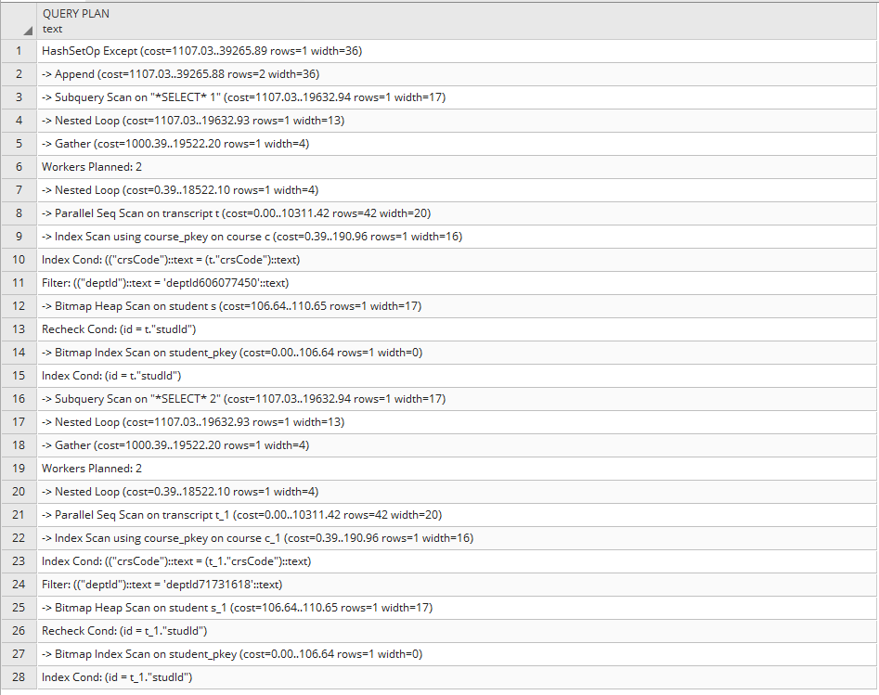

* 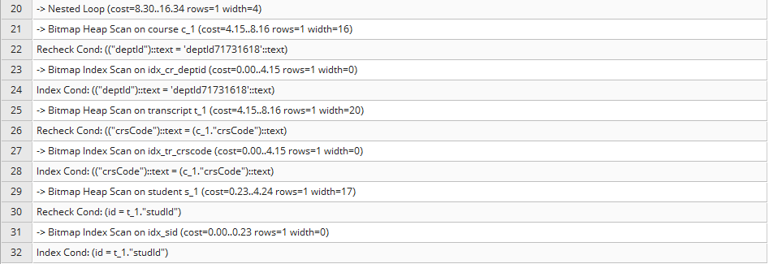PostgreSQL optimized

1. List the names of students who have taken all courses offered by department v8 (deptId).

* 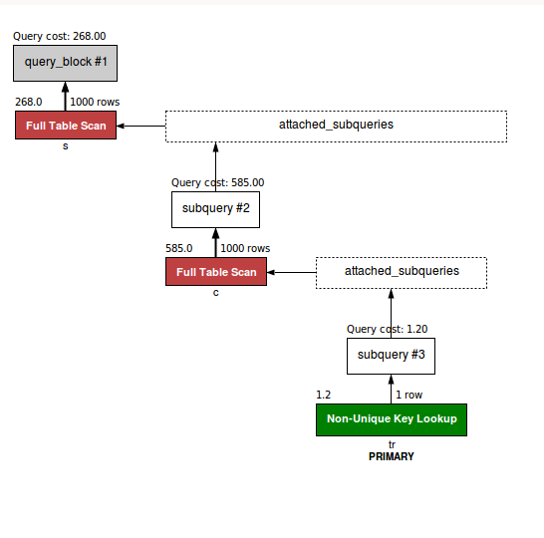MySQL unoptimized
* 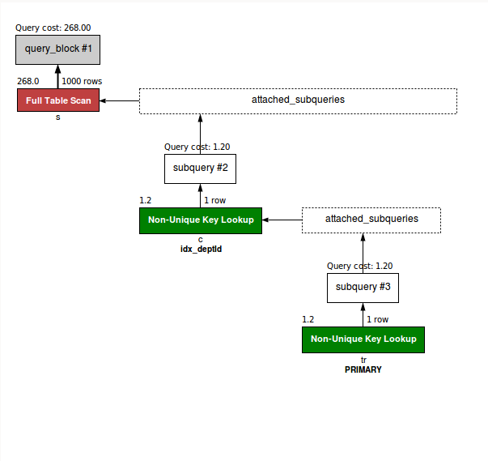MySQL optimized
* 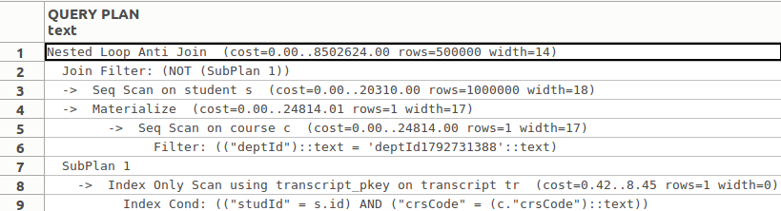PostgreSQL unoptimized
* PostgreSQL optimized

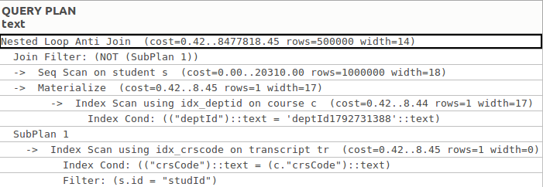

**Query performance results** (Graph)–

X-axis = Time in Milliseconds

Y-axis = Tuples count

1. List the name of the student with id equal to v1 (id).
2. List the names of students with id in the range of v2 (id) to v3 (inclusive).
3. List the names of students who have taken course v4 (crsCode).
4. List the names of students who have taken a course taught by professor v5 (name).
5. List the names of students who have taken a course from department v6 (deptId), but not v7.
6. List the names of students who have taken all courses offered by department v8 (deptId).