A Project Report On
“Crown Kitchen”

For the Partial Fulfilment of the Award of the Degree of
Bachelor of Computer Application of Veer Narmad South
Gujarat University, surat.

Bachelor of Computer Application [B.C.A]
Semester – VI

By
Sarvaiya chirag
Sarvaiya samir

Guided By
Dr. Priyanka Mehta

DEVIBA INSTITUTE OF COMPUTER APPLICATON, SABARGAM
Year : 2025-2026


AMBABA COMMERCE COLLEGE,MANIBA
INSTITUTE OF BUSINESS MANAGEMENT &
DEVIBA INSTITUTE OF COMPUTER

APPLICATION, SABARGAM (Self Finance)
At. Sabargam, Po.Niyol, Tal. Choryasi, Surat-394 325.

Managed By Shree Dakshin Gujarat Shikshan Samaj, Kumbharia

Certificate

This is to certify that Sarvaiya chirag,
Have / has satisfactorily presented their Project work Entitled “Crown Kitchen” as a partial fulfillment of requirements for 6th Semester – B.C.A., during the academic Year 2025-2026.

Guide Name: Dr. Priyanka Mehta

Dr. Falguni M Thakkar
Principal
Ambaba Commerce College, MIBM &
Deviba Institute of Computer Application,
Sabargam
Date :
Place : Sabargam, Surat

AMBABA COMMERCE COLLEGE,MANIBA
INSTITUTE OF BUSINESS MANAGEMENT &
DEVIBA INSTITUTE OF COMPUTER

APPLICATION, SABARGAM (Self Finance)
At. Sabargam, Po.Niyol, Tal. Choryasi, Surat-394 325.

Managed By Shree Dakshin Gujarat Shikshan Samaj, Kumbharia

Certificate

This is to certify that Sarvaiya samir,
Have / has satisfactorily presented their Project work Entitled “Crown Kitchen” as a partial fulfillment of requirements for 6th Semester – B.C.A., during the academic Year 2025-2026.

Guide Name: Dr. Priyanka Mehta

Dr. Falguni M Thakkar
Principal
Ambaba Commerce College, MIBM &
Deviba Institute of Computer Application,
Sabargam
Date :
Place : Sabargam, Surat

ACKNOWLEDGEMENT
Every Project is a masterpiece of hard work and sincere effort of those who are involved in the project. Hard work and success are the two side of the same coin. I am grateful to all of them, who were the part of my hard work and would definitely be an inevitable part of success.
It was an educational phase while studying at the AMBABA COMMERCE COLLEGE. Working highly devoted computer teacher's community and will probably remain the most memorable experience of my life.
Hence this acknowledgement is humble attempt to earnestly thank to all who are directly or indirectly involved in my project work and were of immense help to me with immense pleasure I present this report on the project work " Crown Kitchen ". I am extremely grateful to Principal DR. FALGUNI M. THAKKAR for giving me the opportunity to develop the project and my project guide DR. PRIYANKA MEHTA for the tremendous help that she gave me in my project.
Despite being a faculty, she took great pains to help when she herself was very much pressed for the time. She provides me technical information, which helped me a lot during my project. I would like to state that just as a positive attitude pays off, my hard efforts to bring this project to a successful end would also pay off.
I hope that this project would be one of the most significant stepping ends and would fulfill my aspiration in every aspect.

Thank You
Sarvaiya chirag
Sarvaiya Samir
index

Chapter  no | Description | Page no
1 | Introduction | 7-12
 | 1.1 Existing System | 7
 | 1.2 Limitation of Existing System | 8
 | 1.3 Proposed System Introduction | 9
 | 1.4 Project Profile | 9
 | 1.5 Scope of Proposed System | 10
 | 1.6 Objective of Proposed System | 10
 | 1.7 System Environment Description | 11
2 | Detail Description of Technology Used | 13-15
 | 2.1 what is anguler | 13
 | 2.2 why angulrt | 13
 | 2.3 Node js | 13
 | 2.4 Mongo db | 14
 | 2.5 React Router | 15
3 | System Design | 16-20
 | 3.1 Task Dependency Diagram | 16
 | 3.2 Data Flow Diagram(DFD) | 16
4 | User interface | 21-25
 | 4.1 User side | 21
 | 4.1.1 Home Page | 21
 | 4.1.2 About us Page | 21
 | 4.1.3 MEET OUR TEAM & OUR VALUES | 22
 | 4.1.4 Contect us | 22
 | 4.1.5 Register page | 23
 | 4.1.6 Login Page | 23
 | 4.1.7 Reservation Page | 24
 | 4.2 Admin side | 25-28
 | 4.2.1 Manage restaurant reservations | 25
 | 4.2.2 All Reservations | 26
 | 4.2.3 Popular Dishes (Menu) | 27
 | 4.2.4 Admin Dashbord | 28
 | 4.2.5 Revenue Dashbord | 28
5 | Conclusion | 29-30
6 | Bibliography | 31-32

CHAPTER 1: INTRODUCTION

The Restaurant Reservation Management System is a comprehensive web-based application designed to streamline and automate the reservation process for restaurants. In today's competitive hospitality industry, efficient reservation management is crucial for maximizing customer satisfaction, optimizing table utilization, and enhancing overall operational efficiency.

This system addresses the growing need for digital transformation in the restaurant industry by providing a modern, user-friendly platform that enables customers to make reservations online while giving restaurant administrators powerful tools to manage bookings, customer information, menu items, and staff details.

The application is built using the MERN (MongoDB, Express.js, React, Node.js) technology stack, ensuring scalability, maintainability, and optimal performance. The system incorporates modern web development practices, responsive design principles, and robust security measures to deliver a professional-grade solution suitable for restaurants of all sizes.

  - Existing System
At the moment, the restaurant mostly relies on manual processes, and different parts of the operation don’t really connect with each other. For example, servers usually take orders using pen and paper or a very basic system, which isn’t linked to the kitchen or inventory. This can lead to delays, mix-ups, and mistakes in orders.
Inventory is tracked manually too staff have to physically check stock and write things down, which takes time and can easily lead to errors. On top of that, there's no proper way to collect or analyze customer feedback, so it's hard to know what guests really think or how to improve their experience.
Billing is handled through a basic system that doesn’t offer many modern payment options like digital wallets. And when it comes to reports or analytics, there’s not much available—so managers don’t have the data they need to understand trends, improve the menu, or make smarter staffing decisions.
All in all, the current system isn’t very efficient or flexible. Without better integration and automation, it’s tough to provide a smooth experience for customers or run things more effectively behind the scenes.
  - Limitation of Existing System
The current way the restaurant operates comes with several challenges that affect how smoothly things run, how happy customers are, and how well the management can make informed decisions. Here are some of the key issues:
- Manual Order Taking
Staff still take orders by hand or use very simple systems. This often leads to mistakes, delays, and confusion between the waitstaff and kitchen, especially during busy hours.
- No Integration Between Systems
Different parts of the restaurant like ordering, billing, the kitchen, and inventory aren’t connected. Because of this, the workflow feels disjointed, and important information doesn’t flow smoothly between teams.
- Inventory Management is Time-Consuming
Keeping track of stock is still done manually. It takes a lot of time and is easy to get wrong, which can result in either running out of key ingredients or having too much of what’s not needed.
- Limited Customer Feedback and Engagement
There’s no proper way to gather or review customer feedback. This makes it hard to understand what guests really want or where service could be improved.
- Outdated Billing System
The payment process is limited to just a few options and doesn’t support modern methods like digital wallets or contactless payments, which many customers expect these days.
- Lack of Useful Reports and Insights
The current system doesn’t give real-time data or meaningful reports. As a result, managers struggle to make smart decisions about things like sales trends, staffing, or which menu items are performing well.
- Difficult to Scale the Business
Because so many tasks are manual and systems aren’t connected, it’s hard to grow the business or add new branches without facing big challenges.
- Everyday Tasks Take Too Long
Daily operations like assigning tables, tracking orders, and managing inventory take longer than they should, mainly due to the lack of automation.

1.3 Proposed System – Introduction
To overcome the limitations of the current manual system, we propose implementing an integrated digital restaurant management system. This new system is designed to bring all key operations—such as order taking, billing, inventory, and customer feedback—into one easy-to-use, connected platform.

With this proposed system, orders can be taken digitally (either by staff using tablets or directly by customers through self-service options), and sent instantly to the kitchen. Inventory will be updated in real-time as items are sold or used, reducing the chances of running out of stock or over-ordering.

Billing will be faster and more flexible, supporting multiple modern payment methods including mobile wallets and contactless payments. The system will also allow for better engagement with customers, making it easy to collect feedback, track preferences, and offer loyalty rewards.

On top of that, managers will be able to access detailed reports and real-time data to make informed decisions about staffing, menu performance, and overall business operations.

In short, the proposed system is all about making things more efficient, accurate, and customer-friendly—while giving the management the tools they need to grow and improve the business.
1.4 Project Profile
-Project Title:- “Crown Kitchen”
-Technologies Used :- Anguler, React Router, Axios, Node.js, Express.js, Mongoose

- Frontend:-Anguler, React Router, Axios
-Backend:- Node.js, Express.js, Mongoose,Mongodb
Frontend:
- Anguler – for building interactive user interfaces
- React Router – for managing client-side routing and navigation
- Axios – for handling API requests to the backend
Backend:
- Node.js – for running server-side code using JavaScript
- Express.js – for creating RESTful APIs and handling routing
- Mongoose – for interacting with MongoDB and managing data models
- Mongodb– store user data, profiles, posts, comments
  - Scope of Proposed System
- Functional Scope - Customer-facing and administrative features
- Technical Scope - System architecture and integration capabilities
- Operational Scope - Deployment and maintenance
- Limitations and Exclusions - Current limitations and future enhancements
1.6 Objectives of the Proposed System
The main goal of the proposed system for Crown Kitchen is to make the day-to-day operations smoother, faster, and more reliable—for both customers and staff. Here's what the system aims to achieve:
- Simplify the Order Process
Allow staff (or even customers) to place orders digitally, reducing mistakes and speeding up service.
- Improve Communication Between Staff & Kitchen
Ensure that orders are instantly and clearly sent to the kitchen, avoiding confusion or delays.
- Automate Inventory Management
Keep track of stock levels in real-time so the restaurant always knows what’s available and when to restock.
- Faster and More Flexible Billing
Make the checkout process quick and support multiple payment options like cards, UPI, or mobile wallets.
- Gather and Analyze Customer Feedback
Help the restaurant understand what customers like or dislike, so service and food quality can constantly improve.
- Provide Useful Reports and Insights
Give management access to real-time data on sales, staff performance, and popular menu items to support better decision-making.
- Enhance Customer Experience
From faster service to easier payments and personalized experiences, the system aims to leave customers more satisfied.
- Support Business Growth
Design the system to be scalable—so it can handle more customers, more features, or even additional branches in the future.
1.7 System Environment Description
The proposed system for Crown Kitchen is a full-stack web application that works in a client-server environment. It’s designed to be easy to use, fast, and accessible from various devices like computers, tablets, or smartphones with internet access.
On the frontend, the system is built using Anguler which provide a smooth and responsive user experience. Features like page navigation are handled by React Router, and Axios is used to communicate with the backend securely and efficiently.
The backend is powered by Node.js and Express.js, which handle server-side logic, API routes, and requests. Mongoose is used to interact with MongoDB, which serves as the database for storing information like customer orders, inventory details, menu items, and user data.
The environment supports real-time updates and allows for secure login, role-based access (e.g., admin, staff, and customer), and smooth communication between all system components.
The system is also built to be scalable and easy to maintain, meaning it can grow with the business—whether that’s adding new features, users, or even expanding to more locations.
In short, this environment ensures that the restaurant has a reliable, modern platform that connects the front-of-house, kitchen, and back-office all in one place.

CHAPTER 2 : Detail Description of Technology Used
2.1 what is anguler?
Angular helps developers create fast, dynamic, and interactive websites using HTML, CSS, and TypeScript.


2.2 why angulr ?
Angular is used for projects because it provides a structured framework, fast performance, reusable components, built-in features, and is suitable for large-scale professional applications.

2.3 Node js

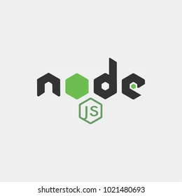

Node.js is a free, open source tool that lets you run JavaScript outside the web browser. With Node.js, you can build fast and scalable applications like web servers, APIs, tools, and more.
Node.js in your restaurant reservation system handles:
- API endpoints for all CRUD operations
- Database connectivity with MongoDB
- User authentication and authorization
- Email notifications for bookings
- File uploads for menu images
- Real-time availability checking
- Analytics and reporting
- Security middleware
- Error handling
- Data validation
Node.js essentially powers the entire backend of your restaurant reservation system, making it fast, scalable, and maintainable

2.4 mongo db
MongoDB works as a NoSQL, document-oriented database that stores data in a flexible, JSON-like format called BSON (Binary JSON). Instead of rows and columns (like SQL), it uses collections and documents:
- Database: A container for collections (similar to schema in SQL).
- Collection: A group of documents (similar to a table).
- Document: A record stored in JSON-like key-value pairs



MongoDB is ideal for your restaurant reservation system because:
- Flexible Data Models: Handles varying menu items, customer preferences, and table configurations
- Real-Time Performance: Fast queries for availability checking and booking confirmations
- Rich Relationships: Natural handling of customer-reservation-table relationships
- Scalability: Grows with your restaurant business
- JSON-Native: Perfect match with React frontend and Node.js backend
- Aggregation Power: Complex analytics and reporting capabilities
- Developer Productivity: Faster development with Mongoose ODM
- Future-Proof: Easy to add new features without schema migrations
MongoDB essentially provides the perfect data foundation for a modern, feature-rich restaurant reservation system

2.5 React Router
React Router is a library that provides routing capabilities for React applications. Routing means handling navigation between different views. React Router is the standard routing library for React applications.
React Router in your Restaurant Reservation System provides:
- Complete Navigation System: Handles all customer and admin routing needs
- Seamless User Experience: No page reloads, smooth transitions between sections
- Authentication Integration: Smart routing based on login status
- Error Handling: Proper 404 handling for invalid routes
- Mobile Optimization: Works perfectly on all devices
- Scalable Architecture: Easy to add new pages and features
- SEO Benefits: Clean URLs and proper page structure
React Router essentially transforms your restaurant website from a traditional multi-page site into a modern, fast, and user-friendly single-page application that provides an excellent experience for both customers making reservations and staff managing the restaurant

CHAPTER 3 :- SYSTEM DESIGN
3.1 Task Dependency Diagram
System analysis and design illustrates the architecture of the system. There are many user for this system. The user is use system by create their account in website. After creating they able to register and reservation system.
3.2 Data Flow Diagram(DFD)
A Data Flow Diagram (DFD) is a graphical representation of how data flows through a system. It helps in analyzing, designing, and documenting a system by illustrating data inputs, processes, storage, and outputs. DFDs are widely used in software development and system analysis to provide a clear understanding of system functionality.
- Characteristics of DFD
1.Graphical Representation – Uses symbols to represent processes, data flows, data stores, and external entities.
2. Hierarchical Structure – Composed of multiple levels to show increasing levels of detail.
3. Focus on Data Movement – Shows how data moves through the system rather than how the system operates.
4. Simplifies Complex Systems – Breaks down a complex system into manageable parts.
5. Does Not Include Control Flow – It focuses on data flow, not on how the system controls or processes data sequentially

- Levels of DFD

DFDs are divided into different levels based on the amount of detail presented.
  - Level 0 (Context Diagram) :-
The highest level of DFD, representing the entire system as a single process.
Shows external entities interacting with the system and the overall data flow.

- Advantages of DFD

  - 1. Easy to Understand – Uses simple symbols, making it accessible even for nontechnical stakeholders.
  - 2. Improves Communication – Helps developers, analysts, and clients understand system functionality.
  - 3. Identifies System Weaknesses – Highlights inefficiencies or unnecessary data flows.
  - 4. Provides a Clear System Overview – Offers a structured breakdown of the system.
  - 5. Aids in System Design – Useful in both the planning and documentation phases of development.

- Disadvantages of DFD

- 1. Lack of Control Flow Representation – Does not show decision-making logic or processing sequence.
- 2. Complexity in Large Systems – As systems grow, DFDs can become too detailed and difficult to manage.
- 3. Requires Proper Understanding – Analysts must fully understand the system to create an accurate DFD.
- 4. No Implementation Details – Does not specify programming languages, databases, or system infrastructure.
Symbols used in DFD

Data Flow

Data Store

Process

External Entity

- User side DFD
This DFD shows the overall data flow of the restaurant management system, where Customer, Admin, and Manager interact with different modules.
The main system processes are Auth & User Management, Menu Management, Order Management, Booking Management, Payment Processing, Contact Management, and Revenue & Reporting.
Each process reads/writes data to its related data stores, such as D1 Users, D2 Menu Items, D3 Orders, D4 Bookings, D5 Payments, D6 Contacts, and D7 Revenue Ledger.
The Payment Gateway Layer acts as an external system that supports payment processing, and this data further flows into the reporting module.
This diagram clearly explains how all modules are interconnected, from booking and ordering to payment and revenue reporting, enabling smooth end-to-end management

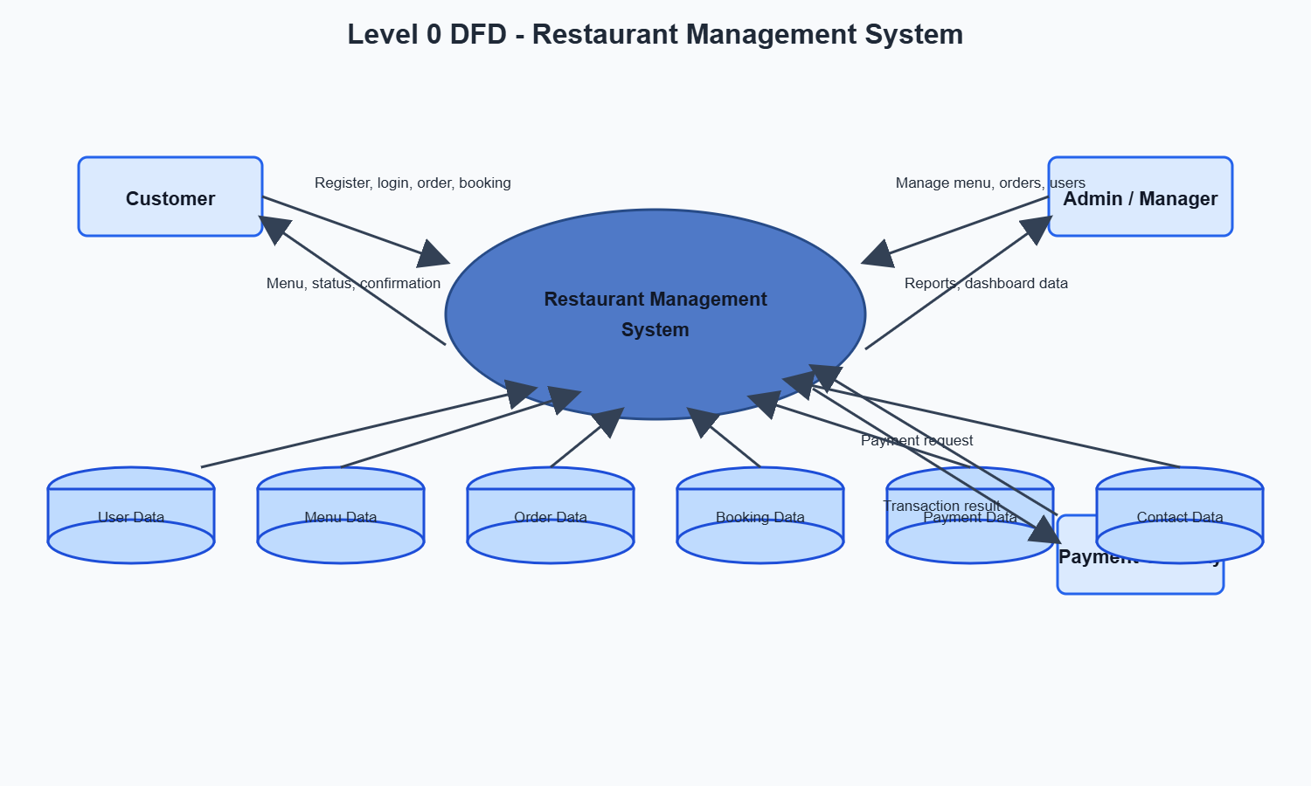

- Admin side DFD
This DFD represents key operations of a restaurant system, including order creation, payment processing, booking creation, and revenue summary generation.
The Customer selects items, makes payments, and submits bookings, while the Admin/Manager requests revenue dashboard data.
Processes such as 3.1 Create Order, 5.1 Create Payment, 4.1 Create Booking, and 7.1 Generate Revenue Summary interact with data stores like Menu, Orders, Revenue, Payments, and Bookings.
The system validates item availability, saves and confirms orders, stores payment status, and records booking/payment amounts.
The Payment Gateway Layer supports secure transaction handling, and all financial data finally contributes to revenue tracking and reporting.

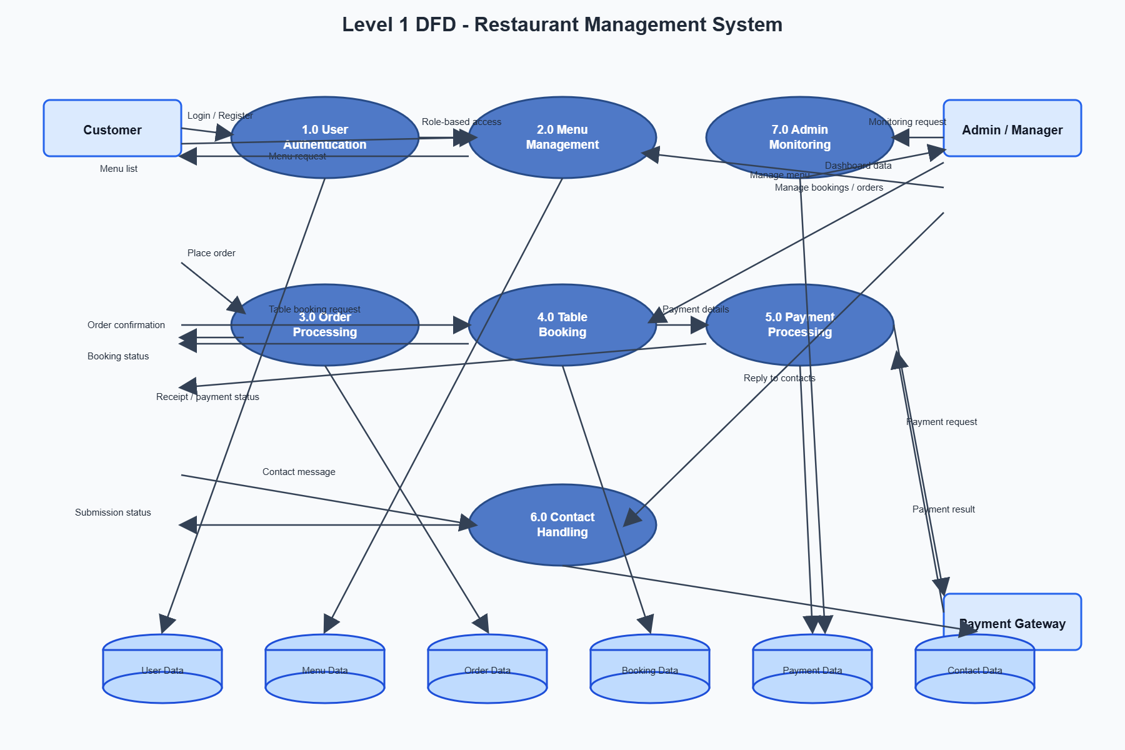

Task dependency diagram
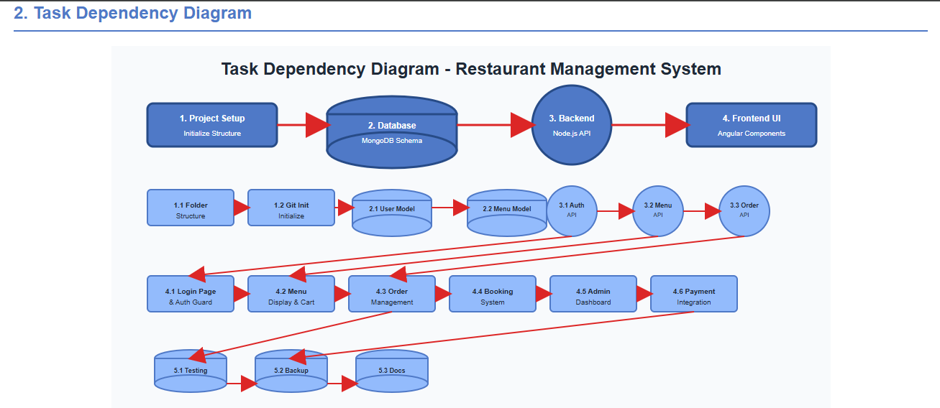

ER Diagram
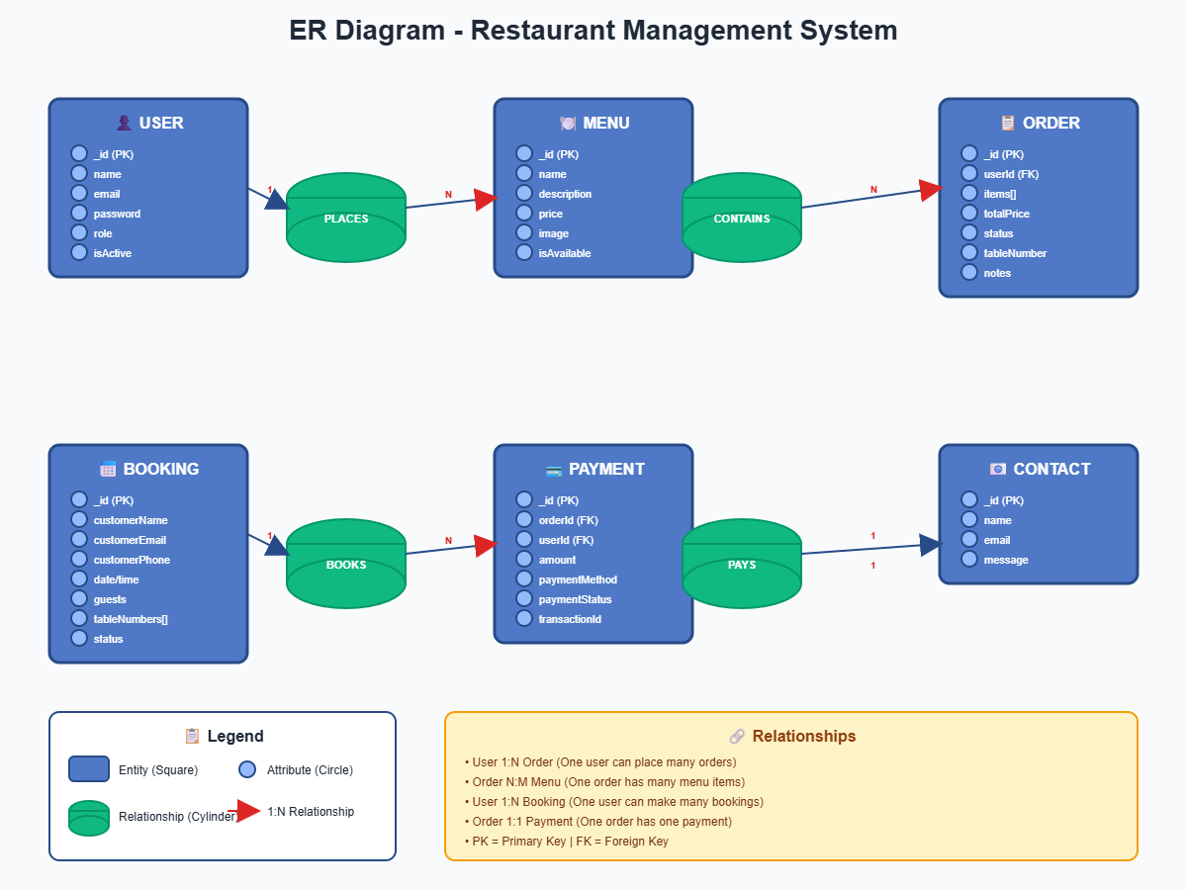

CHAPTER 4: User interface

4.1 User side
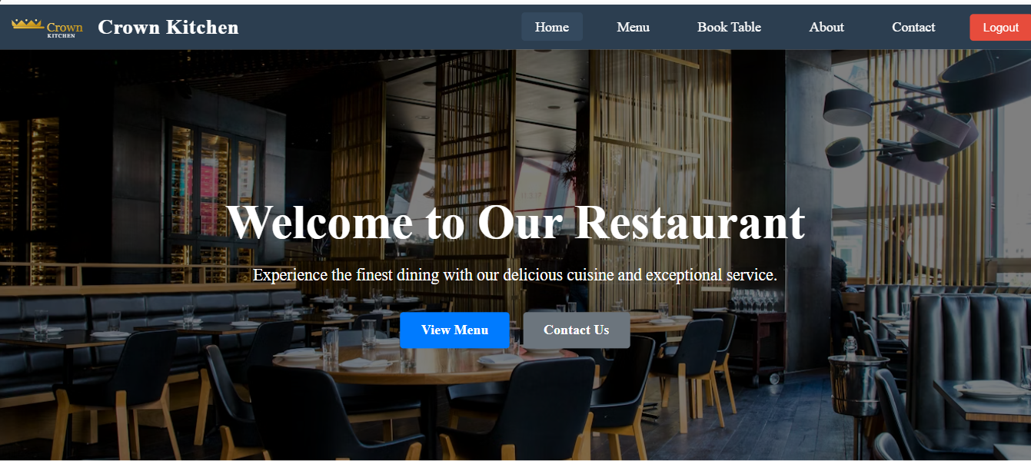
4.1.1 Home Page

4.1.2 About us Page

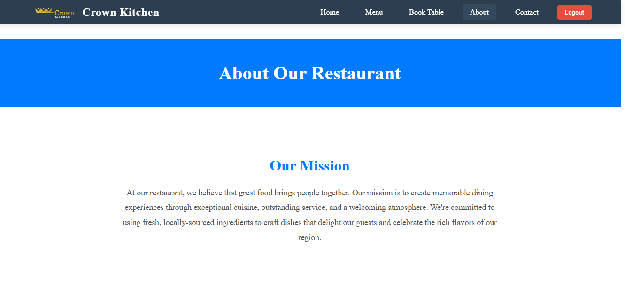

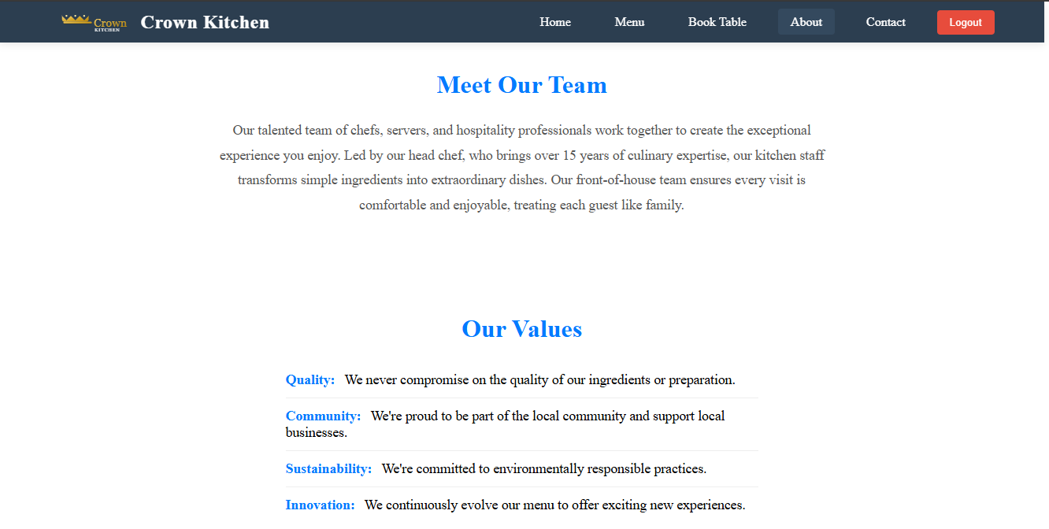
4.1.3 MEET OUR TEAM & OUR VALUES

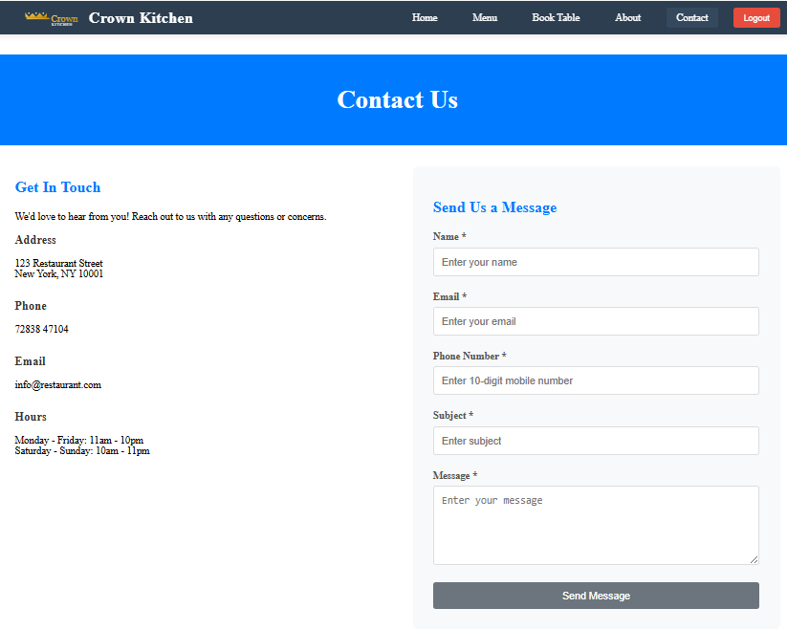
4.1.4 Contect us

4.1.5 Register page
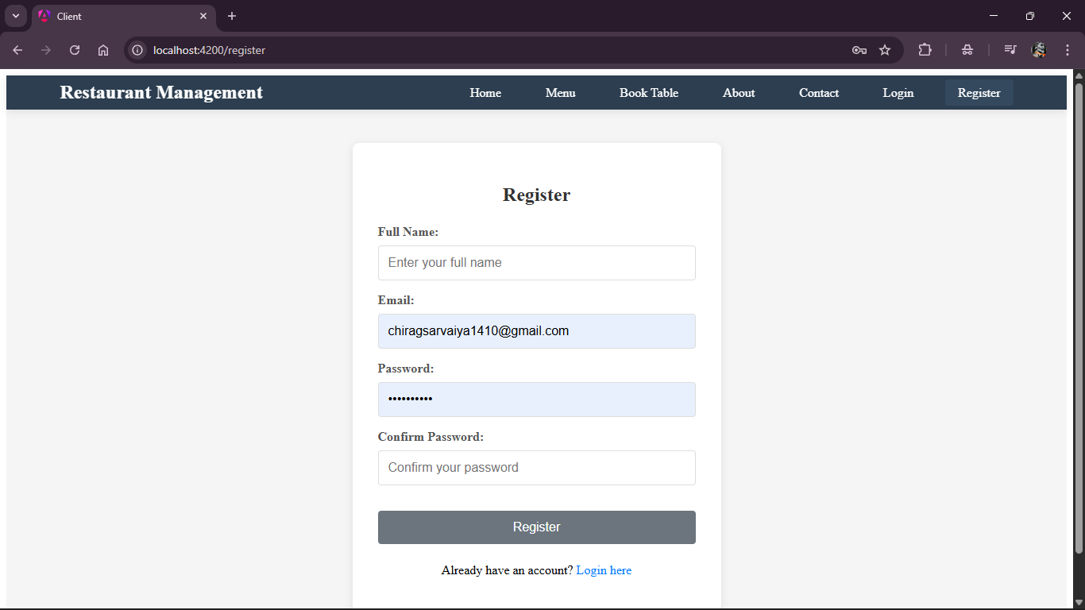

4.1.6 Login Page
If you have Registered, you will be able to log in. if you have not registered, you will not be able to log in.
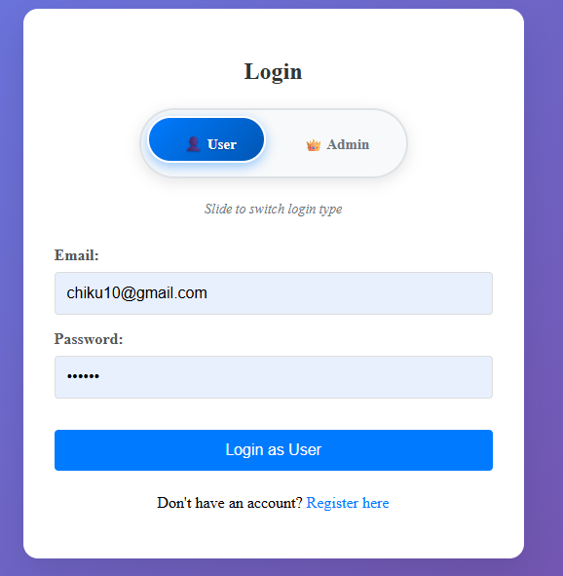

4.1.7 reservation page
If you have login, you will be able to reservation. if you have not login, you will not be able to reservation.
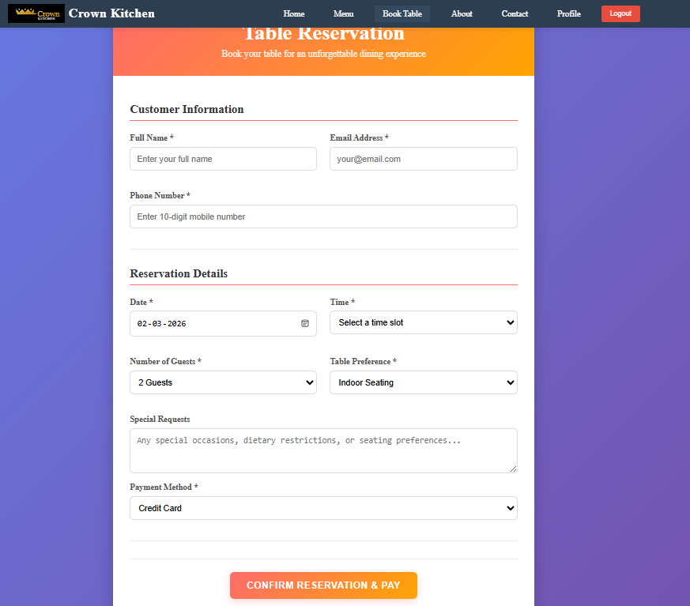

4.2 Admin side
4.2.1 Manage restaurant user
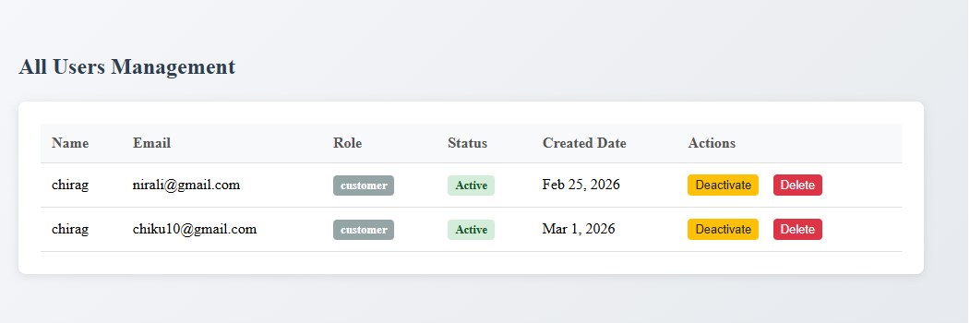

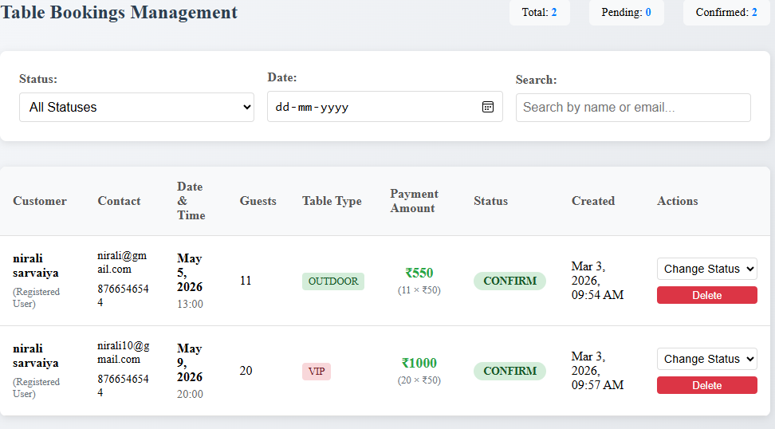
4.2.2 All Reservations

4.2.3Popular Dishes (Menu)
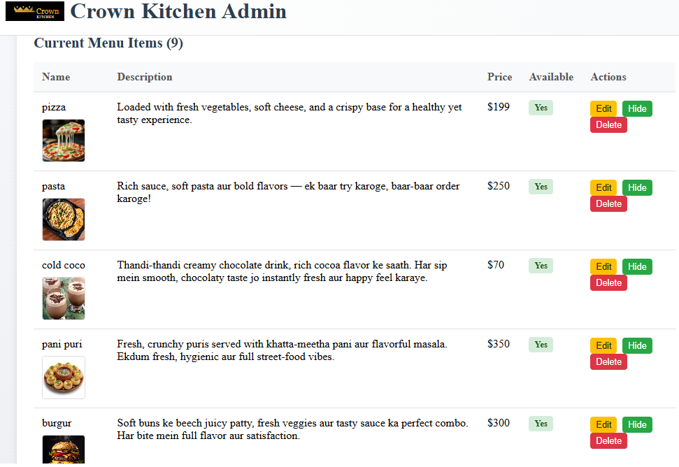

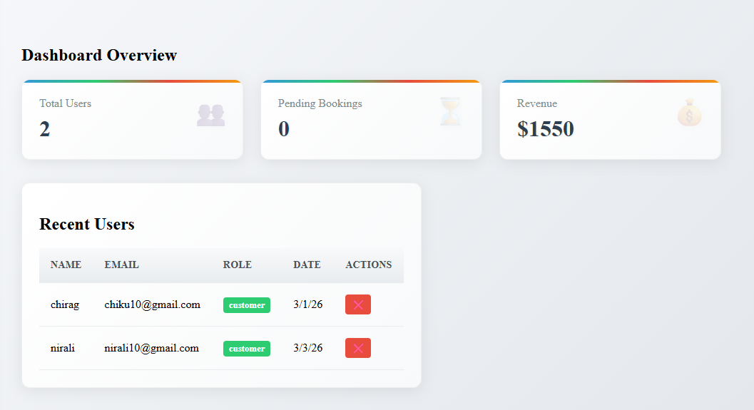
4.2.4 Admin Dashbord
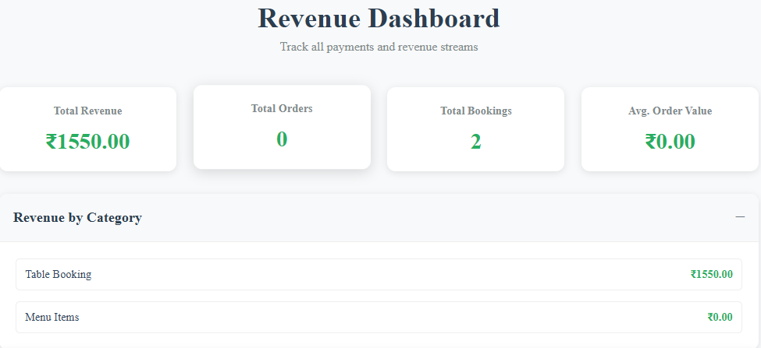
4.2.5 Revenue Dashbord

CHAPTER 5: Conclusion
This Anguler-based Restaurant Reservation System successfully delivers a full-stack solution for browsing menus, making and managing reservations, and administering staff and menu items. The backend provides secure authentication, robust data models, and RESTful APIs, while the frontend offers a responsive, user-friendly interface for both guests and admins. Together, they streamline the reservation workflow end-to-end, demonstrating solid separation of concerns, reusable components, and pragmatic data handling. The result is a deployable, maintainable application that can be extended to meet real-world operational needs.
- Optional “Future Enhancements” (if you want to add a final section)
- Online payments: Integrate Stripe to secure deposits and reduce no-shows.
- Calendar sync: Two-way sync with Google/Outlook for staff visibility.
- Capacity and table logic: Smarter seating algorithms and overbooking rules.
- Notifications: SMS/email reminders and confirmation updates.
- Analytics: Dashboards for peak hours, menu performance, and conversion.
- Role-based permissions: Granular access for managers vs. staff.
- Accessibility and i18n: WCAG compliance, multilingual support.
- Performance and caching: CDN, image optimization, API caching, and SSR/ISR.

This Anguler-based Restaurant Reservation System stands as a robust, full-stack application that addresses the essential needs of modern dining establishments. By combining a secure backend with an intuitive and responsive frontend, the system not only simplifies the reservation process for guests but also empowers staff and administrators to manage operations efficiently. Its modular architecture ensures maintainability and scalability, while the clear separation of concerns and reusable components lay the groundwork for long-term growth.

Designed with real-world deployment in mind, the application offers a strong foundation upon which advanced features—such as online payments, calendar integration, analytics, and role-based access control—can be seamlessly integrated. Whether used by a small local eatery or a growing restaurant chain, this system provides the flexibility and reliability required to meet evolving operational demands.

Ultimately, this project showcases both technical proficiency and thoughtful UX design, delivering a complete solution that enhances customer satisfaction and streamlines business workflows.

CHAPTER 6: Bibliography

Books

-Martin Kleppmann. Designing Data-Intensive Applications. O’Reilly, 2017.
-Mario Casciaro, Luciano Mammarella. Node.js Design Patterns (3rd Ed.). Packt, 2020.
-Kristina Chodorow. MongoDB: The Definitive Guide (3rd Ed.). O’Reilly, 2019.
-Leonard Richardson, Mike Amundsen, Sam Ruby. RESTful Web APIs. O’Reilly, 2013.

Web Resources
Anguler Documentation: https://angular.dev/
React Router Documentation: https://reactrouter.com/
Axios Documentation: https://axios-http.com/
Node.js Documentation: https://nodejs.org/docs/latest/api/
Express.js Documentation: https://expressjs.com/
MongoDB Manual: https://www.mongodb.com/docs/manual/
Mongoose Docs: https://mongoosejs.com/docs/

Research Papers & Articles

- Roy T. Fielding. Architectural Styles and the Design of Network-based Software Architectures (Doctoral dissertation, 2000). [REST origin and constraints]
- Eric Brewer. Towards robust distributed systems (PODC Keynote, 2000). [CAP theorem fundamentals]
- The Twelve-Factor App. Heroku (2011). [Modern app deployment and config practices]

Software & Tools

Node.js — Runtime: https://nodejs.org/en
MongoDB and Atlas:
https://www.mongodb.com/try/download/community
React Router — Routing: https://reactrouter.com/
Mongoose — ODM: https://mongoosejs.com/docs/
Git & GitHub — Version control: https://git-scm.com/

Thank you

