 Project report on

“**MACHINE LEARNING BASED ANTENNA DESIGN SELECTION**”

Submitted in recognition to the fulfi lment of the requirements for the FINAL YEAR PROJECT

**Submitted by:**

CHIRAG DAVE B-05

BHAVESH MODANI B-13

AAYUSH VISHWAKARMA B-25

OMKAR MARKANDEY B-61

**Under the guidance of**

Dr. (Mrs.) Aleefia A. Khurshid

**Department of Electronics Engineering**

**Shri Ramdeobaba College of Engineering and Management,Nagpur**

(An autonomous College affiliated to Rashtrasant Tukadoji Maharaj Nagpur University)

**Session 2024-202**

# **Table of Contents**

|  |  |  |
| --- | --- | --- |
| **Sr No** | **Content** | **Page No.** |
| 1 | **Abstract** | ii |
| 2 | **Introduction** | iii |
| 3 | **Literature Review** | iv |
| 4 | **Working Principle** | vii |
| 5 | **Software Implementations** | ix |
| 6 | **Results** | xiii |
| 7 | **Conclusion** | xiv |
| 9 | **Reference** | xv |

# **Abstract**

This project explores the application of machine learning to optimize the design process of microstrip patch antennas, focusing on achieving target resonance frequencies and return loss (S11) values. Microstrip patch antennas are integral in modern communication systems due to their compact design and compatibility with wireless applications. However, designing antennas that meet specific performance requirements is traditionally complex, requiring expertise, extensive simulation, and physical prototyping. This project proposes a data-driven approach, employing various machine learning algorithms—such as Random Forest, XGBoost, Support Vector Machines (SVM), and Multi-Layer Perceptron (MLP) Neural Networks—to predict antenna design parameters like patch length, width, slot length, and slot width.

The project collects an initial dataset, preprocesses it for training, and evaluates multiple machine learning models. Each model is assessed using performance metrics like Mean Absolute Error (MAE), Mean Squared Error (MSE), and R-squared (R²) scores to determine its accuracy in predicting design parameters based on input frequency and S11. For validation, the machine learning model predictions are tested in HFSS, a leading electromagnetic simulation software. In one instance, the machine-learning-predicted parameters for a 5 GHz input frequency and -20 dB S11 result in an HFSS simulation resonance at 5.8 GHz with an S11 of -21 dB, demonstrating the potential and limitations of the approach. This report discusses the model’s effectiveness, challenges faced, and possible future improvements, offering a foundation for integrating machine learning in antenna design.

# **2. Introduction**

In modern communication systems, antennas play a critical role in ensuring effective signal transmission and reception. Designing optimal antennas, however, is often a complex and resource-heavy process that traditionally requires expert knowledge, simulation software, and considerable trial-and-error adjustments. This process is especially challenging when attempting to meet specific performance goals such as desired resonant frequency and minimum S11 (return loss) levels. Machine learning offers an innovative solution to this challenge by providing data-driven predictive capabilities that can rapidly suggest design parameters based on desired outcomes.

This project focuses on applying machine learning to predict key design parameters, reducing the need for physical prototyping and exhaustive simulation cycles. By analyzing existing antenna design data, we develop models capable of accurately predicting parameters like patch length, patch width, slot length, and slot width to achieve target frequency and S11 values. This project has the potential to significantly shorten antenna design cycles and lower development costs, offering engineers a powerful tool to enhance the efficiency of design processes in wireless communication.

The key objective of this project is to apply machine learning algorithms, including Random Forest, XGBoost, Support Vector Machines, and neural networks, to predict four critical design parameters—patch length, width, slot length, and slot width—based on target frequency and S11 values. HFSS software is then used to validate the model predictions, observing whether the suggested designs meet the required resonant frequency and S11 standards

**3. Literature Survey, Motivation, Problem statement**

* 1. **Literature Survey**

|  |  |  |  |  |  |
| --- | --- | --- | --- | --- | --- |
| **S.N** | **Type of Robot** | **Nature of Work** | **Key points** | **Author** | **Journal** |
| 1. | Eye Bolt Shape Slotted Microstrip Patch Antenna | Design and Prediction | XGBoost for return loss prediction, 5.5 dB gain, 87% efficiency" | J. M. Joshiba and D. Judson | *Sadhana (2024)* |
| 2. | Various Antenna Types | Review | Deterministic, stochastic, and surrogate models for optimization | N. S. Kumar and U. D. Yalavarthi | *ICACSE Journal of Physics: Conference Series (2021)* |
| 3. | Yagi-Uda Antenna for N77 5G Band | Prediction | Random Forest Regression, 3.3–4.2 GHz bandwidth, 7.95 dB gain | M. A. Haque, M. A. Rahman, S. S. Al-Bawri | *Physica Scripta(2024)* |
| 4. | Quasi-Yagi-Uda Antennas for 5G n78 Band | Design and Optimization | Gaussian Process Regression for gain prediction and optimization | J. L. Pérez et al | *IEEE Access(2023)* |
| 5. | Antennas for Biomedical and Sub-6GHz Applications | Optimization | Bayesian Linear Regression for resonant frequency and gain prediction | P. Smith, J. Kim, and A. B. Rogers | *IEEE Transactions on Antennas and Propagation*  *(2023)* |
| 6. | Microstrip Antenna | Dimension Prediction | Auto-Metric Graph Neural Network with Sheep Flock Optimization | Prabhakar, D., Karunakar, P., Rao, S. V. R., & Srinivas, K. | *Intelligent Systems with Applications*  *(2021)* |
| 7. | Smart Antenna | ML for interference rejection, spectrum efficiency, and signal processing | Deterministic, stochastic, and surrogate models for optimization | M. Sadiq, N. B. Sulaiman, M. M. Isa, and M. N. Hamidon | *Heliyon (2022)* |
| 8. | Antenna Design and Radar Signal Processing | Review | Deep learning for design optimization and radar target classification | Y. Kim | *IEICE ISAP Archives*  *(2018)* |
| 9. | Compact Microstrip Antenna | Modeling | Gaussian Process Regression for resonant frequency prediction | Sharma, K., & Pandey, G. P. | *International Journal of Electronics and Communications(2021)* |

**3.2 Motivation**

Given the traditional complexities of antenna design, where small adjustments to parameters can significantly impact performance, machine learning offers an efficient and scalable solution. By reducing the need for multiple simulations and physical testing, machine learning can save time and resources while ensuring reliable design predictions. This project is driven by the potential of data-driven techniques to automate antenna design, enhancing accessibility and efficiency in wireless engineering.

**3.3 Problem Statement**

The primary challenge addressed in this project is predicting microstrip patch antenna design parameters that will yield desired performance outcomes. Specifically, how can machine learning models predict parameters like patch and slot dimensions based on a specified frequency and S11 target? The project aims to create a reliable model that bridges the gap between theoretical design objectives and practical implementation, validated through HFSS simulations.

# **4.Working Principle**

This project’s working principle relies on a structured approach that combines machine learning with electromagnetic simulation for antenna design optimization. We divide the project into four core phases: data collection, preprocessing, model training, and simulation validation.

1. **Data Collection**: The first step involved creating a dataset of microstrip patch antenna designs, including parameters such as patch length, width, slot length, slot width, frequency, and S11. The dataset was filtered to focus on designs with S11 values below -10 dB to ensure quality data points, as lower S11 values generally indicate better antenna performance.
2. **Data Preprocessing**: Preprocessing the dataset was critical for model accuracy. This stage addressed issues such as missing values, normalization, and outlier detection, ensuring consistent data input across models. We standardized features, which improved model performance by scaling the input values and eliminating potential biases.
3. **Model Training**: Using algorithms like Random Forest, XGBoost, Support Vector Machines, and MLP Neural Networks, the project aimed to predict four design parameters based on target frequency and S11 values. Each model was tuned for performance, evaluated using MAE, MSE, and R² scores. A MultiOutputRegressor was employed to handle the multi-dimensional output (design parameters), leveraging each algorithm’s strengths for accurate predictions.
4. **HFSS Validation**: Model-predicted parameters were validated in HFSS, observing resonant frequency and S11 plots to ensure predicted designs met target specifications. This validation step highlighted both the model’s accuracy and the need for potential parameter adjustments, showcasing how machine learning and simulation can be integrated into the design workflow.

The architecture reflects a closed-loop system where machine learning provides initial predictions that are verified through physical simulation, offering a potential blueprint for scalable, automated antenna design.

# **Software description/ Flow Chart**

**5.1 Software description**

The project required several software tools to handle data processing, machine learning model training, and electromagnetic simulation validation:

**Python and Libraries**: Python was chosen for data handling and model training due to its flexibility and robust library ecosystem. Key libraries included Pandas (for data manipulation), Scikit-learn (for machine learning), XGBoost (for gradient-boosted models), and Keras for neural networks.

**Machine Learning Algorithms**: Random Forest and XGBoost were selected for their efficiency in handling non-linear data, while Support Vector Machines and MLP Neural Networks offered versatility for complex relationships. Each algorithm was implemented using Python’s Scikit-learn and Keras libraries, leveraging their built-in tools for multi-output regression.

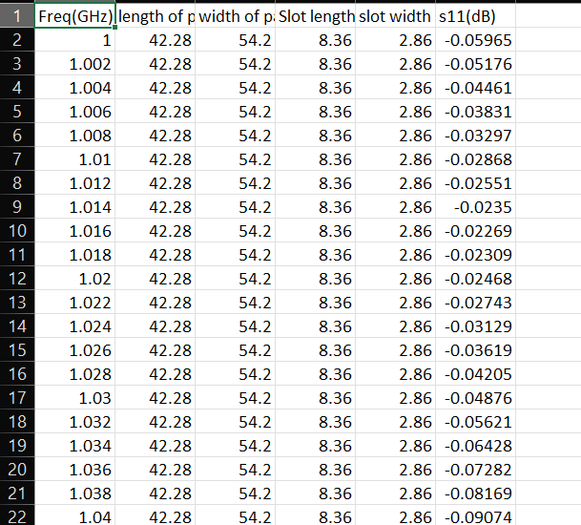

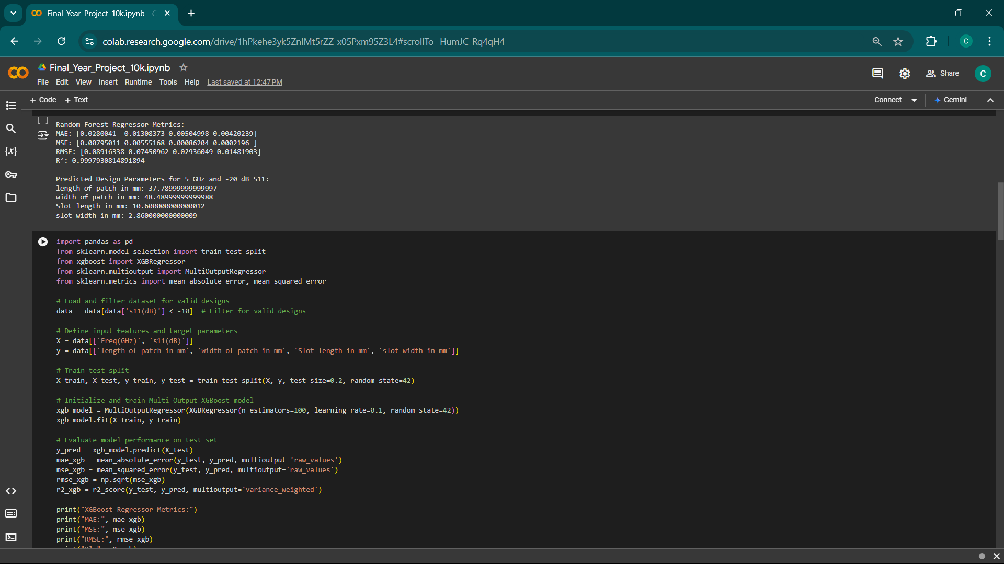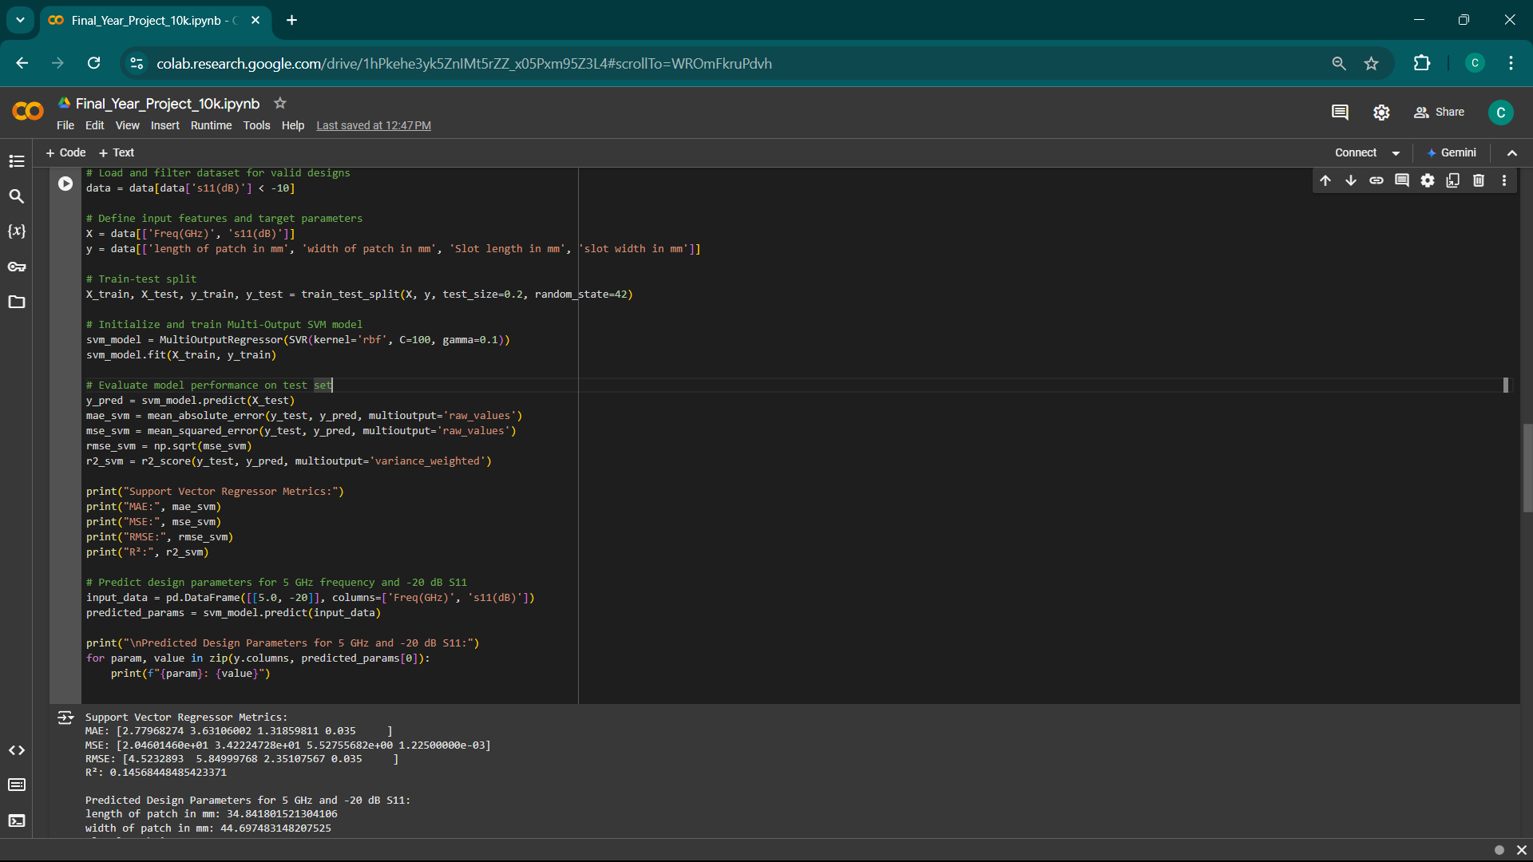

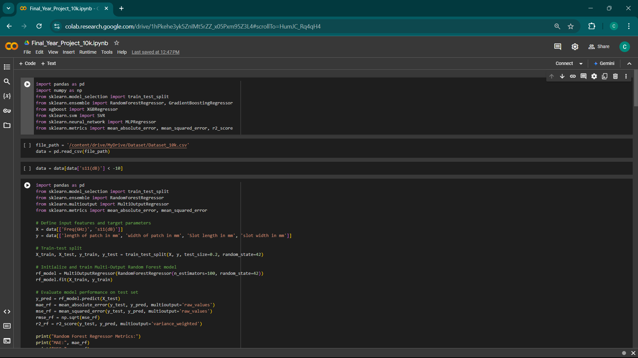

* **HFSS Software**: HFSS, a leading tool in electromagnetic simulation, was used to validate the model predictions by assessing the resulting resonant frequency and S11 output. The HFSS software helped test whether predicted parameters translated effectively to real-world antenna performance

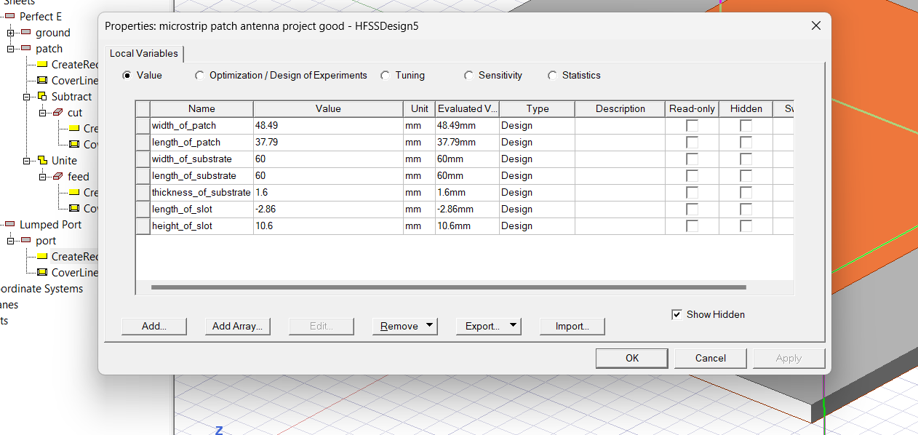

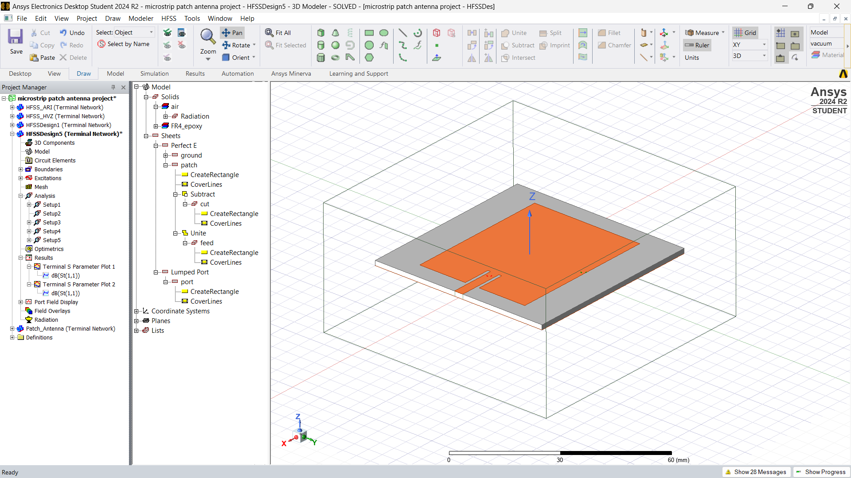

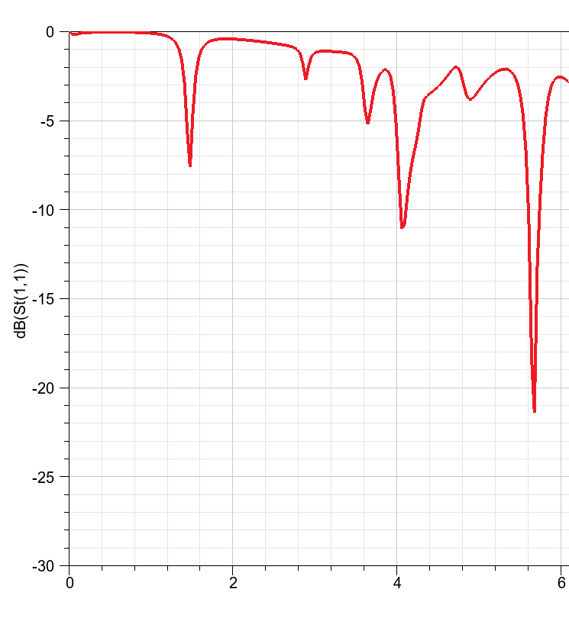

**5.2 Flowchart**

Data Collection & Preprocessing

Feature Selection & Model Training

Predict Parameters Based on Target

Validate Predictions in HFSS

Iterate & Refine Model

**6.Results**

**6.1 Software Testing and Output**

To ensure model reliability, we tested each machine learning model on an independent test set, using performance metrics to assess predictive accuracy. The key metrics used were Mean Absolute Error (MAE), Mean Squared Error (MSE), and R-squared (R²). These metrics helped evaluate each model’s precision in predicting the four design parameters:

* **Random Forest Regressor**: Demonstrated the highest R² score and lowest RMSE, making it the most effective model for accurate design prediction.
* **XGBoost and Support Vector Machines**: While effective, these models showed slightly lower R² values and higher error margins compared to Random Forest.For validation, we tested the design parameters in HFSS by setting an input frequency of 5 GHz with an S11 of -20 dB. The HFSS simulation showed a resonant frequency at 5.8 GHz with an S11 of -21 dB, indicating reasonable alignment but also highlighting areas for potential improvement.
  1. **Challenges Faced**

1. **Limited Dataset**: Initially, the dataset lacked sufficient samples for training an effective model. This limitation was addressed by augmenting data through simulations.
2. **Feature Sensitivity**: Small adjustments in design parameters led to significant performance changes, requiring careful tuning and model validation.
3. **Model Generalization**: Ensuring the model’s ability to generalize across various frequencies and S11 levels proved challenging, especially with high-dimensional data.
4. **Validation in HFSS**: While the machine learning model predicted parameters accurately, achieving ideal resonance in HFSS required tuning.

**8. Conclusion & Future Scope**

In conclusion, this project successfully applied machine learning to predict antenna design parameters based on target frequency and S11 levels. Random Forest emerged as the best-performing algorithm, with high predictive accuracy for patch length, width

**Future Scope**:

* **Larger Dataset**: Expanding the dataset with varied materials, substrates, and dielectric constants can improve model generalizability.
* **Advanced Model Tuning**: Experimenting with additional hyperparameters and using ensemble models could enhance model accuracy.
* **Integration with HFSS**: Automating the validation process by integrating model predictions directly with HFSS would further streamline the design workflow.

**Reference**

**[1]** J. M. Joshiba and D. Judson, "An Eye Bolt Shape Slotted Microstrip Patch Antenna Design and Return Loss Prediction Using Machine Learning," *Sadhana*, vol. 49, no. 77, pp. 1-5, 2024. <https://doi.org/10.1007/s12046-024-02433-y>

**[2]** N. S. Kumar and U. D. Yalavarthi, "A Comprehensive Review on Machine Learning-Based Optimization Algorithms for Antenna Design," *ICACSE Journal of Physics: Conference Series*, vol. 1964, no. 062098, pp. 1-6, 2021. <https://doi.org/10.1088/1742-6596/1964/6/062098>

**[3]** M. A. Haque, M. A. Rahman, S. S. Al-Bawri, et al., "Machine Learning-Based Approach for Bandwidth and Frequency Prediction for N77 Band 5G Antenna," *Physica Scripta*, vol. 99, no. 026005, pp. 1-11, 2024. <https://doi.org/10.1088/1402-4896/ad1d40>

**[4]** J. L. Pérez et al., "Design and Optimization of Quasi-Yagi-Uda Antennas for 5G n78 Band Using Machine Learning," *IEEE Access*, vol. 11, pp. 3289-3301, 2023. <https://doi.org/10.1038/s41598-023-39730-1>

**[5]** P. Smith, J. Kim, and A. B. Rogers, "Machine Learning-Assisted Optimization of Antennas for Biomedical and Sub-6GHz Applications," *IEEE Transactions on Antennas and Propagation*, vol. 71, no. 4, pp. 2000-2012, Apr. 2023.

**[6]** Prabhakar, D., Karunakar, P., Rao, S. V. R., & Srinivas, K. “Prediction of microstrip antenna dimension using optimized auto-metric Graph Neural Network”. *Intelligent Systems with Applications*, 21, 200326, 2021. <https://doi.org/10.1016/j.iswa.2024.200326>

**[7]** M. Sadiq, N. B. Sulaiman, M. M. Isa, and M. N. Hamidon, "A review on machine learning in smart antenna: Methods and techniques," Heliyon, vol. 8, no. 9, pp. 1–15, Sep. 2022. <https://doi.org/10.18421/TEM112-24>

**[8]** Y. Kim, "Application of machine learning to antenna design and radar signal processing: A review", *IEICE ISAP Archives(Conference)*, 2018.

**[9]** Sharma, K., & Pandey, G. P. “Efficient modelling of compact microstrip antenna using machine learning”. *International Journal of Electronics and Communications (AEÜ)*, 135, 153739, 2021. <https://doi.org/10.1016/j.aeue.2021.153739>