## A picture containing text, clipart, sign Description automatically generatedMahavir Education Trust's

## Shah & Anchor Kutchhi Engineering College,

**Chembur, Mumbai 400 088**

## UG Program in Information Technology

|  |  |  |  |  |  |
| --- | --- | --- | --- | --- | --- |
| **Experiment No: 3** | | | | | |
| **Date of Performance:** |  | | | | |
| **Date of Submission:** |  | | | | |
| **Program formation/ Execution/**  **ethical practices (07)** | **Documentation (02)** | **Timely Submission (03)** | **Viva Answer (03)** | **Experiment Marks (15)** | **Teacher Signature with date** |
|  |  |  |  |  |  |

**Experiment 3**

**Aim:** To Perform various GIT operations on local and Remote repositories using GIT Cheat-  
 Sheet.

**Lab Outcome:** To obtain complete knowledge of the “version control system” to effectively track changes augmented with Git and GitHub

**Git Cheat Sheet**

**1. Git configuration:**

**Git config**  
Get and set configuration variables that control all facets of how Git looks and operates.  
**Set the name:**  
$ git config --global user.name "User name"  
**Set the email:**  
$ git config --global user.email "himanshudubey481@gmail.com"  
**Set the default editor:**  
$ git config --global core.editor Vim  
**Check the setting:**  
$ git config -list

**Git alias**  
**Set up an alias** for each command:  
$ git config --global alias.co checkout  
$ git config --global alias.br branch  
$ git config --global alias.ci commit  
$ git config --global alias.st status

**2. Starting a project:**

**Git init**  
**Create a local repository:**  
$ git init

**Git clone**  
**Make a local copy** of the server repository.  
$ git clone

**3. Local changes:**

**Git add**  
**Add a file** to staging (Index) area:  
$ git add Filename  
**Add all files** of a repo to staging (Index) area:  
$ git add*

**Git commit**  
**Record** or snapshots the file permanently in the version history **with a message**.  
$ git commit -m " Commit Message"

**4. Track changes:**

**Git diff**  
Track the changes that have not been staged:   
$ git diff  
Track the changes that have staged but not committed:  
$ git diff --staged  
Track the changes after committing a file:  
$ git diff HEAD  
Track the changes between two commits:  
$ git diff Git Diff Branches:  
$ git diff < branch 2>

**Git status**  
Display the state of the working directory and the staging area.  
$ git status

**Git show Shows objects:**  
$ git show

**5. Commit History:**

**Git log**  
Display the most recent commits and the status of the head:  
$ git log  
Display the output as one commit per line:  
$ git log -oneline  
Displays the files that have been modified:  
$ git log -stat  
Display the modified files with location:  
$ git log -p

**Git blame**  
Display the modification on each line of a file:  
$ git blame <file name>

**6. Ignoring files:**

**.gitignore**  
Specify intentionally untracked files that Git should ignore. Create .gitignore:  
$ touch .gitignore   
List the ignored files:  
$ git ls-files -i --exclude-standard

**7. Branching:**

**Git branch Create branch**  
$ git branch List Branch:  
$ git branch –list  
Delete a Branch:  
$ git branch -d   
Delete a remote Branch:  
$ git push origin -delete   
Rename Branch:  
$ git branch -m

**Git checkout**  
Switch between branches in a repository.  
Switch to a particular branch:  
$ git checkout  
Create a new branch and switch to it:  
$ git checkout -b   
Checkout a Remote branch:  
$ git checkout

**Git stash**  
Switch branches without committing the current branch.   
Stash current work:  
$ git stash  
Saving stashes with a message:  
$ git stash save ""  
Check the stored stashes:  
$ git stash list  
Re-apply the changes that you just stashed:  
$ git stash apply  
Track the stashes and their changes:  
$ git stash show  
Re-apply the previous commits:  
$ git stash pop  
Delete a most recent stash from the queue:  
$ git stash drop  
Delete all the available stashes at once:  
$ git stash clear  
Stash work on a separate branch:  
$ git stash branch

**Git cherry pic**  
Apply the changes introduced by some existing commit:  
$ git cherry-pick

**8. Merging**

**Git merge**  
Merge the branches:  
$ git merge  
Merge the specified commit to currently active branch:  
$ git merge

**Git rebase**  
Apply a sequence of commits from distinct branches into a final commit.  
$ git rebase  
Continue the rebasing process:  
$ git rebase -continue   
Abort the rebasing process:  
$ git rebase --skip

**Git interactive rebase**  
Allow various operations like edit, rewrite, reorder, and more on existing commits:  
$ git rebase -i

**9. Remote:**

**Git remote**  
Check the configuration of the remote server:  
$ git remote -v  
Add a remote for the repository:  
$ git remote add   
Fetch the data from the remote server:  
$ git fetch  
Remove a remote connection from the repository:  
$ git remote rm  
Rename remote server:  
$ git remote rename  
Show additional information about a particular remote:  
$ git remote show  
Change remote:  
$ git remote set-url

**Git origin master**  
Push data to the remote server:  
$ git push origin master   
Pull data from remote server:  
$ git pull origin master

**10. Pushing Updates:**

**Git push**  
Transfer the commits from your local repository to a remote server.   
Push data to the remote server:  
$ git push origin master   
Force push data:  
$ git push -f  
Delete a remote branch by push command:  
$ git push origin -delete edited

**11. Pulling updates:**

**Git pull**  
Pull the data from the server:  
$ git pull origin master  
Pull a remote branch:  
$ git pull

**Git fetch**  
Download branches and tags from one or more repositories.   
Fetch the remote repository:  
$ git fetch< repository Url>   
Fetch a specific branch:  
$ git fetch  
Fetch all the branches simultaneously:  
$ git fetch -all  
Synchronize the local repository:  
$ git fetch origin

**12. Undo changes:**

**Git revert**  
Undo the changes:  
$ git revert  
Revert a particular commit:  
$ git revert

**Git reset**  
Reset the changes:  
$ git reset -hard  
$ git reset -soft:  
$ git reset –mixed

**13. Removing files:**

**Git rm**  
Remove the files from the working tree and from the index:  
$ git rm <file Name>  
Remove files from the Git But keep the files in your local repository:  
$ git rm –cached

**Output:**

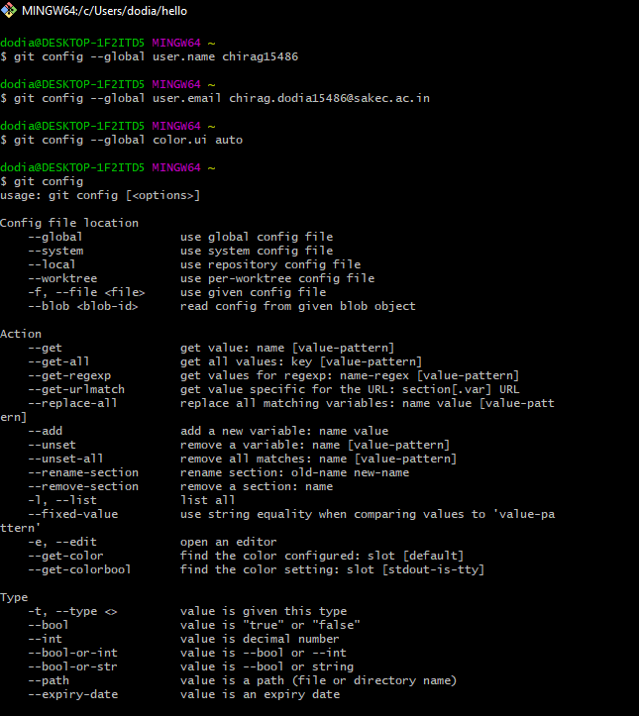

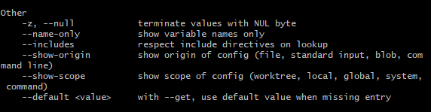

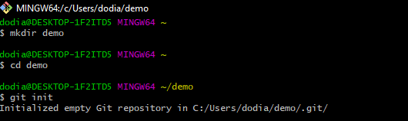

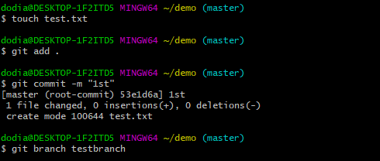

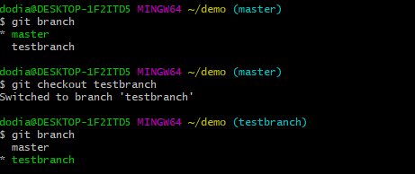

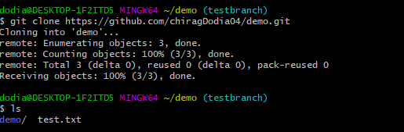

**Conclusion:** Hence, we learnt and implemented various Git commands like creating directory, uploading data to directory, fetching data from directory, etc.