**CS 345 DATABASES LAB**

**POST MIDSEM PROJECT**



**USER MANUAL**

**Group I**

**Mathematics and Computing**

**Aishwarya Gupta(10012301)**

**Chirag Maheshwari(10012315)**

**Parikshit Upadhyaya(10012324)**

**Abhinandan(10012339)**

**ABOUT**

The Project is titled “***wikiblog***”. It is a ***blog and article writing/viewing*** web-application for users.

Its features include:

* Every writer will have a separate user account identified by a *unique username*.
* A user has to authenticate him/her-self using a password set by the user himself.
* Every user will have its own profile (personal details + profile image).
* One user can follow another to get his updates.
* A user can view the blogs and articles without having a user account.
* Every user has the option to write a personal blog or an article for the general community.
* A blog post has only *one* version and it belongs to a particular user.
* An article is anonymous and can be edited or re-written by any user.
* Every version of the article will be stored differentiated from one-another using a version number and its timestamp.
* One can search for other users, articles or even blogs.
* For the search engine to work,
* Blog/article has a set of tags.
* Blog/article contains keywords.
* An article will contain references.
* User has a set of interests, a username.
* A user can rate an article out of 5.

**Salient Features**

1. “wikiblog” allows the users to write articles as well as post blogs. The articles correspond to the “wiki” part in “wikiblog” and “blog” is for posts.
2. Users have to register/login themselves before writing and article or posting a blog-post and even rate an article or like/dislike a bog-post. But, one can view articles, user-profiles, and blog-posts without registering and can search for them using the search bar.
3. Articles are open for editing and rating to all the registered users and all the versions of the article are stored and displayed.
4. Blogs are open for likes/dislikes and comments/replies to the comments by all the registered users.
5. Some features of social networking is also there, for e.g., users can follow other users which allows him/her to look for articles and posts of only the people he/she is interested in.
6. You can look up for an article/post/user based on the keywords and tags for article/post and username and interests for a user.
7. One can see all the users who have liked/disliked a blog-post.
8. On the front page, some of the newly added articles and blogposts are shown.

**INSTRUCTIONS FOR USERS:**

In the pages that follow, a step by step procedure for using the “wikiblog” is illustrated with several screenshots and instructions.

**How to register a new user?**

**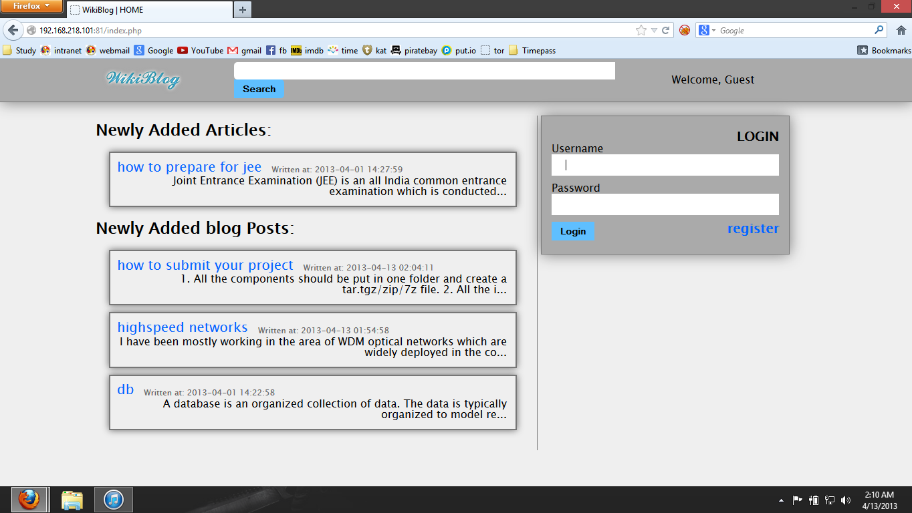**

Shown above is the screenshot of the “wikiblog” homepage. To register a new user, simply click on the “register” button in blue.

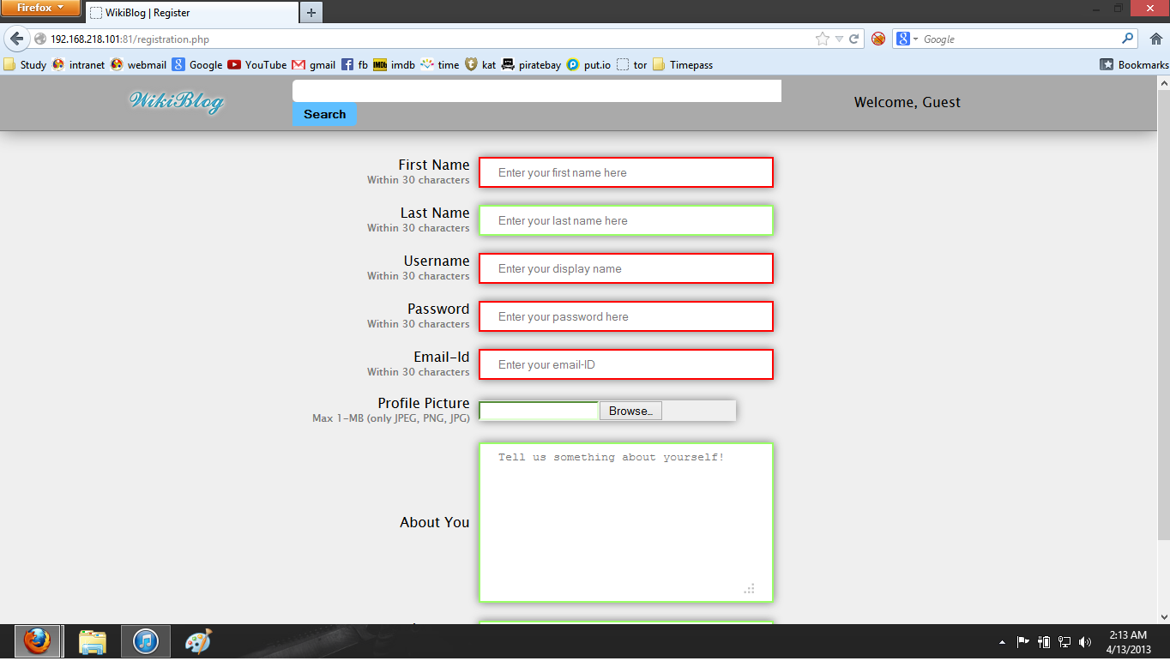

The text boxes highlighted in green are valid entries whereas the red ones are invalid. To register simply fill in the details and click on register button.

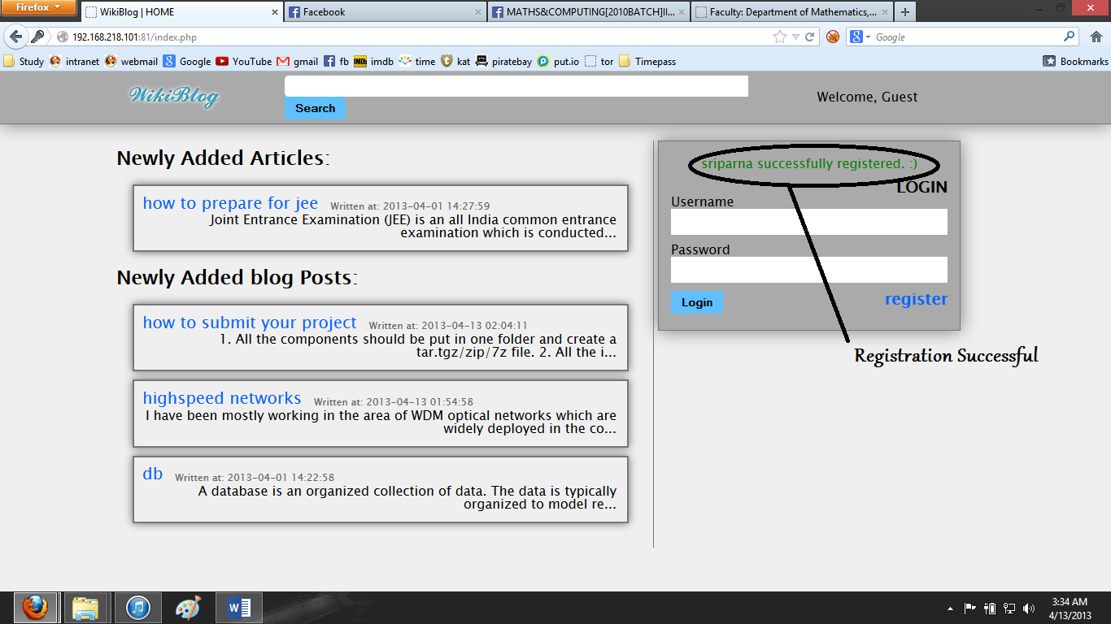

After successful registration.

**How to login if you already have a registered account?**

****

Go to the login page and enter your username and password.

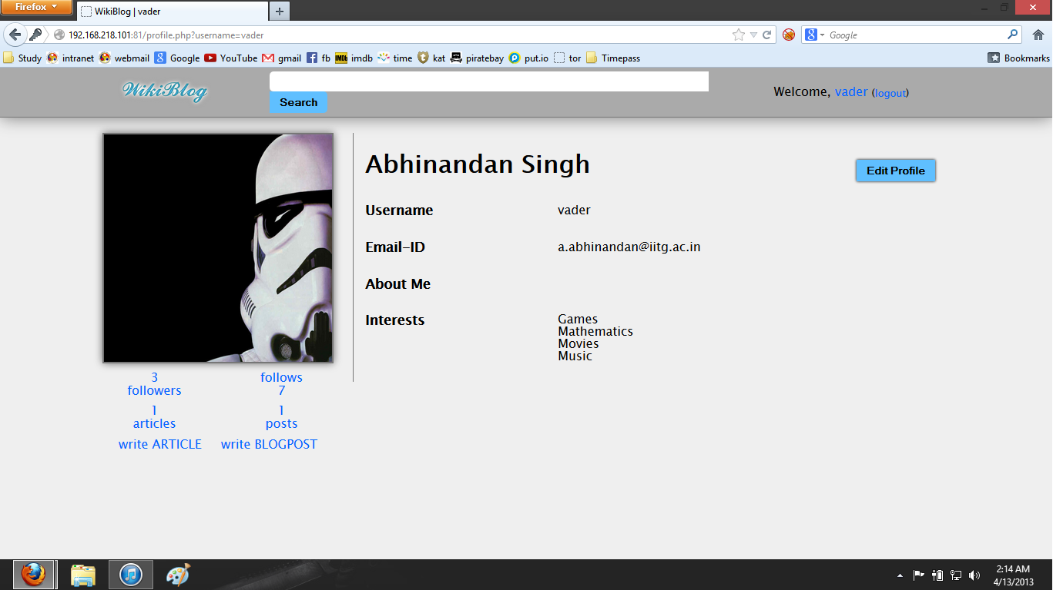

After successful login by user “vader”.

**How to write a new blogpost/article?**

**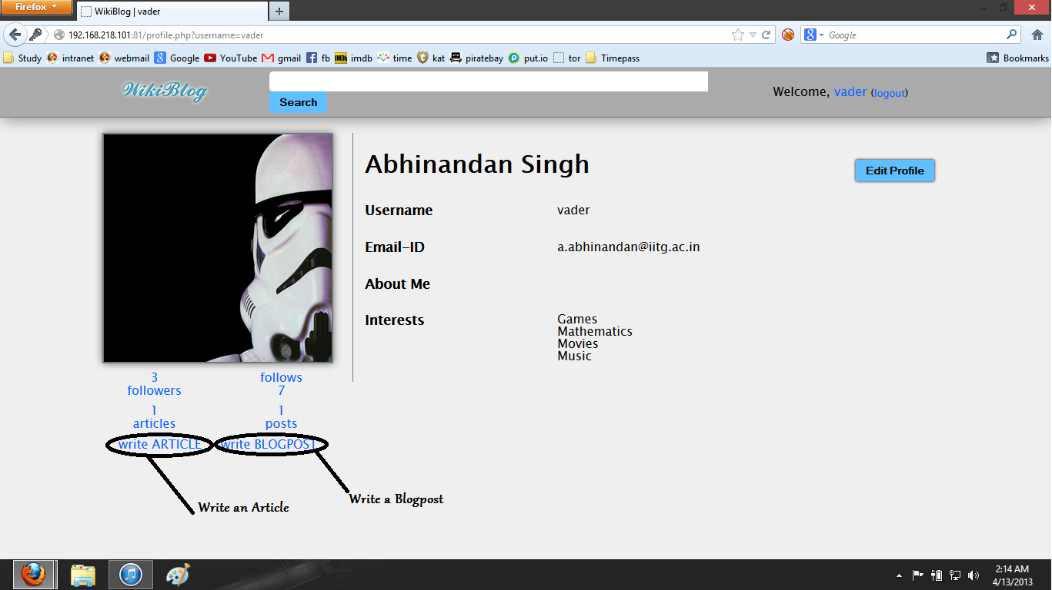**

Click on “Write ARTCLE” for articles and “Write BLOGPOST” for blogs.

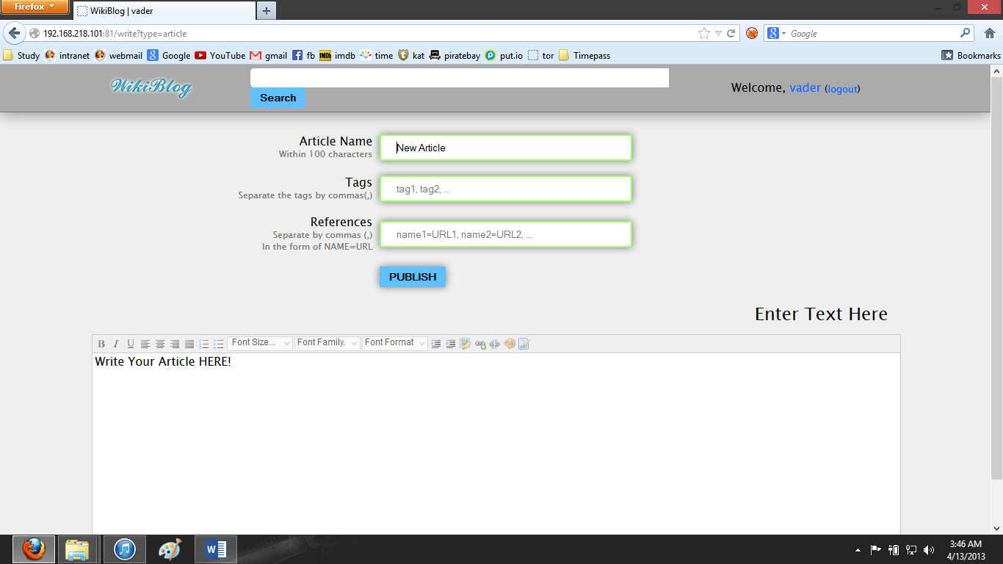

Write an article with heading and tags and references.

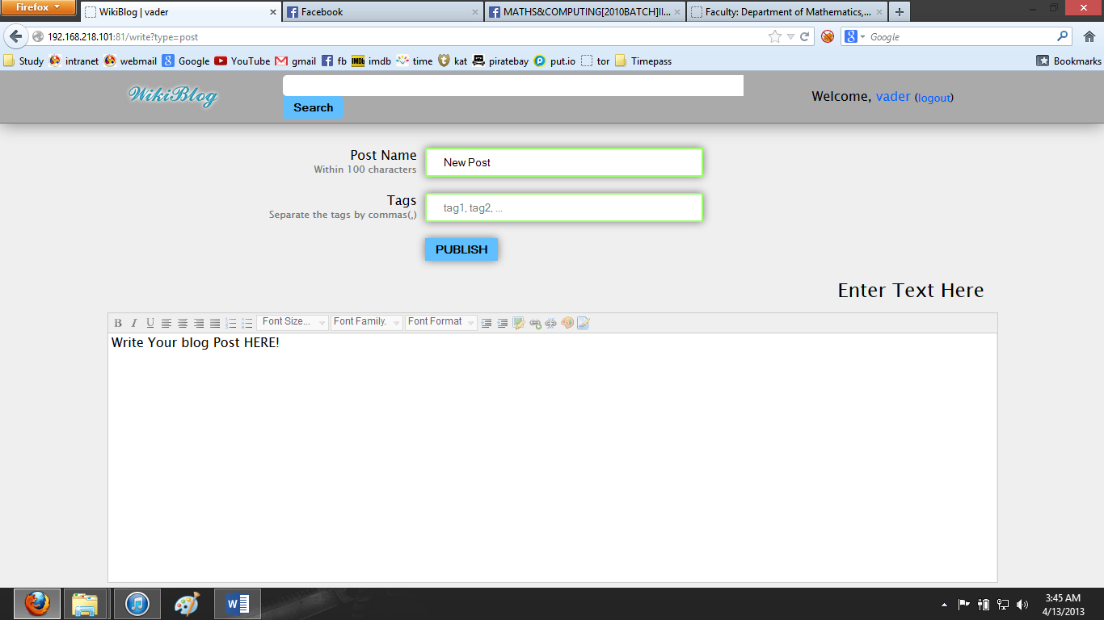

Write a blogpost with heading and tags.

**How to edit an article?**

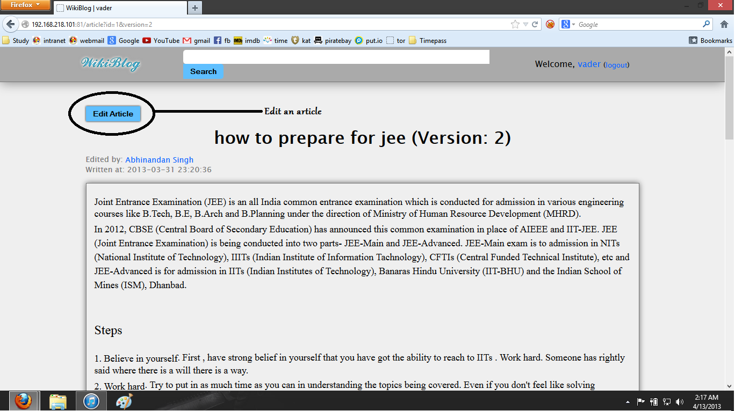

Open the article and click on “Edit Article”.

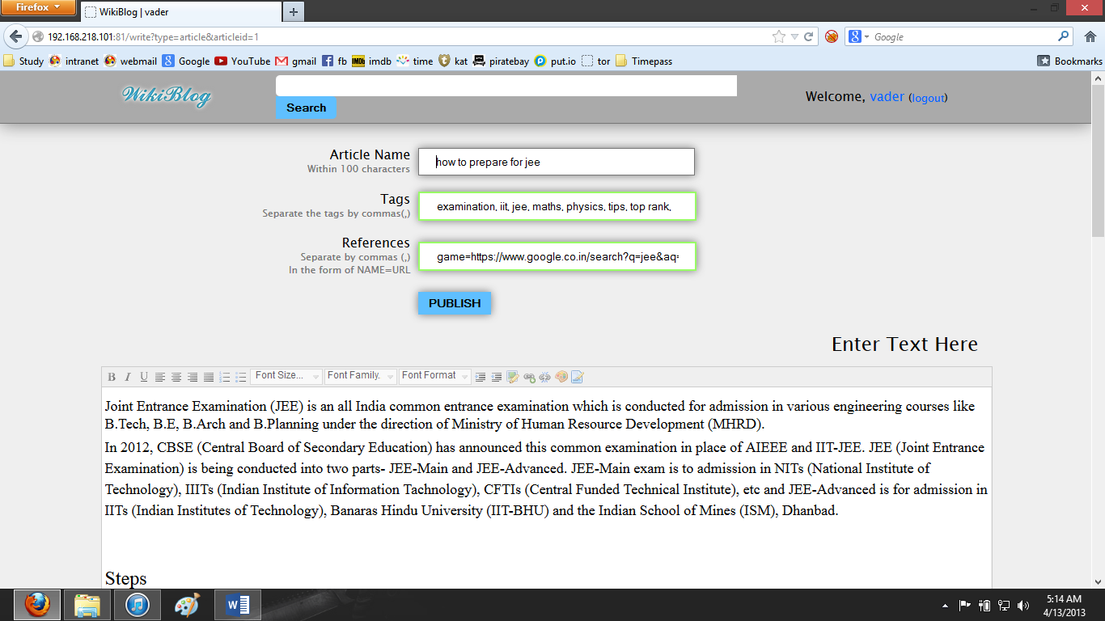

Edit the article and click “Publish”

**How to like/dislike a blogpost or rate an article?**

*Like/Dislike a blogpost*

**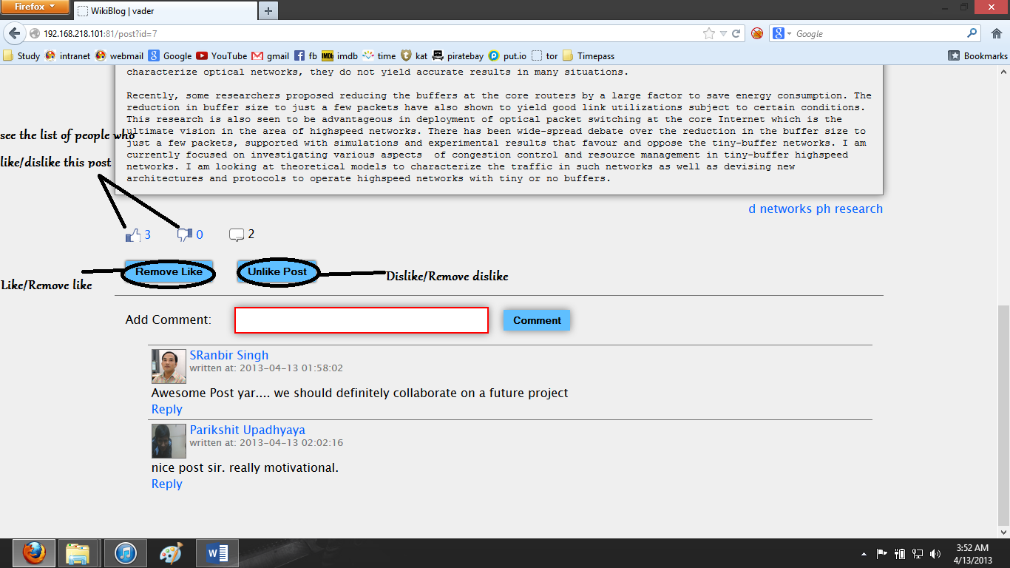**

Click on “Like Post” to like the post and “Remove Like” to remove your like. Similarly for dislike.

You can also see the list of people who like this post by clicking on J:\project\wikiBlog\wikiblog_code\img\like.png and on

J:\project\wikiBlog\wikiblog_code\img\dislike.png to see the list of people who dislike this post.

*Rate an article*

*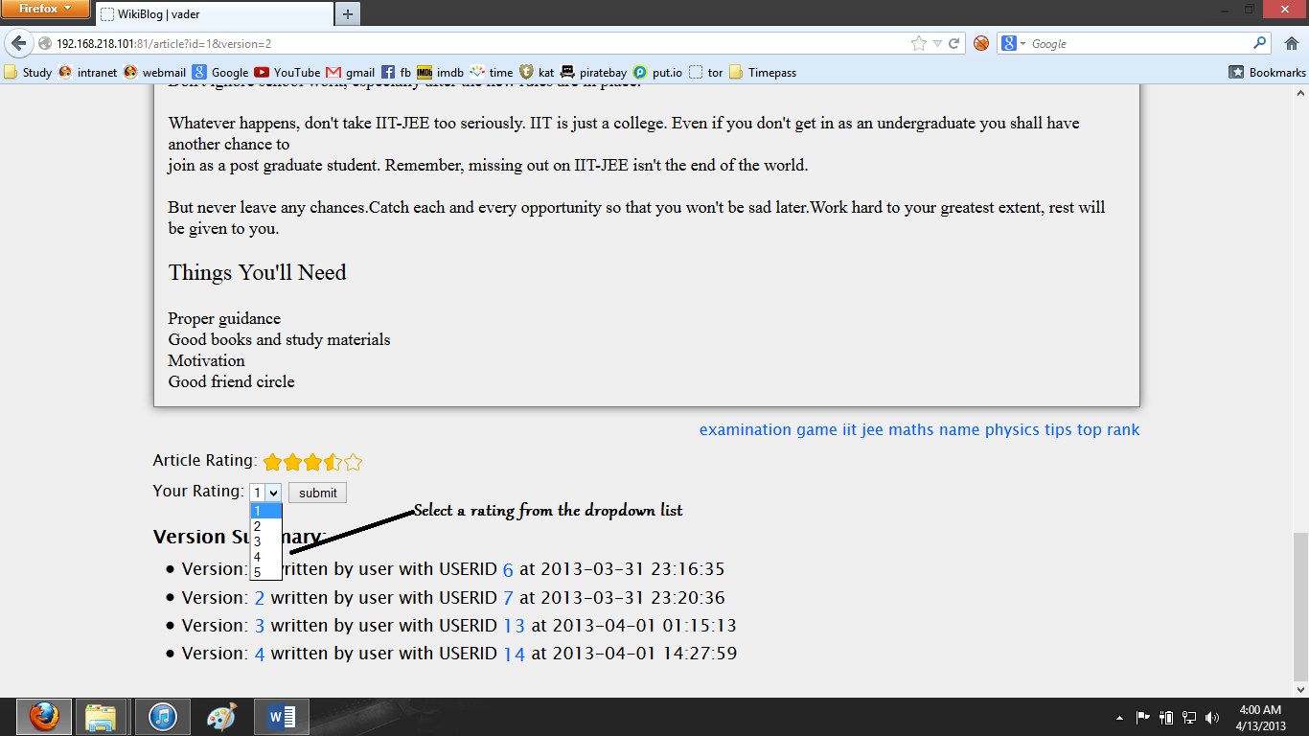*

Select a rating (out of 5) from the dropdown list and click on submit button.

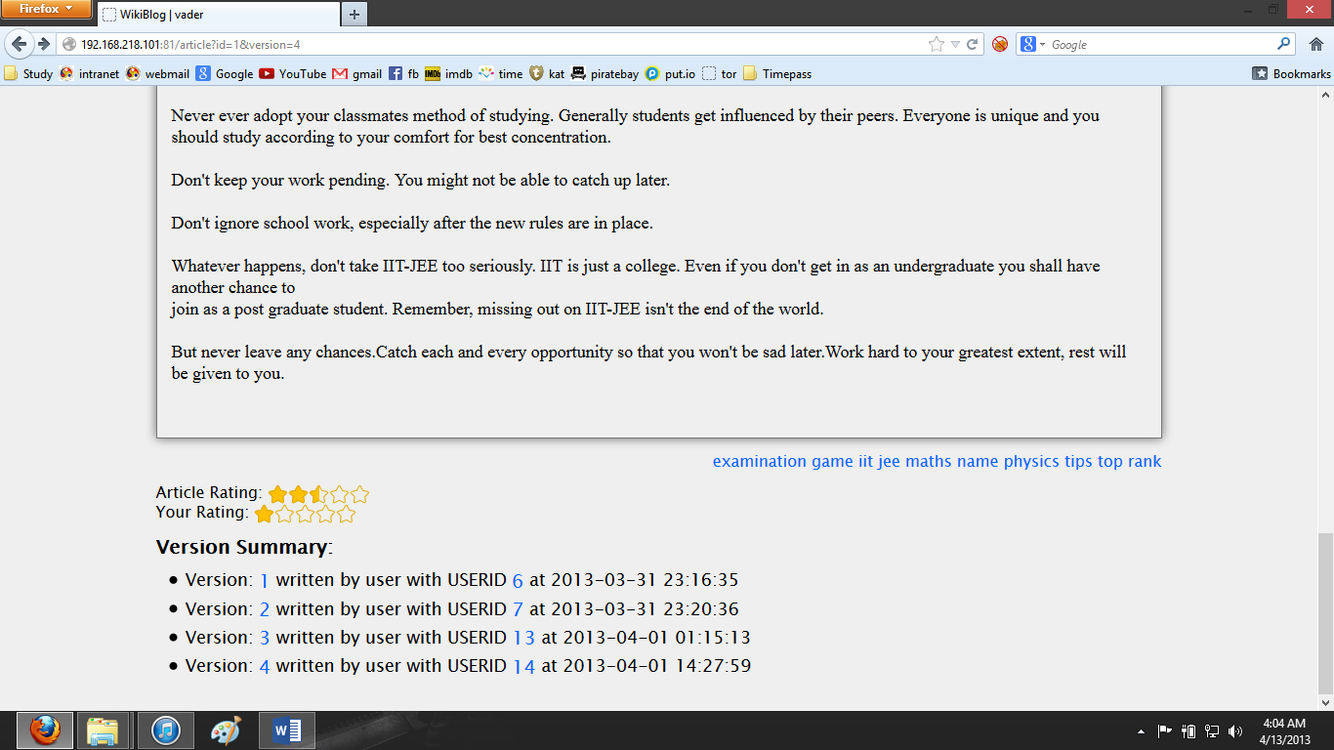

After rating an article.

**How to use the search engine in “wikiblog”?**

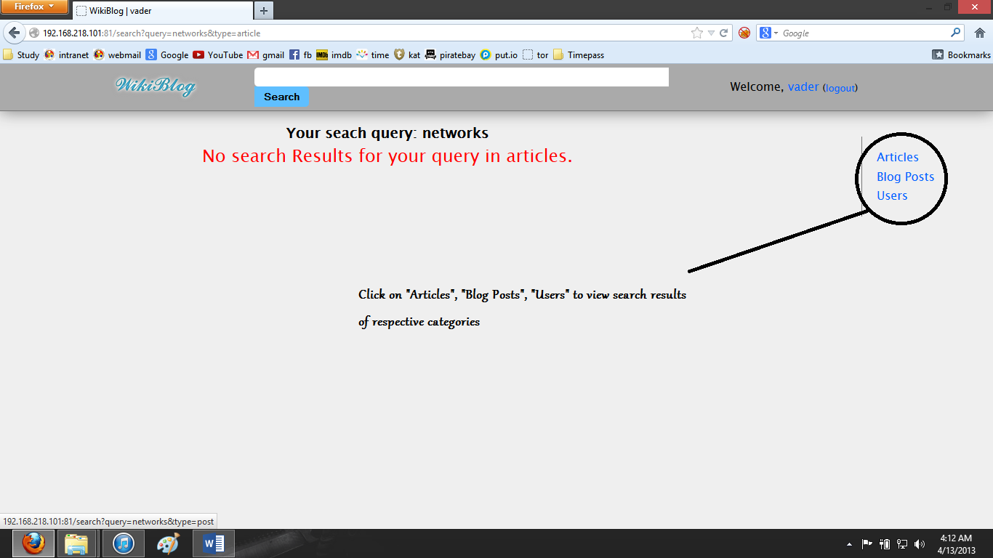

Write the keyword in the search engine and press “Enter”. The default search result is in the “Articles” category. However you can navigate to “Blogposts” as well as “Users” Category.

“Articles” category : Search based on tags, reference and article contents.

“Blogposts” category : Search based on tags and article contents.

“Users” category : Search based on name, username and interests.

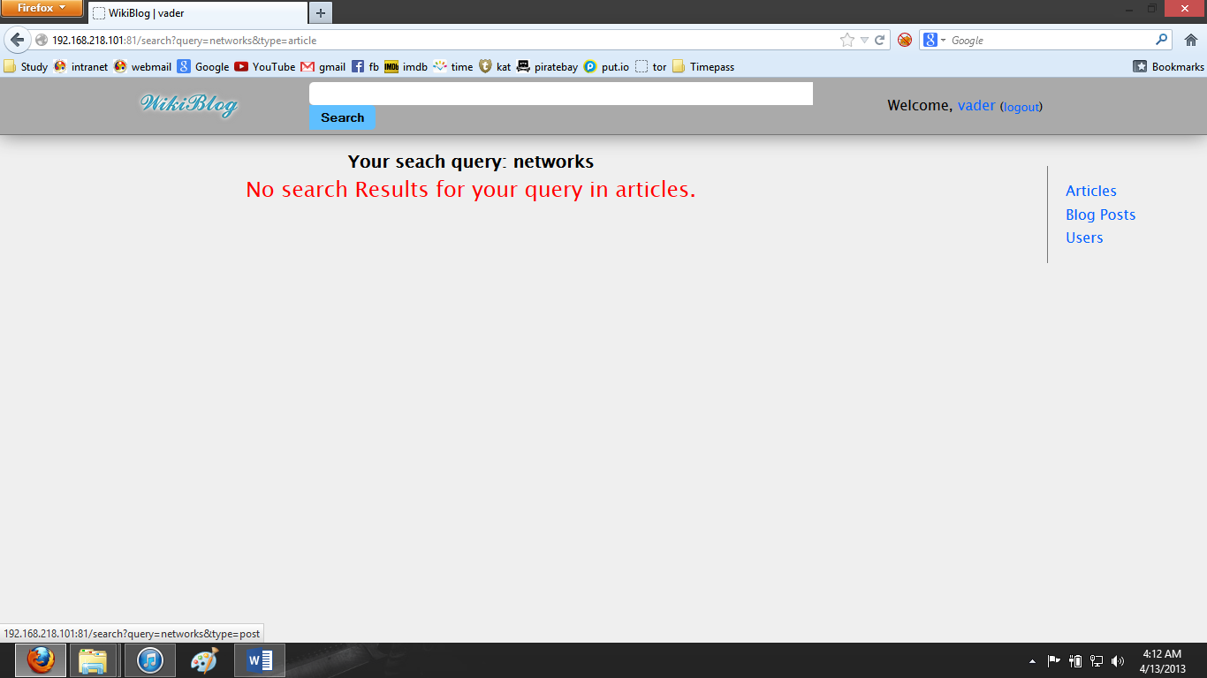

Search results of “networks” in “Articles” category.

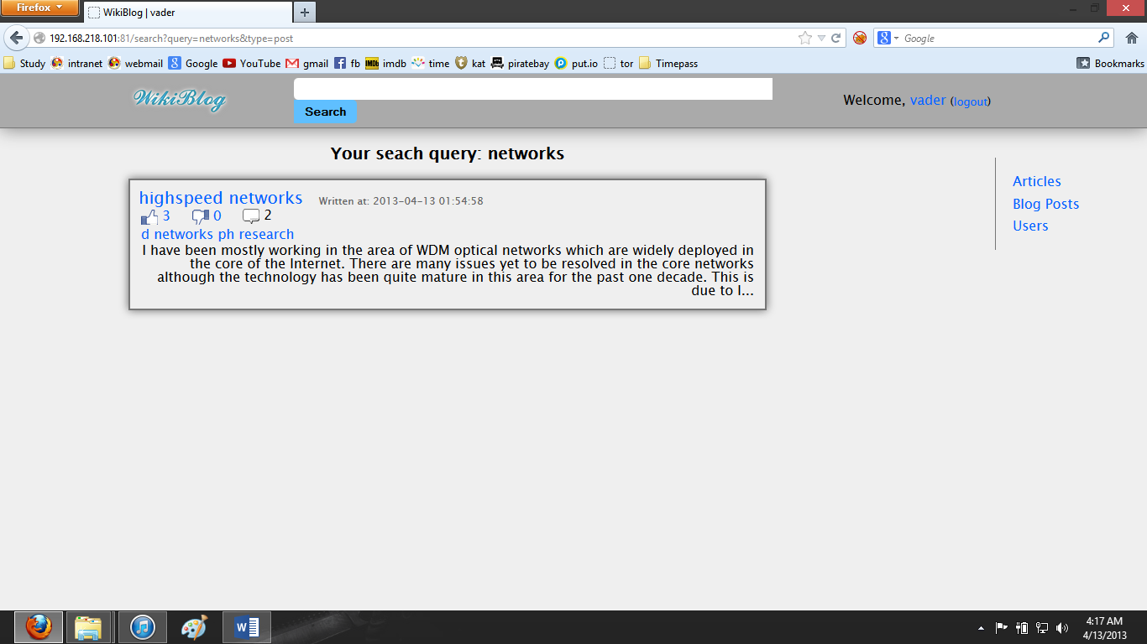

Search results of “networks” in “Blogposts” category.

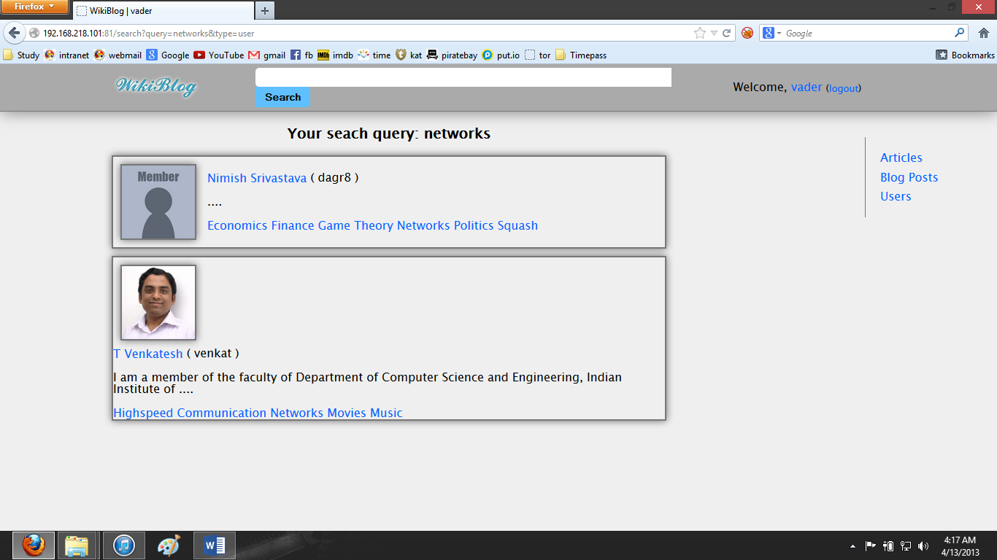

Search results of “networks” in “Users” category.

A few more sample search results:

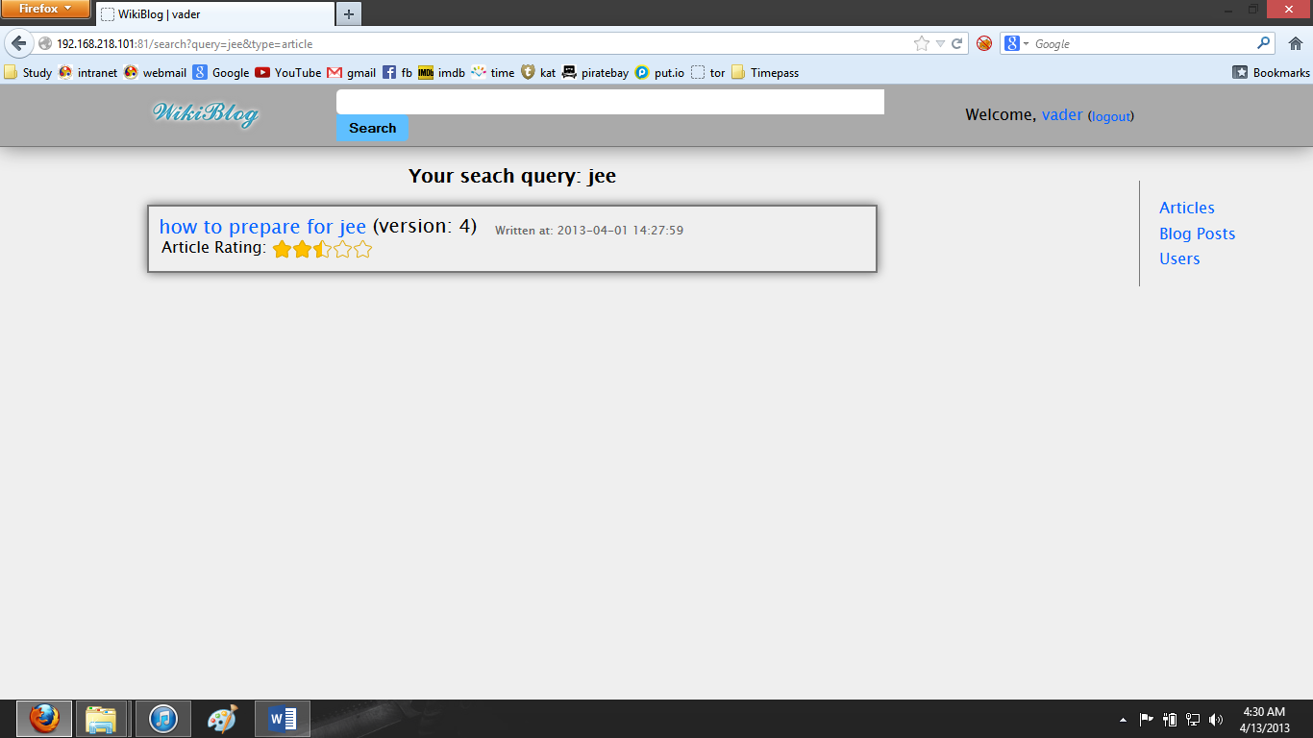

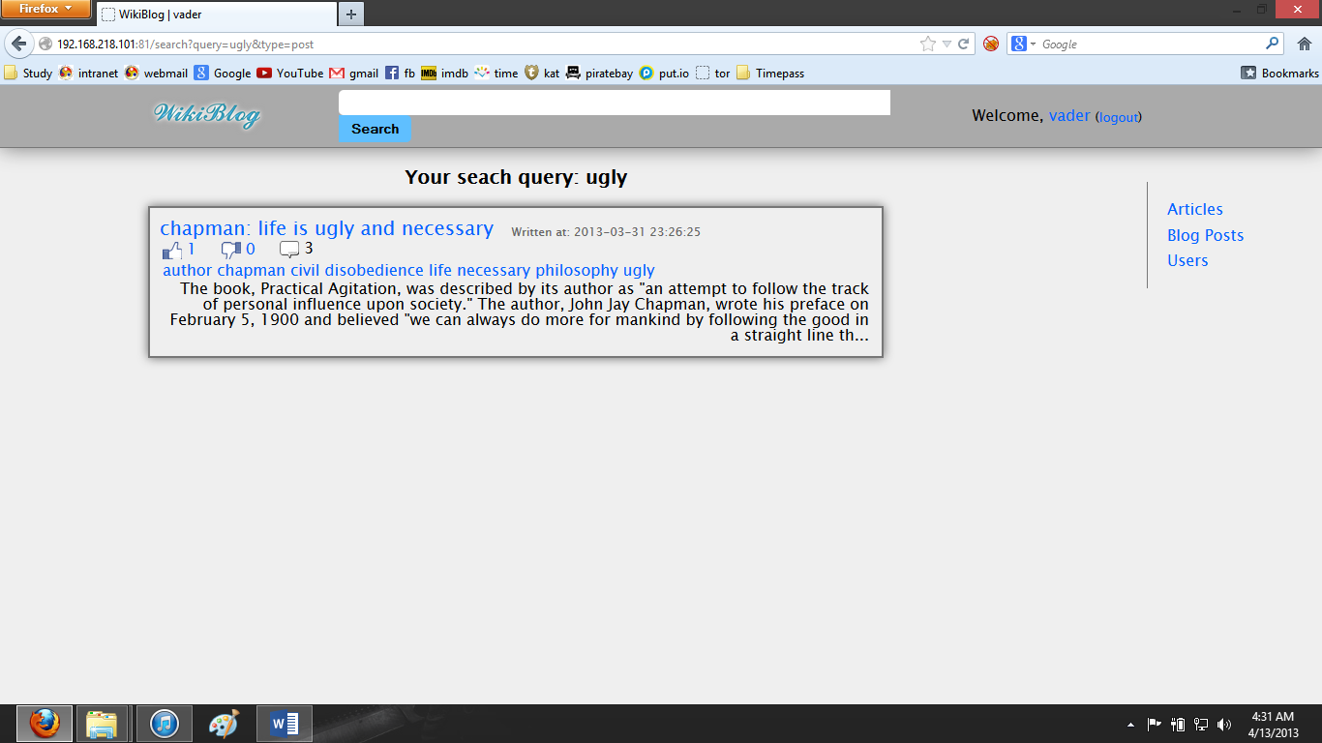

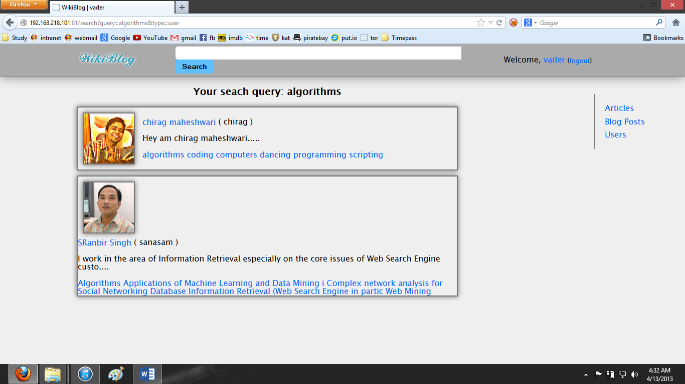

**How to edit your profile details?**

**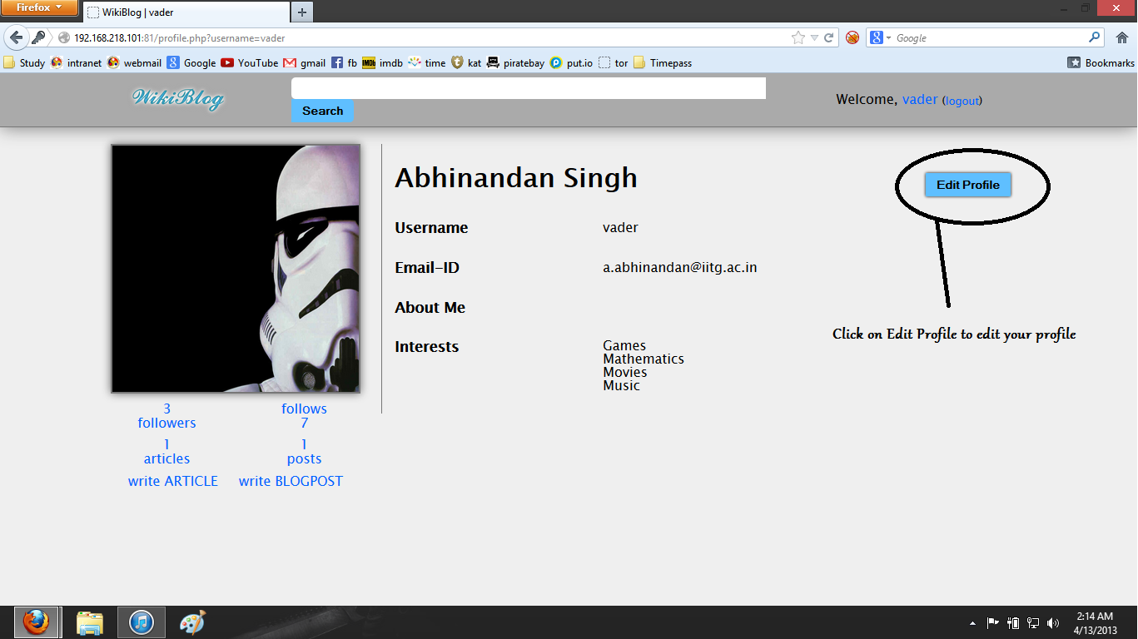**

Go to your profile page and click “Edit Profile”.

**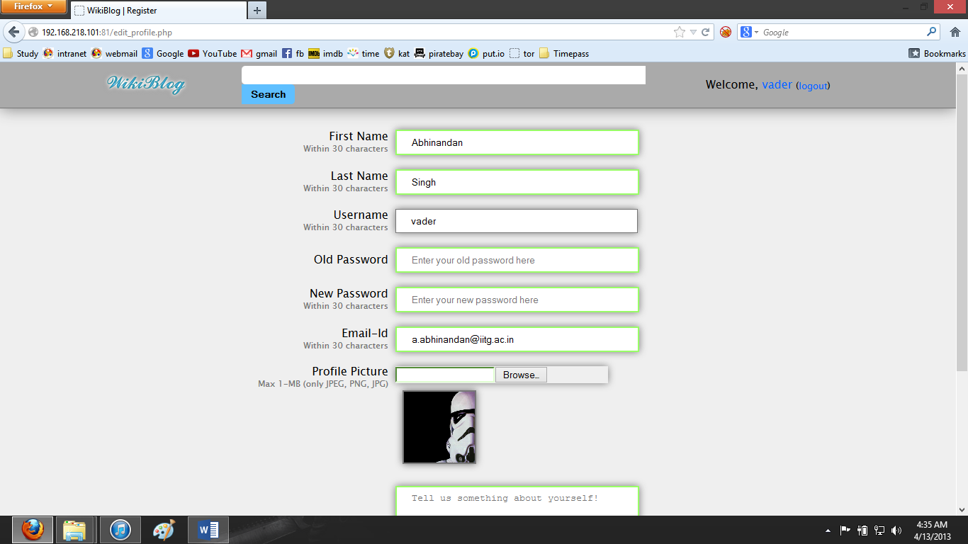**

Enter the new details.

**Note**: You also have to enter the old password to set a new password.

**How to view your followers and followees?**

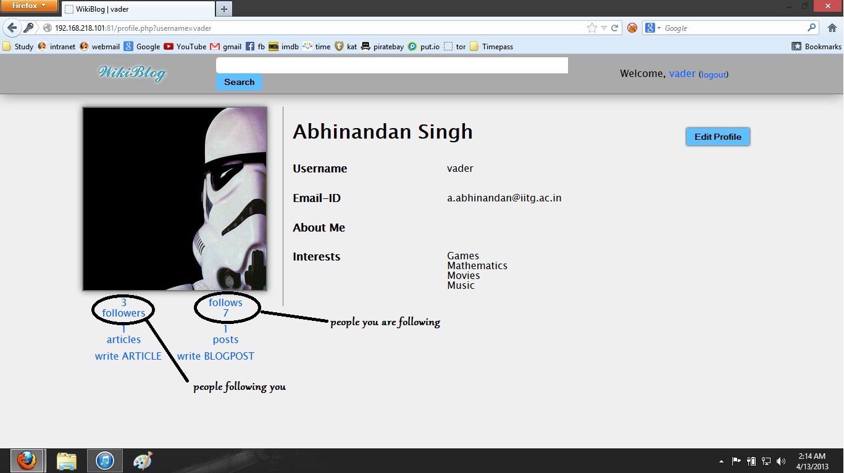

Go to your profile page and click on “follows” to see the list of people you are following and on “followers” to see the list of people who are following you.

**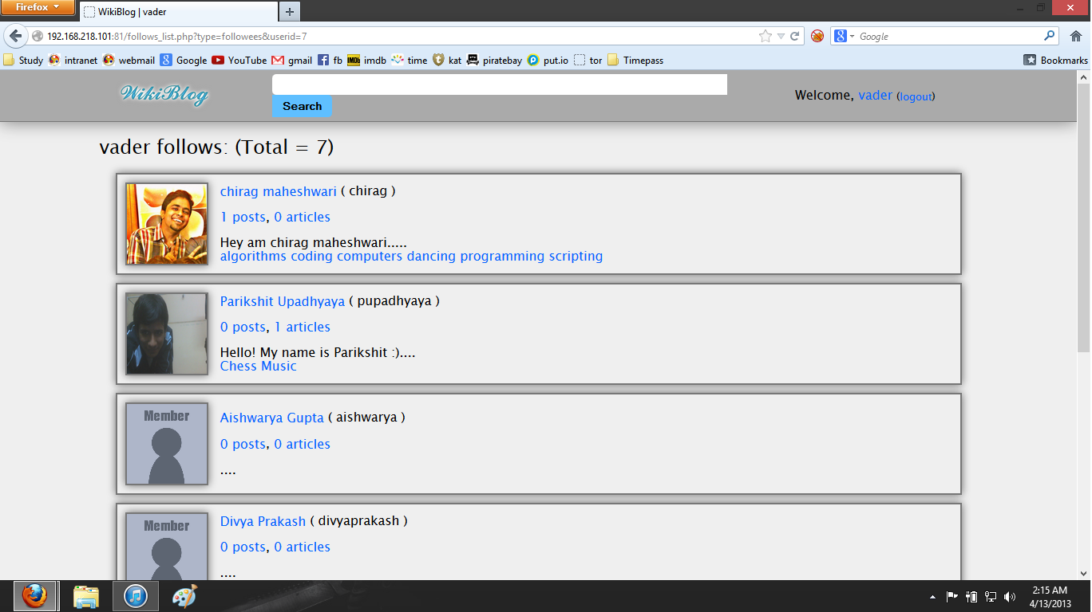**

“vader” follows these people

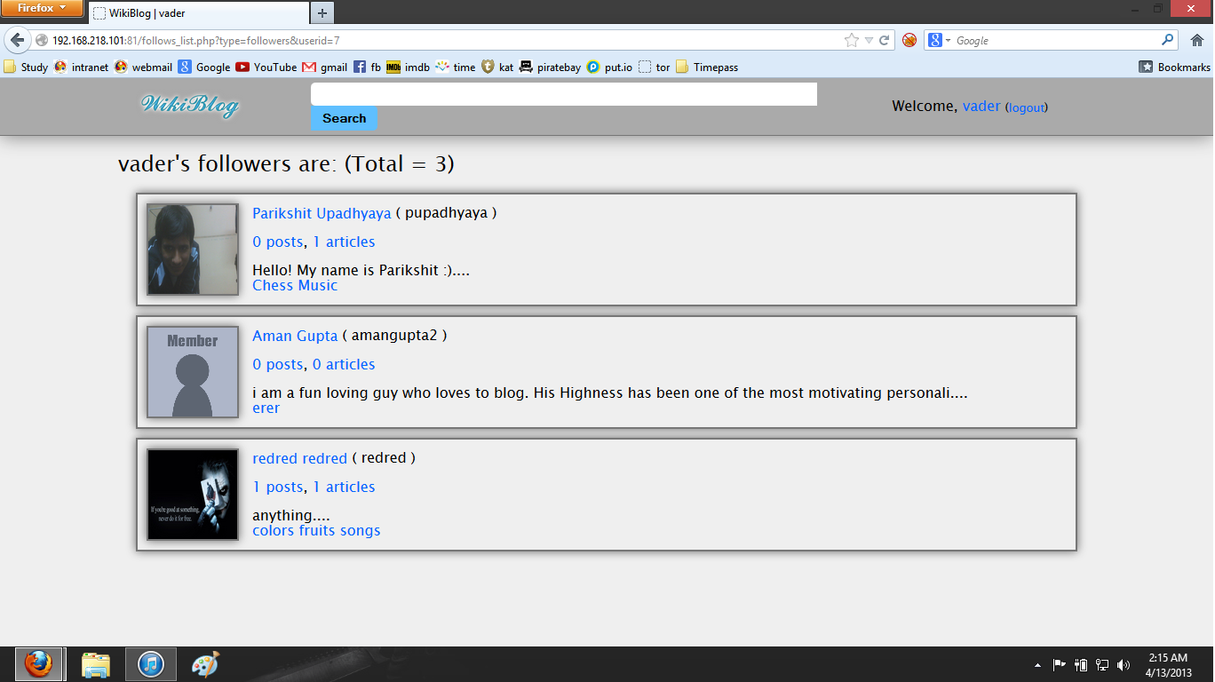

These people follow “vader”.

**How to comment/reply over a comment in a blogpost?**

**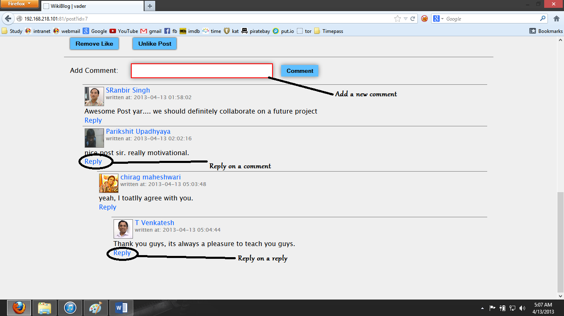**

Click on comment/reply, enter something into the textbox and press “Enter”.