**Location selection for restaurants in Mumbai**

By Chirag Shetty

**Background:**

Mumbai is the most populated city in the world and fifth most densely populated city. Its is the financial capital of India and its no surprise that Mumbai is also the restaurant capital of India. The business has flourished with the local food and cuisine as well as multinational franchises. With such over-crowdedness comes cut throat competition. One of the main aspects of starting or expanding a restaurant business is choosing its location. Location of a restaurant decides the amount of traffic in a restaurant which makes it necessary to optimize.

**Problem:**

A restaurant franchise owner should understand that expanding their business might be limited due to the parent company’s territorial restrictions. Parent companies do not want multiple franchises competing with each other, so spatial and geographic growth might be limited for an owner. Not only is there competition from same franchises but also from already established restaurants. Such restrictions should be considered while setting up a location. Businesses thriving in a certain neighborhood can be expanded easily in similar neighborhoods in a city. Restaurants have a very high risk associated with them while starting out in a new location. If classification of neighborhood is made possible, the restaurant would have lower risk and better chances of survival. Stepping into the highly competitive restaurant industry can be both thrilling and intimidating to new franchise owners. Being able to see the benefits, rewards, and potential failures of a neighborhood, will help prospective owners decide whether or not opening a restaurant franchise is the right decision for them.

**Data:**

Most of the Data associated with restaurants will be collected using the Foursquare API. It is an excellent tool to collect venues at a given co-ordinate. To use the Foursquare API, we first need a list of boroughs in India along with their pin-codes. The resulting data-frame of Boroughs and pin-codes is shown here.

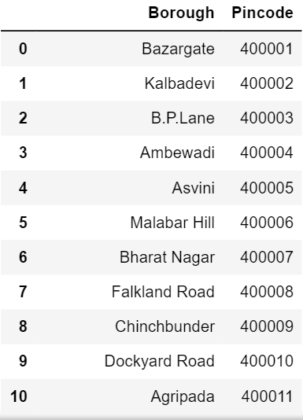

After this the latitude and longitude value for the given pin-codes are required. This can be achieved by using a geocoder. The resulting data-frame should look something like this.

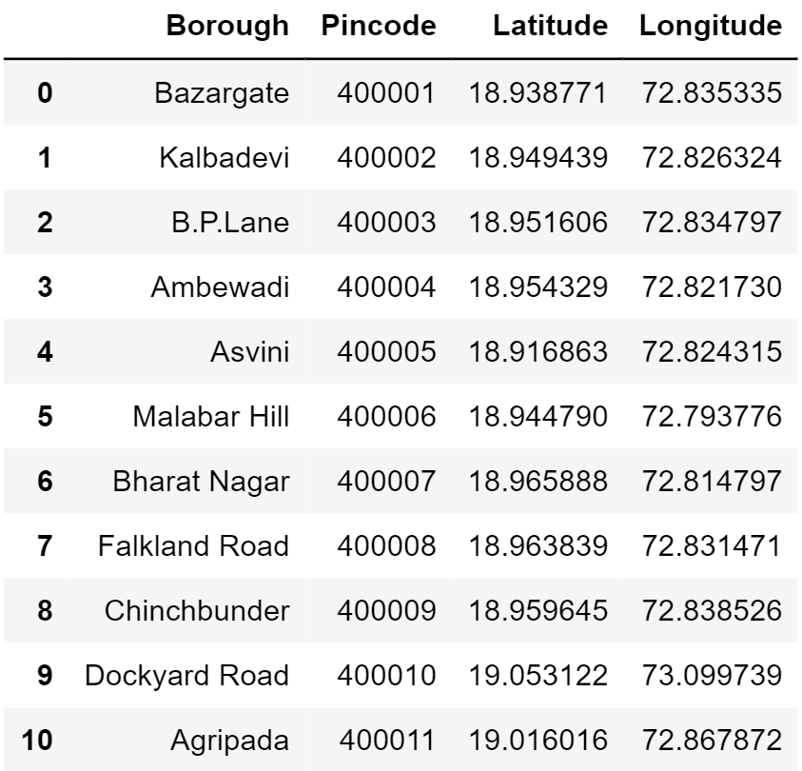

We can begin our analysis by getting the details of restaurant venues in 7.5 km radius of the given location, this will ensure major parts of the city are covered without worrying about overlapping locations. Once the resulting data frame is obtained the process of data collection can be considered complete and we can proceed with exploratory data analysis. Data cleaning is required to get rid of the venues which are not restaurants or venues that are not related to food.

