1.Calculate the average cost of bookings including cancelled status (CostUSD)

SELECT AVG(CostUSD) AS Average_cost FROM travelers_data



2. Find the most popular room class(includes cancelled).

SELECT TOP 1 RoomType, COUNT(*) AS total_booked_RoomType FROM travelers_data GROUP BY RoomType ORDER BY total_booked_RoomType DESC

Creating a view of Confirmed Travelers only

CREATE VIEW Confirmed_booking as

SELECT * FROM travelers_data WHERE BookingStatus='Confirmed'

3. Calculate the total revenue generated by the booking platforms

SELECT BookingPlatform,ROUND(SUM(NetCost),0) AS total_net_revenue FROM Confirmed_booking GROUP BY BookingPlatform ORDER BY total_net_revenue DESC

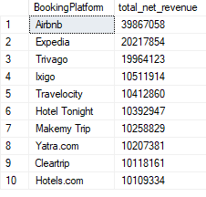

4. Identify the top 5 destinations with the highest booking count.

SELECT TOP 5 Destination, COUNT(*) as Nos_of_Travelers FROM Confirmed_booking GROUP BY Destination ORDER BY Nos_of_Travelers DESC

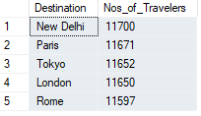

5. Calculate the percentage of bookings with a "Confirmed" status.

SELECT

SUM(CASE WHEN BookingStatus = 'Confirmed' THEN 1 ELSE 0 END) AS total_confirmed_booking,

ROUND(SUM(CASE WHEN BookingStatus = 'Confirmed' THEN 1 ELSE 0 END)*100/ COUNT(*) ,2) AS total_confirmed_booking_percentage

FROM travelers_data;



6. Calculate the average discount offered on room bookings (excluding bookings with no discount).

SELECT ROUND(AVG(ROUND(CostUSD-NetCost,2)),2) as average_discont FROM Confirmed_booking WHERE CostUSD-NetCost<>0



7. Calculate the average discount offered on room bookings (including bookings with no discount).

SELECT ROUND(AVG(ROUND(CostUSD-NetCost,2)),2) AS average_discont FROM Confirmed_booking



8. Calculate the total cost of bookings for each destination with Total Booking count.

SELECT Destination, COUNT(*) Total_Booking ,CAST(SUM(NetCost) AS INT) AS Total_Net_Cost FROM Confirmed_booking GROUP BY Destination ORDER BY Total_Net_Cost DESC

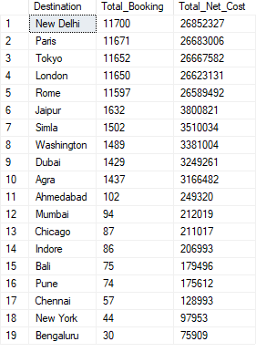

9. Calculate the average number of adults and children per booking.

select AVG(Adults) AS Average_Adult ,AVG(Children) AS Average_Children FROM Confirmed_booking



10. Find the booking with the highest cost.

select CAST(MAX(NetCost) AS INT) AS Highest_Net_Cost FROM Confirmed_booking



11. Calculate the total revenue for each BookingPlatform with total booking count

SELECT BookingPlatform, CAST(SUM(NetCost) AS INT) AS Total_Revenue,COUNT(BookingID) AS Total_Booking FROM Confirmed_booking GROUP BY BookingPlatform

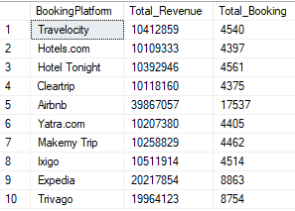

12. Calculate the average cost of bookings for each room class.

SELECT RoomType,ROUND(AVG(NetCost),2) AS Average_NetCost FROM Confirmed_booking GROUP BY RoomType

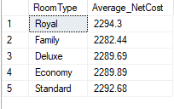

13. Calculate the total revenue for each year.

SELECT YEAR(BookingDate) AS Booked_Year,CAST(SUM(NetCost) AS INT) AS Total_NetCost FROM Confirmed_booking GROUP BY YEAR (BookingDate) ORDER BY Booked_Year

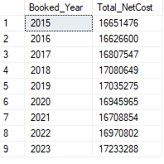

14. Find the most common booking status for each booking platform

SELECT BookingPlatform, BookingStatus,COUNT(*) as No_of_bookingStatus FROM travelers_data GROUP BY BookingStatus,BookingPlatform ORDER BY BookingPlatform

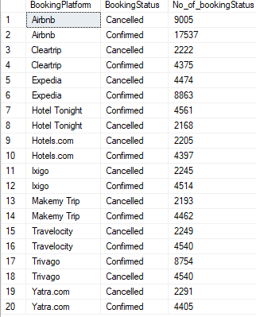

15. Calculate the average hotel stay duration.

SELECT AVG(HotelStayDays) AS Average_Stay FROM Confirmed_booking



16. Calculate the total cost of bookings for confirmed bookings only.

SELECT CAST(SUM(NetCost) AS INT) AS Total_Revenue FROM Confirmed_booking



17. Calculate the total revenue for each room class.

SELECT RoomType, CAST(SUM(NetCost) AS INT) AS Total_Revenue FROM Confirmed_booking GROUP BY RoomType ORDER BY Total_Revenue DESC

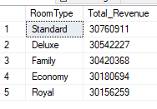

18. Calculate the total cost of bookings for each destination-country combination.

SELECT Destination, Country, CAST(SUM(NetCost) AS INT) AS Total_Revenue FROM Confirmed_booking GROUP BY Destination, Country ORDER BY Total_Revenue DESC

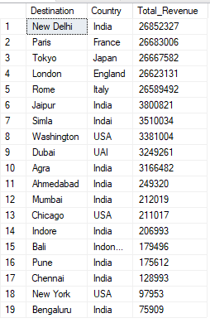

19. Calculate the total cost of bookings for bookings with discounts.

SELECT CAST(SUM(NetCost) AS INT) AS Total_Revenue FROM Confirmed_booking WHERE CostUSD-NetCost<>0



20. Calculate the average discount offered for each room class.

SELECT RoomType, CAST(AVG(CostUSD-NetCost) AS INT) AS Total_Discount FROM Confirmed_booking GROUP BY RoomType ORDER BY Total_Discount DESC

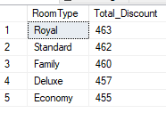

21. Count the number of bookings made for each destination by RoomType.

SELECT RoomType, Destination, COUNT(*) AS Room_Booked FROM Confirmed_booking GROUP BY RoomType, Destination ORDER BY Room_Booked DESC

