Titanic Survival Prediction Project

Submitted By:
Chirag Negi

Course
Masters of Computer Applications (MCA)

Institution
Uttaranchal University

Subject
Data Science

Date Of Submission
17-04-2026

ABSTRACT
This project focuses on predicting passenger survival on the Titanic using data science techniques. The dataset is preprocessed by handling missing values and converting categorical data. Data visualization is performed to understand patterns and relationships. A Logistic Regression model is used to classify whether a passenger survived or not. The model achieved an accuracy of around 80%, showing effective performance.

INTRODUCTION
Data science involves extracting useful insights from data using statistical and machine learning techniques. One common application is classification, where models are used to predict outcomes based on input features.
The Titanic dataset is widely used for such tasks, as it contains information about passengers and their survival status. In this project, the dataset is cleaned, visualized, and analyzed to understand important patterns. A Logistic Regression model is applied to predict whether a passenger survived or not.
This project demonstrates the basic steps of the data science process, including data preprocessing, visualization, and model evaluation.

OBJECTIVES
• Analyze Titanic dataset
• Perform data visualization
• Build a machine learning model for prediction
• Evaluate model performance

DATASET DESCRIPTION
The dataset used in this project is the Titanic dataset, which contains information about passengers aboard the Titanic, including whether they survived or not. It is a widely used dataset for classification problems in data science.
The dataset includes important features such as:
- Age – Age of the passenger
- Sex – Gender of the passenger
- Pclass – Passenger class (1st, 2nd, 3rd)
- Fare – Ticket fare paid
- SibSp – Number of siblings/spouses aboard
- Parch – Number of parents/children aboard
- Survived – Target variable (0 = Not Survived, 1 = Survived)
A new feature called FamilySize was created using SibSp and Parch to improve model performance.
The dataset is publicly available on Kaggle and can also be accessed directly using the Seaborn library in Python.
Dataset Link: https://www.kaggle.com/c/titanic/data

METHODOLOGY
🔹 Data Cleaning
- Handled missing values
- Converted categorical data

🔹 Data Visualization
- Bar plot
- Heatmap
- Survival graph
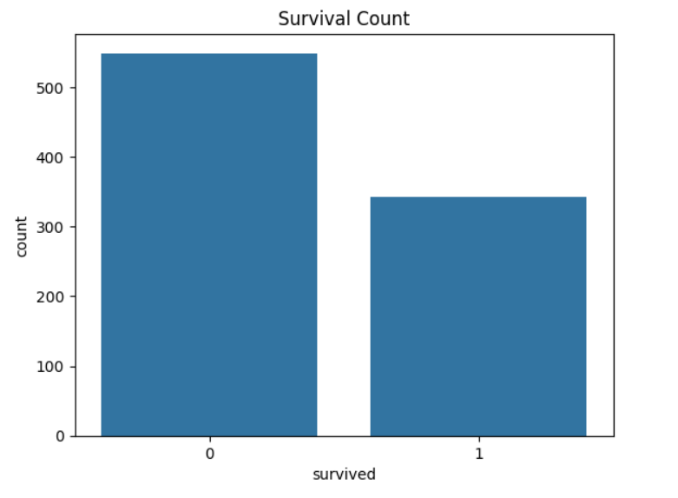

Figure 1: Survival Count Plot

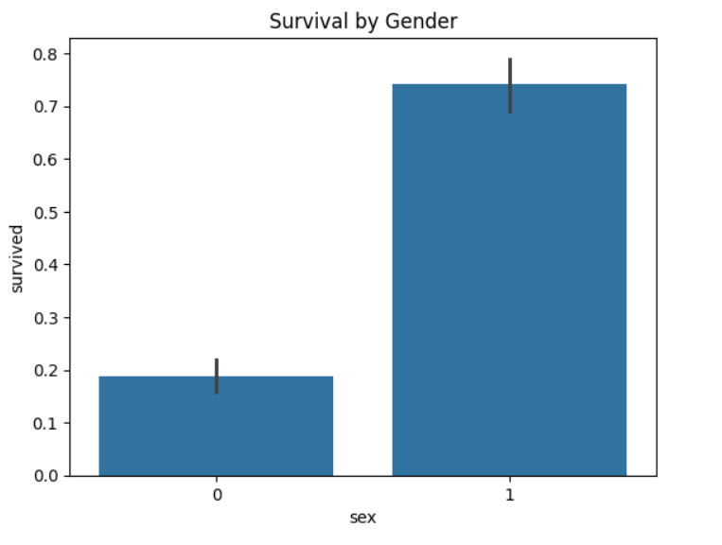
Figure 2: Survival by Gender

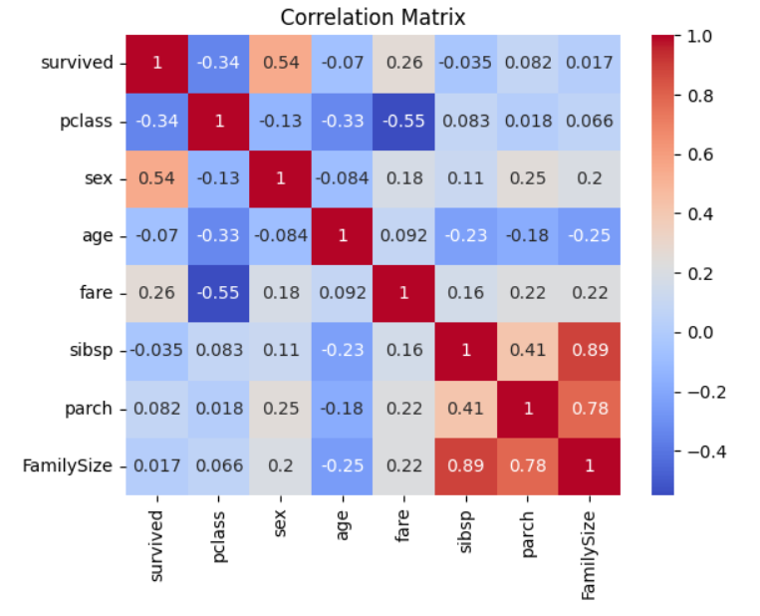
Figure 3: Correlation Heatmap

🔹 Feature Engineering
- Created FamilySize
🔹 Model Building
- Logistic Regression used

IMPLEMENTATION
🔹Data Loading
df = sns.load_dataset('titanic')
🔹Data Cleaning
df['age'].fillna(df['age'].mean(), inplace=True)
df['sex'] = df['sex'].map({'male': 0, 'female': 1})
🔹Feature Engineering
df['FamilySize'] = df['sibsp'] + df['parch']
🔹Train-Test Split
X_train, X_test, y_train, y_test = train_test_split(X, y, test_size=0.2)
🔹Model Building
model = LogisticRegression(max_iter=200)
model.fit(X_train, y_train)
🔹Evaluation
print(accuracy_score(y_test, y_pred))
print(confusion_matrix(y_test, y_pred))

RESULTS
Accuracy:
The model achieved an accuracy of 80.44%
Confusion Matrix:
[[92 13]
[22 52]]
Screenshots:
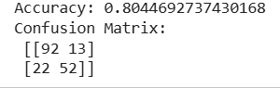

Figure 4: Confusion Matrix

DISCUSSION
The model performed well with an accuracy of around 80%, indicating that it can effectively predict passenger survival. The confusion matrix shows that most predictions were correct, with fewer misclassifications. It was observed that factors such as gender and passenger class had a significant impact on survival, as females and higher-class passengers had higher chances of survival. Overall, the results demonstrate that machine learning models can provide reliable predictions when the data is properly processed.

CONCLUSION
This project successfully demonstrated the application of data science techniques to predict Titanic passenger survival. The dataset was preprocessed, visualized, and analyzed to understand important patterns. A Logistic Regression model was built and evaluated, achieving good accuracy. The project highlights the importance of data preprocessing, feature selection, and model evaluation in building effective machine learning models. It provides a clear understanding of the complete data science workflow.

REFERENCES
- Titanic Dataset – https://www.kaggle.com/c/titanic/data
- Seaborn Documentation
- Scikit-learn Documentation
- Python Official Documentation

