ClassicModels Database-Advance SQL Queries
1.Find the total number of employees reporting under each manager recursively.

Approach 1: Top-Down Recursive CTE
WITH RECURSIVE emp_hierarchy AS (
SELECT reportsTo AS manager_id, employeeNumber AS employee_id
FROM employees
WHERE reportsTo IS NOT NULL
UNION ALL
SELECT eh.manager_id, e.employeeNumber
FROM emp_hierarchy eh
JOIN employees e ON e.reportsTo = eh.employee_id
)
SELECT manager_id, COUNT(employee_id) AS Total_emp_under_manager
FROM emp_hierarchy
GROUP BY manager_id;
Explanation: This approach uses a recursive CTE to traverse the hierarchy from the manager downwards to find all direct and indirect subordinates.
It effectively links every employee to their respective ancestor manager in the chain for accurate counting.

Approach 2: Bottom-Up Recursive CTE
WITH RECURSIVE manager_chain AS (
SELECT employeeNumber AS employee_id, reportsTo AS manager_id
FROM employees
WHERE reportsTo IS NOT NULL
UNION ALL
SELECT mc.employee_id, e.reportsTo
FROM manager_chain mc
JOIN employees e ON mc.manager_id = e.employeeNumber
WHERE e.reportsTo IS NOT NULL
)
SELECT manager_id, COUNT(employee_id) AS total_employees
FROM manager_chain
GROUP BY manager_id;
Explanation: This method starts with individual employees and recursively moves upward to identify every manager in their reporting line.
By grouping by the higher-level managers found in the chain, it tallies the total workforce managed by each leader.
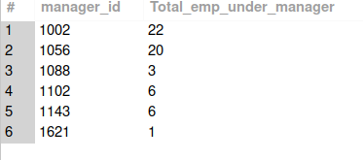
--------------------

2. Identify the maximum depth of the organizational hierarchy.

Approach 1: Recursive CTE Depth Tracking
WITH RECURSIVE CTE_depth AS (
SELECT employeeNumber, reportsTo, 1 AS level
FROM employees WHERE reportsTo IS NULL
UNION ALL
SELECT e.employeeNumber, e.reportsTo, level+1
FROM employees e JOIN CTE_depth cd
ON cd.employeeNumber = e.reportsTo
)
SELECT MAX(level) AS Hierarchy_depth FROM CTE_depth;
Explanation: This query assigns a numerical level to each employee starting from the top executive (level 1) and incrementing downwards.
The final MAX(level) identifies the deepest point in the organizational structure.

Approach 2: Fixed-Level Self-Joins
SELECT MAX(depth) AS max_depth
FROM (
SELECT e1.employeeNumber, 1 +
(e2.employeeNumber IS NOT NULL) +
(e3.employeeNumber IS NOT NULL) +
(e4.employeeNumber IS NOT NULL) +
(e5.employeeNumber IS NOT NULL) AS depth
FROM employees e1
LEFT JOIN employees e2 ON e2.reportsTo = e1.employeeNumber
LEFT JOIN employees e3 ON e3.reportsTo = e2.employeeNumber
LEFT JOIN employees e4 ON e4.reportsTo = e3.employeeNumber
LEFT JOIN employees e5 ON e5.reportsTo = e4.employeeNumber
) t;
Explanation: This approach uses a series of LEFT JOIN operations to manually check for subsequent levels in the hierarchy.
It is a non-recursive alternative suitable for databases with a known or limited maximum hierarchy depth.
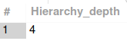
--------------------

3.Create a recursive query to display each employee along with the full chain of offices they belong to.

Approach 1: Recursive CTE (Management Chain Mapping)
WITH RECURSIVE office_chain AS (
SELECT
e.employeeNumber,
e.reportsTo,
CAST(o.city AS CHAR(1000)) AS office_path
FROM employees e
JOIN offices o ON e.officeCode = o.officeCode

UNION ALL

SELECT
oc.employeeNumber,
m.reportsTo,
CONCAT(oc.office_path, ' -> ', o.city)
FROM office_chain oc
JOIN employees m ON oc.reportsTo = m.employeeNumber
JOIN offices o ON m.officeCode = o.officeCode
)
SELECT employeeNumber, office_path
FROM office_chain
WHERE reportsTo IS NULL;

Explanation: This approach uses a Recursive CTE to traverse the management hierarchy, dynamically appending office cities to a path string as it moves up the chain.
The CAST function is used in the anchor member to pre-allocate character length, preventing the "Data too long" error as the string grows during recursion.

Approach 2: Multiple Self-Joins (Fixed-Depth Path)
SELECT
e1.employeeNumber,
CAST(CONCAT(o1.city,
COALESCE(CONCAT(' -> ', o2.city), ''),
COALESCE(CONCAT(' -> ', o3.city), ''),
COALESCE(CONCAT(' -> ', o4.city), '')) AS CHAR(1000)) AS office_chain
FROM employees e1
JOIN offices o1 ON e1.officeCode = o1.officeCode
LEFT JOIN employees e2 ON e1.reportsTo = e2.employeeNumber
LEFT JOIN offices o2 ON e2.officeCode = o2.officeCode
LEFT JOIN employees e3 ON e2.reportsTo = e3.employeeNumber
LEFT JOIN offices o3 ON e3.officeCode = o3.officeCode
LEFT JOIN employees e4 ON e3.reportsTo = e4.employeeNumber
LEFT JOIN offices o4 ON e4.officeCode = o4.officeCode;

Explanation: This method uses a series of LEFT JOIN operations to manually link employees to their managers' offices up to a specific depth in the hierarchy.
By wrapping the CONCAT function in a CAST, the query ensures the output column is wide enough to store the combined names of multiple cities without truncation.
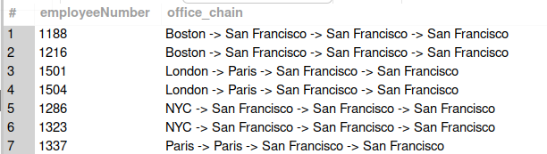

4.For each customer, calculate the running total of their payments using SUM as a window function.

Approach 1: SUM() Window Function
SELECT c.customerNumber, c.customerName, p.amount,
SUM(p.amount) OVER(PARTITION BY customerNumber ORDER BY paymentDate ROWS BETWEEN UNBOUNDED PRECEDING AND CURRENT ROW) AS running_total
FROM customers c
JOIN payments p ON c.customerNumber = p.customerNumber;
Explanation: This utilizes the standard SQL OVER clause to calculate a cumulative sum for each customer over time.
It is highly efficient and automatically handles the windowing for each payment record.

Approach 2: Correlated Subquery
SELECT c.customerNumber, c.customerName, p.paymentDate, p.amount,
(SELECT SUM(p2.amount) FROM payments p2 WHERE p2.customerNumber = p.customerNumber AND p2.paymentDate <= p.paymentDate) AS running_total
FROM customers c
JOIN payments p ON c.customerNumber = p.customerNumber
ORDER BY c.customerNumber, p.paymentDate;
Explanation: This method calculates the running total by running a separate sum for every row that counts all previous payments.
While accurate, it can be significantly slower than the window function approach on larger datasets.
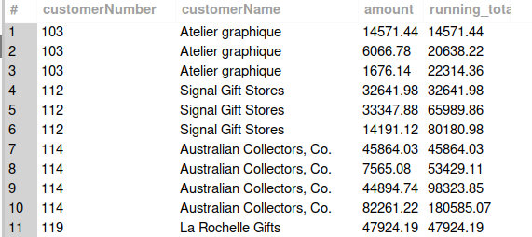
--------------------

5.Determine the ROW_NUMBER of orders placed by each customer, ordered by the order date.

Approach 1: ROW_NUMBER() Window Function
SELECT customerNumber, orderNumber, orderdate,
ROW_NUMBER() OVER(PARTITION BY customerNumber ORDER BY orderDate) AS order_rank
FROM orders;
Explanation: This approach assigns a sequential integer to each order for every customer based on the chronological order date.
It is the most direct and performance-optimized way to rank items within specific groups.

Approach 2: Correlated Subquery Count
SELECT o1.customerNumber, o1.orderNumber, o1.orderDate,
(SELECT COUNT(*) FROM orders o2 WHERE o2.customerNumber = o1.customerNumber AND o2.orderDate <= o1.orderDate) AS order_rank
FROM orders o1
ORDER BY o1.customerNumber, o1.orderDate;
Explanation: This query determines the rank by counting how many orders exist for the same customer with an earlier date.
This provides a ranking logic equivalent to ROW_NUMBER without using modern window functions.
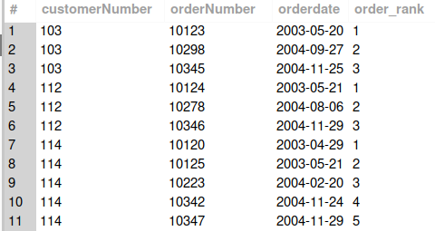
--------------------

6. Use FIRST_VALUE and LAST_VALUE to identify the first and last products ordered by a specific customer.

Approach 1: Direct Window Functions
SELECT DISTINCT c.customerNumber, c.customerName,
FIRST_VALUE(p.productName) OVER(PARTITION BY c.customerNumber, c.customerName ORDER BY o.orderDate) AS First_Order,
LAST_VALUE(p.productName) OVER(PARTITION BY c.customerNumber, c.customerName ORDER BY o.orderDate ROWS BETWEEN UNBOUNDED PRECEDING AND UNBOUNDED FOLLOWING) AS Last_Order
FROM customers c
JOIN orders o ON c.customerNumber = o.customerNumber
JOIN orderdetails od ON o.orderNumber = od.orderNumber
JOIN products p ON od.productCode = p.productCode
ORDER BY customerNumber;
Explanation: Uses FIRST_VALUE and LAST_VALUE to pluck the first and last product names from the sorted transaction history.
The frame UNBOUNDED PRECEDING AND UNBOUNDED FOLLOWING ensures the entire range is evaluated for each customer.

Approach 2: CTE with Window Functions
WITH CTE_First_Last AS (
SELECT DISTINCT c.customerNumber, c.customerName,
FIRST_VALUE(p.productName) OVER(PARTITION BY c.customerNumber, c.customerName ORDER BY orderDate) AS First_Order,
LAST_VALUE(p.productName) OVER(PARTITION BY c.customerNumber, c.customerName ORDER BY orderDate ROWS BETWEEN UNBOUNDED PRECEDING AND UNBOUNDED FOLLOWING) AS Last_Order
FROM customers c
JOIN orders o ON c.customerNumber = o.customerNumber
JOIN orderdetails od ON o.orderNumber = od.orderNumber
JOIN products p ON od.productCode = p.productCode
)
SELECT * FROM CTE_First_Last;
Explanation: This approach wraps the window function logic in a CTE to separate data preparation from final selection.
It improves code readability and allows for easier secondary filtering if needed.
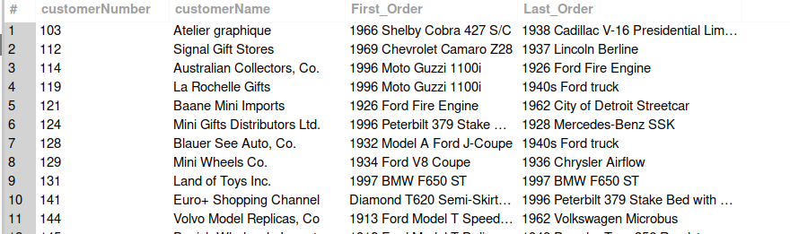
--------------------

7. Segment employees into groups based on the number of subordinates they manage.

Approach 1: LEFT JOIN with CASE
SELECT e.employeeNumber AS emp_id, COUNT(e2.employeeNumber) AS Managing,
CASE
WHEN COUNT(e2.employeeNumber) = 0 THEN 'Individual Contributer'
WHEN COUNT(e2.employeeNumber) BETWEEN 1 AND 3 THEN 'Small Team Manager'
ELSE 'Large Team Manager'
END AS emp_segment
FROM employees e
LEFT JOIN employees e2 ON e.employeeNumber = e2.reportsTo
GROUP BY emp_id
ORDER BY Managing DESC;
Explanation: Performs a self-join to link managers to their subordinates and counts the occurrences.
The CASE statement then categorizes them into clear functional groups based on the count.

Approach 2: Subquery in FROM Clause
SELECT e.employeeNumber AS emp_id, COALESCE(s.sub_count,0) AS Managing,
CASE
WHEN COALESCE(s.sub_count,0) = 0 THEN 'Individual Contributor'
WHEN COALESCE(s.sub_count,0) BETWEEN 1 AND 3 THEN 'Small Team Manager'
ELSE 'Large Team Manager'
END AS emp_segment
FROM employees e
LEFT JOIN (
SELECT reportsTo, COUNT(*) AS sub_count
FROM employees WHERE reportsTo IS NOT NULL
GROUP BY reportsTo
) s ON e.employeeNumber = s.reportsTo
ORDER BY Managing DESC;
Explanation: Aggregates the reporting counts first in a derived table before joining back to the main employee table.
Using COALESCE ensures that employees with no subordinates are correctly handled as having zero managed staff.
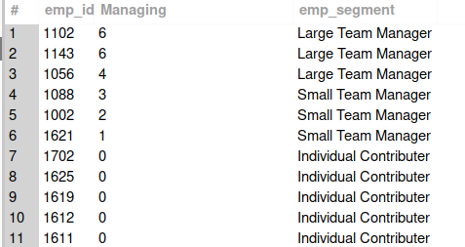

--------------------

8. For each customer, segment their payments into quartiles and calculate the percentage of payments in each quartile.

Approach 1: Nested Aggregation with NTILE
SELECT customerNumber, quartile, COUNT(*) AS payments_in_quartile,
ROUND(COUNT(*) * 100.0 / SUM(COUNT(*)) OVER(PARTITION BY customerNumber), 2) AS percentage
FROM (
SELECT customerNumber, NTILE(4) OVER(PARTITION BY customerNumber ORDER BY amount) AS quartile
FROM payments
) t
GROUP BY customerNumber, quartile
ORDER BY customerNumber, quartile;
Explanation: Groups payments into four equal parts per customer using NTILE(4) and then calculates their frequency.
The percentage is derived using a nested window function to get the total count within the same group.

Approach 2: Multi-step CTE Approach
WITH quartile_data AS (
SELECT customerNumber, NTILE(4) OVER(PARTITION BY customerNumber ORDER BY amount) AS quartile
FROM payments
),
total_payments AS (
SELECT customerNumber, COUNT(*) AS total_count
FROM payments GROUP BY customerNumber
)
SELECT q.customerNumber, q.quartile, COUNT(*) AS payments_in_quartile,
ROUND(COUNT(*) * 100.0 / t.total_count, 2) AS percentage
FROM quartile_data q
JOIN total_payments t ON q.customerNumber = t.customerNumber
GROUP BY q.customerNumber, q.quartile, t.total_count;
Explanation: This method breaks the logic into a ranking step and a total-count step using two CTEs.
It provides a more modular structure that is easier to debug and verify for complex percentage calculations.
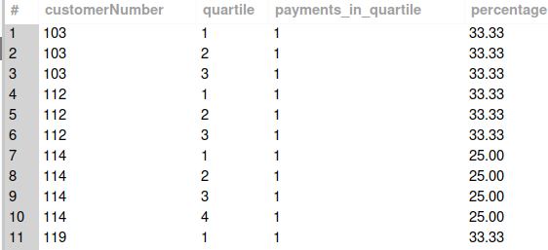

--------------------

9. Determine the total quantity of products sold in each country.

Approach 1: Multi-Table JOIN
SELECT c.country AS Country, SUM(od.quantityOrdered) AS Quantity
FROM customers c
JOIN orders o ON c.customerNumber = o.customerNumber
JOIN orderdetails od ON o.orderNumber = od.orderNumber
GROUP BY c.country;
Explanation: This query uses standard joins to trace order quantities back to the customer's home country.
It is the standard relational method for aggregating metrics across multiple descriptive tables.

Approach 2: Pre-aggregated Subquery
SELECT c.country AS Country, SUM(t.total_qty) AS Quantity
FROM customers c
JOIN orders o ON c.customerNumber = o.customerNumber
JOIN (
SELECT orderNumber, SUM(quantityOrdered) AS total_qty
FROM orderdetails GROUP BY orderNumber
) t ON o.orderNumber = t.orderNumber
GROUP BY c.country;
Explanation: This query sums quantities at the order level first before joining to customers and countries.
This can sometimes optimize performance by reducing rows involved in the primary join operations.
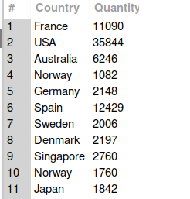

--------------------

10. Find customers whose total payments exceed the average payment for all customers.

Approach 1: HAVING with Subquery
SELECT c.customerNumber Cust_Number, c.customerName AS Cust_Name, SUM(p.amount) Amount
FROM customers c
JOIN payments p ON c.customerNumber = p.customerNumber
GROUP BY Cust_Number, Cust_Name
HAVING Amount > (
SELECT AVG(total_payments) FROM (
SELECT SUM(amount) AS total_payments FROM payments GROUP BY customerNumber
) t
) ORDER BY Amount DESC;
Explanation: This uses a HAVING clause to filter grouped results based on a dynamically calculated global average.
It identifies high-value customers by comparing their individual sum to the mean of all customer sums.

Approach 2: CTE for Better Readability
WITH customer_totals AS (
SELECT customerNumber, SUM(amount) AS total_payment
FROM payments GROUP BY customerNumber
)
SELECT c.customerNumber AS Cust_Number, c.customerName AS Cust_Name, ct.total_payment AS Amount
FROM customer_totals ct
JOIN customers c ON ct.customerNumber = c.customerNumber
WHERE ct.total_payment > (SELECT AVG(total_payment) FROM customer_totals)
ORDER BY Amount DESC;
Explanation: Pre-calculates customer totals in a CTE, making the final comparison and join logic much cleaner.
This approach is generally preferred for complex comparisons where the same aggregate value is used multiple times.
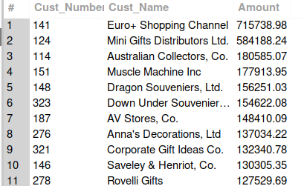

--------------------

11. Calculate the average time it takes for orders to be shipped after the orderDate for each country.

Approach 1: Subquery Calculation
SELECT Country, ROUND(AVG(day_diff)) AS Avg_Days
FROM (
SELECT c.country AS Country, DATEDIFF(o.shippedDate, o.orderDate) AS day_diff
FROM orders o JOIN customers c ON o.customerNumber = c.customerNumber
) k
GROUP BY Country ORDER BY Avg_Days;
Explanation: This calculates the difference in days for every single order before averaging them by country.
It provides a straightforward performance metric for logistics efficiency across geographical regions.

Approach 2: CTE for Shipping Metrics
WITH shipping_time AS (
SELECT c.country, DATEDIFF(o.shippedDate, o.orderDate) AS ship_days
FROM orders o JOIN customers c ON o.customerNumber = c.customerNumber
)
SELECT country, ROUND(AVG(ship_days)) AS Avg_Days
FROM shipping_time GROUP BY country ORDER BY Avg_Days;
Explanation: By defining shipping_time as a CTE, the query separates time-calculation from the logic of regional averaging.
This makes it easier to add further filters, such as excluding orders that haven't shipped yet.
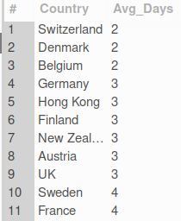
--------------------

12. Determine the top 5 products with the highest total sales (quantityOrdered * priceEach).

Approach 1: Standard Aggregation and Limit
SELECT p.productName AS Product_Name, SUM(od.quantityOrdered * od.priceEach) AS total_sales
FROM products p JOIN orderdetails od ON p.productCode = od.productCode
GROUP BY Product_Name ORDER BY total_sales DESC LIMIT 5;
Explanation: Multiplies quantity by price for every order line and sums them to get total revenue per product.
The LIMIT 5 ensures only the most profitable items are displayed.

Approach 2: CTE for Revenue Calculation
WITH cte_total_sales AS (
SELECT p.productName AS Product_Name, SUM(od.quantityOrdered * od.priceEach) AS total_sales
FROM products p JOIN orderdetails od ON p.productCode = od.productCode
GROUP BY Product_Name
)
SELECT Product_Name, total_sales FROM cte_total_sales
ORDER BY total_sales DESC LIMIT 5;
Explanation: Similar to approach 1 but structured for scalability by placing core logic in a CTE.
This allows for easier refinement, such as calculating percentage of total sales from these top products.
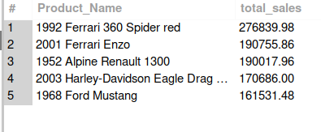
--------------------

13. Identify customers who have placed orders but never received them (i.e., shippedDate IS NULL).

Approach 1: Distinct Join with NULL check
SELECT DISTINCT c.customerNumber, c.customerName
FROM customers c JOIN orders o ON c.customerNumber = o.customerNumber
WHERE o.shippedDate IS NULL;
Explanation: Simply joins customers to orders and filters for rows where the shipping date has not been recorded.
DISTINCT ensures each customer is listed only once even if they have multiple pending orders.

Approach 2: EXISTS Clause
SELECT c.customerNumber, c.customerName
FROM customers c
WHERE EXISTS (
SELECT 1 FROM orders o WHERE o.customerNumber = c.customerNumber AND o.shippedDate IS NULL
);
Explanation: Uses semi-join logic to check for the presence of at least one unshipped order per customer.
This is often more efficient as the database stops searching once it finds a single matching record.
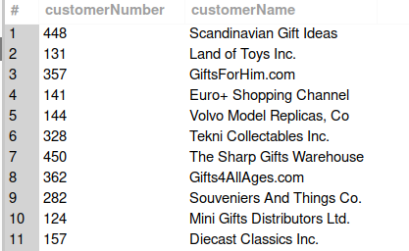
--------------------

14. List employees who do not have a manager (reportsTo IS NULL) and also do not manage anyone.

Approach 1: NOT IN Subquery
SELECT employeeNumber, CONCAT(firstName, ' ', lastName) AS employee_name
FROM employees
WHERE reportsTo IS NULL AND employeeNumber NOT IN (
SELECT reportsTo FROM employees WHERE reportsTo IS NOT NULL
);
Explanation: Filters for top-level staff (no manager) and then excludes anyone whose ID appears in the reportsTo column.
It effectively isolates employees who sit outside the traditional reporting chain.

Approach 2: NOT EXISTS Subquery
SELECT e1.employeeNumber, CONCAT(e1.firstName, ' ', e1.lastName) AS employee_name
FROM employees e1
WHERE reportsTo IS NULL AND NOT EXISTS (
SELECT 1 FROM employees e2 WHERE e1.employeeNumber = e2.reportsTo
);
Explanation: Uses the NOT EXISTS operator to verify that no other employee record references the current employee as manager.
This avoids potential pitfalls with NULL values that can occur with NOT IN in some database environments.
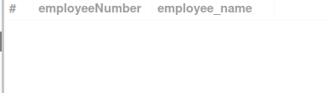
--------------------

15. Identify the month with the highest number of orders placed in the dataset.

Approach 1: Group and Limit
SELECT MONTHNAME(orderDate) AS Month_Name, COUNT(orderNumber) AS Total_Orders
FROM orders GROUP BY Month_Name ORDER BY Total_Orders DESC LIMIT 1;
Explanation: Aggregates order counts by month name and sorts them to find the most frequent value.
Simple and effective for pinpointing peak seasonal demand.

Approach 2: HAVING with ALL Subquery
SELECT MONTHNAME(orderDate) AS M, COUNT(orderNumber) AS Total_Orders
FROM orders GROUP BY M
HAVING COUNT(orderNumber) >= ALL (
SELECT COUNT(orderNumber) FROM orders GROUP BY MONTH(orderDate)
);
Explanation: Compares each month's total against a list of all monthly totals to find the maximum.
This mathematical approach handles ties automatically if multiple months share the exact same count.
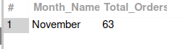
--------------------

16. Write a query to find customers who have not placed any orders in the past 12 months.

SELECT c.customerNumber, c.customerName
FROM customers c JOIN orders o ON c.customerNumber = o.customerNumber
GROUP BY c.customerNumber, c.customerName
HAVING MAX(o.orderDate) < CURDATE() - INTERVAL 12 MONTH
ORDER BY c.customerNumber;
Explanation: Checks the most recent order date for each customer to see if it is older than one year.
Only customers who have historically ordered but have since stopped are included in this result.

Approach 2: WHERE NOT EXISTS
SELECT c.customerNumber, c.customerName
FROM customers c
WHERE NOT EXISTS (
SELECT 1 FROM orders o
WHERE o.customerNumber = c.customerNumber AND o.orderDate >= CURDATE() - INTERVAL 12 MONTH
) ORDER BY c.customerNumber;
Explanation: Identifies customers who do not have any orders recorded within the last 12-month window.
This approach is comprehensive as it includes both lapsed customers and those who may have never ordered.
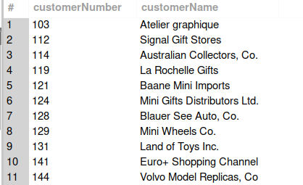
--------------------

17. Identify all customer-employee pairs where the employee’s office is in the same city as the customer.

Approach 1: Triple Table JOIN
SELECT c.customerName, CONCAT(e.firstName, ' ', e.lastName) AS employee_name, c.city
FROM customers c
JOIN employees e ON c.salesRepEmployeeNumber = e.employeeNumber
JOIN offices o ON e.officeCode = o.officeCode
WHERE c.city = o.city;
Explanation: Connects customers to their assigned reps and those reps to their office locations.
Filtering for matching cities reveals opportunities for local account management and face-to-face service.

Approach 2: JOIN with Subquery
SELECT c.customerName, CONCAT(e.firstName, ' ', e.lastName) AS employee_name, c.city
FROM customers c
JOIN employees e ON c.salesRepEmployeeNumber = e.employeeNumber
WHERE c.city = (SELECT city FROM offices WHERE officeCode = e.officeCode);
Explanation: Uses a scalar subquery to find the office city for each employee during the filtering step.
This reduces main JOIN complexity while achieving the same geographical match.
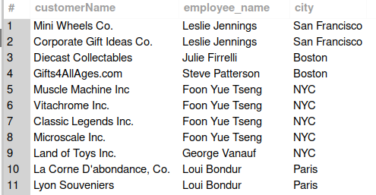
--------------------

18. Calculate the total buyPrice of all products in stock and compare it to the total MSRP value.

Approach 1: Direct Summation
SELECT SUM(buyPrice * quantityInStock) AS total_buy_price,
SUM(MSRP * quantityInStock) AS total_msrp_value
FROM products;
Explanation: Calculates total cost of inventory versus potential market value if units were sold.
This provides a high-level view of current assets and potential profit margins.

No Alternate Approach Required
-- Standard aggregation is the optimal way to solve this valuation.
Explanation: Simple arithmetic summation across the products table is efficient.
Used primarily for financial reporting and stock audits.
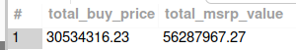

--------------------

19. Write a query to check if there are any circular reporting structures in the employees table.

Approach 1: Recursive Path Cycle Check
WITH RECURSIVE reporting_chain AS (
SELECT employeeNumber, reportsTo, employeeNumber AS start_employee FROM employees
UNION ALL
SELECT e.employeeNumber, e.reportsTo, rc.start_employee
FROM employees e JOIN reporting_chain rc ON e.employeeNumber = rc.reportsTo
)
SELECT * FROM reporting_chain WHERE start_employee = reportsTo;
Explanation: Traces reporting paths recursively and alerts if an employee eventually reports back to themselves.
Essential for identifying data entry errors or logical flaws in organizational data.

Approach 2: Direct A-B-A Check
SELECT e1.employeeNumber AS emp1, e2.employeeNumber AS emp2
FROM employees e1
JOIN employees e2 ON e1.reportsTo = e2.employeeNumber AND e2.reportsTo = e1.employeeNumber;
Explanation: Specifically looks for 'mutually reporting' pairs where two employees report directly to each other.
A simpler, faster check for the most common type of hierarchy error.
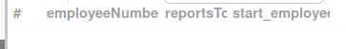
--------------------

20. Write a query to identify employees who have not completed any sales in the past 6 months.

Approach 1: LEFT JOIN with Aggregation
SELECT e.employeeNumber, CONCAT(e.firstName, ' ', e.lastName) AS EmployeeName
FROM employees e
LEFT JOIN customers c ON c.salesRepEmployeeNumber = e.employeeNumber
LEFT JOIN orders o ON c.customerNumber = o.customerNumber
GROUP BY e.employeeNumber
HAVING MAX(o.orderDate) IS NULL OR MAX(o.orderDate) < CURDATE() - INTERVAL 6 MONTH;
Explanation: Analyzes order dates per rep and identifies those whose last sale was over half a year ago.
The IS NULL condition ensures reps who have never made a sale are also flagged.

Approach 2: WHERE NOT EXISTS Semi-join
SELECT e.employeeNumber, CONCAT(e.firstName, ' ', e.lastName) AS EmployeeName
FROM employees e
WHERE NOT EXISTS (
SELECT 1 FROM customers c
JOIN orders o ON c.customerNumber = o.customerNumber
WHERE c.salesRepEmployeeNumber = e.employeeNumber AND o.orderDate >= CURDATE() - INTERVAL 6 MONTH
);
Explanation: Excludes any employee who has a recorded order within the last 6 months.
This logic is highly effective for generating performance reports for HR or sales managers.



