COD Process
Shipper Info.
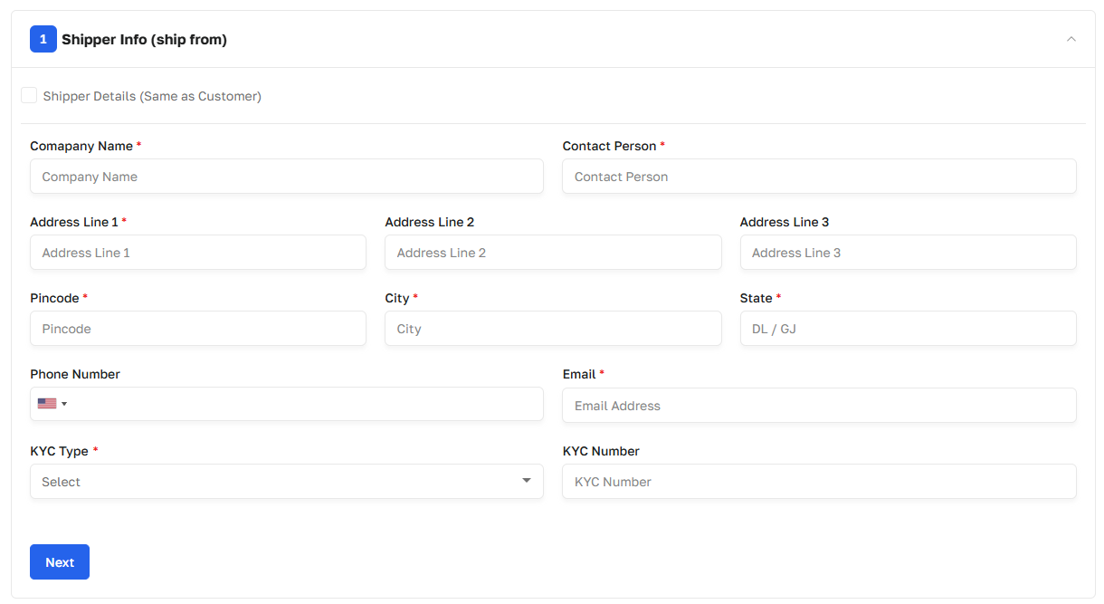

Bill To
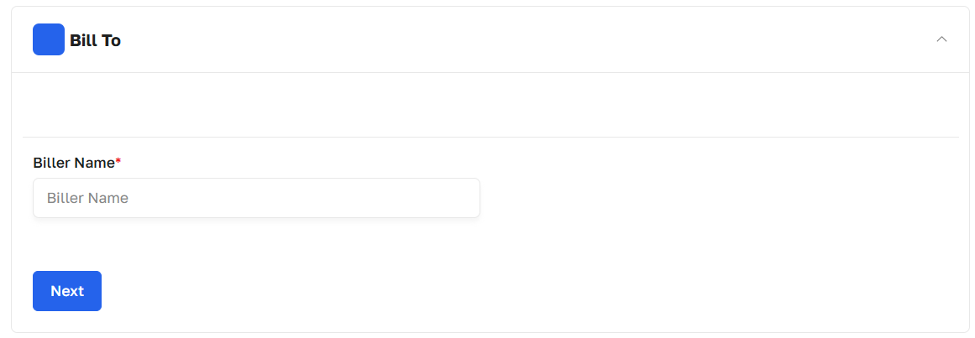

Consignee Info (ship to)
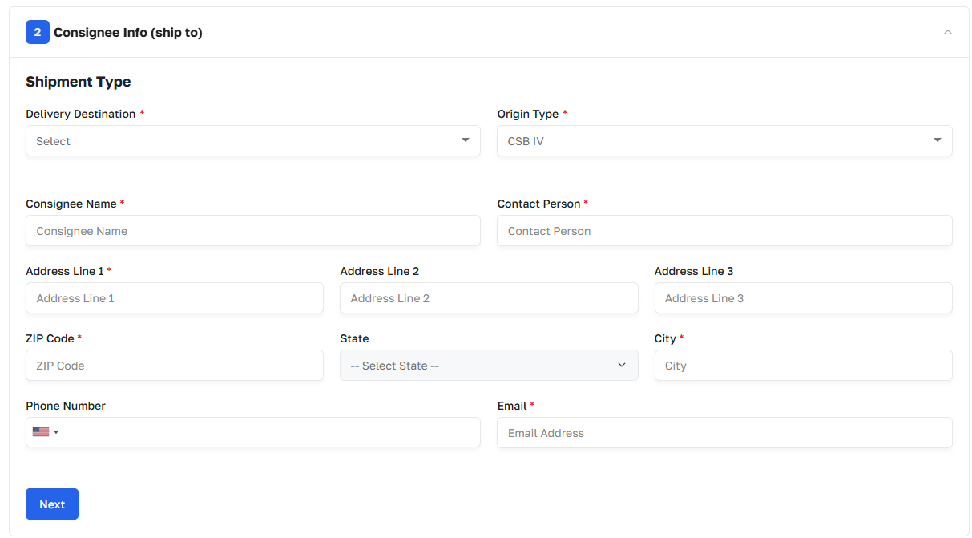

Package Dimension
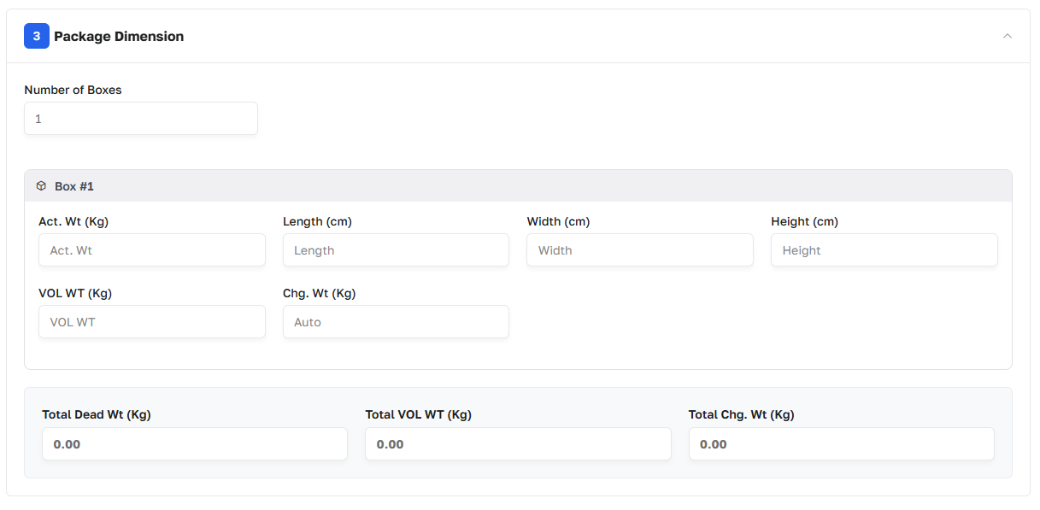

Shipment Invoice
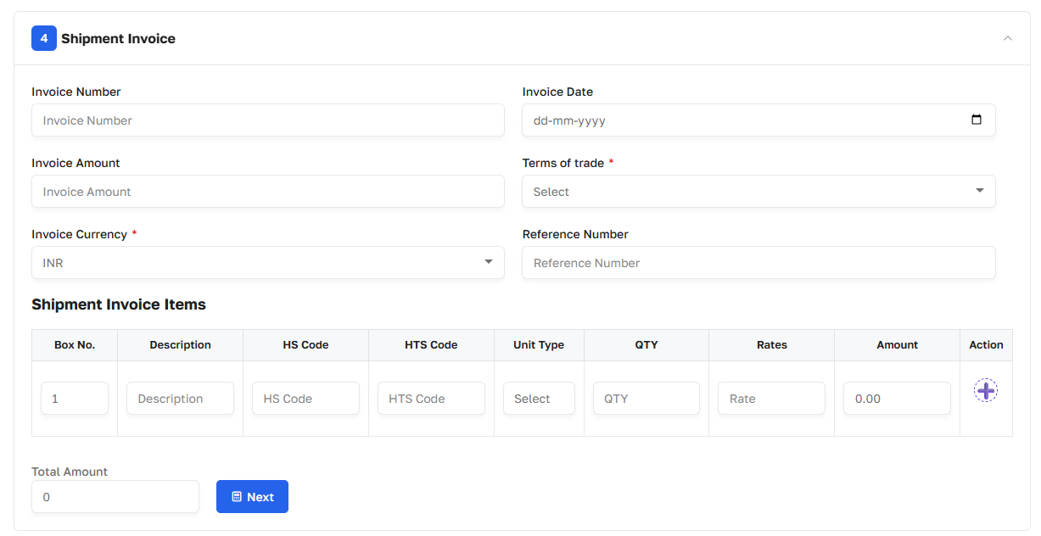
Shipment Type
Self UPS

Remark (mandatory)

Submit

1. COD – Cash on Delivery
- Self Option
  - If the Admin User selects Self during shipment creation, the shipment will be moved to the Received tab on the Admin side.
- UPS Option
  - If the Admin User selects UPS during shipment creation, the shipment will be moved to the Manifested tab on the Admin side.
- Financial User
  - The Financial User will close the shipment by entering the Final Amount.

FOC Process
Shipper Info.
Consignee Info (ship to)

Package Dimension
Shipment Invoice

Shipment Type
Self

Remark (Mandatory)

Submit

2. FOC – Free of Cost
- Bill To Section
  - The Bill To section is not required for FOC shipments.
- Self Option
  - If the Admin User selects Self during shipment creation, the shipment will be moved to the Received tab on the Admin side.

Note: COD & FOC process use only Single Form with all above conditions

**This is another module of shipment**
3. Prepaid Shipment
- Customer Wallet Recharge
  - If a shipment is being created for a customer with Payment Mode = Cash, the customer's wallet must first be recharged using the Cash Payment Mode.
  - The wallet should not be recharged using Credit for this process.
- API Selection for Manifestation
  - During shipment creation, the user must select the API/Shipping Service through which the shipment needs to be manifested.
  - Available options may include:
    - United Ground Premium
    - United Air Express
    - Overseas
    - Ship-Universal DHL
    - FedEx
    - Other configured shipping APIs

