|  |  |
| --- | --- |
| NAME | Chirag |
| UID | 23BCS14318 |
| CLASS | 622-B |

* ADBMS PRACTISE 4.2
* CODE (Part-A):- **Prevent Duplicate Enrollments Using Locking**

CREATE TABLE StudentEnrollments (

    enrollment_id INT PRIMARY KEY AUTO_INCREMENT,

    student_name VARCHAR(100),

    course_id VARCHAR(10),

    enrollment_date DATE,

    UNIQUE (student_name, course_id)

);

INSERT INTO StudentEnrollments (student_name, course_id, enrollment_date)

VALUES ('Ashish', 'CSE101', CURDATE()),

       ('Smaran', 'CSE102', CURDATE()),

       ('Vaibhav', 'CSE101', CURDATE());

-- User 1 starts a transaction

START TRANSACTION;

INSERT INTO StudentEnrollments (student_name, course_id, enrollment_date)

VALUES ('Varun', 'CSE101', CURDATE());

COMMIT;

-- User 1 starts a transaction

START TRANSACTION;

INSERT INTO StudentEnrollments (student_name, course_id, enrollment_date)

VALUES ('Varun', 'CSE101', CURDATE());

ROLLBACK; --Rollbacks because of the duplication

SELECT * FROM StudentEnrollments;

* OUTPUT

* CODE (Part-B):- **Use SELECT FOR UPDATE to Lock Student Record Insertion**

START TRANSACTION;

SELECT * FROM StudentEnrollments

WHERE student_name = 'Ashish' AND course_id = 'CSE101'

FOR UPDATE;

START TRANSACTION;

-- User B tries to update the same row

UPDATE StudentEnrollments

SET enrollment_date =DATE '2024-09-20'

WHERE student_name = 'Ashish' AND course_id = 'CSE101';

* OUTPUT

User B will be blocked until User A finishes the transaction.

* CODE (Part-C):- **Demonstrate Locking Preserving Consistency in Concurrent Transactions**

-- User A starts a transaction

START TRANSACTION;

SELECT * FROM StudentEnrollments

WHERE student_name = 'Ashish' AND course_id = 'CSE101'

FOR UPDATE;

UPDATE StudentEnrollments

SET enrollment_date = '2024-07-02'

WHERE student_name = 'Ashish' AND course_id = 'CSE101';

START TRANSACTION;

-- User B attempts to update the same row

UPDATE StudentEnrollments

SET enrollment_date = '2024-07-03'

WHERE student_name = 'Ashish' AND course_id = 'CSE101';

-- User A commits the transaction

COMMIT;

-- User B commits the transaction

COMMIT;

* Ouput:

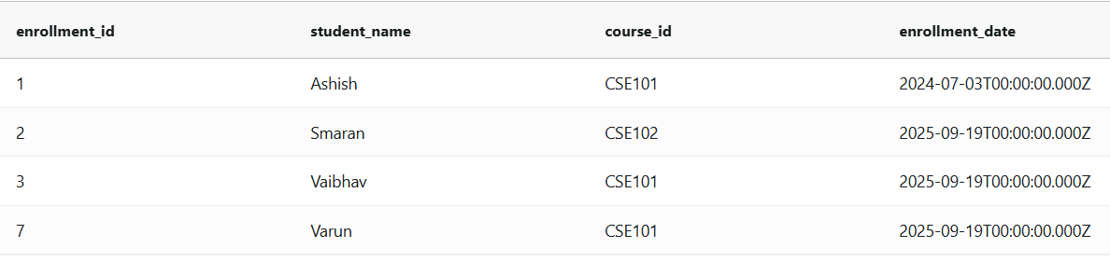

--Only the last transaction committed will be reflected.