|  |  |
| --- | --- |
| NAME | Chirag |
| UID | 23BCS14318 |
| CLASS | 622-B |

* ADBMS PRACTISE 4.3
* CODE (Part-A):- **Simulating a Deadlock Between Two Transactions**

CREATE TABLE StudentEnrollment (

    student_id      INT PRIMARY KEY,

    student_name    VARCHAR(100),

    course_id       VARCHAR(10),

    enrollment_date DATE

);

INSERT INTO StudentEnrollment

VALUES (1, 'Ashish', 'CSE101', DATE '2024-06-01'),

(2, 'Smaran', 'CSE102', DATE '2024-06-01'),

(3, 'Vaibhav', 'CSE103', DATE '2024-06-01');

START TRANSACTION;

UPDATE StudentEnrollment

SET enrollment_date = DATE '2024-09-01'

WHERE student_id = 1;

UPDATE StudentEnrollment

SET enrollment_date = DATE '2024-09-02'

WHERE student_id = 2;

START TRANSACTION;

UPDATE StudentEnrollment

SET enrollment_date = DATE '2024-09-03'

WHERE student_id = 2;

UPDATE StudentEnrollment

SET enrollment_date = DATE '2024-09-04'

WHERE student_id = 1;

* OUTPUT

Both transactions try to lock each other's rows in reverse order. This causes a deadlock, and the database automatically rolls back one transaction (usually the one that waited longest) to break the cycle.

* CODE (Part-B):- **Applying MVCC to Prevent Conflicts During Concurrent Reads/Writes**

INSERT INTO StudentEnrollment

VALUES (1, 'Ashish', 'CSE101', '2024-06-01');

COMMIT;

START TRANSACTION;

SELECT student_id, student_name, course_id, enrollment_date

FROM StudentEnrollment

WHERE student_id = 1;

START TRANSACTION;

UPDATE StudentEnrollment

SET enrollment_date = '2024-07-10'

WHERE student_id = 1;

COMMIT;

SELECT student_id, student_name, course_id, enrollment_date

FROM StudentEnrollment

WHERE student_id = 1;

COMMIT;

SELECT student_id, student_name, course_id, enrollment_date

FROM StudentEnrollment

WHERE student_id = 1;

* 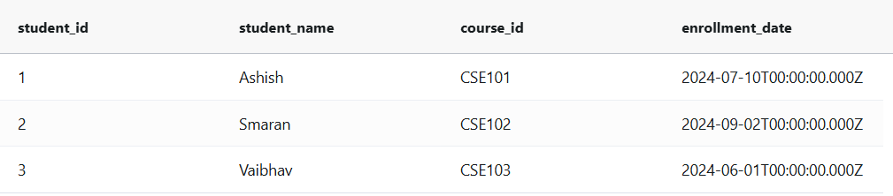OUTPUT
* CODE (Part-C):- **Comparing Behavior With and Without MVCC in High-Concurrency**
* **Using Traditional Locking::**

--Session 1(Writer):

START TRANSACTION;

UPDATE StudentEnrollment

SET enrollment_date = '2024-07-11'

WHERE student_id = 1;

--Session 2(Reader):

START TRANSACTION;

SELECT enrollment_date

FROM StudentEnrollment

WHERE student_id = 1

FOR UPDATE;

* Ouput:
* Session 2 blocks until Session 1 commits.
* Reader cannot access the row because SELECT FOR UPDATE acquires a lock.
* **Using MVCC::**

--Session 1(Writer):

START TRANSACTION;

UPDATE StudentEnrollment

SET enrollment_date = '2024-07-11'

WHERE student_id = 1;

COMMIT;

--Session 2(Reader):

START TRANSACTION;

SELECT enrollment_date

FROM StudentEnrollment

WHERE student_id = 1;

* Ouput:
* Reader does not block.
* Sees the old value if its transaction started before the writer committed.
* **Traditional Locking**: The reader is blocked until the writer commits because SELECT … FOR UPDATE acquires an exclusive lock. The writer holds the lock on the row until it commits.
* **MVCC (Multiversion Concurrency Control):** The reader sees a consistent snapshot of the data without being blocked, even while the writer updates the row concurrently. The writer can commit the update without affecting the reader’s transaction.