Output

Step – 1 – Compile the code, here the compiler used is 0.8.0+ version

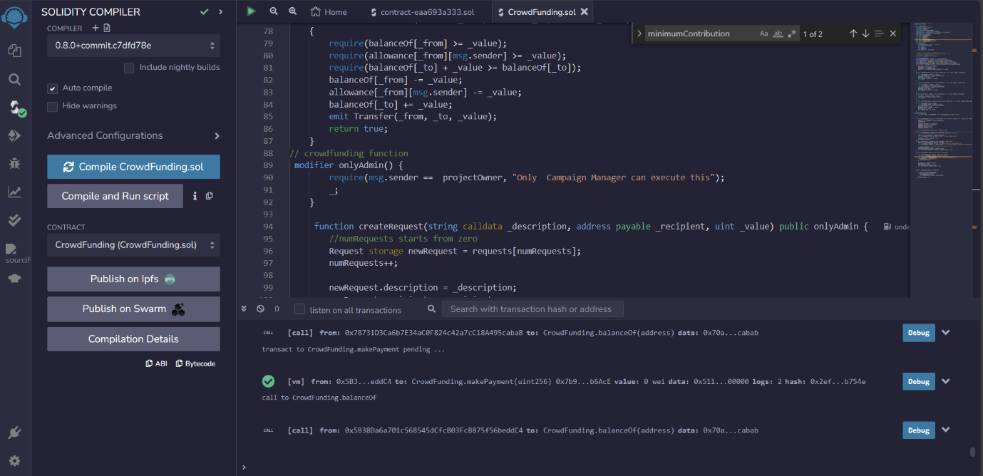

Step – 2 – Deploy the contract with the initial address as the admin’s address, enter the Funds amount and duration of the contract and then deploy it. Once deployed, we can see the success transaction message in the transaction area.

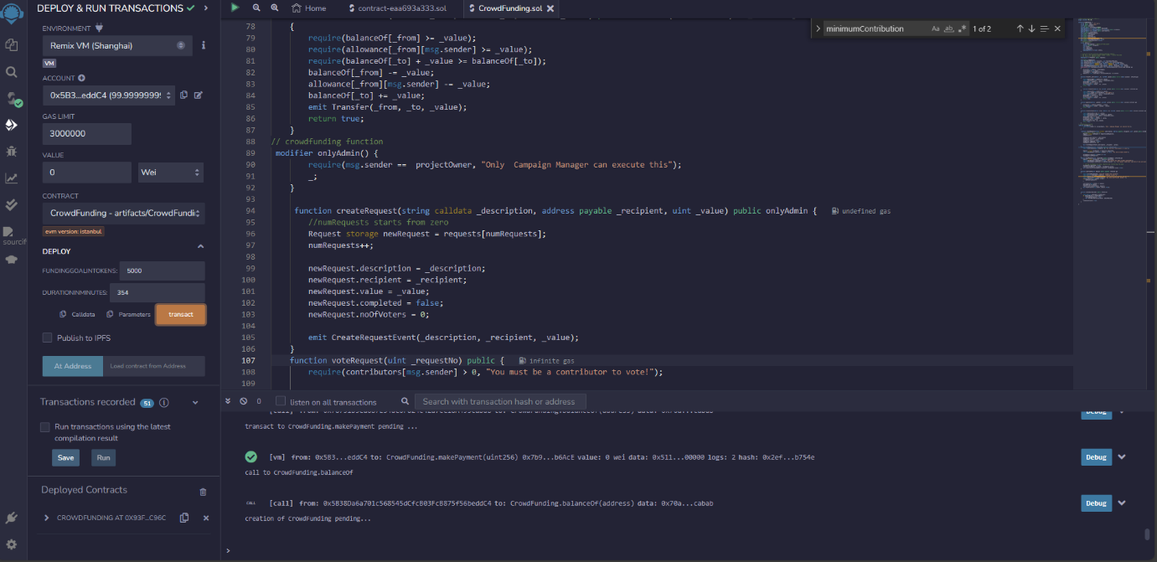

Step – 3 – Now, the admin will transfer the VIT coin currency to each of the contributors using the transfer function (this is only admin enabled function and none of the user can access this function due to the condition applied in line 62). After the transaction, each of the contributors can verify their balance using balanceof function.

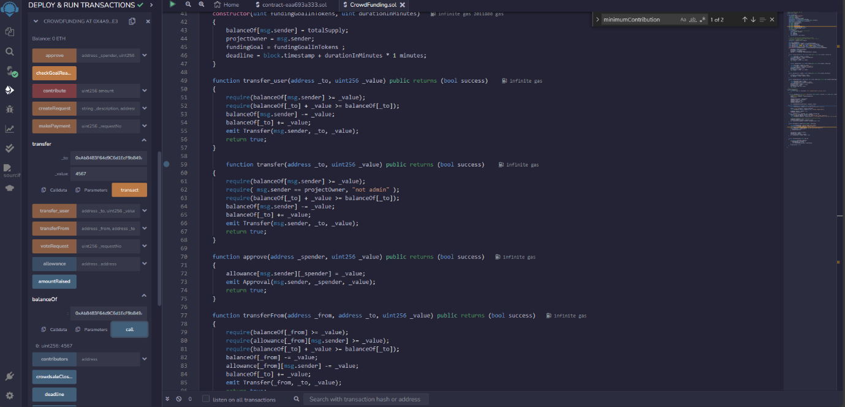

Step – 4 – After sending money to three contributors, the balanceof function is used to show the balance coins remaining with the admin. (total Supply of VIT Coins are 100000).

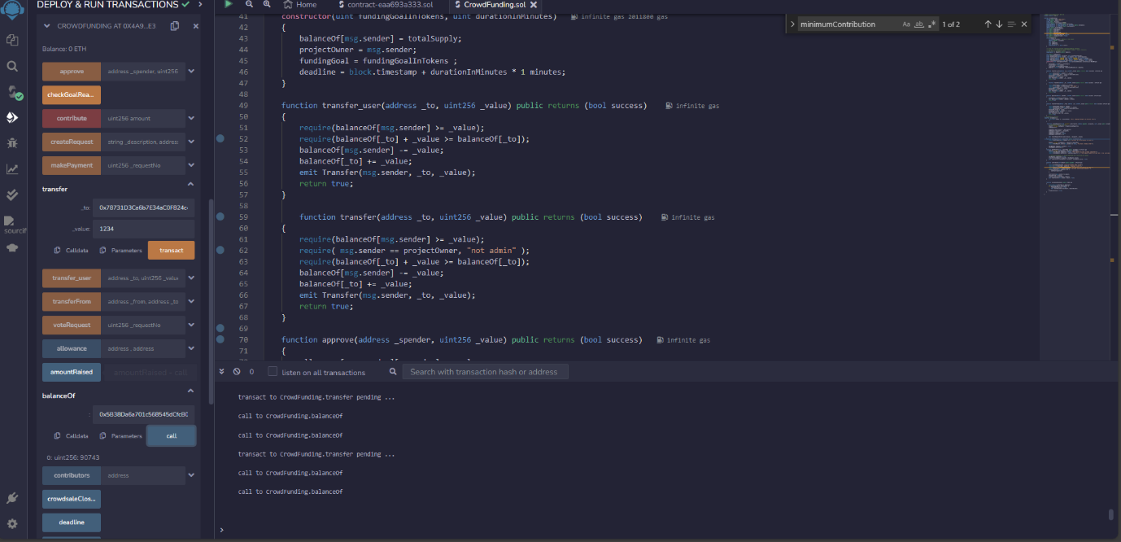

Step – 5 – Now, each of the contributors can contribute to the campaign using the contribute function.

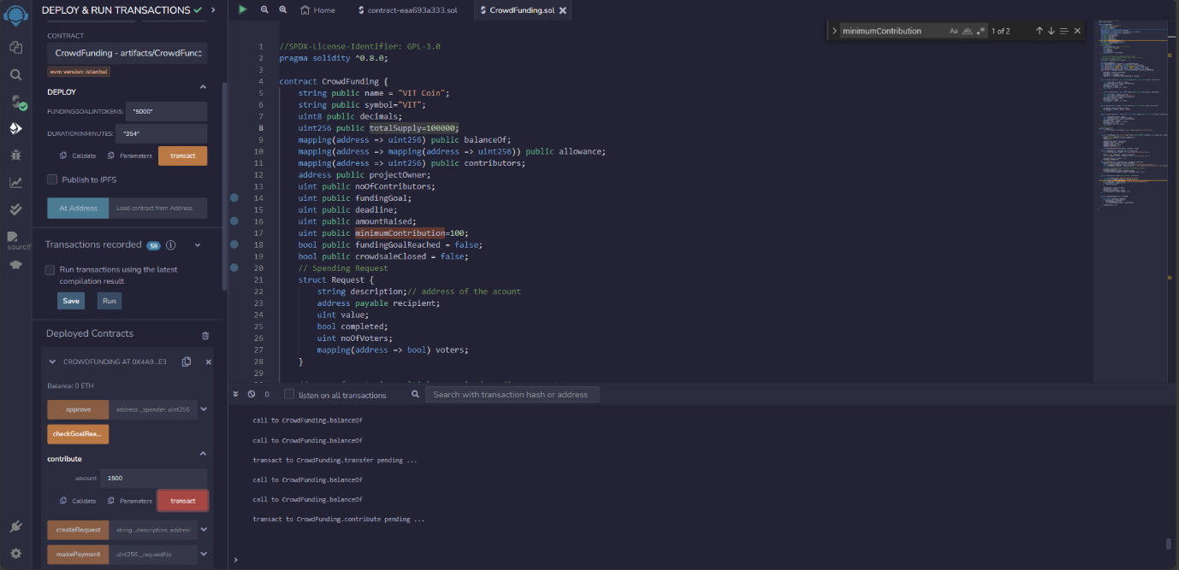

Step – 6 – Now the admin will create the spending request using the contribute function. Here the spending request is created for the task name – “ The Cloud Computing” along the address of the recipient and the value requested by the task

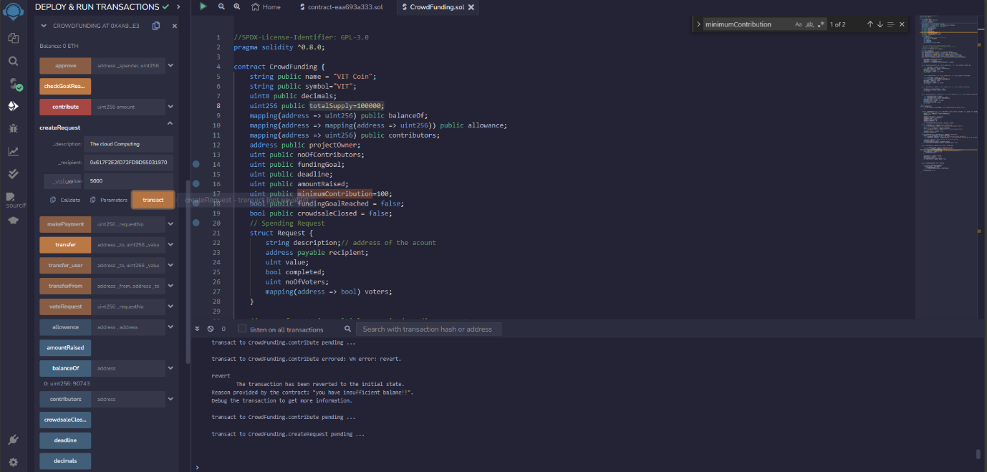

Step – 7 – After creating the request, the request function is used to verify the details of the spending request.

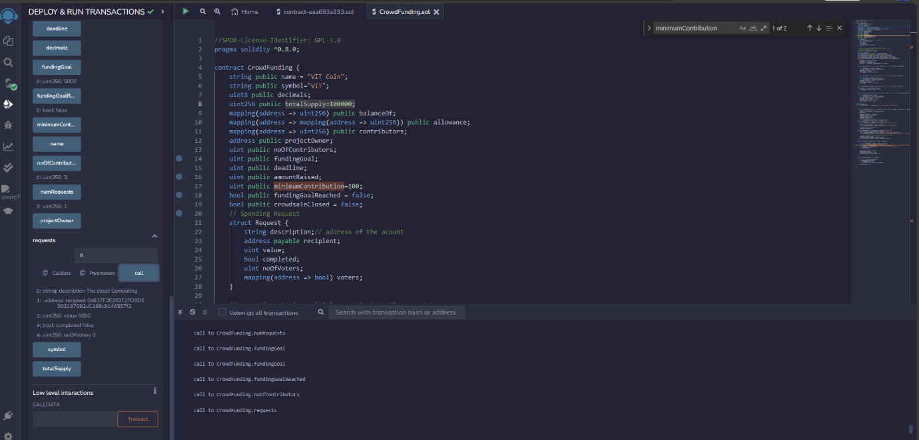

Step – 8 – Voting by individual contributors for each of the created spending request and this is done using the voteRequest function.

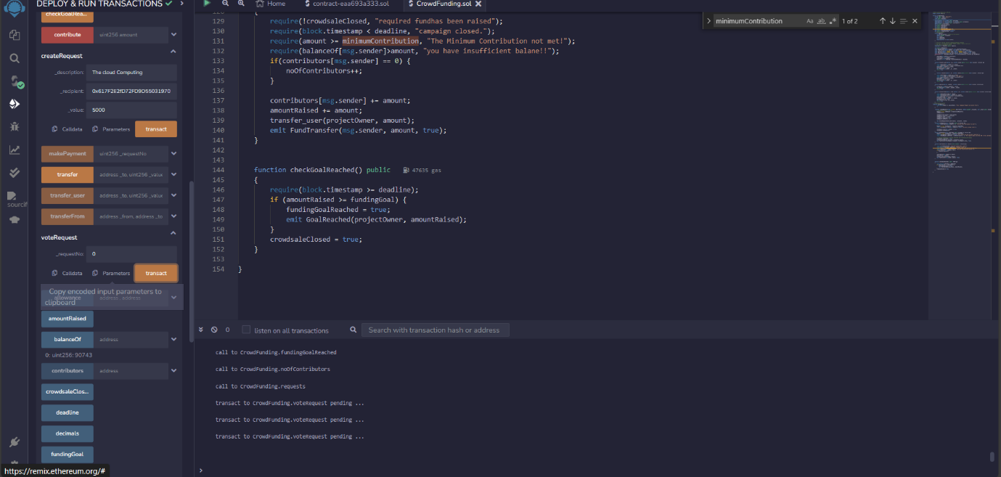

Step – 9 – Now the admin will verify the number of votes for each of the spending request and if the number of votes are greater than the threshold, then the amount is transferred by the admin to the recipient of the spending request and this is done using the makePayment function and the recipient can verify whether they have received by money or not by using the balanceOf function.

