A novel Brain tumor Classification Algorithm using MDCN algorithm on MRI based images

Abstract:

In the area of image processing, the study of brain tumors involves intricate analysis and interpretation of medical images such as MRIs and CT scans. Leveraging advanced algorithms and techniques, image processing plays a pivotal role in detecting, classifying, and understanding the characteristics of brain tumors. Deep convolutional neural networks, well-known for their adeptness in feature extraction, have proven their efficacy in various detection and classification tasks. Nevertheless, they necessitate substantial training datasets and meticulous parameter tuning. The Modified Dense Convolutional Network (MDCN) proposed in this study presents a valuable classification framework for categorizing brain tumors. Leveraging the capabilities of pre-trained networks, the MDCN adapts them to the specific context of brain tumor classification through the incorporation of transfer learning techniques. The data loader constructs mini-batches for model training, significantly reducing the training time. Additionally, optimization approaches are employed to enhance the overall model efficiency and reduce computational costs. The MDCN is applied to the BrainTumorBD Dataset, comprising a total of 4,205 images. Experimental results demonstrate that the proposed system outperforms existing techniques, achieving superior performance and overall throughput.

Keywords:

Brain Tumor detection, Deep convolutional neural networks, Transfer Learning, Optimization, BrainTumorBD Dataset

Introduction:

According to the 2016 reclassification by the World Health Organization (WHO), a brain tumor pertains to abnormal growth in the central nervous system, resulting in a decline in brain tissue size and disruption to the neural network. Brain tumors, categorized as cancerous or non-cancerous (benign and malignant), manifest in areas like meningioma, glioma, and pituitary, each varying in malignancy. Initial assessments by oncologists utilize medical imaging, particularly Magnetic Resonance Imaging (MRI) and Computed Tomography (CT) scans, to detect structural changes. Surgical biopsy may be required for detailed diagnosis if a brain tumor is suspected, with advancements in imaging technologies enhancing contrast and resolution for accurate identification.

Traditionally, brain tumor identification processes have heavily relied on human experts using their knowledge, experience, and, at times, basic diagnostic tools. However, the human-centric approach has inherent limitations, including subjectivity, potential for errors, and scalability challenges. In the contemporary era, where technology and healthcare intertwine more seamlessly, the convergence of machine learning and medical imaging holds great promise for brain tumor detection and classification. Deep Learning, a subset of machine learning, has demonstrated substantial potential in various applications, with deep neural networks (DNNs) taking the lead in tasks requiring image recognition and classification.

A prominent architecture in the deep learning community is the Dense Convolutional Network (DenseNet). Distinguished by its unique ability to establish direct connections between any two layers, ensuring maximal information flow, DenseNet is highly efficient and mitigates the vanishing gradient problem often encountered in deep networks. However, challenges persist, and its efficacy in specific tasks, such as brain tumor classification, warrants exploration. Brain tumors exhibit diverse characteristics, and accurately classifying and detecting them using algorithms presents several challenges:

* Data Imbalance: Some tumor types may be more prevalent than others, leading to an imbalance in the training dataset. Algorithms trained on such imbalanced datasets might be biased towards detecting common tumors while overlooking or misclassifying rarer ones.
* Overlapping Symptoms: Certain brain tumors may have symptoms that are similar or overlap with others, complicating accurate classification. For example, one type of tumor-induced anomaly may resemble another, leading to potential misclassification.
* Image Quality and Diversity: The quality of medical images is crucial for algorithm performance. Variations in imaging conditions, angles, and resolution, along with issues such as shadows or blurriness, can impact accuracy.
* Ambient Noise: Medical images may include background clutter or other structures, introducing noise that can hinder accurate tumor identification.
* Incomplete Data: Effective algorithms require a substantial amount of training data. Missing images of specific tumor types or stages can hinder the algorithm's ability to identify them.
* Computational Complexity: Some advanced algorithms may demand high computational resources, posing challenges for real-time processing or deployment on devices with limited computing capabilities.

Motivated by these challenges and the imperative for advanced, accurate, and scalable solutions in brain tumor classification, this literature introduces a novel algorithm: the Modified Dense Convolution Network (MDCN). Seeking to overcome pitfalls from previous methods, MDCN capitalizes on the strengths of the original DenseNet architecture while introducing tailored modifications for the intricate task of classifying brain tumors. The algorithm aims to provide a more accurate, efficient, and actionable tool for healthcare professionals and the broader scientific community.

A distinctive feature of the Modified Dense Convolution Network is its adept utilization of transfer learning. Recognizing the resource-intensive nature of training deep learning models from scratch, transfer learning enables the algorithm to leverage pre-existing knowledge from related tasks, optimizing efficiency. This is complemented by data loaders, ensuring efficient batch processing for streamlined and accelerated training. To address challenges such as overfitting and unnecessary computational expenditure, the algorithm embraces optimization strategies, particularly early stopping mechanisms, balancing bias and variance. The proposed MDCN algorithm's efficiency is evaluated based on accuracy, F1 score, and precision, utilizing the BrainTumorBD dataset, specifically chosen for its inclusion of diverse brain tumor classes. Comparative assessments involve algorithms such as Visual Geometry Group (VGG16), Residual Network (ResNet), Traditional-DenseNet, and Convolution Neural Network (CNN).

In summary, the main contributions and novelty of the proposed algorithm are outlined as follows:

* MDCN integrates the synergy of transfer learning and advanced data loader techniques, leveraging pre-trained models and streamlining the data ingestion process for optimal transmission.
* Advanced optimizer techniques ensure that MDCN converges efficiently, reducing training times and enhancing robustness.
* While building on the DenseNet architecture, MDCN introduces innovative modifications to enhance the network's ability to capture and differentiate subtle features of various brain tumors.
* MDCN achieves an impressive accuracy of 96.51% in detecting and classifying brain tumors, setting a new benchmark when compared to traditional and state-of-the-art algorithms.

The subsequent sections of this work include a review of existing works in Section 2, the formulation and discussion of the introduced algorithm in Section 3, a summary of experimental findings in Section 4, and a concluding Section 5.

Literature Survey:

1. Brain tumor MRI images identification and classification based on the recurrent convolutional neural network

Detecting and analyzing brain tumors are crucial for any diagnostic system, and substantial research has been dedicated to procedural development over time. This study aims to enhance tumor detection accuracy by implementing an efficient automated system. Various segmentation algorithms have been devised to improve the precision of brain tumor classification, recognizing the complexity of brain image segmentation in medical image processing. The proposed method encompasses MRI image preprocessing, segmentation using the improved K-means clustering algorithm, feature extraction using the gray level co-occurrence matrix, and image classification utilizing a recurrent convolutional neural network (RCNN). The experiments, conducted on a Kaggle dataset with 394 testing sets and 2870 training set MRI images, demonstrate superior results compared to previous methods. The proposed RCNN classifier achieves a 95.17% accuracy in classifying brain tumor tissues from MRI images, outperforming BP, U-Net, and RCNN methods.

1. Classification of Brain Tumors from MRI Images Using a Convolutional Neural Network

Brain tumor classification traditionally involves a biopsy, typically conducted during definitive brain surgery. Technological advancements, coupled with machine learning, offer non-invasive alternatives for radiologists in tumor diagnostics. This study introduces a simplified convolutional neural network (CNN) architecture specifically designed for classifying three brain tumor types using T1-weighted contrast-enhanced magnetic resonance images. The network's performance was assessed through various cross-validation methods and databases, demonstrating a high accuracy of 96.56% in the record-wise cross-validation with augmented data. With strong generalization capability and efficient execution speed, this new CNN architecture holds promise as an effective decision-support tool for radiologists in medical diagnostics.

1. Classification of Brain MRI Tumor Images Based on Deep Learning PGGAN Augmentation

The high prevalence of brain tumors across age groups highlights the importance of early and accurate tumor type identification for optimal treatment planning. Convolutional Neural Networks (CNNs) have improved the precision of brain tumor classification from magnetic resonance images (MRIs). However, limited MRIs may lead to CNN overfitting. Augmentation, recognized as a solution, optimizes the learning stage, enhancing overall efficiency. This study assesses a novel approach, employing a VGG19 feature extractor and one of three classifiers for brain tumor MRI classification. A Progressive Growing Generative Adversarial Network (PGGAN) augmentation model produces realistic MRIs, addressing image scarcity for deep learning. Results demonstrate superior classification accuracy of gliomas, meningiomas, and pituitary tumors (98.54%) compared to prior studies, with additional performance metrics considered.

1. Explainable Convolutional Neural Networks for Brain Cancer Detection and Localisation

Brain cancer is widely acknowledged as an extremely aggressive tumor type, with a survival rate of approximately 30%. This study introduces a method for detecting and localizing brain cancer through the analysis of magnetic resonance images. Leveraging deep learning, specifically convolutional neural networks and class activation mapping, the proposed method aims to provide explainability by highlighting areas in medical images associated with brain cancer. The evaluation, conducted on 3000 magnetic resonance images from a freely available dataset, demonstrates promising results. The accuracy in brain cancer detection ranges from 97.83% to 99.67% across four different models (VGG16, ResNet50, Alex_Net, and MobileNet), affirming the efficacy of the proposed approach.

1. Brain Pathology Classification of MR Images Using Machine Learning Techniques

Detecting and classifying brain tumors from MRI scans before initiating therapy is vital, considering tumors as anomalous tissue collections. Employing machine learning for tumor segmentation and classification in brain MRI scans is challenging yet crucial for diagnostics, preoperative planning, and postoperative evaluations. Accurate tumor location determination on a brain MRI is paramount, and advancements in machine learning classifiers can enable non-invasive malignancy detection. The process involves pre-processing, skull stripping, tumor segmentation, and measurement (size and form). To mitigate overfitting in CNN models due to a large training image set, this study employs deep CNN with transfer learning. The CNN-based Relu architecture and SVM with fused features (HOG and LPB) classify glioma or meningioma in brain MRI tumors. The method's effectiveness is assessed using precision, recall, F-measure, and accuracy metrics, revealing SVM with combined LBP and HOG achieving 97% accuracy, and deep CNN achieving 98%.

1. Brain Tumor Detection Based on Deep Learning Approaches and Magnetic Resonance Imaging

This study tackled the complex task of brain tumor detection in MRI scans using an extensive dataset of brain tumor images. By fine-tuning a YOLOv7 model through transfer learning, we significantly improved its performance in detecting gliomas, meningiomas, and pituitary brain tumors. Our proposed deep learning model exhibited promising results, accurately identifying the presence and precise location of brain tumors in MRI images. Compared to standard techniques, our approach achieved a remarkable 99.5% accuracy in our analysis. However, recognizing the need for further investigation, especially for small tumors, ongoing research in brain tumor identification is crucial for continuous refinement of our detection systems. This pursuit aims to enhance diagnostic capabilities in the challenging battle against brain cancers for both patients and medical practitioners.

1. MRI-Based Effective Ensemble Frameworks for Predicting Human Brain Tumor

Early diagnosis of brain tumors is crucial for patient survival, with untreated cases having a rapid mortality risk. To achieve early and effective detection, an automated method is essential. This study focuses on early brain tumor detection using brain MRI data and efficient learning paradigms. Convolutional Neural Networks (CNN) excel in visual feature extraction, and deep convolutional layers are employed for efficient classification of brain tumor patients. The deep CNN extracts comprehensive features for model training, enhancing precision in tumor and non-tumor patient classifications. The study explores five machine learning (ML) methods to broaden understanding and significance in brain tumor classification. Additionally, an ensemble of three high-performing ML models (Extreme Gradient Boosting, Ada-Boost, and Random Forest - XG-Ada-RF) is proposed for binary class classification, achieving the highest accuracy of 95.9% for tumors and 94.9% for normal cases. This ensemble approach outperforms individual methods, demonstrating improved accuracy.

1. Object Detection for Brain Cancer Detection and Localization

Brain cancer, a highly aggressive tumor, significantly impacts patient survival, with approximately 70% facing poor outcomes. This paper introduces an automated method utilizing magnetic resonance imaging for brain cancer detection and localization. The goal is to enhance detection precision and localize brain cancer for improved prognosis and treatment. The YOLO model is employed, achieving a detection precision of 0.943 and a recall of 0.923 in analyzing 300 brain images. For brain cancer localization, an mAP_0.5 of 0.941 is attained, demonstrating the proposed model's effectiveness.

1. Brain Tumor Segmentation from MRI Images Using Handcrafted Convolutional Neural Network

This research presents an innovative hybrid approach for brain tumor segmentation in magnetic resonance imaging (MRI) scans, crucial for diagnosis and treatment planning. The method combines handcrafted features, including intensity, texture, and shape, with a convolutional neural network (CNN) designed for automatic feature detection. The hybrid method integrates these features into a new CNN through distinct pathways. Using the Brain Tumor Segmentation (BraTS) challenge dataset, various assessment measures such as segmentation accuracy, dice score, sensitivity, and specificity were employed. Results demonstrated superior performance compared to traditional handcrafted or individual CNN-based methods, highlighting the effectiveness of our approach. The inclusion of handcrafted features enhanced CNN performance, offering a more robust and generalizable solution with potential applications in real-world clinical settings. Future research directions may explore alternative feature fusion techniques and incorporate additional imaging modalities to further enhance method performance.

1. An Augmented Modulated Deep Learning Based Intelligent Predictive Model for Brain Tumor Detection Using GAN Ensemble

Detecting brain tumors in the early stages poses a challenge for clinicians globally, given the rigorous diagnosis in advanced stages. Despite existing clinical tools and machine learning (ML) models for effective patient diagnosis, they exhibit lower accuracy and prolonged screening times. This underscores the need for a more precise model facilitating accurate early-stage brain tumor screening. This research presents a performance analysis of various generative adversarial networks (GANs) for early brain tumor detection. Introducing a novel hybrid enhanced predictive convolutional neural network (CNN) using a GAN ensemble, brain tumor image data is augmented and classified using a modulated CNN technique. The soft voting approach, based on GAN results, determines the final prediction. Evaluation with a progressive-growing generative adversarial network (PGGAN) architecture yields superior results, outperforming others with accuracy, precision, recall, F1-score, and negative predictive value (NPV) at 98.85%, 98.45%, 97.2%, 98.11%, and 98.09%, respectively. Additionally, PGGAN demonstrates very low latency (3.4 s), enhancing real-time identification of brain cell tissues. Thus, utilizing PGGAN augmentation with the proposed modulated CNN technique suggests optimal performance in brain tumor detection using the soft voting approach.

1. Brain tumor detection in MR image using superpixels, principal component analysis and template based K-means clustering algorithm

In the contemporary era, human brain tumors pose an extreme threat to individuals, leading to inevitable consequences. The increasing complexity of a patient's life underscores the critical need for early tumor detection to save and extend their lifespan. Consequently, the medical field demands enhanced brain tumor detection methods. While existing approaches, such as random forest, Fuzzy C-means, artificial neural network (ANN), and wavelet transform, fall short in accuracy and entail longer execution times (in minutes), this paper introduces an improved brain tumor detection scheme. Leveraging the template-based K-means (TK) algorithm with superpixels and principal component analysis (PCA), our approach efficiently identifies human brain tumors with reduced execution times. Essential features are extracted using both superpixels and PCA, enhancing accuracy, followed by image enhancement using a filter. Subsequently, image segmentation is performed through the TK-means clustering algorithm. Experimental results demonstrate that our proposed detection scheme achieves superior accuracy and significantly reduced execution times (in seconds) compared to existing methods for brain tumor detection in MR images.

1. Logistic Regression Machine Learning Algorithm On Mri Brain Image For Fast And Accurate Diagnosis

In the medical field, the demand for swift and precise diagnoses is critical for effective treatment. Current technologies often lack this capability, necessitating the development of efficient diagnostic applications. This study proposes a computer-aided automatic detection system for brain disorders and tumors using logistic regression (LR)-based machine learning (ML) classification and global threshold segmentation for pre-processing. The methodology involves image acquisition and de-noising in the first stage, followed by ML-based classification and regression in the second stage. The experiment utilizes 120 brain images, including 15 normal and 105 abnormal cases from a real-time MRI brain database. The computational approach employs threshold segmentation coupled with LR-ML classification, achieving a remarkable accuracy of 99.46% on training and testing images. A comparison with recent techniques underscores the superior speed, real-time capabilities, and accuracy of the LR-ML with threshold segmentation for brain diagnosis.

The investigation uncovers a shared objective among all algorithms: the enhancement of detection rates and precise image classification through diverse techniques. Despite the existence of numerous algorithms, each asserting superior performance, only a few genuinely enhance detection and classification, as revealed by an in-depth literature review. Factors such as computational efficiency, scalability, and generalization ability can impede an algorithm's effectiveness. In response to these challenges and with the aim of surpassing existing algorithms, a novel approach has been introduced. This advanced method for brain tumor detection and classification places a strong emphasis on performance and accuracy. The Modified Dense Convolution Network (MDCN) not only confronts these challenges directly but also streamlines training time and necessitates fewer epochs. This innovative algorithm builds upon the foundation of the established Dense Net algorithm.

Proposed Method:

1. Brain Tumor image dataset

The comprehensive diagnosis and detection of brain tumors necessitate a dataset of considerable richness and depth, meticulously curated and assembled from the BrainTumorBD Dataset. Boasting a total of 4,205 images, this dataset presents an exhaustive portrayal of three different brain tumor ailments. Intriguingly, among these, 3100 images depict distinct individual tumor, offering a glimpse into the breadth and diversity inherent in real-world scenarios. Noteworthy among these are diseases such as meningioma, glioma, and pituitary conditions. Each of these three categories comprises 1400 images, ensuring a well-balanced representation. The ensuing figure provides a visual representation of brain tumor samples from specific classes within the dataset, with each image sized pixel of 500 x 500 dimensions.

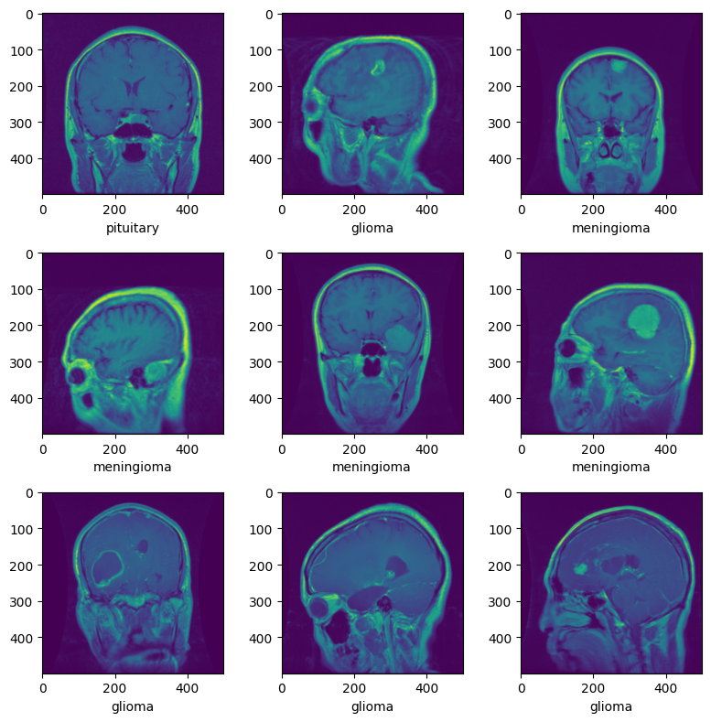

Figure 1: Sample of different brain tumor along with the class name.

1. Normalization and Splitting

Enhancing the efficacy of pre-trained models hinges on the normalization of input images to align with the training conditions of these models. Achieving this involves employing a transformation sequence that standardizes the images to a specific format and a predefined range of values. A conventional transformation sequence involves reading the images into the PILImage format using Torchvision and subsequently converting them to FloatTensor format with a value range of [0, 1] through the application of the ToTensor function. The subsequent step in image normalization entails subtracting the mean pixel value (0.5) from each image and dividing the result by the standard deviation (0.5). This meticulous process ensures that the image values are transformed to fall within the desired range of [0, 1], aligning them with the model's training expectations.

-- (1)

In this context, µ denotes the mean, and σ represents the standard deviation, both consistently set at 0.5. C signifies the mini-batch channel, while H corresponds to height, and W denotes width, with a minimum expectation of 224 for both H and W. The BrainTumorBD dataset undergoes a meticulous normalization process utilizing the mean and standard deviation of its pixel values. Specifically, the mean pixel values for each channel are 0.467, 0.489, and 0.437, while the standard deviation for each channel is 0.232, 0.287, and 0.245. The normalization procedure involves deducting the mean pixel value from each channel and subsequently dividing it by the channel's standard deviation, thereby transforming the pixel values into the desired range of [0, 1].

To address concerns related to imbalanced datasets, a prudent approach involves partitioning the data into an 80:20 ratio for training and validation, thereby establishing distinct datasets for each purpose. Organized within individual folders named after their respective classes, the images benefit from automatic labeling, facilitating seamless categorization. The DataLoader adeptly manages these labeled images, overseeing both the Training Data (Image) and the corresponding Label (Class Name). This meticulous organization unfolds into three well-defined classes. Subsequently, the data undergoes processing, channeling it either through CUDA (GPU) or the CPU, paving the way for model definition. Furthermore, Torchvision offers a versatile subset encompassing model definitions tailored for various tasks, including but not limited to object detection, image classification, and semantic segmentation. This expansive toolkit ensures a comprehensive and efficient framework for diverse model applications.

1. Transfer-Learning

Transfer Learning facilitates the adaptation of deep learning models that have previously undergone training on extensive datasets, such as the Open Images Dataset featuring 600 classes, leading to swifter and more precise outcomes when applied to novel datasets. This method goes beyond the exclusive retraining of Fully Connected layers, often opting for the comprehensive retraining of all layers to tailor the model for specific tasks, such as the intricate domain of brain tumor classification. Through the meticulous refinement of Convolutional Neural Network (CNN) layers, either entirely or partially, the model aligns pre-trained features with the distinctive characteristics of the new dataset. The intricate process involves leveraging backpropagation, utilizing the backward function to optimize the model's performance. The zero-grad optimizer plays a pivotal role in erasing past gradients, ensuring a clean slate for each new training iteration and preventing any lingering influence from prior loss stages. Given their pre-training on the expansive ImageNet dataset, these models inherently possess foundational features that prove valuable across a myriad of computer vision tasks. This foundational knowledge, integral for effective feature extraction, seamlessly extends to new images, even when their classes diverge from those in the original dataset. Through the fusion of both pre-trained and newly acquired weights, the model undergoes an evolutionary process, transforming into a proficient feature extractor meticulously crafted for the incoming set of images. This integrative approach ensures a synergistic utilization of prior knowledge and newly acquired insights, fostering a comprehensive evolution of the model's capabilities.

1. Fine-Tuning

Early Stopping is a vital technique in machine learning, primarily used to determine the most optimal model configuration under a given set of conditions. Essentially, during the training process, there exists a juncture at which the model's performance on the validation dataset plateaus or even deteriorates. When the model reaches this saturation point, where there's no noticeable improvement in its output, the Early Stopping technique is used. The conditions triggering this approach often revolve around achieving the best accuracy or registering the lowest loss. For the proposed model, selecting the iteration with the lowest loss is imperative to harness the highest accuracy. While training this model, it's crucial to note that the weights of the pre-existing, pre-trained network remain untouched. The emphasis, instead, is on the freshly instituted classifier, which is meticulously trained to derive weights that best complement the new data combinations. The overarching goal of such fine-tuning is dual-pronged: first, to assimilate and adapt to novel features and, second, to seamlessly integrate and process the newly introduced brain tumor data, building upon the foundation provided by the pre-existing dataset.

1. Model Architecture

In this research endeavor, the primary aim is to categorize brain tumor images into three distinct classes. The methodology integrates sophisticated deep learning frameworks, specifically PyTorch and torchvision. These frameworks leverage pre-trained models, ensuring a robust control mechanism to counteract overfitting, thereby securing optimal outcomes. As illustrated in Figure 2, the block diagram of DenseNet delineates a structure featuring four dense blocks, each characterized by a growth rate (k) of 32. The numerical designation "121" in "DenseNet-121" signifies the cumulative layer count within the neural network. The envisaged Modified Dense Convolution Network (MDCN) architecture incorporates a diverse array of layers, encompassing multiple convolution and pooling layers meticulously distributed across dense and transition blocks. The architectural composition comprises three transition layers, each with 6, 12, and 24 layers respectively, a classification layer comprising 16 layers, and four DenseBlocks. The design principles of DenseNet are instrumental in fostering feature reuse and curtailing the model's parameters. This, in turn, augments the model's precision when discerning brain tumor diseases based on the dataset at hand. Moreover, the proposed model, as highlighted earlier, harnesses additional techniques such as transfer learning, fine-tuning, and optimization to further elevate the overall accuracy of the model.

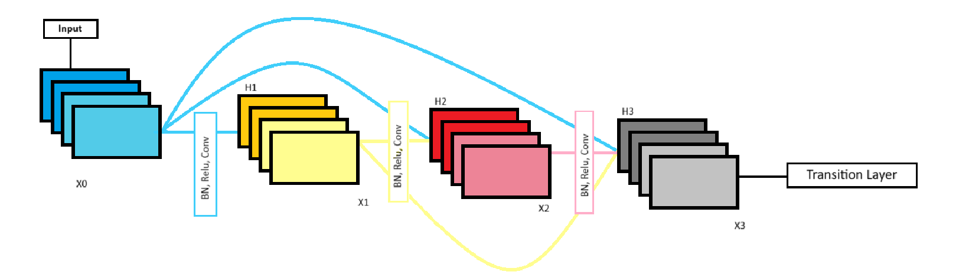

Figure 2: Components inside a Dense Block

In DenseNet, every dense layer consolidates outputs from all preceding layers, ensuring uniformity in depth. The workflow of DenseNet is depicted in Figure-3, providing an overview of how it processes brain tumor images by employing a combination of Dense Blocks and Transition Layers. As an image progresses through the dense blocks, the dimensions of the feature map remain consistent, though the number of filters may vary. Following each dense block, the image advances to a transition layer, responsible for handling convolution and pooling. Significantly, these layers manage downsampling activities outside of the dense blocks. To ensure effective concatenation of features, it is imperative that feature maps within a dense block maintain matching sizes. The incorporation of a bottleneck convolution layer before each convolution proves efficient in reducing input feature maps, thereby optimizing computational performance. The transition layers in DenseNet are characterized by batch normalization, a convolution layer, and an average pooling layer.

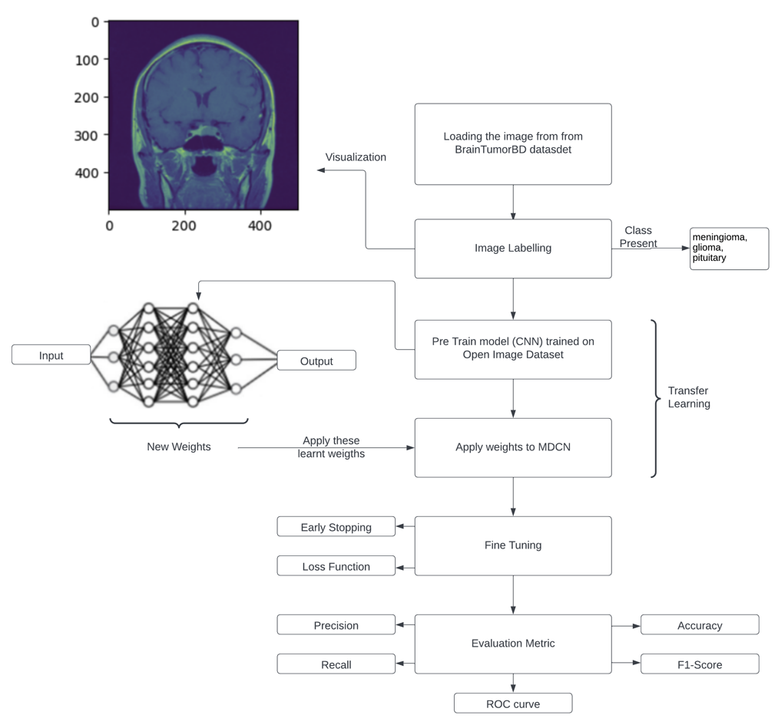

Figure 3: Propose Model Architecture

Figure-4 offers a detailed depiction of the processes occurring within the dense block of the DenseNet architecture. This block consists of a BN (batch normalization) layer, a ReLU (rectified linear unit) activation function, and convs (convolution operations). Following the final dense block, a global average pooling layer is present, linking to a Softmax classifier. Considering DenseNet comprises L layers, there will be a total of L (L + 1)/2 direct connections associated with these L layers.

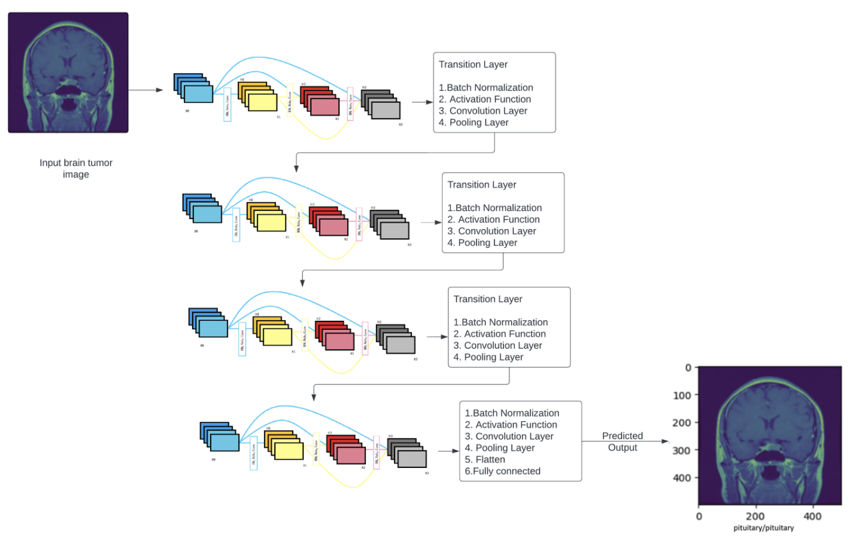

Figure 4: MDCN with four dense blocks.

As illustrated in figure-4, the layer within the non-linear transformations receives the following input:

--(2)

The amalgamation of feature maps from layer 0 to k-1 is denoted as . In this arrangement, each layer utilizes the feature maps of all the preceding layers. Additionally, each subsequent layer employs its own feature maps. Hence, for a particular layer k and the layers above it in the depth dimension H, as illustrated in figure 4, the DenseNet output is articulated as:

--(3)

In Equation (2), all the inputs to H are consolidated into a unified tensor during processing. Within the structure of DenseNet, the dimensions of feature maps can be modified through convolution and pooling operations. The proposed model incorporates Batch Normalization, a technique designed to standardize either the inputs or the activations from the preceding layer. In the realm of transfer learning and convolutional neural networks, the rectified linear activation function is widely utilized. DenseNet is divided into Dense blocks, each having distinct filters while maintaining consistent dimensions. The Transition Layer performs down-sampling and incorporates batch normalization. Average pooling calculates the mean for specific sections of the feature map, thereby down-sampling each segment to its average value. The model adopts the Cross Entropy loss function and employs the Adam optimizer for weight updates. A learning rate of 1e-05 has been set, and the batch size is designated as 5. This deep learning architecture encompasses a total of 5,968,048 parameters.

1. Optimizer

In the presented framework, we assessed various optimizers to determine the optimal accuracy for the proposed model. We compared the effectiveness of Stochastic Gradient Descent (SGD), RMSProp, and Adam optimizers. Adam, which integrates Stochastic Gradient Descent and RMSProp while introducing momentum, was included in the evaluation. It is noteworthy that Adam calculates the learning rate for each parameter individually.

--(4)

Here a represents the moment of a specific variable, while V denotes a given variable. Meanwhile, 'E' signifies the expected value of the variable t. A comparative evaluation of various optimizers was conducted, revealing that Adam outperformed other options including Adadelta, Adagrad, RMSProp, Nadam, and SGD, achieving an impressive accuracy of 95.13%. Utilizing the Adam optimizer and Cross Entropy loss function, the proposed MDCN model attained a commendable accuracy of 96.51%.

Experimental Results:

1. Environmental Setup

All investigations and experiments were conducted within a simulated environment, utilizing Visual Studio Code (VSCode) as the integrated development environment. The coding language employed for these activities was Python 3.8. The experimental setup involved a computer with the following configuration: a 12th Gen Intel(R) Core(TM) i7-12700H processor operating at 2.30 GHz, equipped with an NVIDIA Corporation RTX3060 graphics card, and 6.00 GB RAM. Furthermore, various libraries played a crucial role in the implementation of the proposed model. These included TensorFlow (version 2.10.0), Keras (version 2.10.0), Pandas (2.0.2), NumPy (version 1.25.2), and Matplotlib (version 3.7.2). These libraries collectively contributed to the successful execution and analysis of the model within the specified simulated environment.

1. Brench Mark algorithms

The proposed algorithm's performance was evaluated by comparing it with several other algorithms, including Visual Geometry Group (VGG16), Residual Network (ResNet), Traditional-DenseNet, and Convolution Neural Network (CNN), focusing on their accuracy over 30 and 50 epochs. The choice of CNN was driven by its effectiveness in image detection, given its capability to learn and extract features from images through convolutional layers, making it a widely used algorithm in image classification. While CNNs are traditional and widely recognized for their image classification capabilities, VGG16, ResNet, and DBN represent state-of-the-art algorithms. VGG16, a variant of the VGG model, is a deep CNN designed for image recognition and classification, offering enhanced performance due to its depth with 16 layers. RNN, with its memory unit, contributes to increased processing time and accuracy. The inclusion of Traditional-DenseNet in the comparison was motivated by the fact that the proposed MDCN algorithm is primarily based on it. Therefore, Traditional-DenseNet serves as a suitable benchmark for evaluating the efficiency and improvements brought by the MDCN algorithm.

1. Image Visualization

Besides identifying the image's class-label, the image visualization function will also display the image marked with its predicted class. Once this process is done, the results can be seen as illustrated in figure 5.

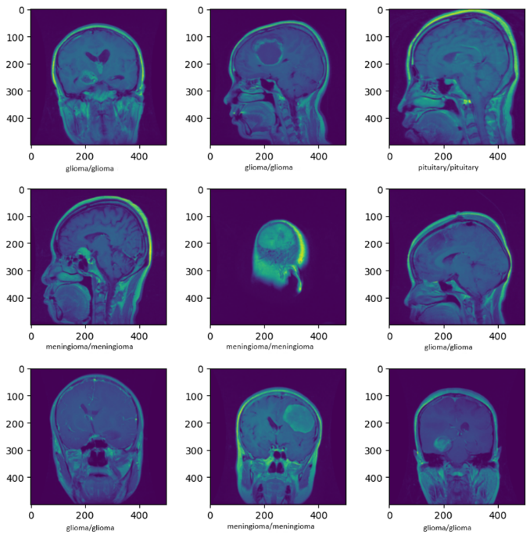

Figure 5: The real prediction result of the suggested model.

1. Evaluation Matrix

The effectiveness of the proposed system is evaluated using various metrics, such as Precision, Accuracy, F1-Score, Recall, False Positive Rate, and True Positive Rate. Accuracy is computed by comparing the correctly classified entries to the overall count, as demonstrated in Equation (5). Precision is determined by the ratio of correctly predicted abnormal cases to the total cases identified as abnormal, as expressed in Equation (6). Recall, represented in Equation (7), signifies the fraction of correctly identified abnormal cases in relation to the total number of genuine abnormal cases. The F1 Score, outlined in Equation (8), offers a balanced measure between Precision and Recall, serving as their harmonic mean to assess the system's accuracy.

--(5)

---(6)

---(7)

---(8)

* 1. Accuracy and Loss Graph

The suggested method is tested on a dataset. In the devised MDCN strategy, activation functions like ReLU and softmax are utilized. We opted for a batch size of 5, employed the Adam optimizer, and chose cross-entropy as the loss function. The training was undertaken with varying epoch values, ranging between 30 and 50. It was observed that the model achieved optimal validation accuracy and minimized loss at 50 epochs. The performance metrics of the model, namely accuracy and loss over 30 epochs, are illustrated in Figure 6 and Figure 7, respectively.

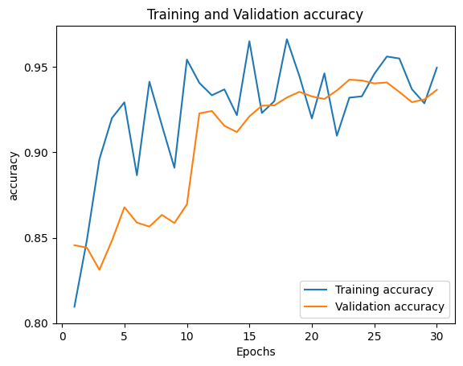

Figure 6: Accuracy during training and validation after 30 epochs.

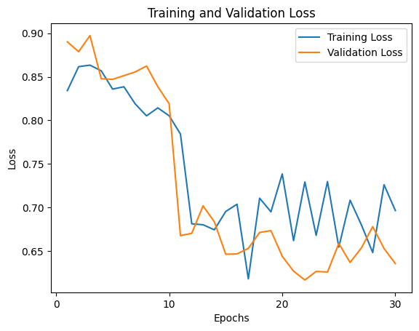

Figure 7: Loss during training and validation after 30 epochs.

The proposed model’s performance in terms of accuracy and loss with 50 epochs is given in Figure 8 and Figure 9.

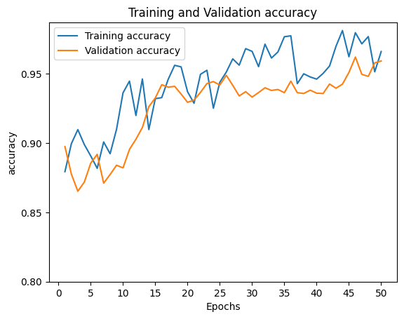

Figure 8: Accuracy during training and validation after 50 epochs.

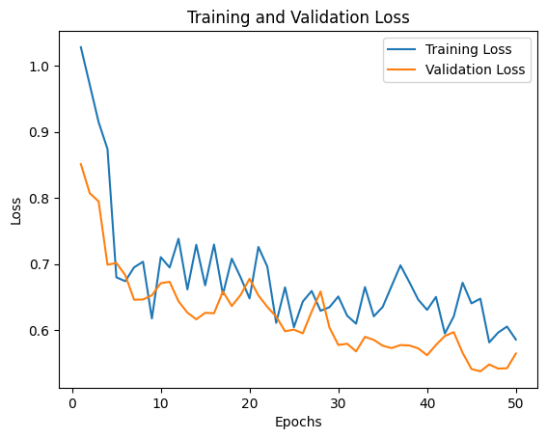

Figure 9: Loss during training and validation after 50 epochs.

As depicted in Figure 8 and Figure 9, by employing 50 epochs, our proposed model significantly improves detection accuracy, reaching a commendable 96.51%. The empirical outcomes clearly indicate that our system outperforms other existing algorithms in detecting various diseases.

* 1. Comparison with traditional benchmark algorithms

Figure 10 presents a performance comparison of the proposed model at 30 epochs against established algorithms, including the Visual Geometry Group (VGG16), Residual Network (ResNet), Traditional-DenseNet, and Convolution Neural Network (CNN). The findings clearly indicate that the proposed model outshines the other algorithms in its performance.

Figure 10. Comparison for 30 epochs.

Figure 11 presents a performance comparison of the proposed model at 50 epochs against established algorithms, including the Visual Geometry Group (VGG16), Residual Network (ResNet), Traditional-DenseNet, and Convolution Neural Network (CNN). The findings clearly indicate that the proposed model outshines the other algorithms in its performance.

Figure 11. Comparison for 50 epochs.

Conclusion

In this study, an innovative model was introduced, leveraging the capabilities of deep learning and CNN (convolutional neural networks) for the purpose of brain tumor detection and classification. Specifically, the model incorporated the DenseNet architecture, a well-established deep learning structure, with the primary goal of identifying brain tumors from MRI images. The data utilized in this study originated from the BrainTumorBD dataset, a comprehensive repository of images and information related to brain tumors. The model's training process underwent careful scrutiny at two different intervals, namely 30 epochs and 50 epochs, to assess its resilience and adaptability. To further enhance the system's performance, the model embraced the concept of Early Learning, a crucial element in augmenting the efficiency and overall output of deep learning systems. The incorporation of transfer learning, a technique that repurposes pre-trained models for new tasks, seamlessly integrated into the DenseNet framework. The algorithm also employed the Early Stopping mechanism, various optimizers, diverse loss functions, and a Learning Rate (LR) Scheduler, dynamically adjusting learning rates for improved convergence. The culmination of this research yielded groundbreaking results. The newly developed algorithm demonstrated an impressive true detection rate while effectively minimizing false detections. This achievement was particularly notable when compared to existing systems. After undergoing 50 epochs of training, the model achieved an outstanding accuracy rate exceeding 96.51%. Furthermore, the system exhibited exceptionally high Precision, Recall, and F1 Scores, with average values of 96.32%, 95.23%, and 96.38%, respectively. These metrics highlight that the proposed model outperforms many of its counterparts in brain tumor detection and classification.

Reference