#a. Find out top 5 attributes having highest correlation (select only Numeric features).
#b. Find out top 3 reasons for having more crime in a city.
#c. Which all attributes have correlation with crime rate?
COBRA_YTD2017<-read.csv(C:\Users\CHIRAG\Downloads\ACADgILdCOBRA-YTD2017.csv')
require(Amelia)
library(Rcpp)
data<-COBRA_YTD2017
data[4:10,3] <- rep(NA,7)
data[1:5,4] <- NA
data <- data[-c(5,6)]
summary(data)
library(car)
## Loading required package: carData
fit<-lm(beat~MinOfucr+ MaxOfnum_victims+loc_type+neighborhood+x+y,data =COBRA_YTD2017)
fit
summary(fit)

➢ P-values are very important because, we can consider linear model to be statistically significant only.
➢ When both these p-values are less that the pre-determined statistical determined level, which is ideally 0.05.
➢ This is visually interpreted by the significance stars at the end of the row.
➢ The more stars beside the variable’s p-value, the more significant the variable.

When there is a p-value, there is a null and alternative hypothesis associated with it.
Null and Alternate Hypothesis
➢ In Linear regression, the Null Hypothesis is that the coefficients associated with the variables is equal to zero.
➢ The alternate hypothesis is that the coefficients are not equal to zero.
➢ There exists a relationship between the independent variable in question and the dependent variable.

GVIF Df GVIF^(1/(2*Df))
beat 18.615002 1 4.314511
MaxOfnum_victims 1.016947 1 1.008438
loc_type 1.027692 1 1.013752
neighborhood 201.207857 237 1.011253
x 37103.058286 1 192.621542
y 37121.328278 1 192.668960
lm(formula = MinOfucr ~ beat + MaxOfnum_victims + loc_type +
neighborhood + x + y, data = COBRA_YTD2017)

Coefficients:
(Intercept) beat
183.98780 0.14243

Call:
lm(formula = MinOfucr ~ beat + MaxOfnum_victims + loc_type +
neighborhood + x + y, data = COBRA_YTD2017)

Residuals:
Min 1Q Median 3Q Max
-333.96 -36.06 21.83 61.68 438.61

vif(fi)>5
GVIF Df GVIF^(1/(2*Df))
beat TRUE FALSE FALSE
MaxOfnum_victims FALSE FALSE FALSE
loc_type TRUE TRUE FALSE
neighborhood TRUE TRUE FALSE
x TRUE FALSE TRUE
y TRUE FALSE TRUE

#b. Find out top 3 reasons for having more crime in a city.
- Which all attributes have correlation with crime rate?

at$dayofWeek <- weekdays(as.Date(at$occur_date))

at$hour <- sub(":.*", "", at$occur_time)

at$hour <- as.numeric(at$hour)

ggplot(aes(x = hour), data = at) + geom_histogram(bins = 24, color='white', fill='black') +

ggtitle('Histogram of Crime Time')

#The crime time distribution appears bimodal with peaking around midnight and again at the noon, then again between 6pm and 8pm.
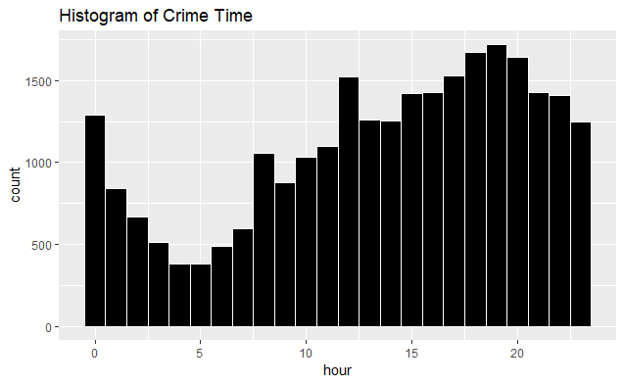
#topCrimes_1 <- topCrimes %>% group_by(`UC2 Literal`,occur_time) %>%
#summarise(total = n())
#ggplot(aes(x = occur_time, y = total), data = topCrimes_1) +
#geom_point(colour="blue", size=1) +
#geom_smooth(method="loess") +
#xlab('Hour(24 hour clock)') +
# ylab('Number of Crimes') +
#ggtitle('Top Crimes Time of the Day') +
#facet_wrap(~`UC2 Literal`)

#Downtown and midtown are the most common locations where crimes take place, followed by Old Fourth Ward and West End.
larceny theft are the top crimes in Atlanta followed by aggravated assault

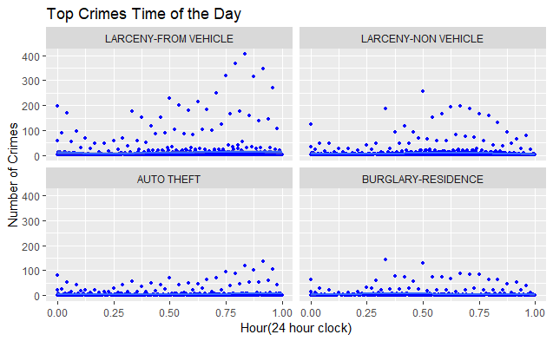

kable(count(COBRA_YTD2017, loc_type, sort=TRUE), "html", col.names=c("Crime Type", "Frequency")) %>%

kable_styling(bootstrap_options="striped", full_width=FALSE)

COBRA_YTD2017 %>%

group_by(days, loc_type) %>%

summarize(freq=n()) %>%

ggplot(aes(reorder(days, -freq), freq)) +

geom_bar(aes(fill=loc_type), position="dodge", stat="identity", width=0.8, color="black") +

xlab("Day of Week") +

ylab("Frequency") +

labs(fill="Crime Type") +

ggtitle("Crime by Day of the Week")

kable

#The data provides crime type frequency and crime by day of the week.#Among the high crime categories, larceny tend to increase on Fridays and Saturdays. while burglary residence generally occurred more often during the weekdays than the weekends. Auto theft were least reported on Thursdays and increase for the weekends.
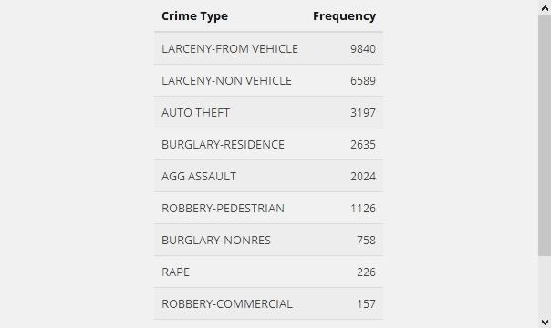

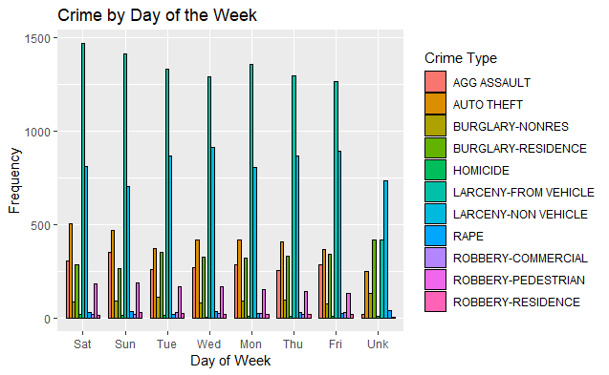

R Markdown
This is an R Markdown document. Markdown is a simple formatting syntax for authoring HTML, PDF, and MS Word documents. For more details on using R Markdown see http://rmarkdown.rstudio.com.
When you click the Knit button a document will be generated that includes both content as well as the output of any embedded R code chunks within the document. You can embed an R code chunk like this:
summary(cars)
## speed dist
## Min. : 4.0 Min. : 2.00
## 1st Qu.:12.0 1st Qu.: 26.00
## Median :15.0 Median : 36.00
## Mean :15.4 Mean : 42.98
## 3rd Qu.:19.0 3rd Qu.: 56.00
## Max. :25.0 Max. :120.00

Including Plots
You can also embed plots, for example:
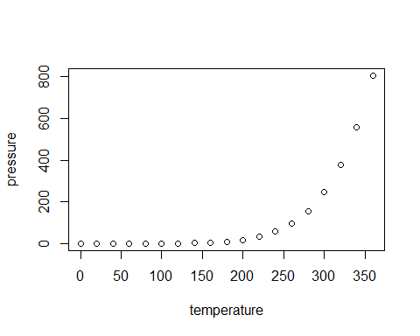
Note that the echo = FALSE parameter was added to the code chunk to prevent printing of the R code that generated the plot.

