The Music Men

Charles Flood, Chirag Arora, Hung Nguyen

Application Description:

Our application is based on a brick-and-mortar music store database. The database will track the instruments and their subsequent accessories, as well as the students that are or have been enrolled in private music lessons hosted by the music store.

Database Description:

The database is composed of only a few tables. The base table is 'Instruments' which, surprisingly, contains a list of the instruments the store carries and deals in. This table is supported by the 'Description' table which contains descriptions of the instruments in a one-to-one relationship. The 'Accessory' table, on the other hand, has a many-to-many relationship to 'students', explaining student can have many accessories and many accessories can have students. Finally, the 'Instrument’ table has a one-to-many relationship with the 'accessories' table since, we assumed that one instrument can have many accessories.

Hibernate was used primarily for the most basic queries, such as printing out the contents of a given table. In order to handle the multiplicity of relationships between accessories, instruments, and students, we used HQL, Hibernate's built in SQL variant. All interaction is still done through Hibernate.

Source Data:

The source data for this database was not derived from any on-line source. Rather it is a mix of random data and a general knowledge of orchestral instruments.

ER Diagrams: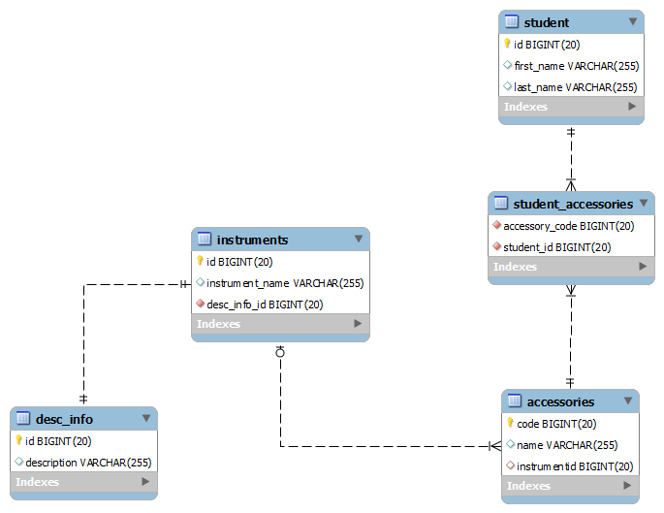

Application Instructions:

1. Once prompted for command, enter create to create the tables.
2. Now, enter load to load the data.
3. Now enter instruments to see the all the instruments.
4. Enter students to see all name of students with accessories owned by them.
5. Enter accessories to see all the accessories available.
6. Enter accessories <instruments> which will print all the accessories associated with that instrument.
7. Enter student <accessory> which will print student who own that accessory.