Lambda
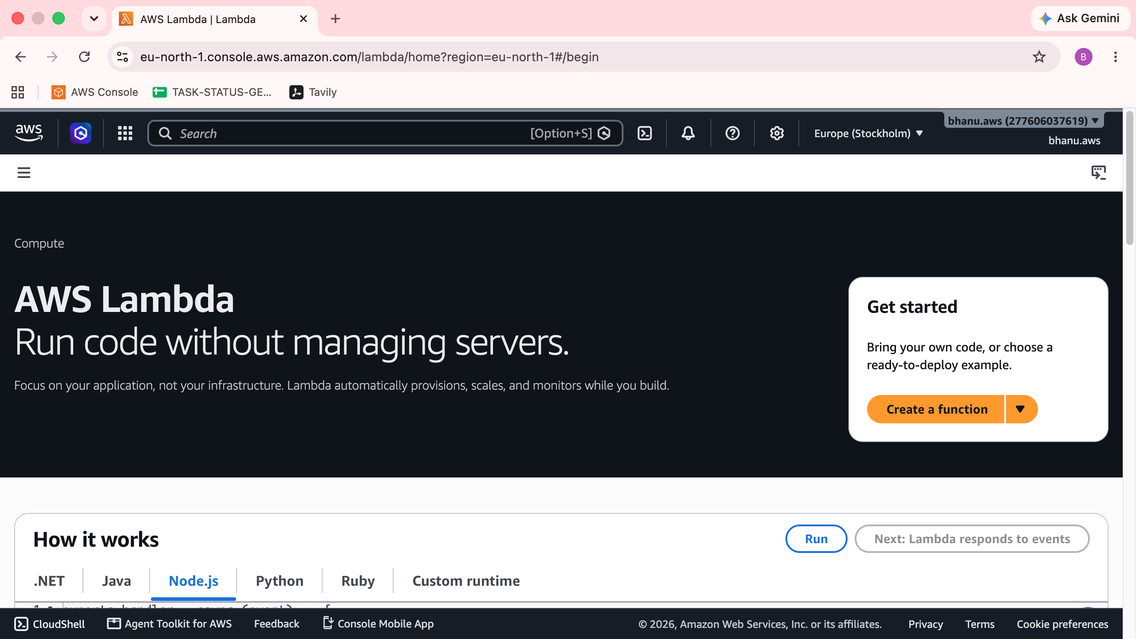

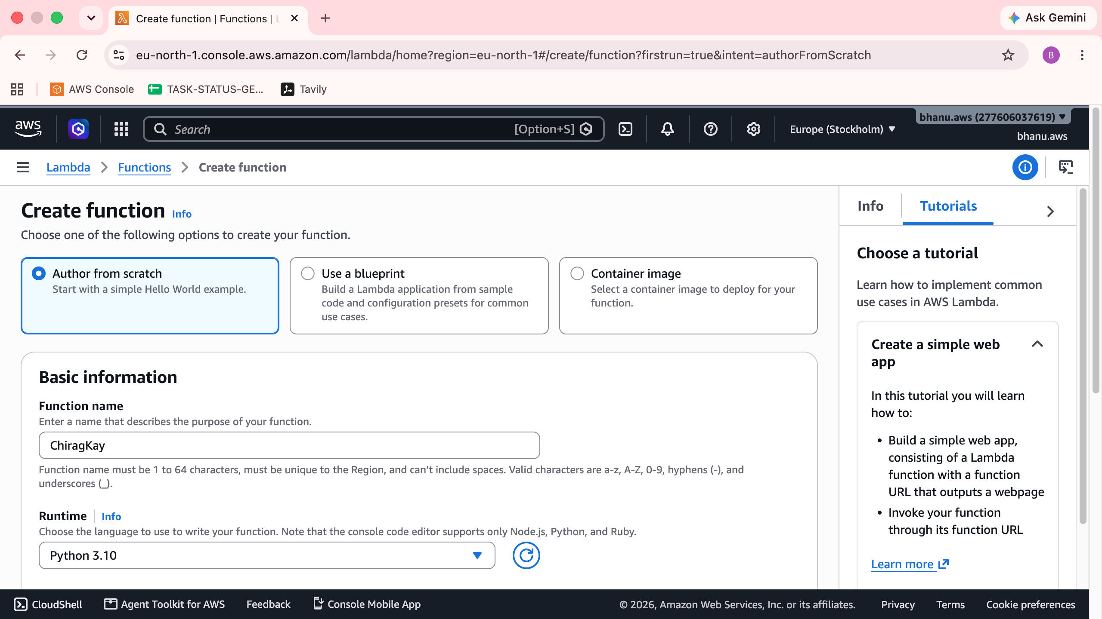
Create the Function
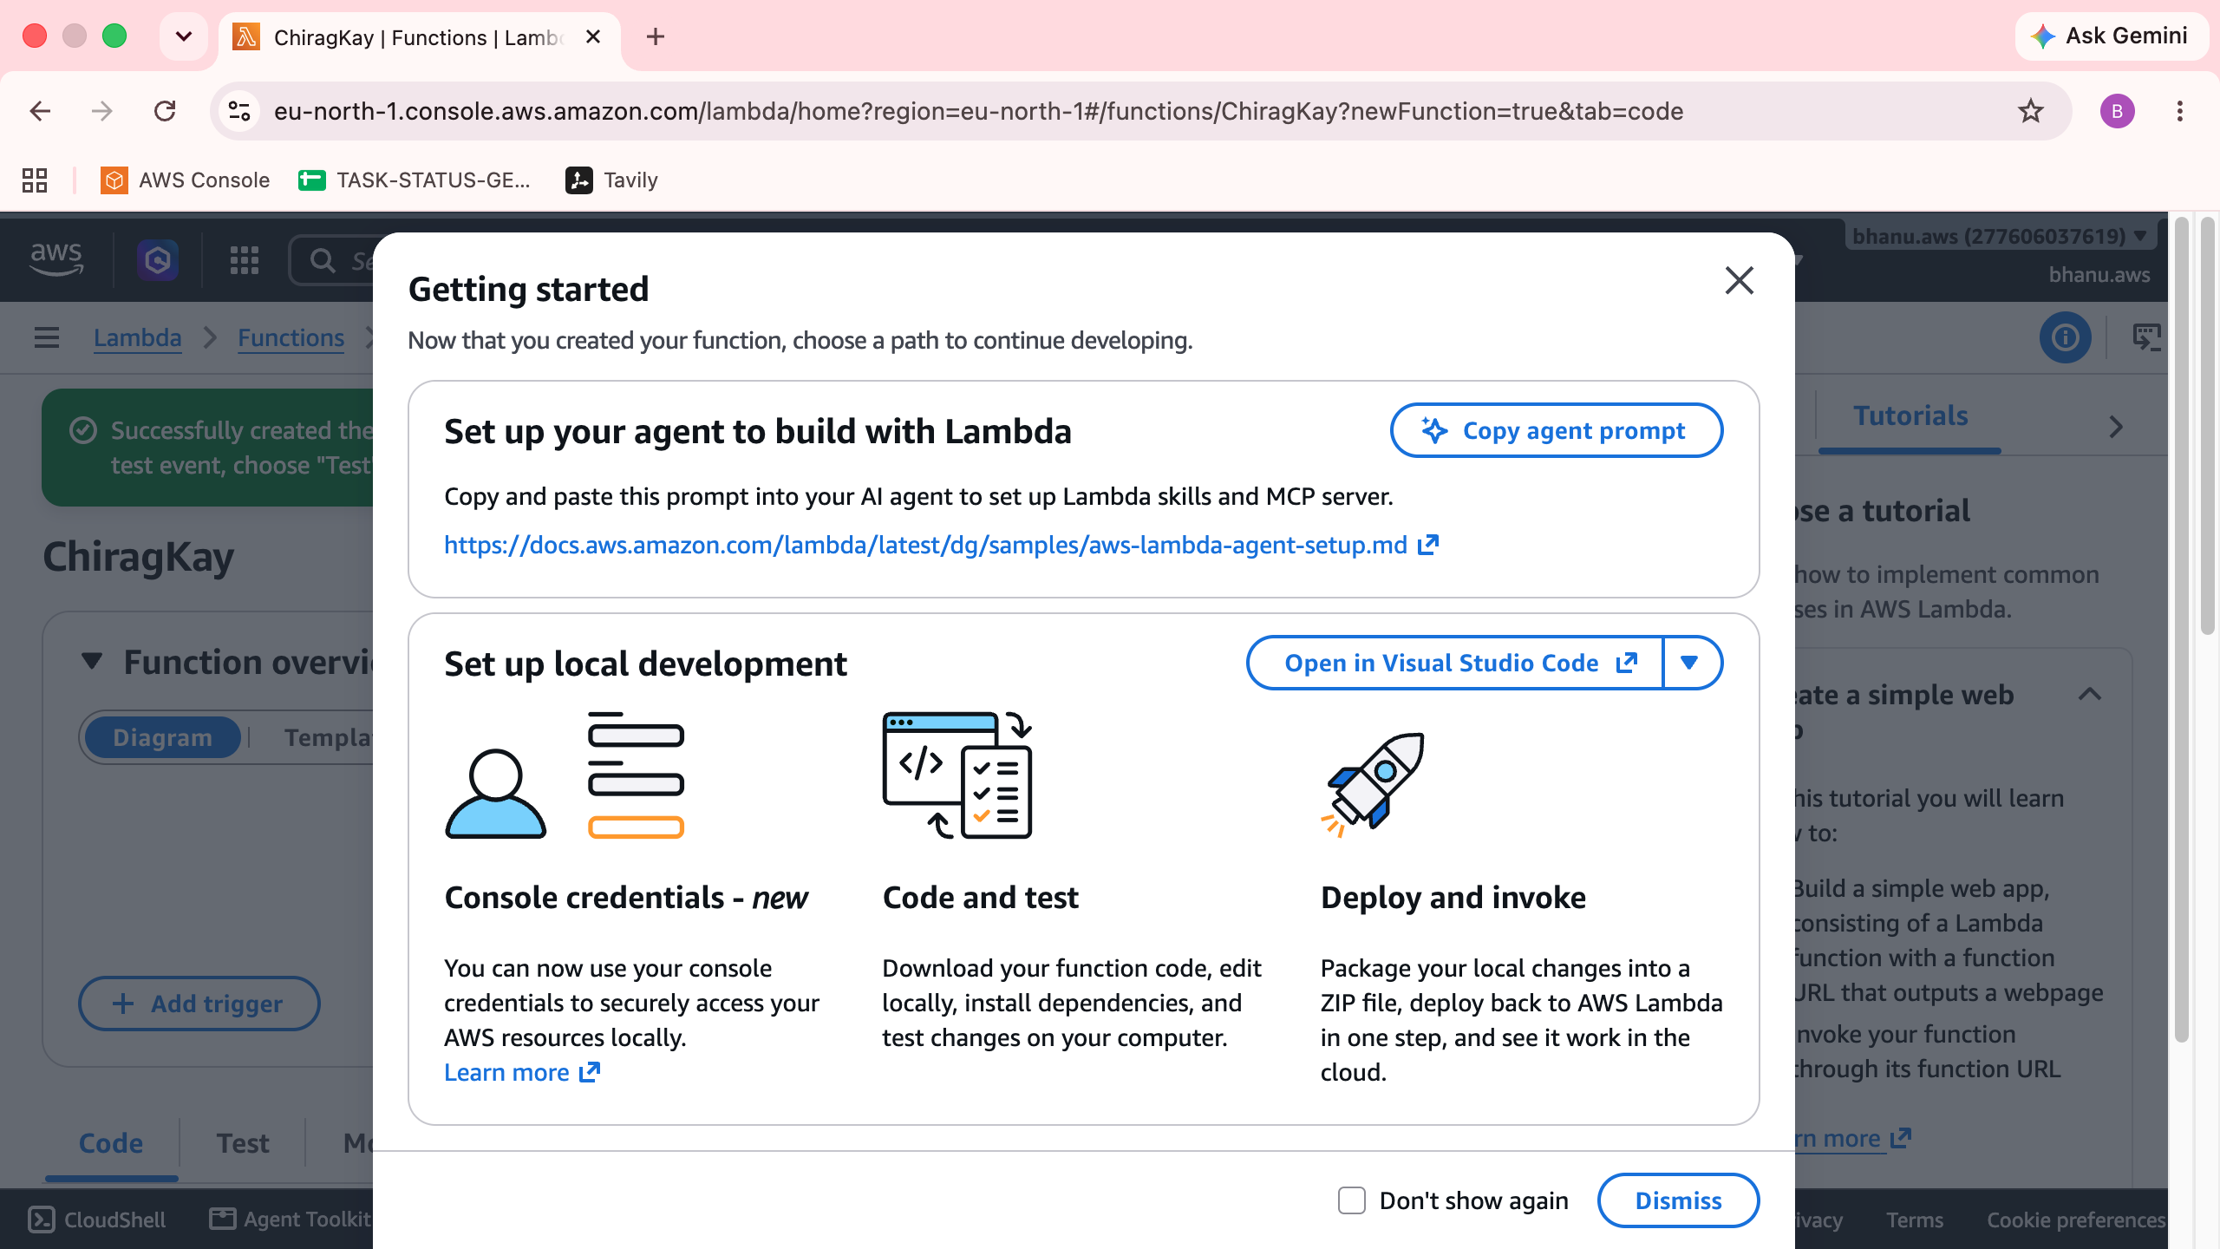
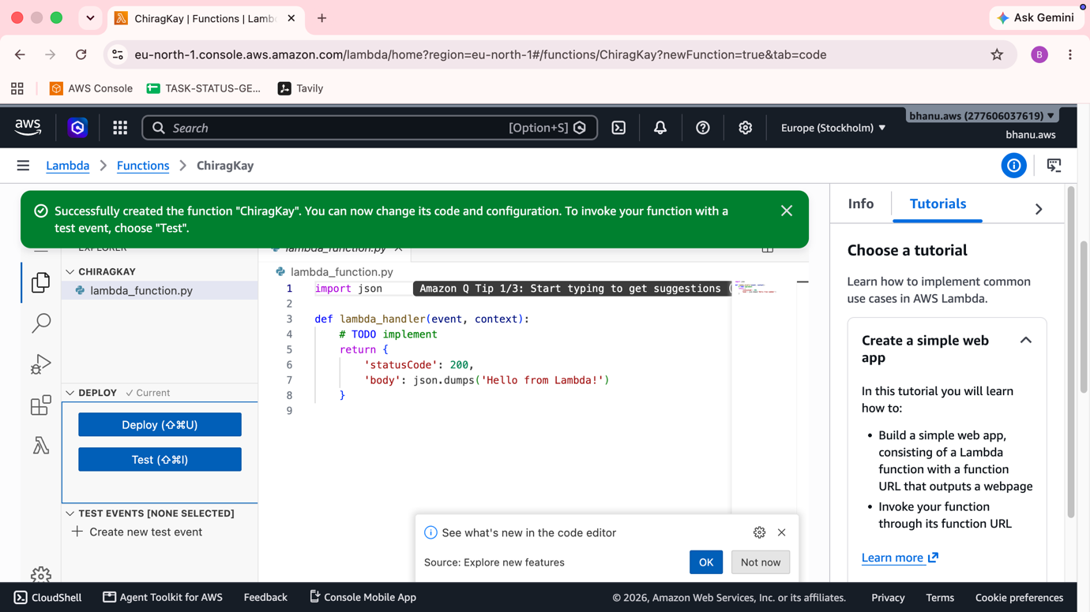
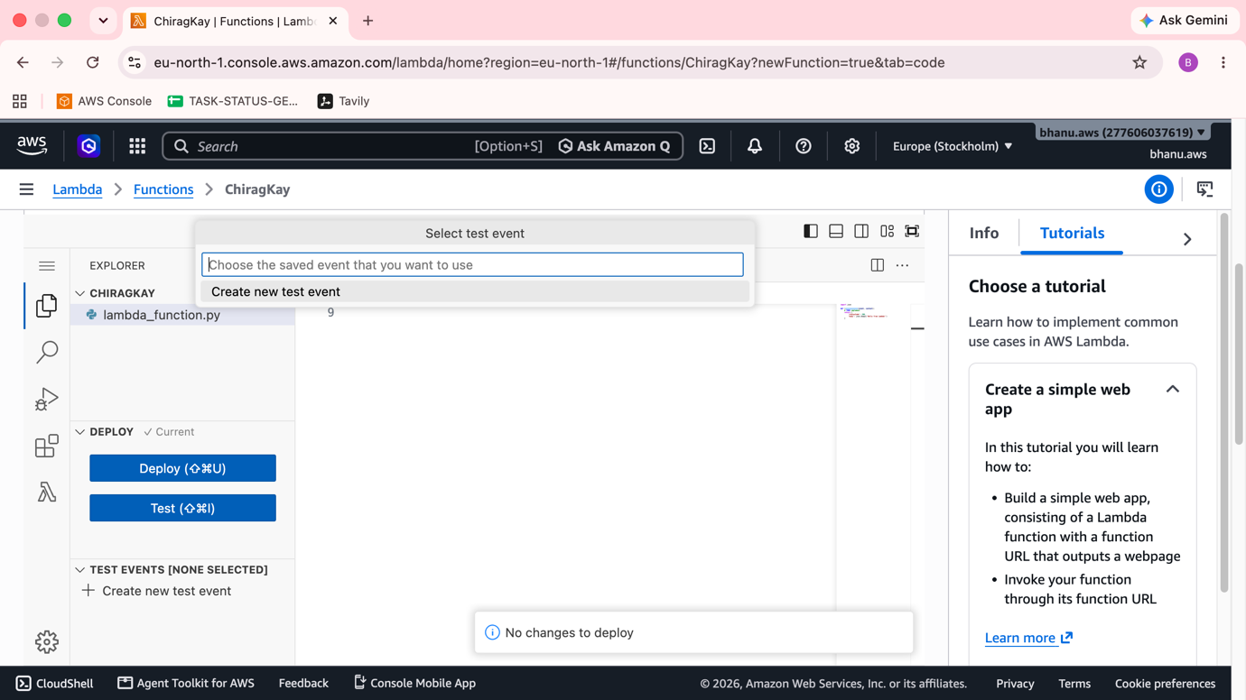
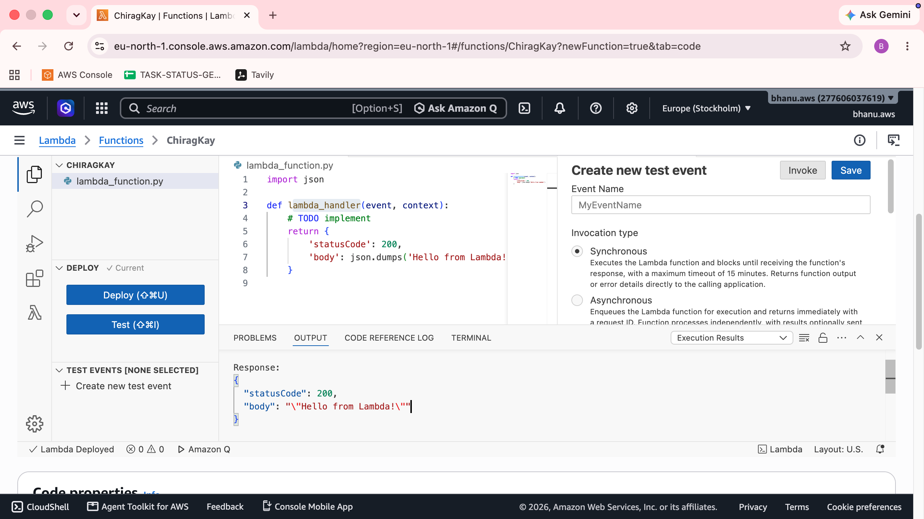
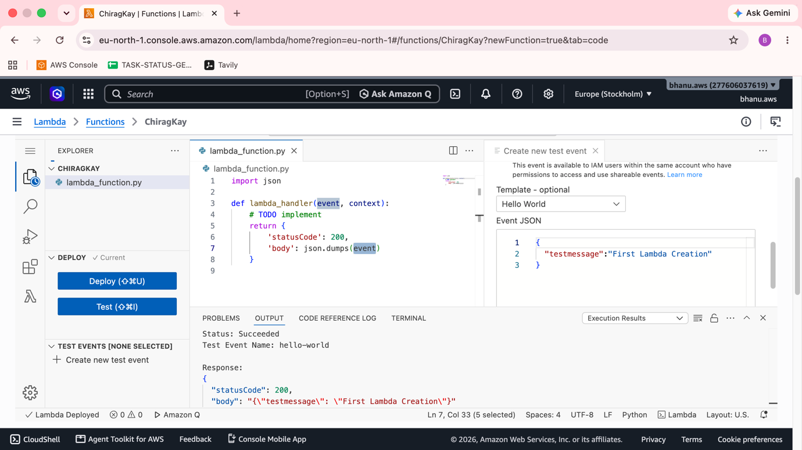
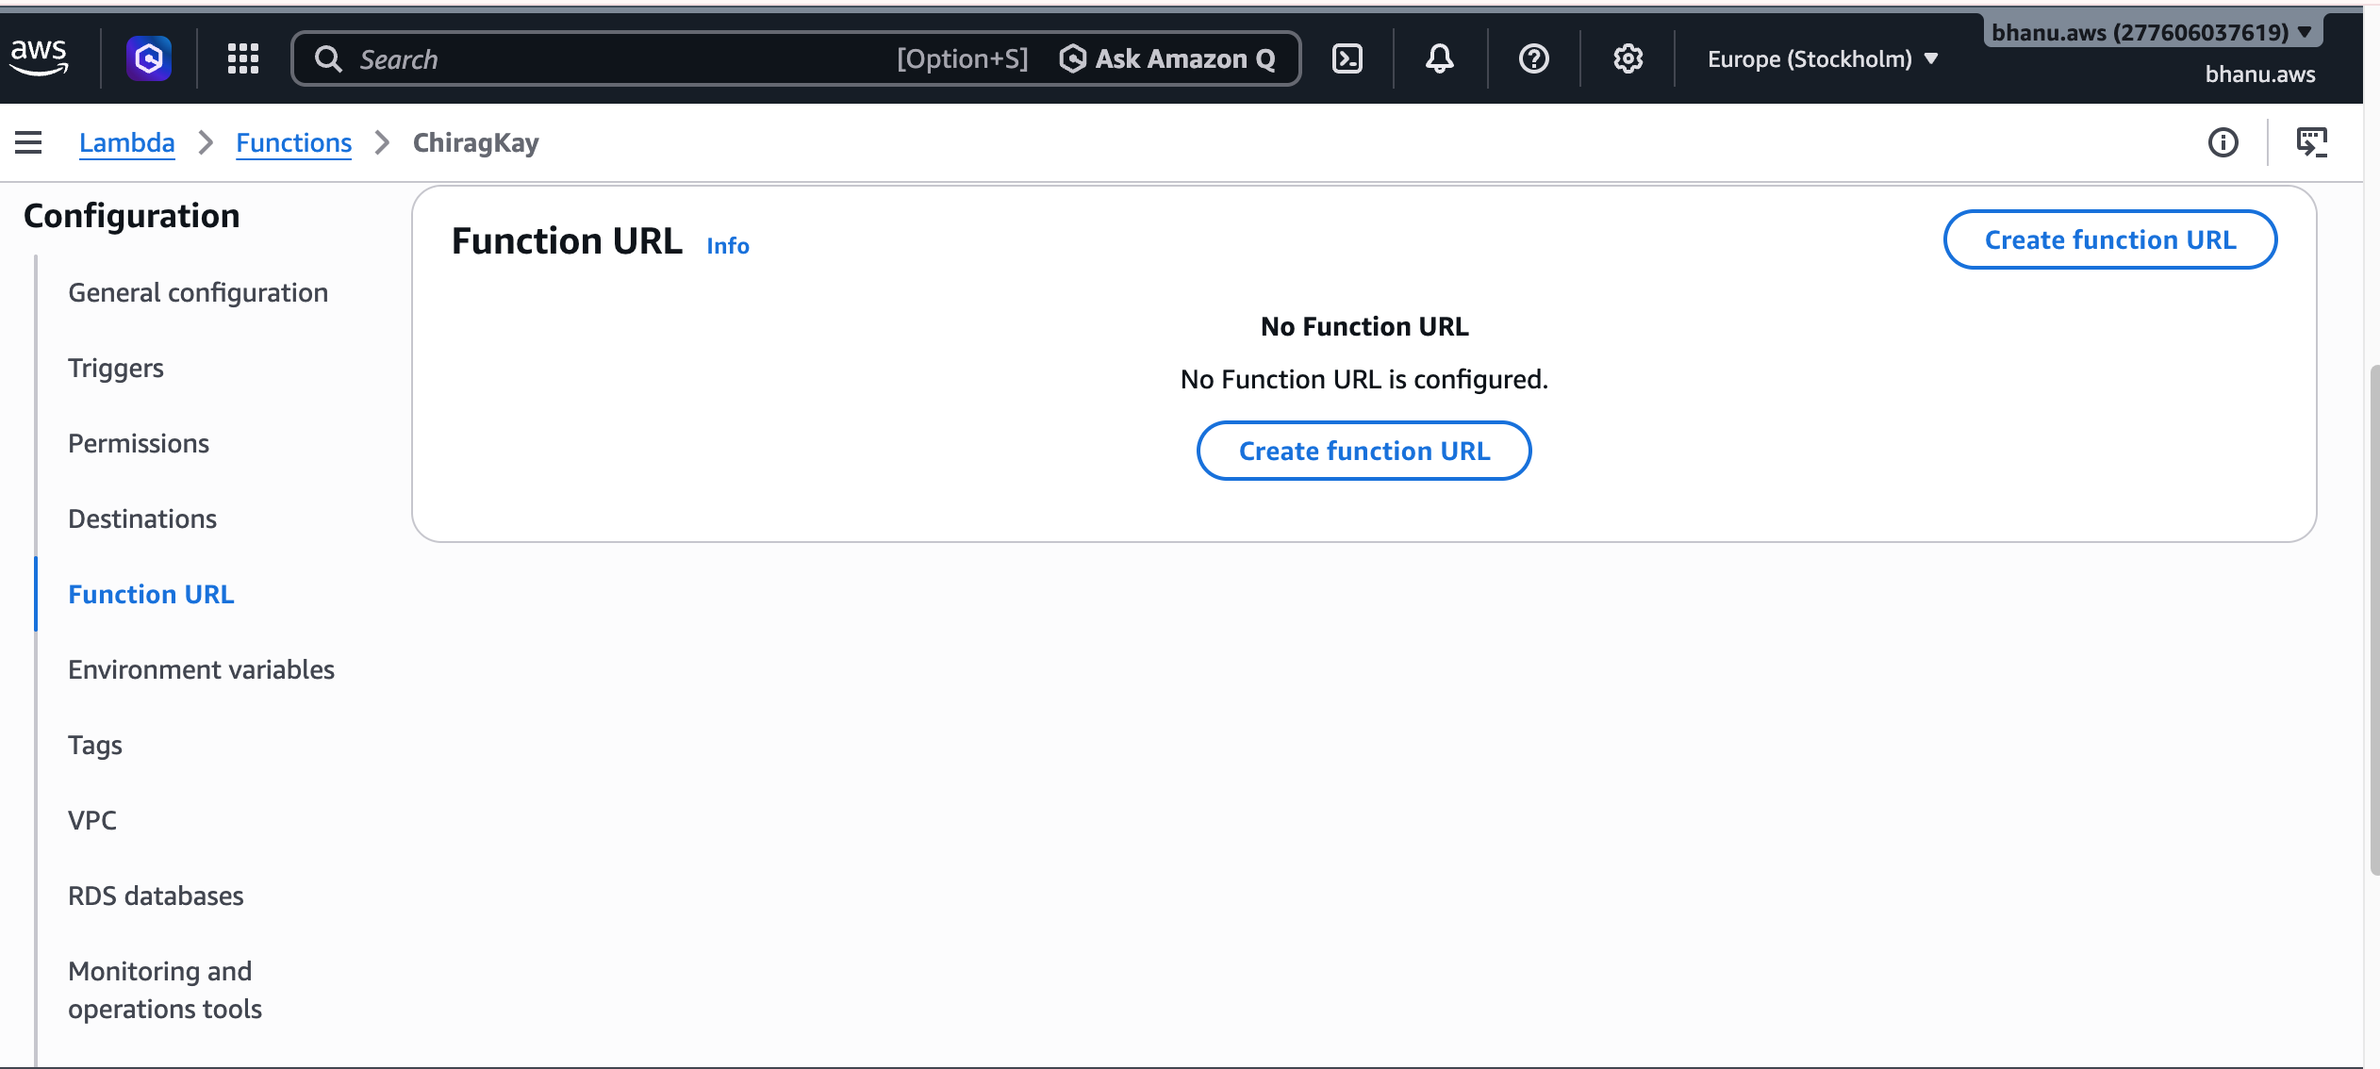

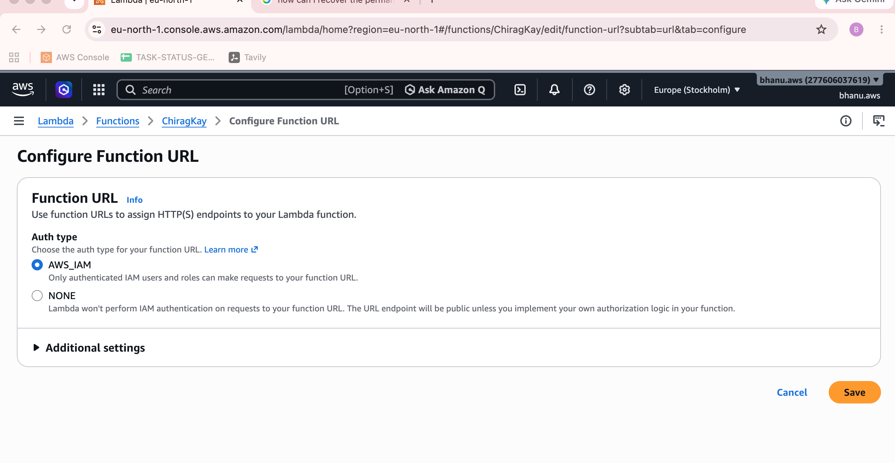
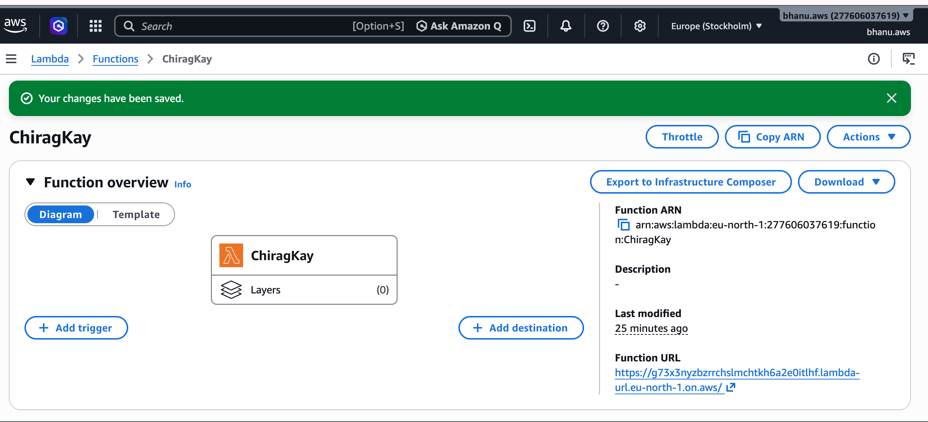
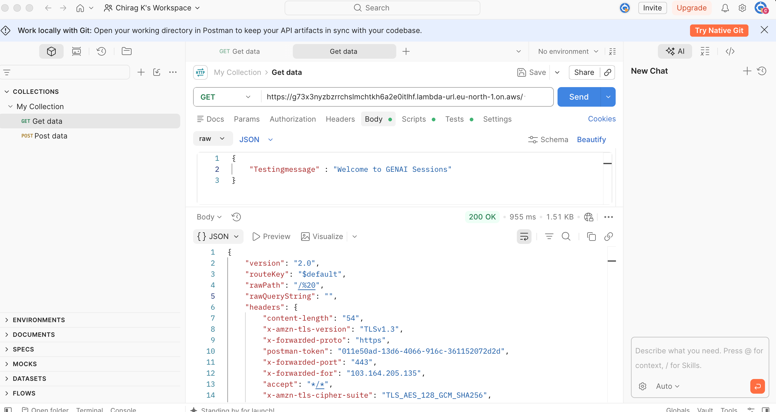
Request
{
"Testingmessage" : "Welcome to GENAI Sessions"
}

Response
{
"version": "2.0",
"routeKey": "$default",
"rawPath": "/%20",
"rawQueryString": "",
"headers": {
"content-length": "54",
"x-amzn-tls-version": "TLSv1.3",
"x-forwarded-proto": "https",
"postman-token": "011e50ad-13d6-4066-916c-361152072d2d",
"x-forwarded-port": "443",
"x-forwarded-for": "103.164.205.135",
"accept": "*/*",
"x-amzn-tls-cipher-suite": "TLS_AES_128_GCM_SHA256",
"x-amzn-trace-id": "Root=1-6aa9fadf-7028dc457479f4010c543251",
"host": "g73x3nyzbzrrchslmchtkh6a2e0itlhf.lambda-url.eu-north-1.on.aws",
"content-type": "application/json",
"accept-encoding": "gzip, deflate, br",
"user-agent": "PostmanRuntime/7.56.1"
},
"requestContext": {
"accountId": "anonymous",
"apiId": "g73x3nyzbzrrchslmchtkh6a2e0itlhf",
"domainName": "g73x3nyzbzrrchslmchtkh6a2e0itlhf.lambda-url.eu-north-1.on.aws",
"domainPrefix": "g73x3nyzbzrrchslmchtkh6a2e0itlhf",
"http": {
"method": "GET",
"path": "/ ",
"protocol": "HTTP/1.1",
"sourceIp": "103.164.205.135",
"userAgent": "PostmanRuntime/7.56.1"
},
"requestId": "336ffe1f-9c52-4447-af78-f775ef94c319",
"routeKey": "$default",
"stage": "$default",
"time": "16/Sep/2026:02:11:43 +0000",
"timeEpoch": 1789524703923
},
"body": "{\n \"Testingmessage\" : \"Welcome to GENAI Sessions\"\n}",
"isBase64Encoded": false
}
