A Non-Planar Three-Dimensional Printing Workflow for the Prusa MK4 Using Siemens NX, NX Post Builder, and Python

Tushar Arun Itankarᵃ, Chirag Zinzuvadiyaᵃ, Abhishek Sherkhaneᵃ, Shubhranshu Chakrabartiᵃ

ᵃ Institute of Mechanical Engineering, TU Clausthal, Germany (Interdisciplinary Research Project, SoSe 2026, Group A1) Technische Universität Clausthal, 38678 Clausthal-Zellerfeld, Germany

ARTICLE INFO |  | ABSTRACT
Article availability (online):  GitHub: https://github.com/chiragroyal003-CAZ/A-Non-Planar-3D-Printing-Workflow-for-the-Prusa-MK4.git |  | Non-planar 3D printing enhances conventional fused deposition modelling (FDM) by following curved geometries, thereby improving surface quality and reducing staircase effects. However, implementation on standard desktop printers remains difficult due to challenges in toolpath generation, extrusion control, and G-code compatibility. This study develops a practical non-planar 3D printing workflow for the Prusa MK4 printer using Siemens NX Additive Manufacturing, NX Post Builder, and Python-based post-processing. The proposed method successfully converts NX-generated motion data into printer-ready G-code by systematically addressing coordinate mismatch, extrusion interpretation, travel motion handling, and support alignment. The results demonstrate that non-planar printing can be effectively integrated into a standard desktop FDM environment utilizing commercial CAD/CAM software and custom scripting. Ultimately, the findings confirm the workflow's feasibility, highlighting extrusion calibration and comprehensive print validation as primary areas for future optimization.
Keywords:
Non-planar 3D printing
Planar vs Non-planar
Fused Deposition Modelling
SiemensNX
Prusa Slicer

- Introduction
CAD | Computer-Aided Design
CAM | Computer-Aided Manufacturing
CNC | Computer Numerical Control
E | Absolute Extrusion Value
FDM | Fused Deposition Modelling
NC | Numerical Control
Table.no: 1 – Nomenclature
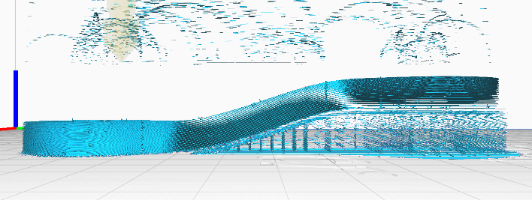
Additive manufacturing, particularly Fused Deposition Modelling (FDM), is widely utilized for prototyping and functional part production [5]. In standard FDM workflows, components are built in flat, horizontal layers along the Z-axis. While this planar approach is highly reliable, it creates significant challenges when printing curved, sloped, and overhanging surfaces. Planar slicing results in poor surface quality due to the "staircase effect"(Fig. no:1.1 - Planar slicing with support structure by Prusa Slicer) and leads to weak interlayer strength because the material cannot align continuously with the part's geometry [1].
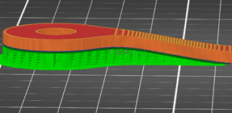
Fig. no: 1.1 - Planar slicing with support structure by Prusa Slicer

Non-planar 3D printing addresses these limitations by allowing the toolpath to follow the part's true curved geometry in three-dimensional space. This advanced deposition method can improve surface quality, reduce staircase artifacts, and align deposited material with stress directions to potentially enhance overall mechanical properties [7]. However, most standard desktop slicers, such as Ultimaker Cura and Prusa Slicer, do not support general non-planar toolpaths [10]. The literature highlights several severe technical constraints preventing this integration, primarily the lack of robust collision avoidance algorithms in open-source slicers. Furthermore, physical hardware restrictions such as bulky print head geometries and protruding cooling fan ducts severely limit the nozzle's Z-axis mobility, increasing the risk of mechanical collisions during non-planar deposition [12]. The non-planar slicing used in this project is depicted as below (Fig. no: 1.2 – Front view of non-planar slicing).

Fig. no: 1.2 – Front view of Non planar slicing
While industrial Computer-Aided Manufacturing (CAM) systems like Siemens NX feature advanced Additive Manufacturing modules capable of generating non-planar, collision-aware toolpaths, their output is not directly targeted at standard desktop FDM printers While some experimental open-source slicers offer non-planar capabilities, the novelty of this research lies in successfully leveraging the robust, collision-aware path planning of an established industrial CAM system and translating it for use on standard, unmodified FDM hardware [1], [13].
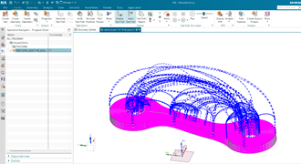
Consequently, a significant research gap exists, as there is currently no standard workflow to take non-planar tool-paths generated in Siemens NX and execute them directly on a desktop FDM printer like the Prusa MK4 [1]. NX postprocessors are primarily designed for subtractive milling, meaning they output numerical control (NC) codes for tool changes, spindle control, and coolant, which are incompatible with 3D printer firmware [13]. Furthermore, as noted in recent studies, fundamental technical constraints complicate the translation of industrial CAM output for FDM [10]. Because subtractive CAM environments are intrinsically designed to calculate tool feed- rates rather than volumetric material flow, they lack native mechanisms to calculate precise filament extrusion [12]. Thus, practical challenges remain in correctly interpreting machine coordinate systems, handling travel moves, and accurately calculating material extrusion values when relying on industrial CAM output.

The primary objective and the core novel contribution of this research is to develop a practical, reproducible non-planar 3D printing workflow for the Prusa MK4 printer that effectively links industrial CAM generation with desktop fabrication [1]. This study utilizes the Siemens NX Freeform Additive Buildup operation to generate non-planar toolpaths and NX Post Builder to export the initial motion data. To bridge the compatibility gap, a custom Python post-processing script is developed to automatically convert the raw NX output into a Marlin-compatible G-code format suitable for standard FDM firmware [16]. This methodology addresses the challenges of filtering milling-specific artifacts, accurately mapping extrusion values, handling travel motions, and aligning coordinate mismatch to enable robust non-planar printing on standard FDM hardware [12].

2. Methodology
To overcome the challenges of utilizing an industrial Computer-Aided Manufacturing (CAM) system for desktop FDM printing, a comprehensive workflow was developed (Fig. no: 2.1 – Our workflow). The primary software process chain consisted of CAD model preparation, additive manufacturing setup, non-planar toolpath generation, NX Post Builder export, and Python post-processing, which was subsequently followed by physical validation and experimental printing.
The target geometry, which included curved and overhanging features suited for non-planar deposition, was imported into Siemens NX. To ensure correct coordinate alignment for the additive operation, the part was positioned such that its bottom surface was located at Z = 0 in the absolute coordinate system. A specific Manufacturing Coordinate System was defined on the bottom face of the part to establish a consistent origin for the subsequent toolpath generation.

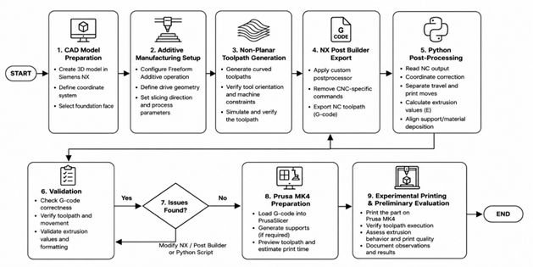

Fig. no: 2.1 – Our workflow
2.2 Freeform Additive Buildup Toolpath Generation
A Freeform Additive Buildup operation within the NX Additive Manufacturing module was utilized to generate the non-planar motion (Fig. no: 2.2 – Freeform Additive Build-up by NX Siemens). To prevent "invalid rotary position" errors commonly encountered when industrial software attempts to tilt the tool for multi-axis machines, the operation was restricted to a 3-axis machine configuration [13].

Fig. no: 2.2 – Freeform Additive Build-up by NX Siemens
The tool axis was strictly fixed in the +Z direction. By selecting the bottom faces as the Foundation Face, the slicing and path generation correctly progressed upward (+Z), creating a toolpath that smoothly followed the curved topology of the part without triggering 5-axis rotary requirements.

2.3 NX Post Builder Customization
By default, NX postprocessors are designed for subtractive CNC milling and output numerical control codes—such as tool changes (T01, M06), spindle commands (M03), coolant triggers (M08), and tool length offsets (G43)—which are unrecognizable to standard 3D printer firmware. To resolve this, a custom 3-axis postprocessor (designated as fdmtrial_3x) was developed using NX Post Builder. All milling-specific commands were stripped from the operation events. The linear motion outputs were simplified to pure spatial coordinates and feed rates (G1 X Y Z F).
Additionally, custom program start and end sequences were configured to act as placeholders for FDM heater and motor commands (e.g., M104, M140, M84).

2.4 Python-Based Conversion and Support Integration
The raw output exported from NX Post Builder lacked material extrusion calculations and complete initialization parameters. A custom Python script was developed to convert this raw NC data into a fully printable, G-code format for the Prusa MK4. The script performed the following critical functions:
Extrusion Calculation: Because NX does not natively compute filament flow for FDM, the script calculated the 3D spatial distance of each G1 segment and accumulated an absolute extrusion value. This was governed by a physically derived volumetric calculation equating the volume of the deposited rode to the volume of the extruded filament.
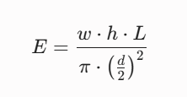
The required filament length for a given segment as calculated from this formula: -
- Travel Motion Filtering: A strict geometric classifier was implemented to distinguish true deposition moves from travel moves. Unnecessary long-distance repositioning segments were identified using distance and Z-jump thresholds, and converted into non-extruding G0 travel moves to prevent stringing and material waste.
- Coordinate Shifting: To ensure the part printed safely on the Prusa MK4, the script scanned the toolpath bounding box and mathematically shifted all X and Y coordinates to centre the part on the 252×210 mm build plate.
- Support Integration: Support Integration: For overhanging sections, planar support structures were generated using Prusa Slicer. The Python script was utilized to merge the support G-code with the non-planar part G-code by systematically parsing both files to prevent firmware conflicts. First, the script stripped redundant homing (G28), bed levelling (G29), and heating commands from the Prusa Slicer output to prevent the machine from resetting mid-print. It then synchronized the absolute extrusion (E) values between the final layer of the support structure and the first movement of the non-planar toolpath. Furthermore, the script applied bounding-box coordinate adjustments to ensure accurate spatial alignment between the planar support interface and the non-planar object. Finally, standard Marlin-style startup and shutdown routines were injected to finalize the combination

3. Results and Discussion
3.1. Toolpath Execution
The proposed workflow was evaluated through file inspection and preliminary physical testing on a Prusa MK4 3D printer. The results confirmed that the machine accurately executed the non-planar motion paths generated by Siemens NX. The toolhead smoothly followed the varying Z-axis topology of the curved test part without triggering the "invalid rotary position" errors that previously halted the industrial CAM post-processing. This demonstrated that advanced non-planar toolpaths generated by industrial CAM software could be successfully constrained and translated into a 3-axis Cartesian framework suitable for standard FDM hardware.
3.2. Extrusion and Startup Sequence Challenges
While the geometric motion was interpreted correctly, initial print tests revealed inconsistent filament extrusion. The printer frequently executed the correct spatial movements without depositing material (often referred to as "ghost printing"). Investigation revealed that this was not a hardware failure, but rather a consequence of the absolute extrusion mode (M82) handling within the generated G-code. Because Siemens NX does not natively track filament usage, the custom Python script was required to mathematically accumulate the E-values. However, discrepancies in the initial startup sequence and missing priming commands meant the nozzle was not sufficiently pressurized before the non-planar operation commenced. Consequently, the Python script had to be refined to inject proper Marlin-style priming sequences and strictly maintain a monotonically increasing extrusion value corresponding to the 3D spatial distance of each segment.
3.3. Coordinate Alignment and Support Structures
An additional challenge emerged when integrating support structures for the overhanging sections of the geometry. Preliminary evaluations showed a distinct coordinate mismatch—specifically an offset of approximately 14 mm along the X-axis—between the main part G-code (processed from NX) and the support G-code (generated in PrusaSlicer). Because the two software environments established their global origins differently, the structures were visibly misaligned on the print bed as shown below (Fig. no: 3.1 – Misalignment of Part and Support structure). This limitation was successfully mitigated by implementing a bounding-box scanning and shifting algorithm within the Python post-processing script, ensuring the support structures and the non-planar object shared an identical spatial origin.
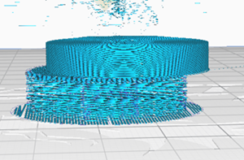
Fig. no: 3.1 – Misalignment of Part and Support structure

3.4. Parameters
The parameters for 3D printing in our case are as follows:
Parameter Categorization | Parameters | Value
Nozzle setting | Nozzle diameter | 0.4 mm
Thermal settings | Nozzle temperature | 200°C
 | Bed temperature | 70°C
Motion settings | Printing speed | 15 mm/s
 | Layer thickness | 0.2 mm
Material settings | Infill density | 100%

Table.no: 2 – Printing parameters
3.5. Overall Assessment and Limitations
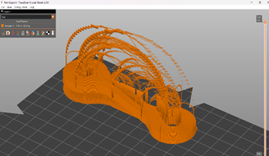
The findings confirm the viability of bridging an industrial CAD/CAM environment with a desktop FDM printer using custom post-processing. The methodology successfully eliminates subtractive milling artifacts and addresses the gap between NC codes and 3D printer firmware. However, as a prototype workflow, it currently relies heavily on manual script execution and exact extrusion parameter tuning. The process remains highly sensitive to extrusion calibration and support coordinate matching. Future iterations of this workflow must focus on automating the alignment of support structures and implementing dynamic extrusion scaling to ensure reliable, high-quality manufacturing of complex non-planar geometries. Below given are the isometric and side views of our work from simulation from PrusaSlicer. (Fig. no:3.2 & 3.3)
Fig. no:3.2 – Our final non planar toolpath in Prusa Slicer (Isometric view)
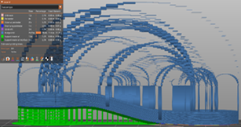
Fig. no: 3.3 – Our final non planar toolpath in Prusa Slicer (side view)

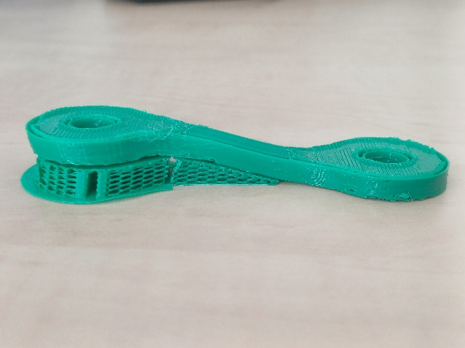
Ultimately, the 3D printed part can be seen below:

Fig. no: 3.4: - Final 3D printed product

4. Conclusion and Future Work
4.1. Conclusion
This research successfully developed a practical end-to-end workflow to generate non-planar 3D printing G-code for a standard desktop FDM printer (Prusa MK4) using Siemens NX Additive Manufacturing, NX Post Builder, and custom Python post-processing. The study demonstrated that industrial 3-axis non-planar CAM paths can be effectively translated into standard 3-axis FDM motion by mathematically assigning absolute extrusion values and filtering out subtractive milling artefacts. [13] Furthermore, challenges related to coordinate mismatches between the primary object and Prusa Slicer-generated support structures were successfully resolved through automated coordinate shifting within the Python script. Ultimately, this research presents a novel contribution to the field by demonstrating that non-planar printing can be executed on standard FDM hardware without relying solely on specialized open-source slicers, successfully bridging the gap between advanced industrial path generation and accessible desktop manufacturing. [1], [10]
4.2. Future Work
While the conceptual workflow is fully functional, several areas require further optimization to ensure consistent manufacturing quality. Immediate future work will focus on refining the Python script to automate support integration and G-code merging into a more robust, single pipeline. Additionally, extrusion handling and startup priming sequences will be optimized to eliminate inconsistencies and enhance extrusion reliability.
Subsequent research phases will involve conducting comprehensive physical tests on the Prusa MK4 to evaluate key metrics such as surface finish, dimensional accuracy, and overall print quality. These non-planar prints will be directly compared against standard planar prints to quantify the mechanical and aesthetic benefits of the workflow. Finally, the developed methodology will be extended to accommodate more complex geometries and tested across different desktop printer architectures to assess its broader scalability and application.

5. References
[1] A. Afshari, J.-A. Tröger, J. Meyer, S. Hartmann, and D. Inkermann, “Non-planar 3D printing—Enhancing Design Potentials by Advanced Slicing Algorithms and Path Planning,” Procedia CIRP, vol. 136, pp. 284–289, 2025, doi: 10.1016/j.procir.2025.08.050.
[2] E. Ottonello, P.-A. Hugron, A. Parmiggiani, and S. Lefebvre, “QUICKCURVE: Revisiting slightly non-planar 3D printing,”
[3] A. López-Arraza b al, Á. Guzmán-Bautista, W. Solórzano-Requejo, F. Franco-Martínez, and M. Villaverde, “Axisymmetric non-planar slicing and path planning strategy for robot-based additive manufacturing,” Materials & Design, vol. 241, p. 112915, 2024.
[4] B. Darweesh, M. P. Gutierrez, and S. Schleicher, “Non-planar granular 3D printing,” Construction Robotics, vol. 7, pp. 291–306, 2023, doi: 10.1007/s41693-023-00107-5.
[5] F. J. Mercado Rivera and A. J. Rojas Arciniegas, “Additive manufacturing methods: techniques, materials, and closed-loop control applications,” Int. J. Adv. Manuf. Technol., vol. 109, no. 1–2, pp. 17–31, 2020, doi: 10.1007/s00170-020-05663-6.
[6] S. Hasanov et al., “Review on Additive Manufacturing of Multi-Material Parts: Progress and Challenges,” J. Manuf. Mater. Process., vol. 6, no. 1, p. 4, 2021, doi: 10.3390/jmmp6010004.
[7] I. Gibson, D. Rosen, and B. Stucker, Additive Manufacturing Technologies: 3D Printing, Rapid Prototyping, and Direct Digital Manufacturing. Springer, 2015, doi: 10.1007/978-1-4939-2113-3.
[8] D. Syrylbayev et al., “Optimisation of Strength Properties of FDM Printed Parts—A Critical Review,” Polymers, vol. 13, no. 10, p. 1587, 2021, doi: 10.3390/polym13101587.
[9] A. W. Hashmi, H. S. Mali, and A. Meena, “The Surface Quality Improvement Methods for FDM Printed Parts: A Review,” in Fused Deposition Modeling Based 3D Printing, Cham: Springer, 2021, pp. 167–194, doi: 10.1007/978-3-030-68024-4_9.
[10] P. Nayyeri, K. Zareinia, and B. Bouhergara, “Planar and nonplanar slicing algorithms for fused deposition modeling technology: a critical review,” Int. J. Adv. Manuf. Technol., vol. 119, no. 5–6, pp. 2785–2810, 2022, doi: 10.1007/s00170-021-08347-x.
[11] X. Guidetti et al., “Stress flow guided non-planar print trajectory optimization for additive manufacturing of anisotropic polymers,” Additive Manufacturing, vol. 72, p. 103628, 2023, doi: 10.1016/j.addma.2023.103628.
[12] D. Ahles et al., “3D Printing of Nonplanar Layers for Smooth Surface Generation,” in 2019 IEEE 15th Int. Conf. on Automation Science and Engineering (CASE), 2019, pp. 1737–1743, doi: 10.1109/COASE.2019.8843116.
[13] P. Schaechtl, B. Schleich, and S. Wartzack, “On the Potential of Slicing Algorithms in Additive Manufacturing for the Optimization of Geometrical Part Accuracy,” Procedia CIRP, vol. 114, pp. 215–220, 2022, doi: 10.1016/j.procir.2022.10.030.
[14] A. S. Palani, P. Sathiya, and D. Palanisamy, eds., [Book/Chapter title not fully visible], Springer Nature Singapore, 2022, pp. 691–714.
[15] F. Insero, V. Furlan, and [authors], “Non-planar slicing for filled free-form geometries in robot manufacturing,” Journal/Conference not fully visible, 2023, doi: 10.1007/s10845-023-02250-w.
[16] A. M. Cendrero et al., “From planar printing strategies towards eco-efficiency,” Sustainability, vol. 13, no. 4, p. 1599, 2021, doi: 10.3390/su13041599.
[17] T. Zhang et al., “— Automatic non-planar slicing algorithm for additive manufacturing of complex geometries,” Additive Manufacturing, 2023, doi: 10.1016/j.addma.2023.103541.

