### **A**

**Mini Report**

ON

“Collage Management System”

SUBMITTED TO

SANT GADGE BABA AMRAVATI UNIVERSITY IN THE PARTIAL FULFILLMENT OF THE DEGREE OF

### **BACHELOR OF ENGINEERING**

### **IN**

**COMPUTER SCIENCE AND ENGINEERING**

**BY:**

### Mr. Chirag Badhe (09) Mr. Aditya Narkhede(02)

Mr. Atul Date(07) Mr. Abhishek Raje(01)

### Mr. Abhishek Sharma( )

**GUIDED BY:**

### **PROF. G. V. Patil**

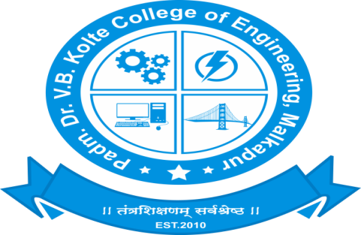

**DEPARTMENT OF COMPUTER SCIENCE & ENGINEERING**

**PADM. DR.V. B. KOLTE COLLEGE OF ENGINEERING, MALKAPUR- 443101 2022-23**

## 

## 

## 

## CERTIFICATE

It is certified that the work contained in the seminar titled **“Collage Management System”**, by **Group** Padm. Dr. V. B. Kolte College of Engineering, Malkapur from the Department of “Computer Science & Engineering” has been carried out under my/our supervision, and this work has not been submitted elsewhere for a degree in Computer Science & Engineering - BE (Computer Science and Engineering).

**Guided By:-**

Asst. Prof. G. V. Patil

Department of Computer Science & Engineering

Padm. Dr. V. B. Kolte College of Engineering, Malkapur

**Principal HOD**

Dr. A. W. Kharche Asst. Prof. S. L. Farpat

Padm. Dr. V. B. K.COE, Malkapur Dept. of Computer Science &Engineering

Padm. Dr. V. B. K.COE, Malkapur

## 

## 

## 

## ACKNOWLEDGEMENT

I express deep gratitude for the enthusiasm and valuable suggestions that I got from my guide **Asst. Prof. G. V. Patil** of the Computer Science & Engineering Department for the successful completion of the seminar report. This was not possible without his invaluable guidance. I pay deep regards to our HOD **Prof. S. L. Farpat** and Principal **Dr. A. W. Kharche** who are instrumental in setting standards for the students to achieve. Finally, I am thankful to all the people who are related to the Seminar directly or indirectly.

**Name Of Students:-**

* Aditya Narkhede *(21BD310941)*
* Chirag Badhe *(21BD310948)*
* Abhishek Raje *(21BD310940)*
* Abhishek Sharma *(21BD310988)*
* Atul Date *(21BD310946)*

**Abstract**

This report specifies the various processes and techniques used in gathering requirements, designing, implementing and testing for the project on college management system. The problems regarding the current system in the college were analyzed and noted. This project aims to solve some of those problems and thus, add more value to the current system. The requirements were gathered from all the stakeholders and based on that we created a requirements models and designed the software based on the based. The project was implemented in the form of a website using django(python).

Using the various resources and tools we gathered along the way, we implemented the college ERP system using some features that solve the current problems in the system such as a provision to edit the attendance and marks before locking it at the end. The software was also tested using the various testing methods and results were positive.

Thus, the results can be integrated in the current ERP system to improve it’s working and solve some of the existing problems.