Database Assignment

Problem Statement: There can be multiple customers, who can place multiple orders on the site. Now a sales person can handle these orders will distribute into multiple sales persons (One order will be assign to one salesperson only). So a sales person can have multiple orders of multiple customers.

1) Create Database

sql query – create database ecom;

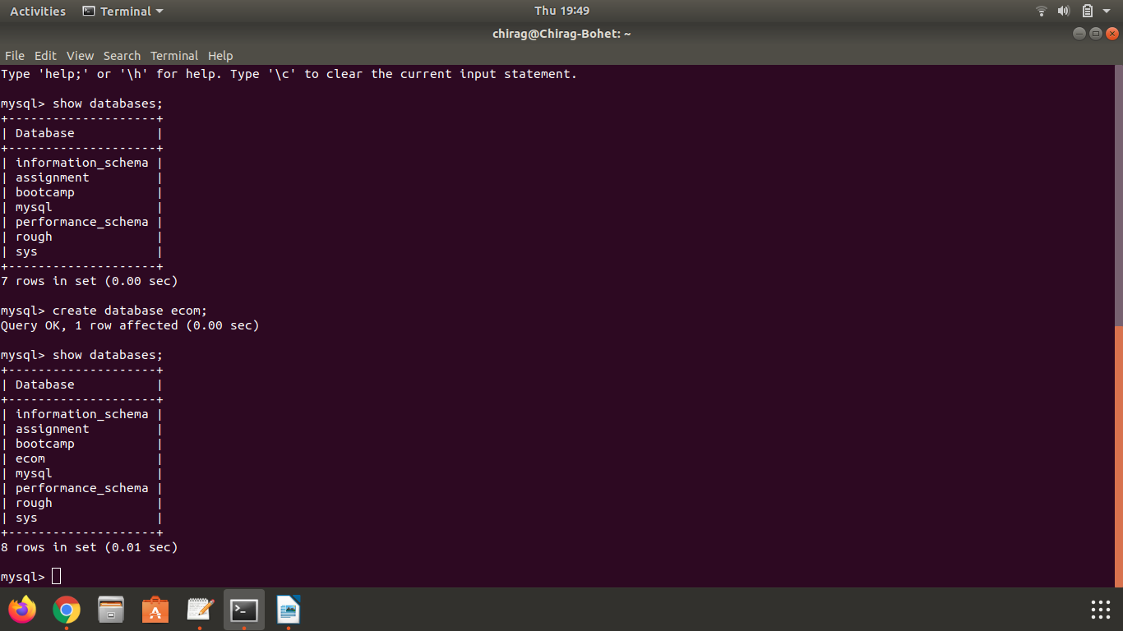

2) Design Schema

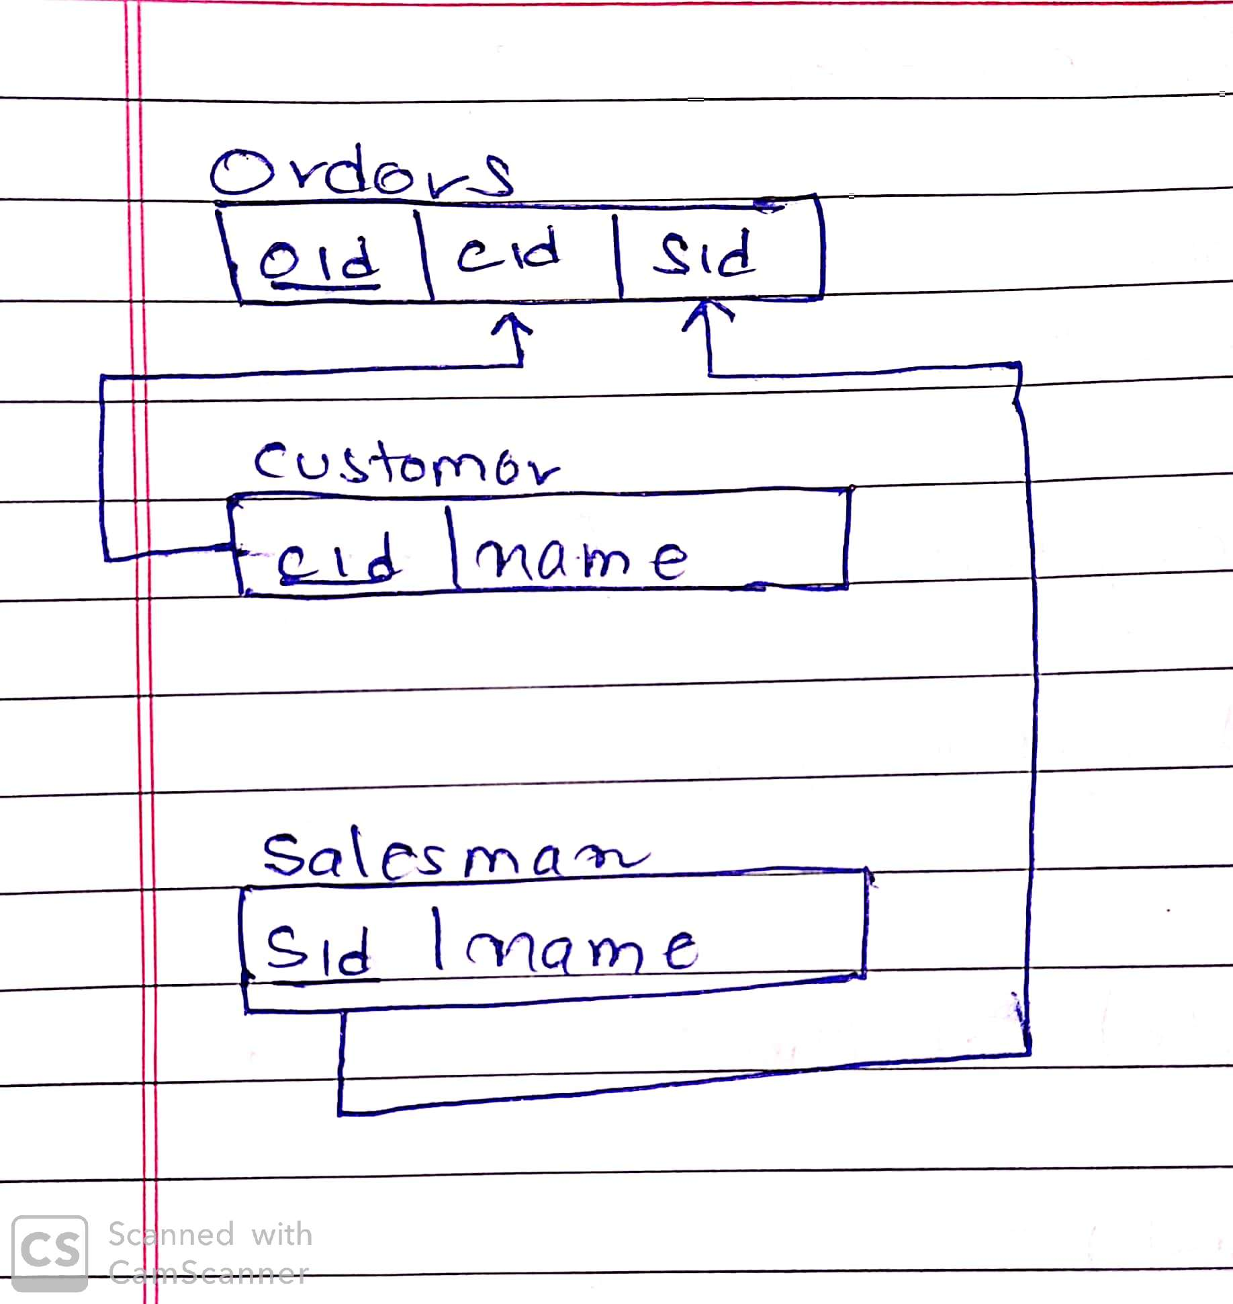

3) Create tables

sql queries -

CREATE TABLE customer(
cid int NOT NULL,
name varchar(20),
PRIMARY KEY (cid)
);

CREATE TABLE salesman(
sid int NOT NULL,
name varchar(20),
PRIMARY KEY (sid)
);

CREATE TABLE orders(
oid int NOT NULL AUTO_INCREMENT,
cid int NOT NULL,
sid int NOT NULL,
FOREIGN KEY(cid) REFERENCES customer(cid),
FOREIGN KEY(sid) REFERENCES salesman(sid),
PRIMARY KEY(oid)
);

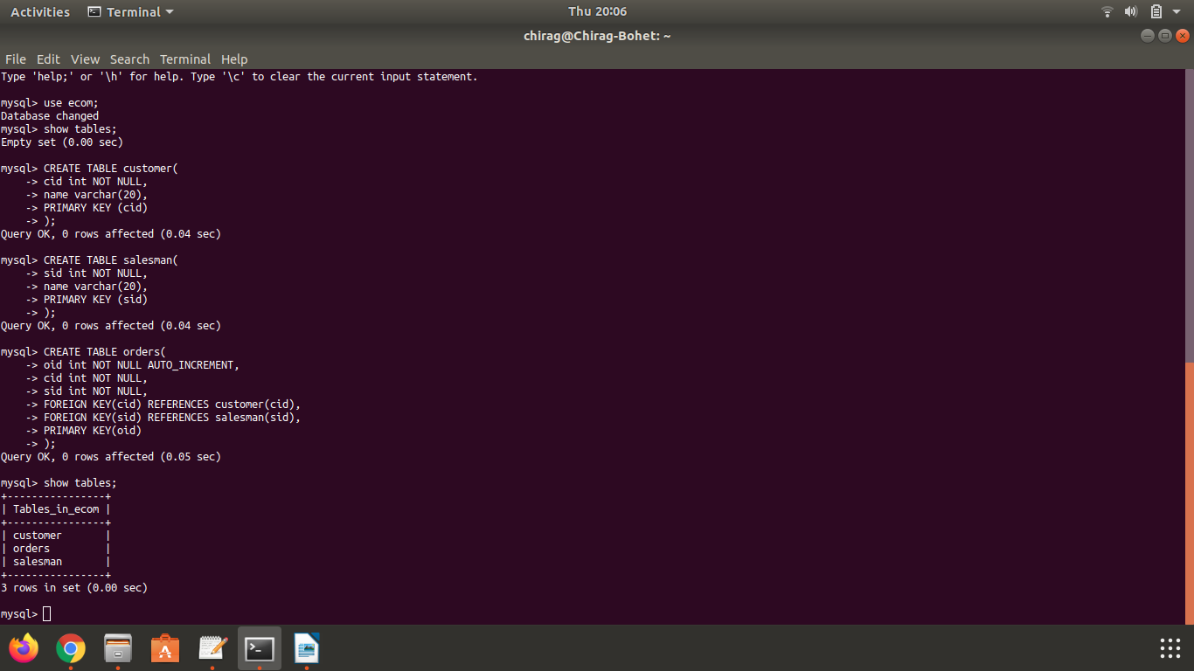

4) Insert sample data

sql query used :

INSERT INTO <tablename> (<col1>,<col2>...<coln>)VALUES (<val1>,<val2>...<valn>);

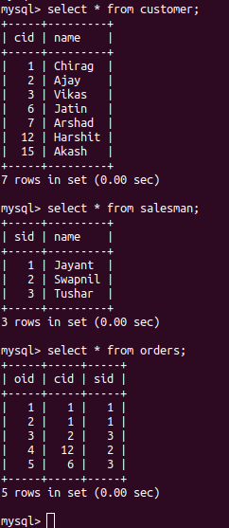

5) Find the sales person have multiple orders.

sql query :

SELECT salesman.sid, salesman.name, COUNT(*) as NumberOfOrders
FROM salesman
INNER JOIN orders
ON salesman.sid = orders.sid
GROUP BY sid
HAVING COUNT(*) > 1;

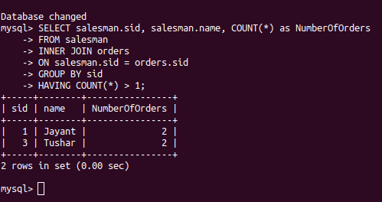

6) Find the all sales person details along with order details

sql query :

SELECT *
FROM salesman
INNER JOIN orders ON salesman.sid = orders.sid;
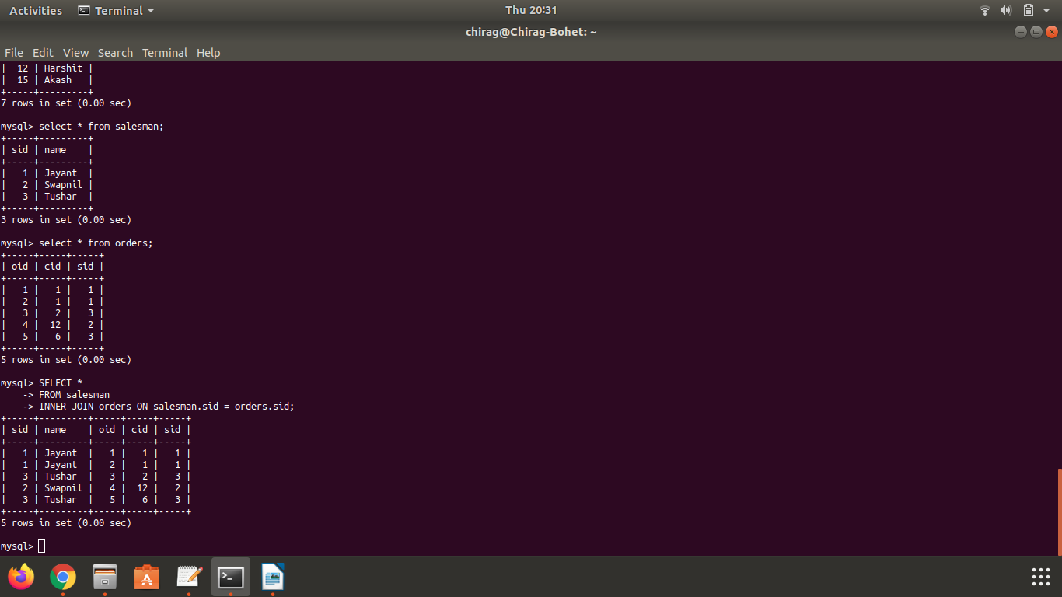

7) Create index

sql query :

CREATE INDEX idx_orderid
ON orders (oid);

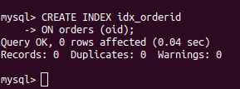

8) How to show index on a table
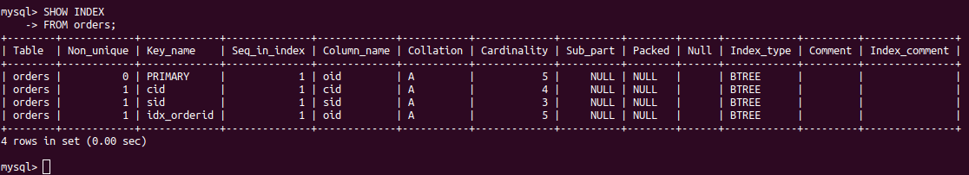
9) Find the order number, sale person name, along with the customer to whom that order belongs to.

sql query :

SELECT orders.oid as OrderNumber, salesman.name as SalesmanName, customer.name as CustomerName
FROM salesman
INNER JOIN orders ON salesman.sid = orders.sid
INNER JOIN customer ON orders.cid = customer.cid;
