Git Assignment

1) Git Setup https://confluence.atlassian.com/bitbucket/set-up-git-744723531.html

Followed the website and installed git successfully.

2) Initialize a Git Repository.

Command used - git init
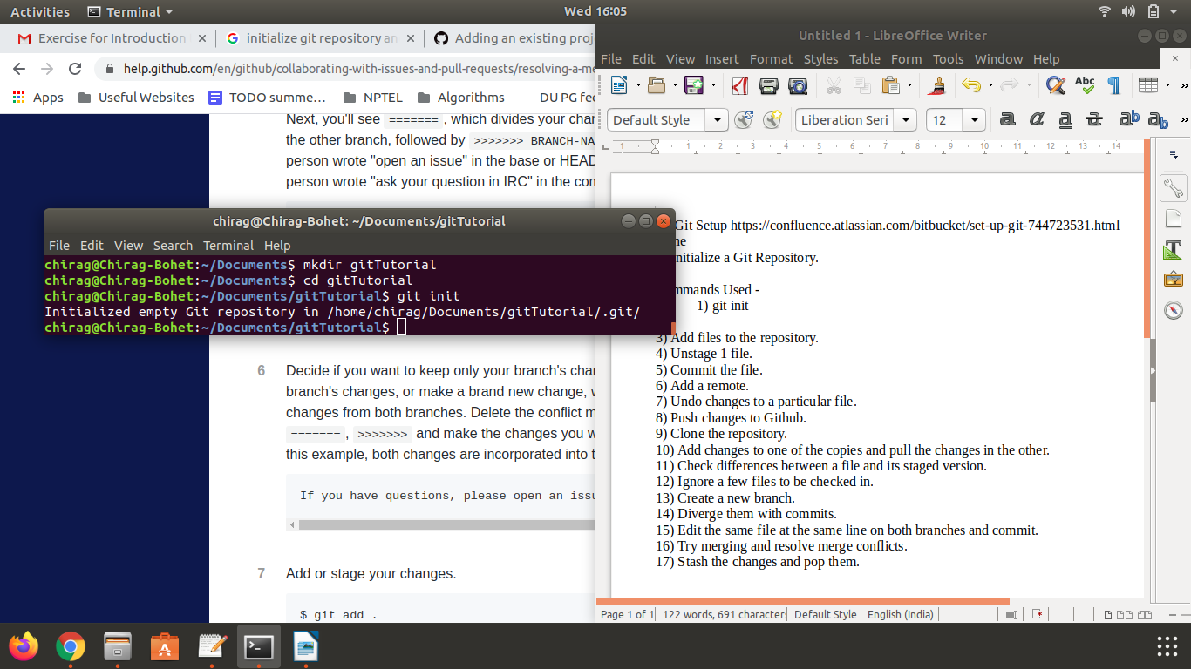

3) Add files to the repository.

Command used - git add f1.txt f2.txt

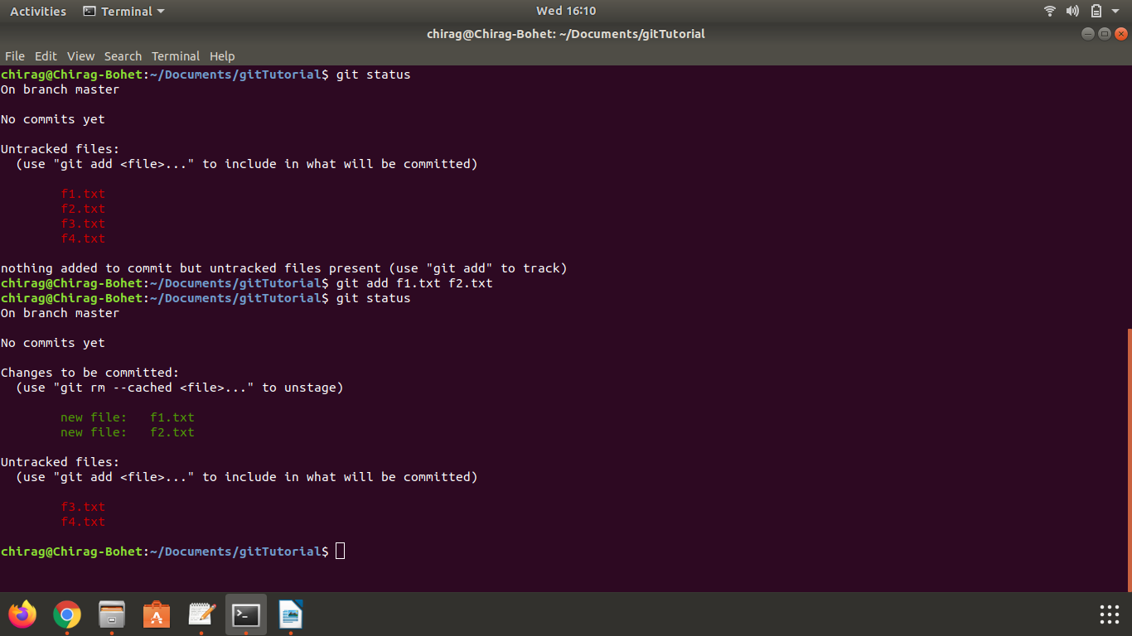

4) Unstage 1 file.

Command used - git reset HEAD – f1.txt

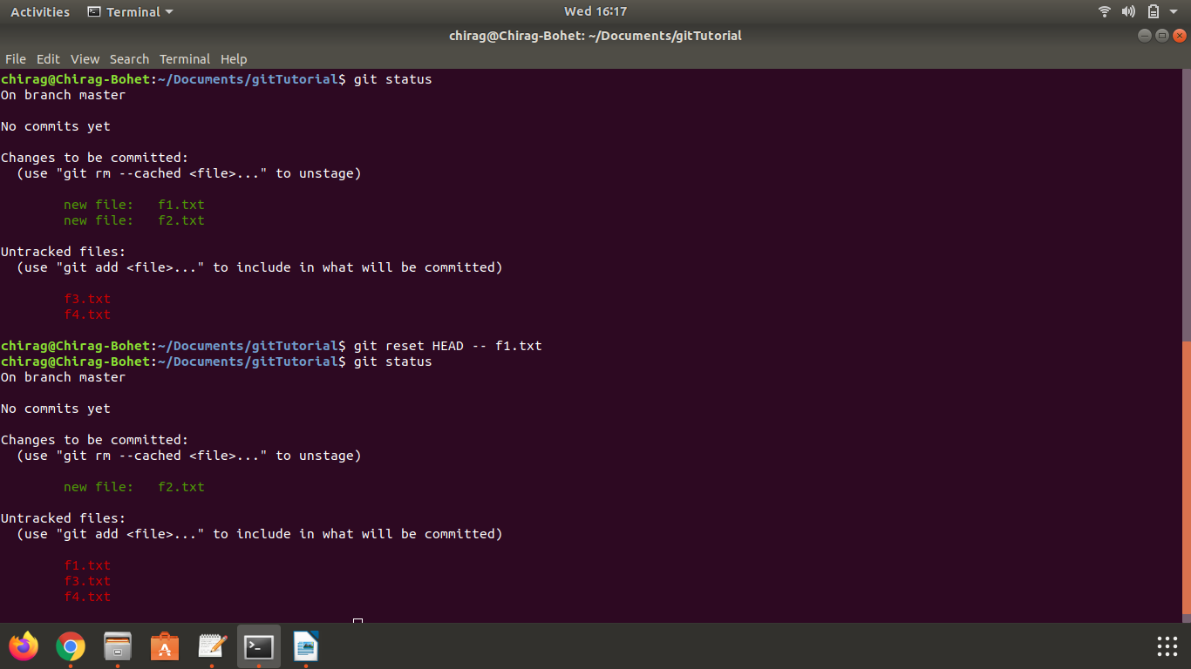
5) Commit the file.

Command used - git commit -m "This is my first commit!"

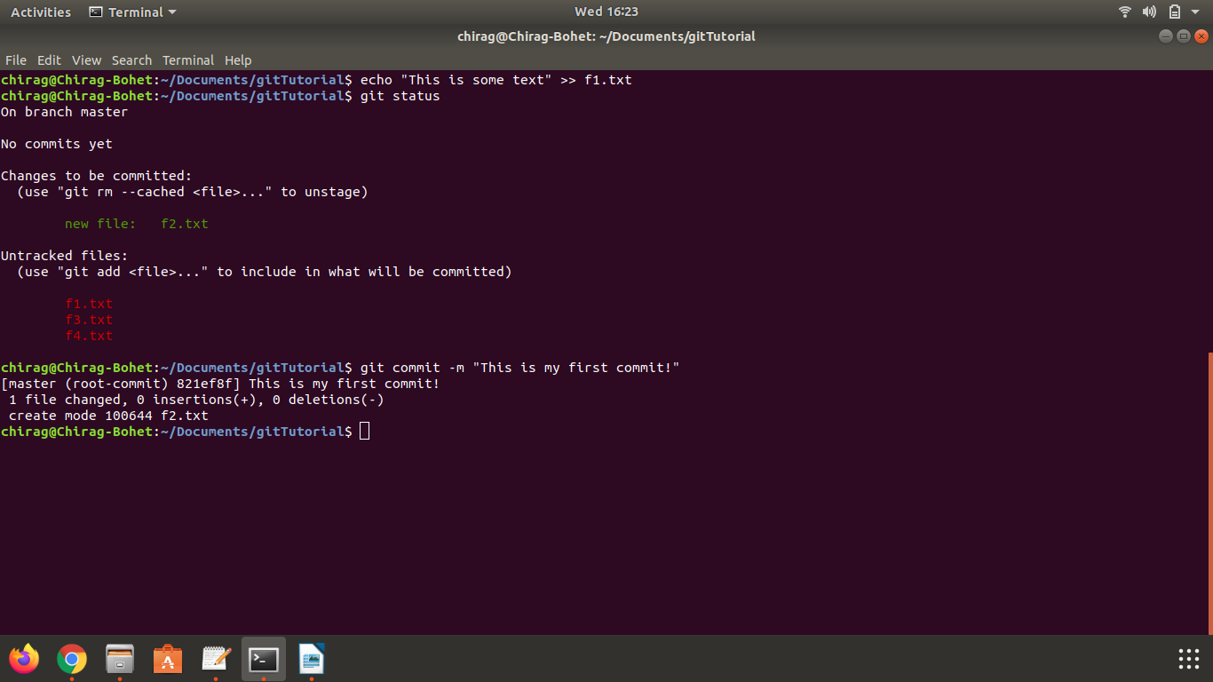

6) Add a remote.

Command used - git remote add origin git@github.com:chiragbohet/gitTutorial.git

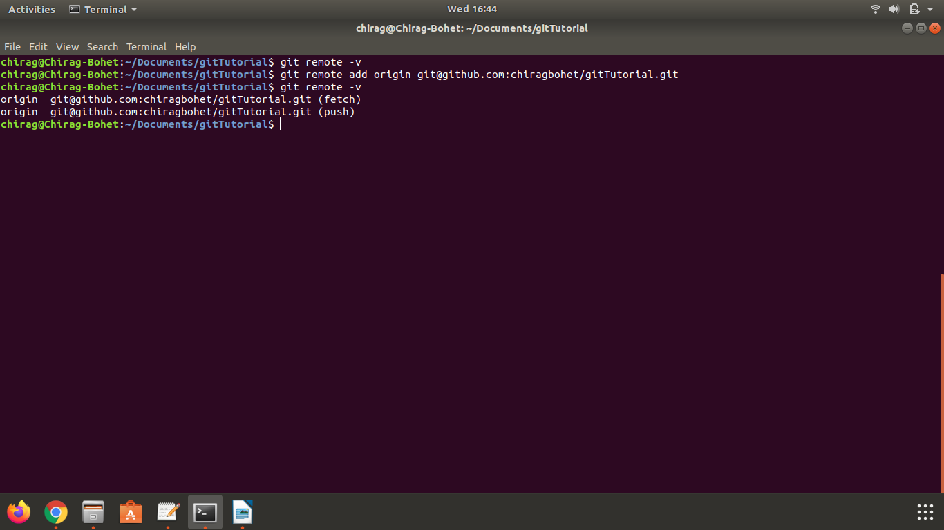
7) Undo changes to a particular file.

This can be done in multiple ways, I have explored two.

1) git revert
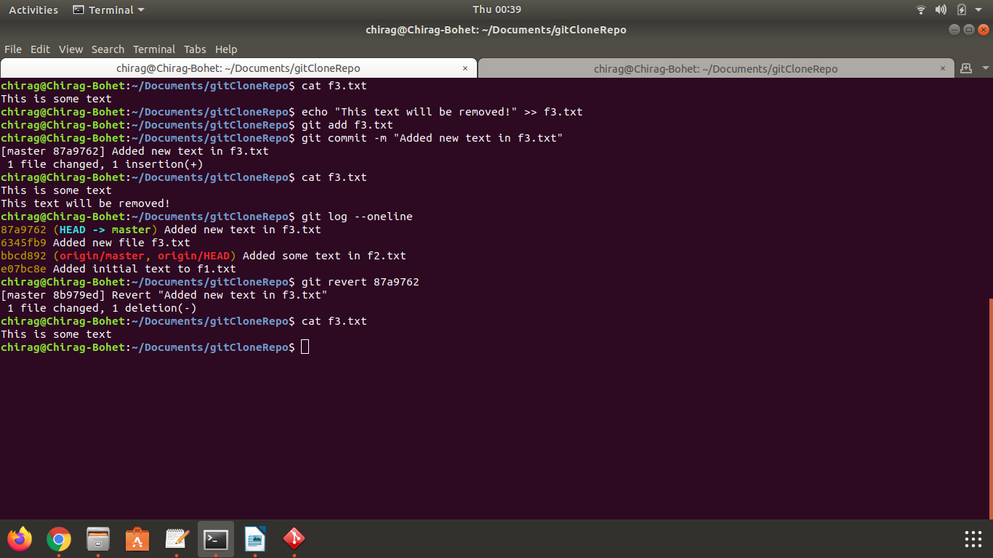

2) git reset

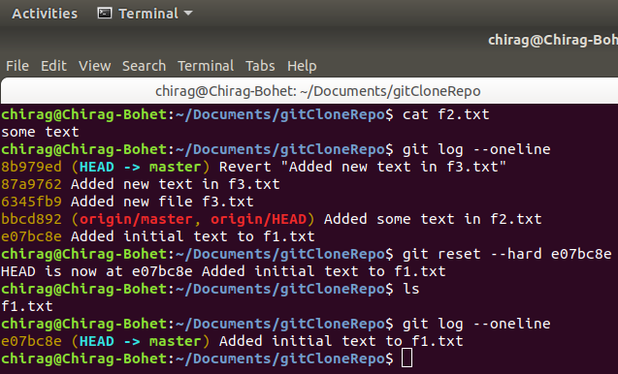

8) Push changes to Github.

Command used - git push origin master

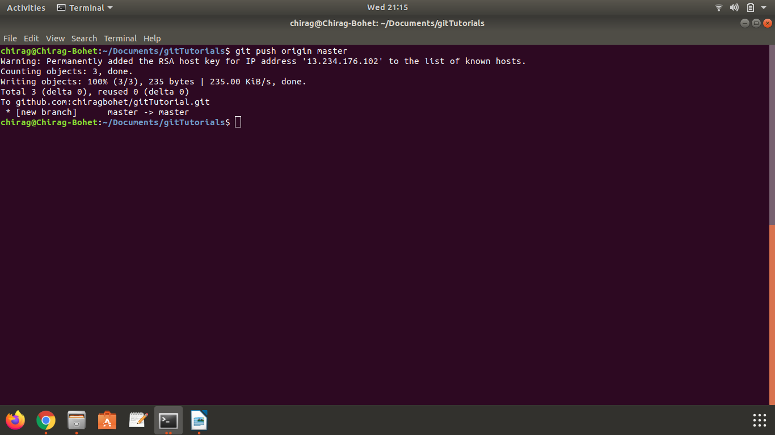
Github screenshot

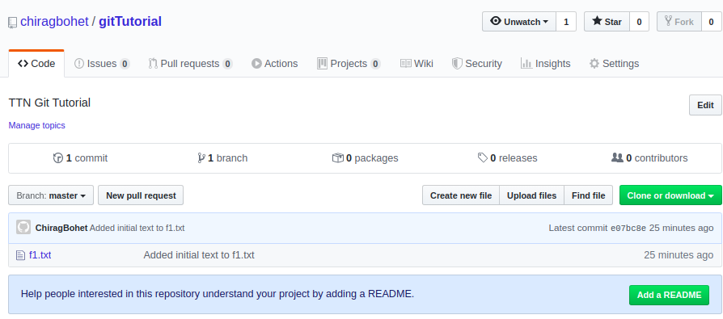

9) Clone the repository.

Command used -
git clone git@github.com:chiragbohet/gitTutorial.git ~/Documents/gitCloneRepo

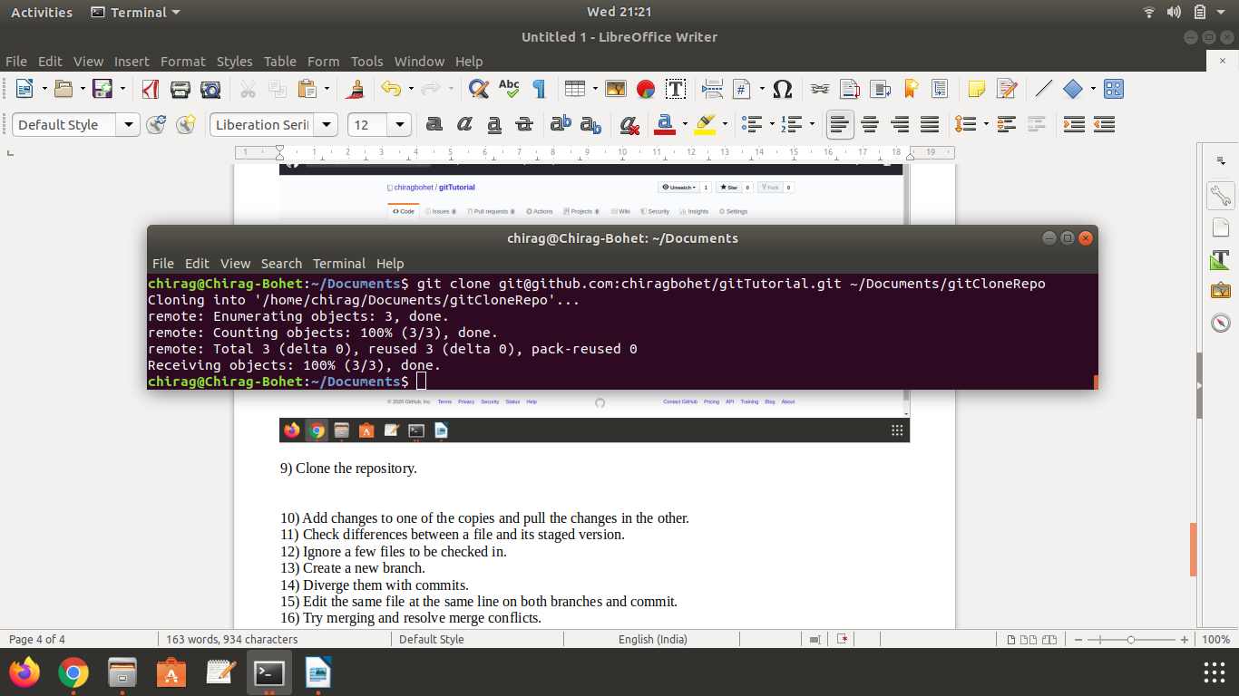

10) Add changes to one of the copies and pull the changes in the other.

Command used -
1) git push origin master

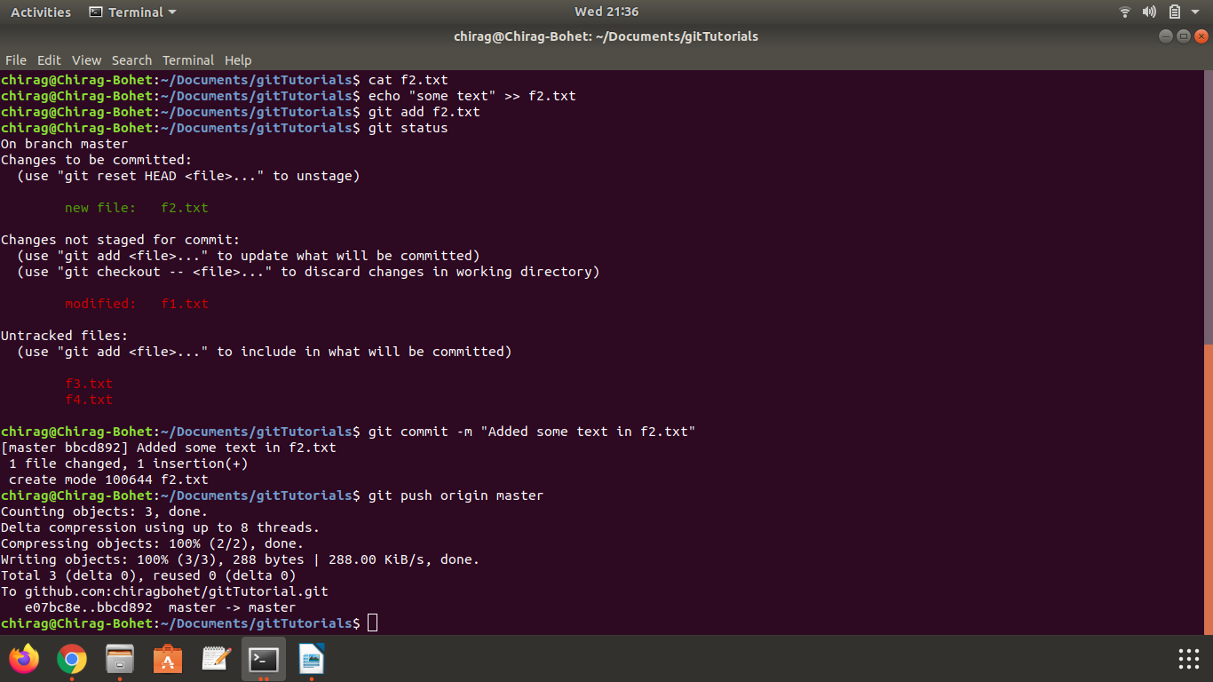
2) git pull origin master

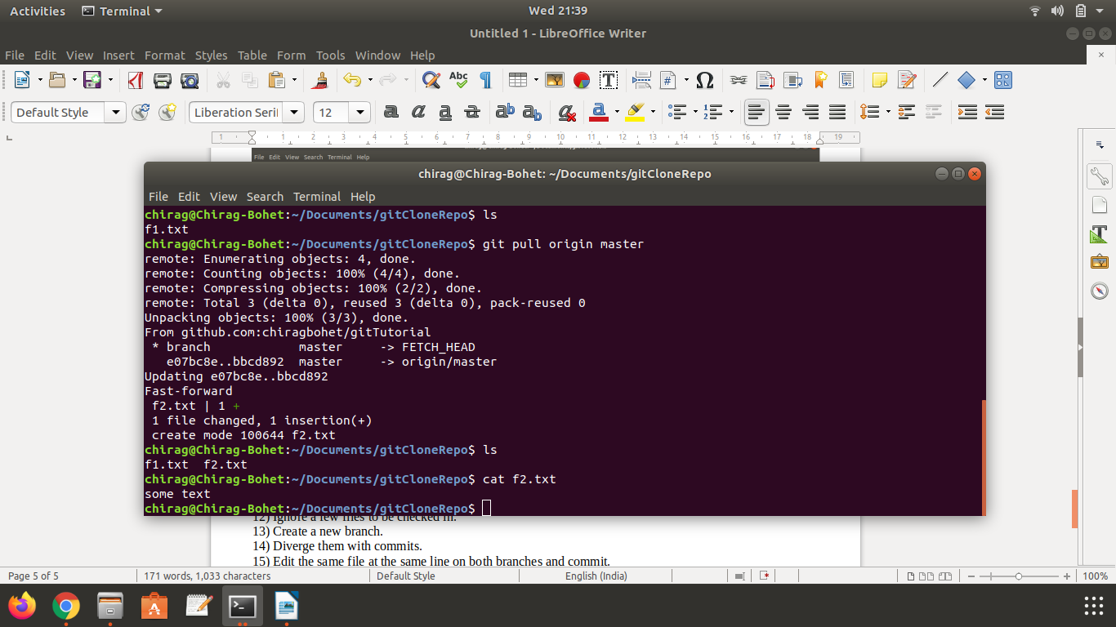
11) Check differences between a file and its staged version.

Command used - git diff –staged

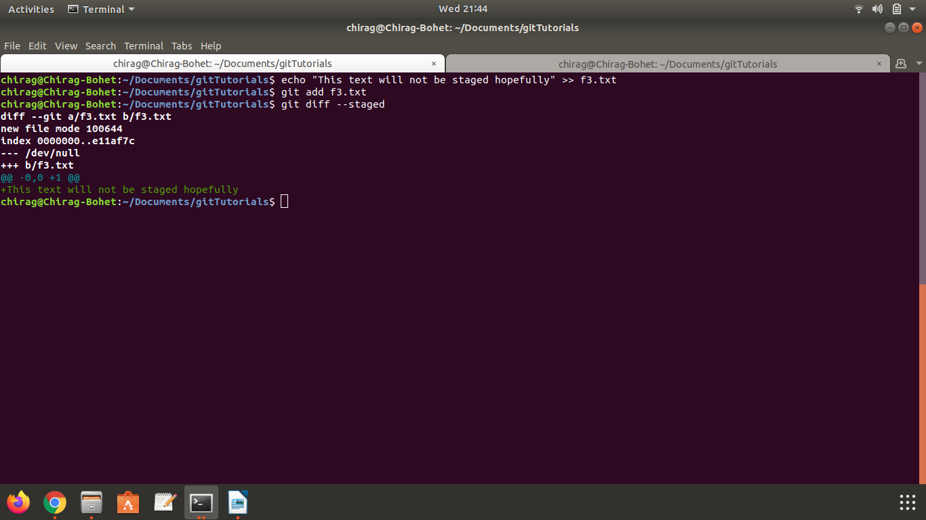

12) Ignore a few files to be checked in.

Used .gitignore to ignore a file.

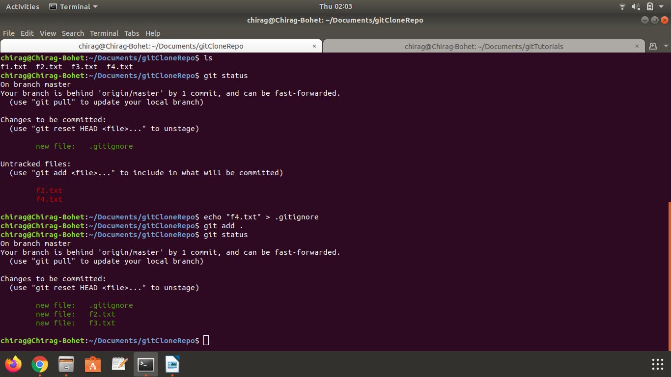

13) Create a new branch.

Command used - git branch b1
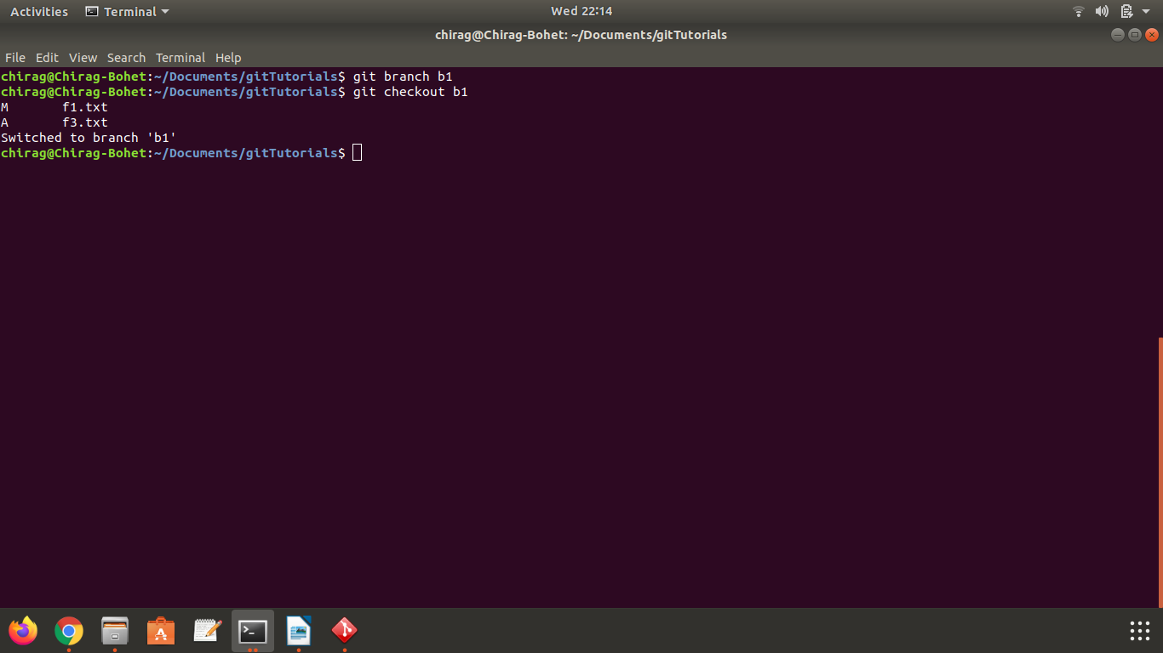
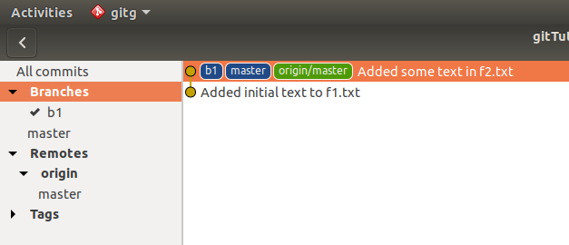

14) Diverge them with commits.

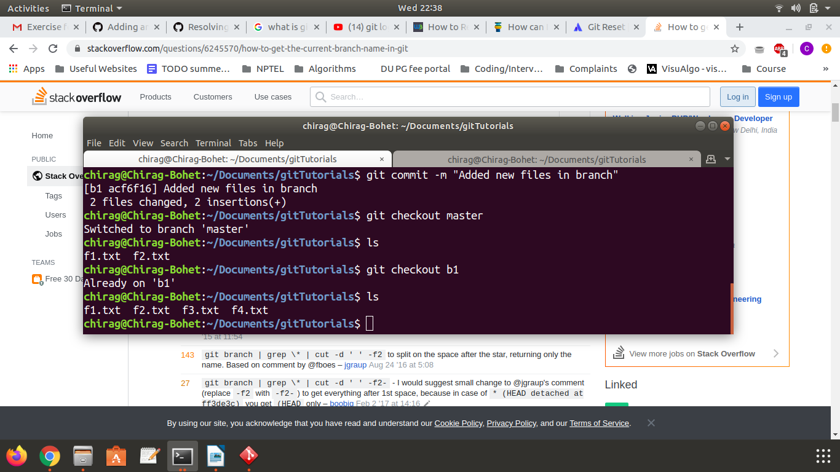
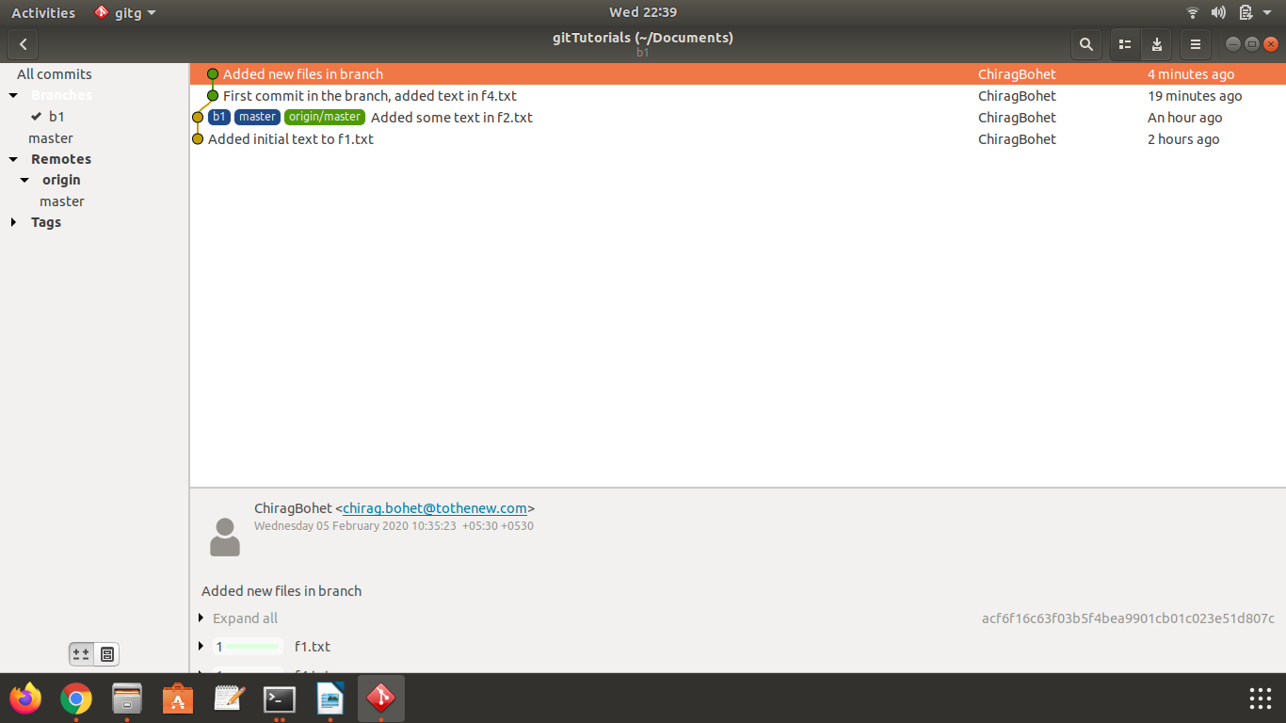

15) Edit the same file at the same line on both branches and commit.

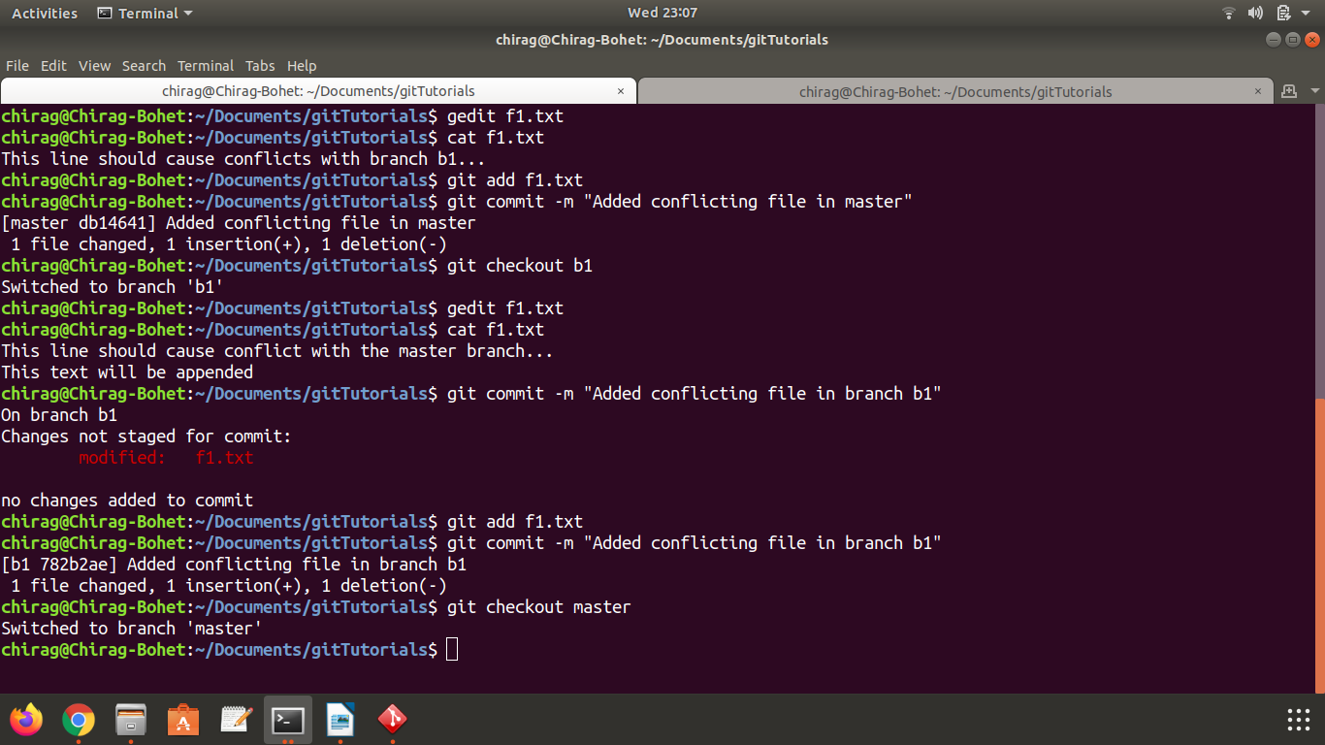
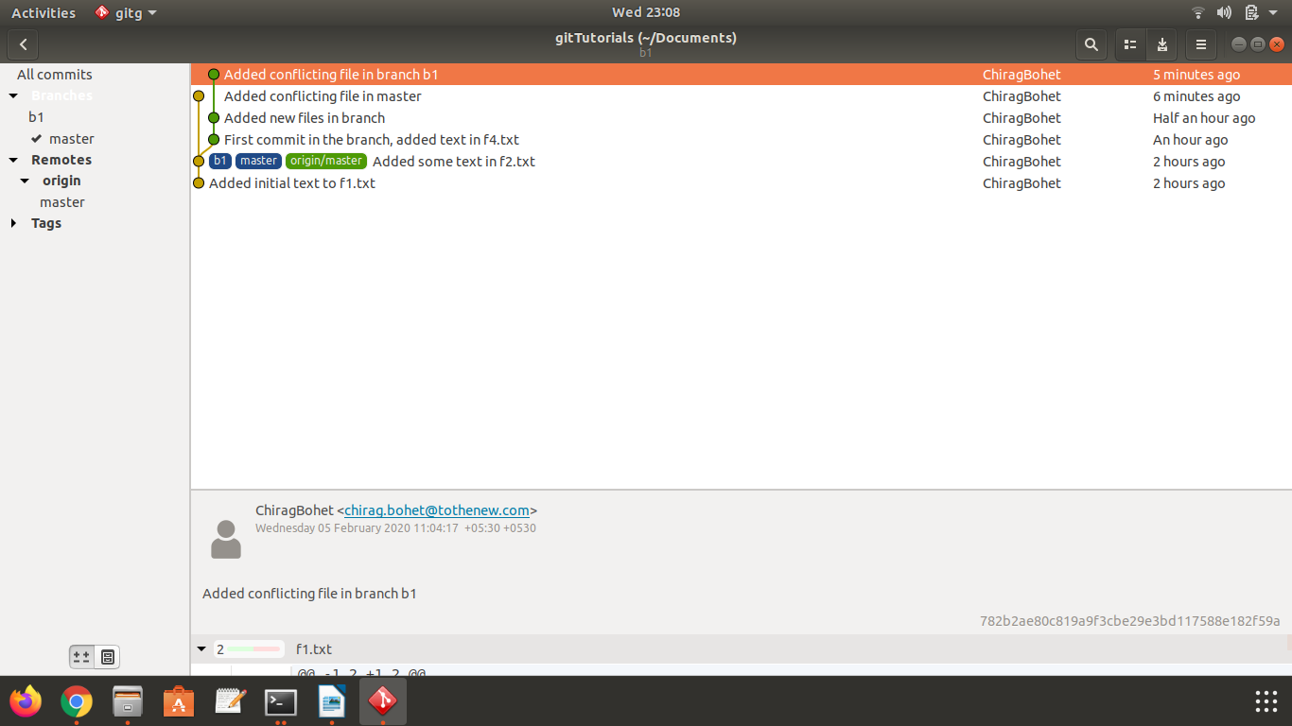

16) Try merging and resolve merge conflicts.

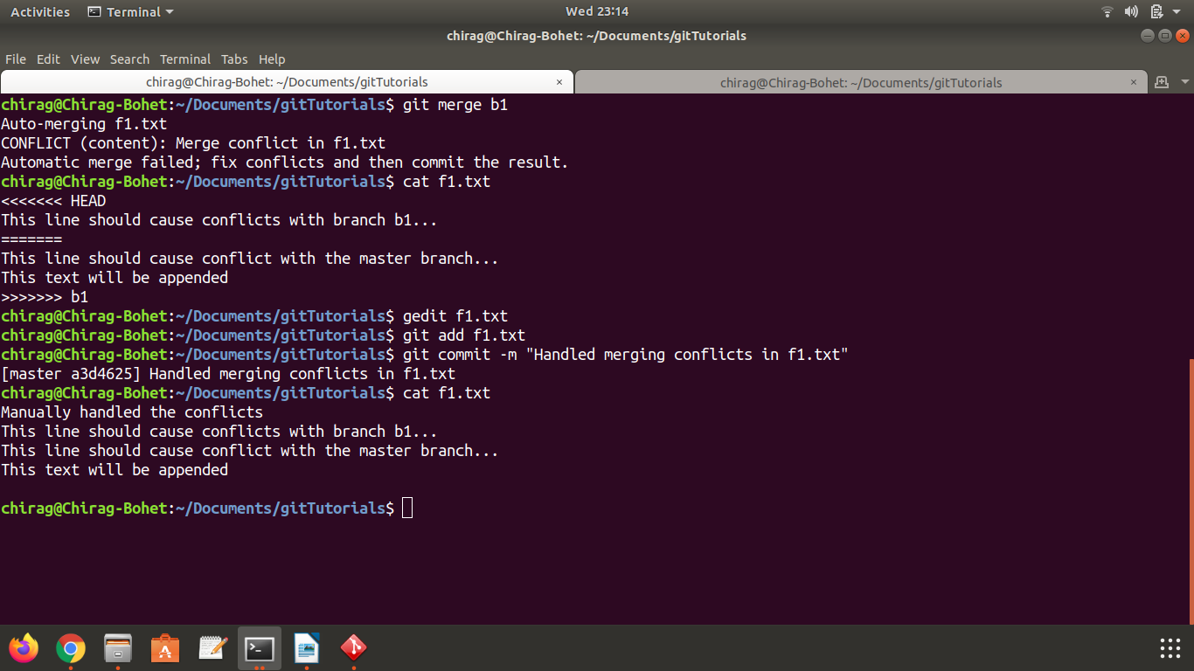
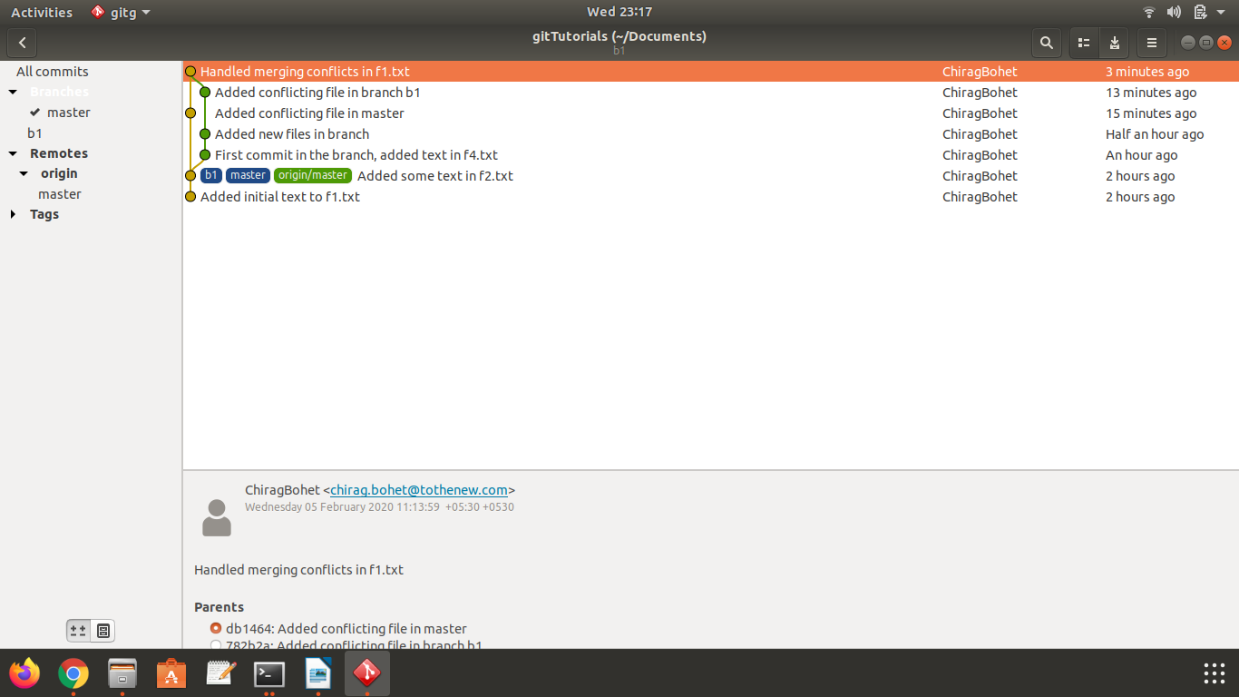

17) Stash the changes and pop them.

Commands used -
1) git stash save
2) git stash apply
3) git stash drop
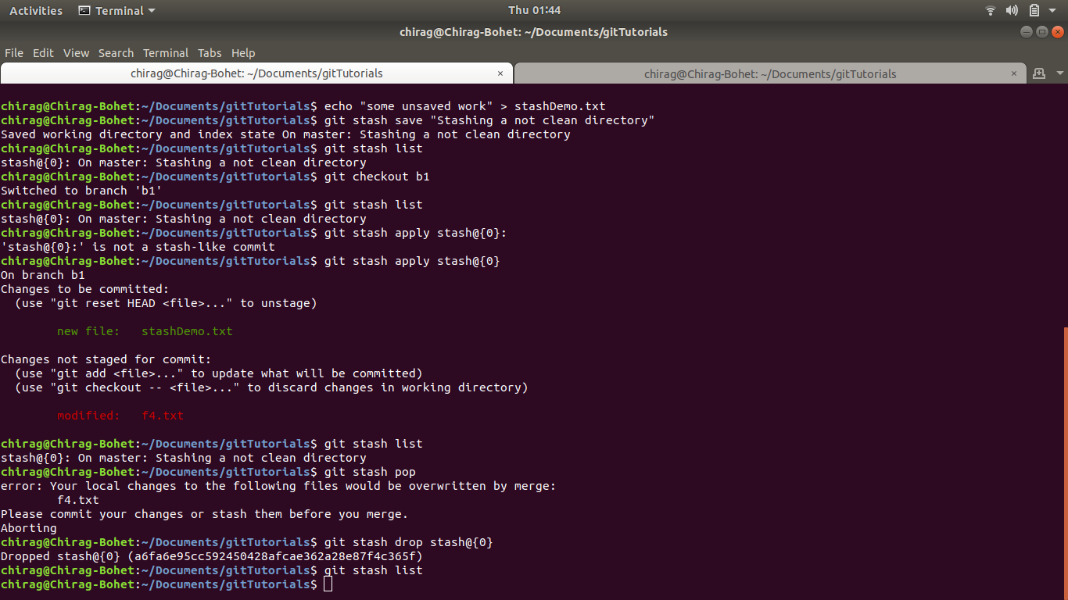

18) Add the following code to your .bashrc file :

color_prompt="yes"
parse_git_branch() {
git branch 2> /dev/null | sed -e '/^[^*]/d' -e 's/* \(.*\)/(\1)/'
}
if [ "$color_prompt" = yes ]; then
PS1='\u@\h\[\033[00m\]:\[\033[01;34m\]\W\[\033[01;31m\] $(parse_git_branch)\[\033[00m\]\$ '
else
PS1='\u@\h:\W $(parse_git_branch)\$ '
fi
unset color_prompt force_color_prompt

