Gradle Assignment

Instructions :

Following parameters are to be considered for exercise submission:

- Complete project has to be submitted.
- .gradle, .idea, build directories should be excluded
- A text file containing the relevant URLs which are referenced and any other documentation.

Questions :

1) Add a gradle dependency and its related repository url.

A dependecy can be added in Gradle by mentioning it in the build.gradle file inside the ‘dependencies’ section.

build.gradle

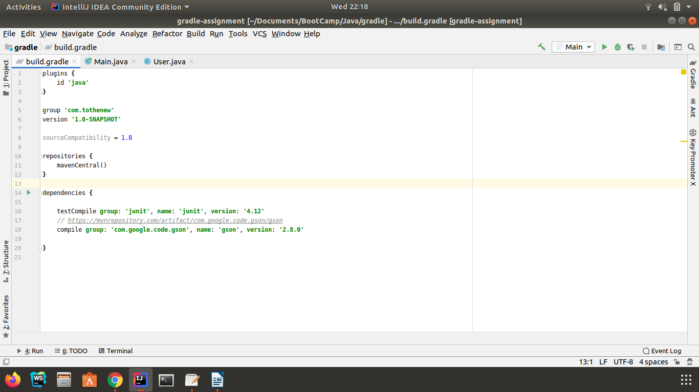

User.java

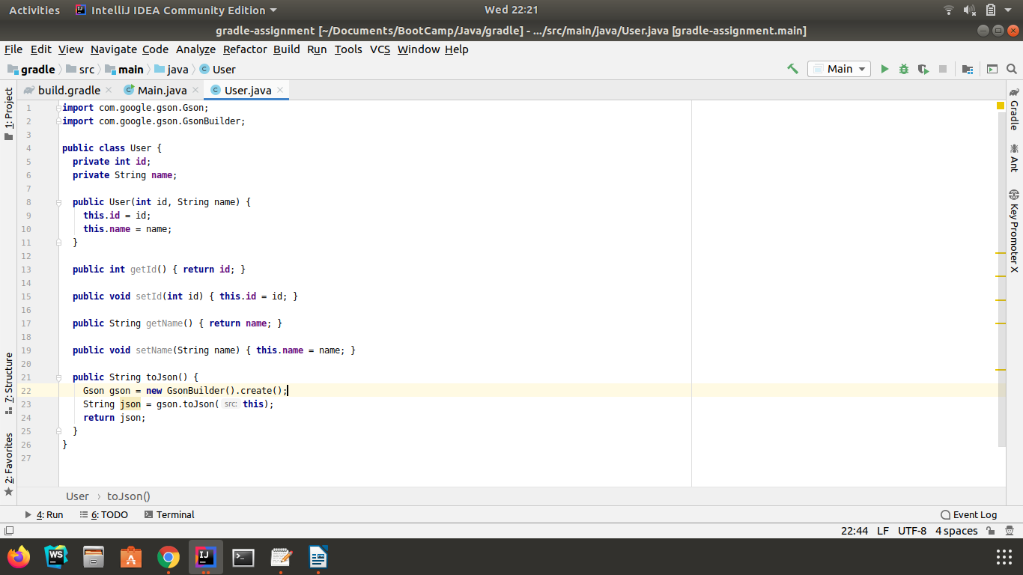

Main.java

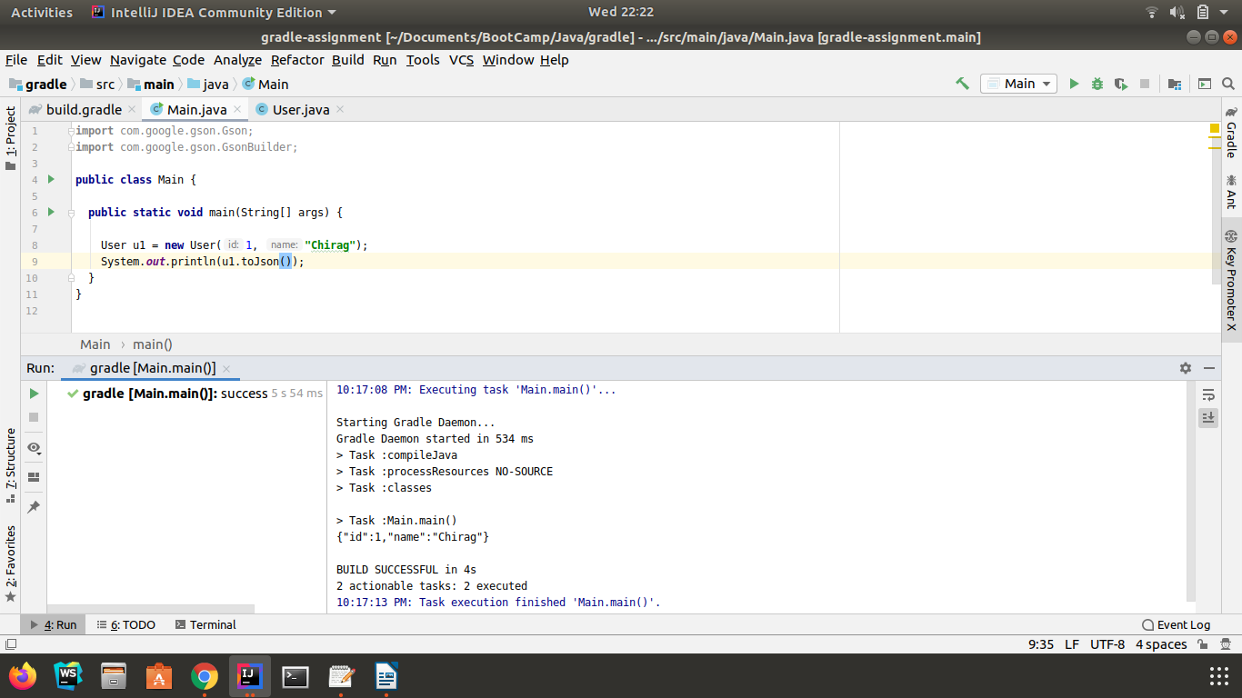

Output of : ‘gradle dependencies –configuration compile’

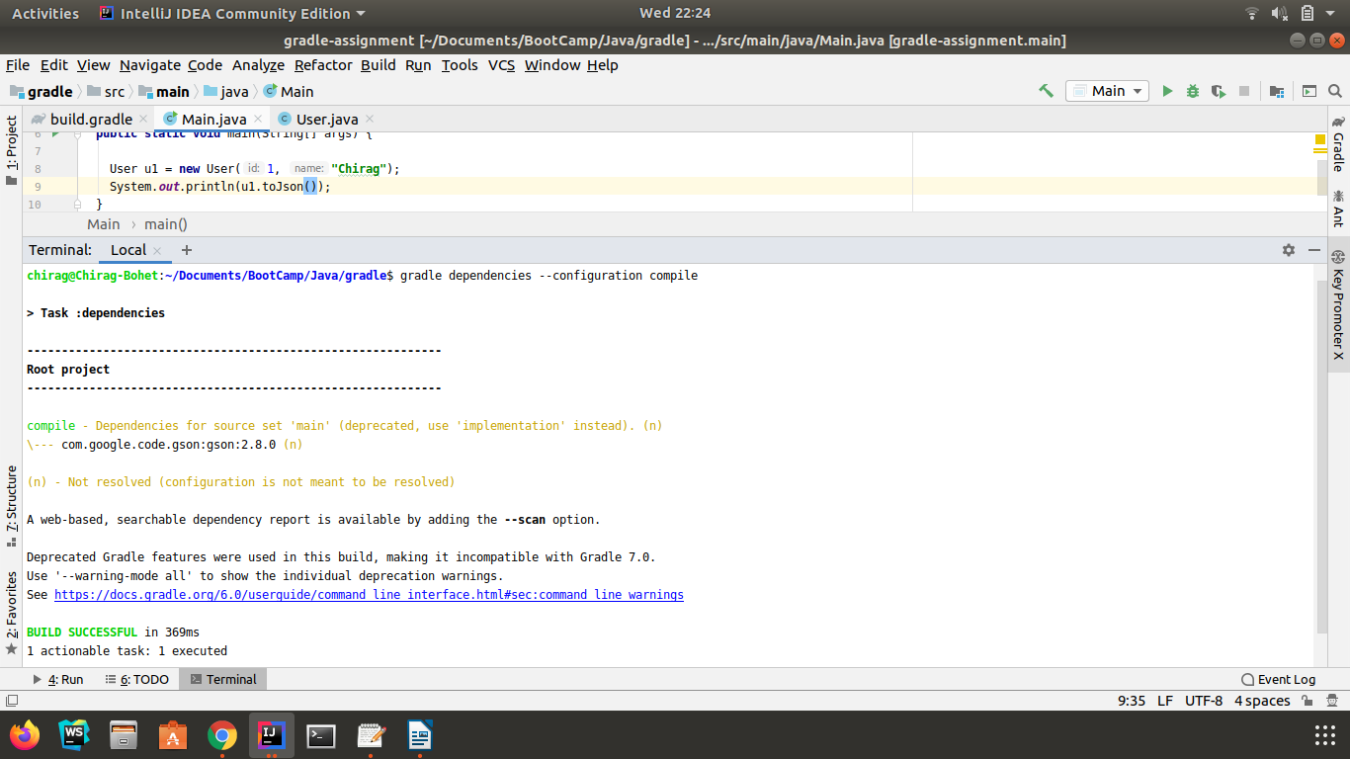

2) Using java plugin, make changes in the manifest to make the jar executable. Using java -jar JAR_NAME, the output should be printed as "Hello World"

build.gradle

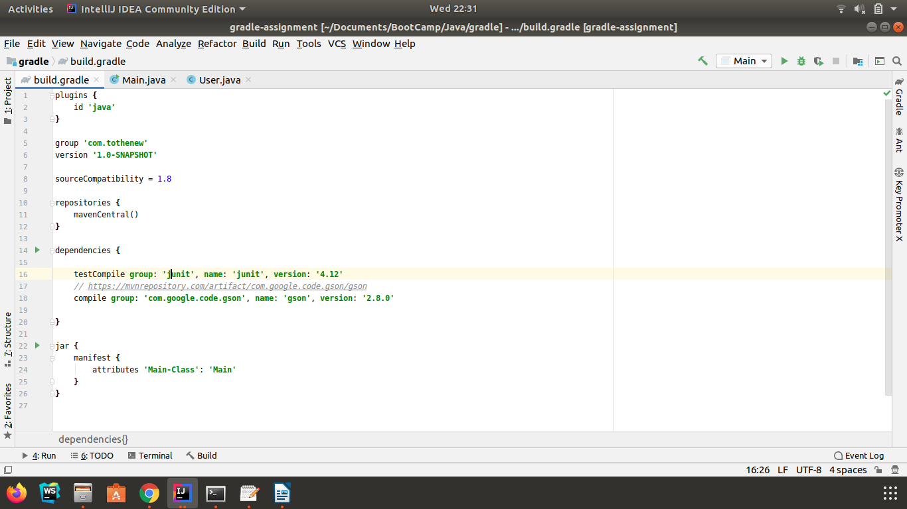

Main.java

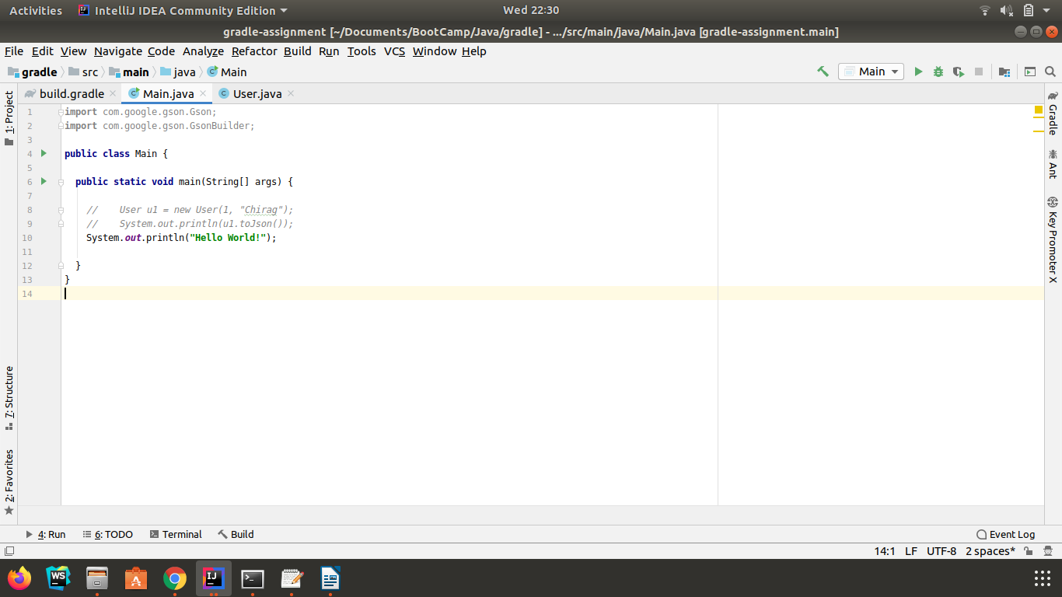

Output of : ‘java -jar gradle-assignment-1.0-SNAPSHOT.jar’

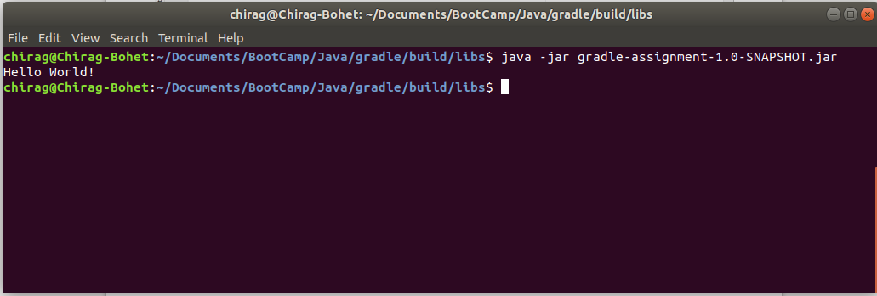
resources : https://stackoverflow.com/questions/21721119/creating-runnable-jar-with-gradle

3) Differentiate between the different dependency scopes: compile, runtime, testCompile, testRuntime using different dependencies being defined in your build.gradle.

https://docs.gradle.org/5.3.1/userguide/java_plugin.html#sec:java_plugin_and_dependency_management

4) Create a custom plugin which contains a custom task which prints the current date-time.

ShowDateTime.groovy

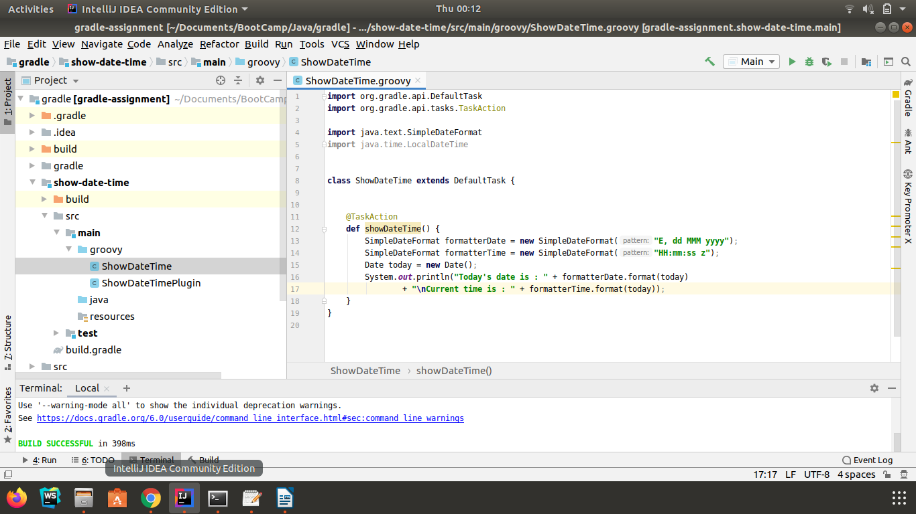

ShowDateTimePlugin.groovy

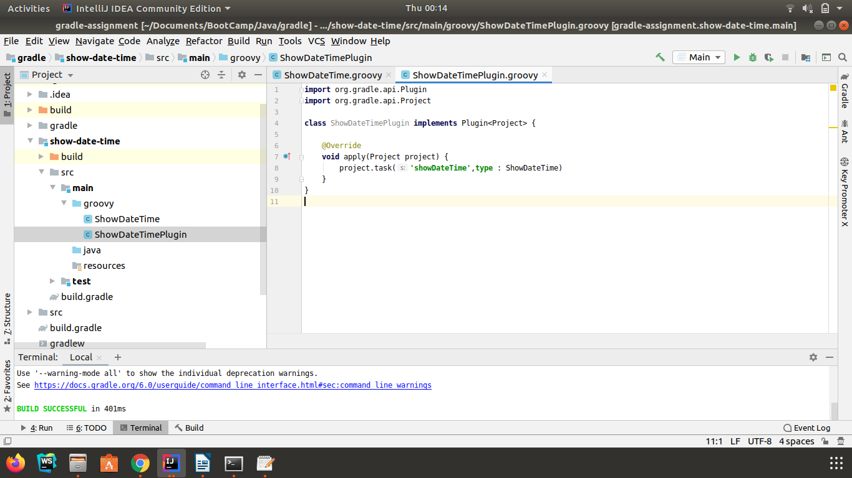

build.gradle (root project)

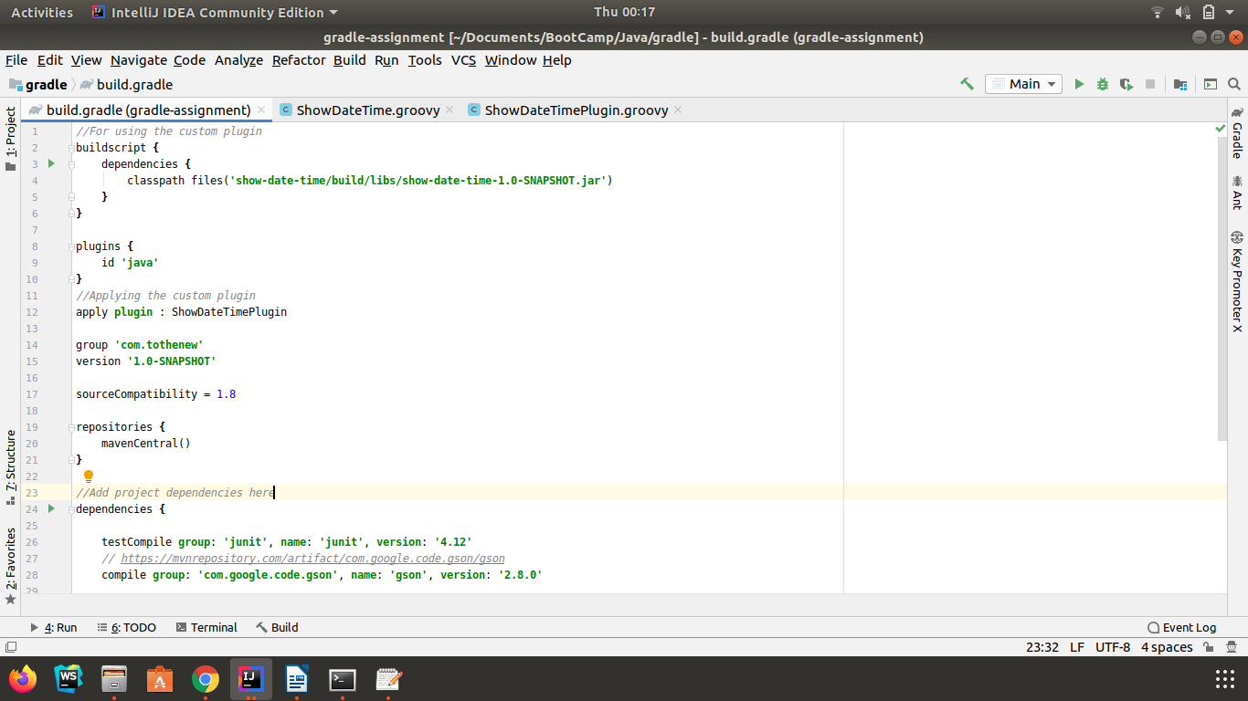

settings.gradle (root project)

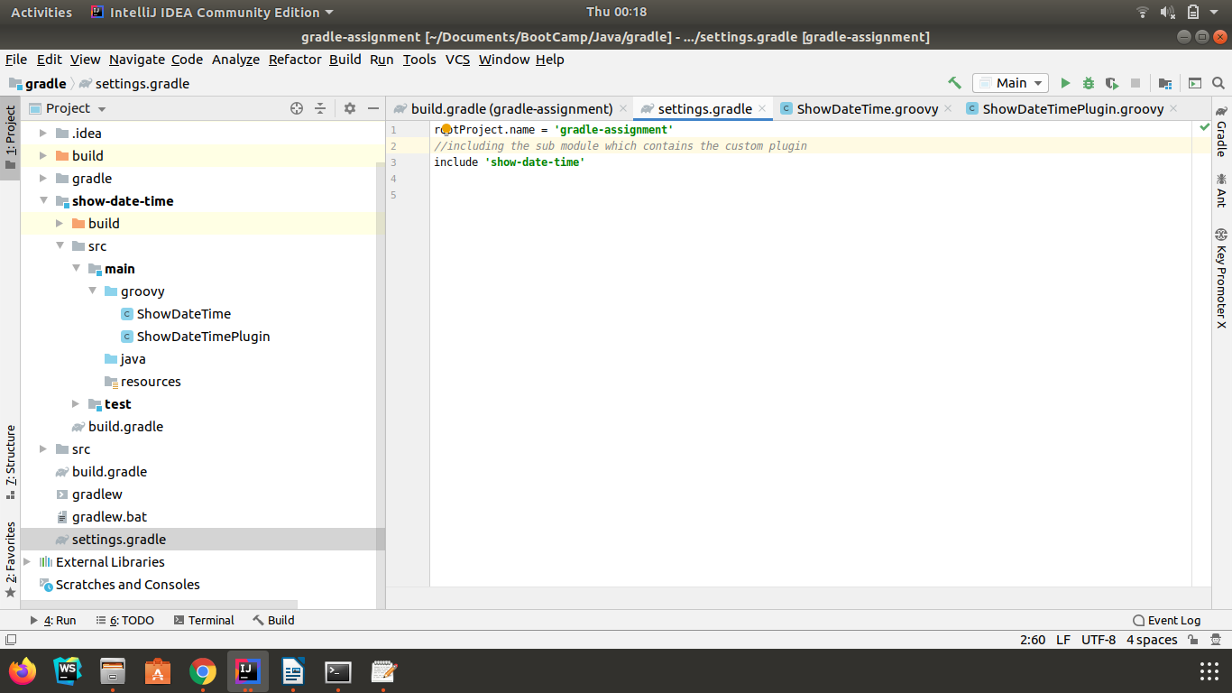

build.gradle (plugin module)

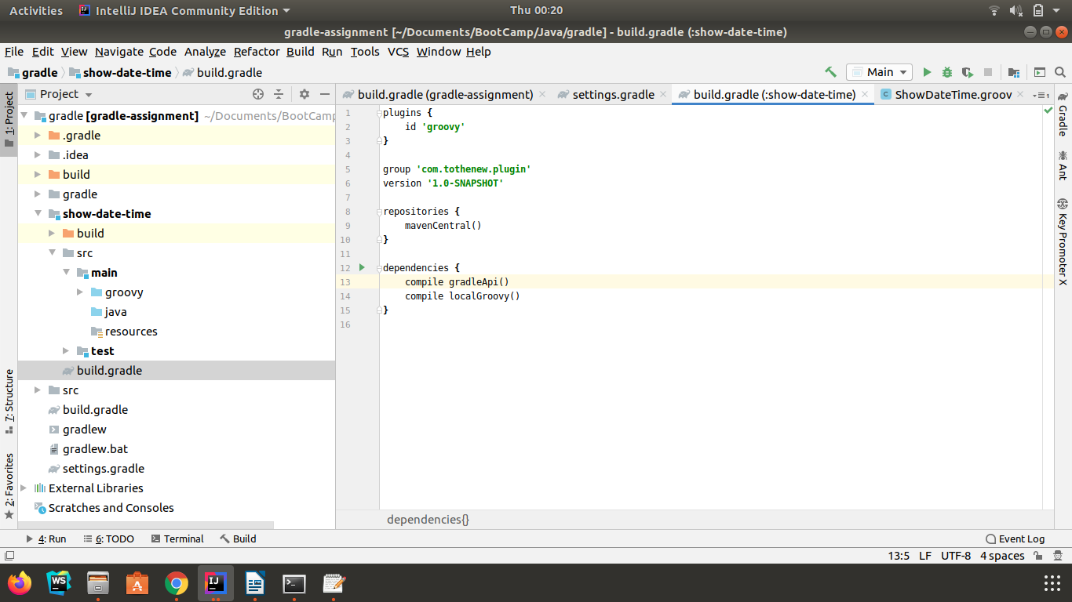

Output of : gradle showDateTime

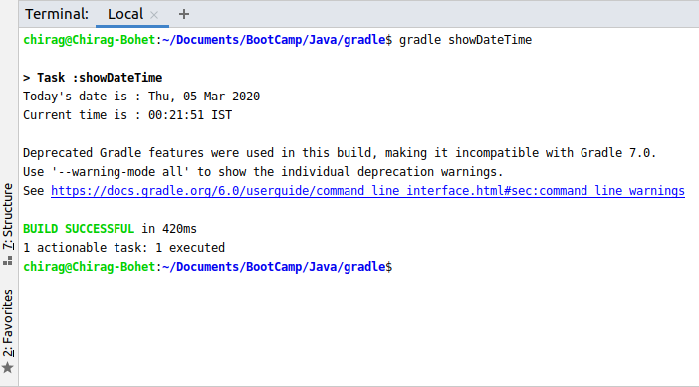

5) Using that plugin in your project, execute that task after the jar task executes.

build.gradle

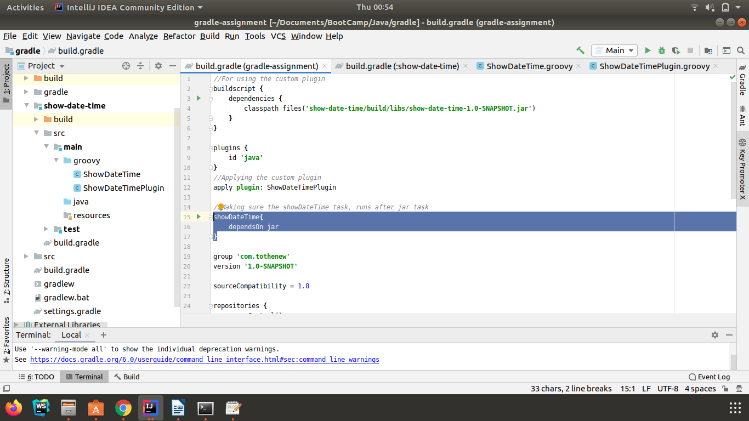

Output of : gradle showDateTime --console verbose

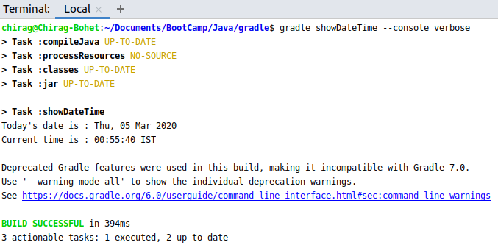

6) Instead of using default source set, use src/main/javaCode1, src/main/javaCode2 to be taken as code source. Make sure that the JAR created contains files from both the directories and not from src/main/java.

Build.gradle

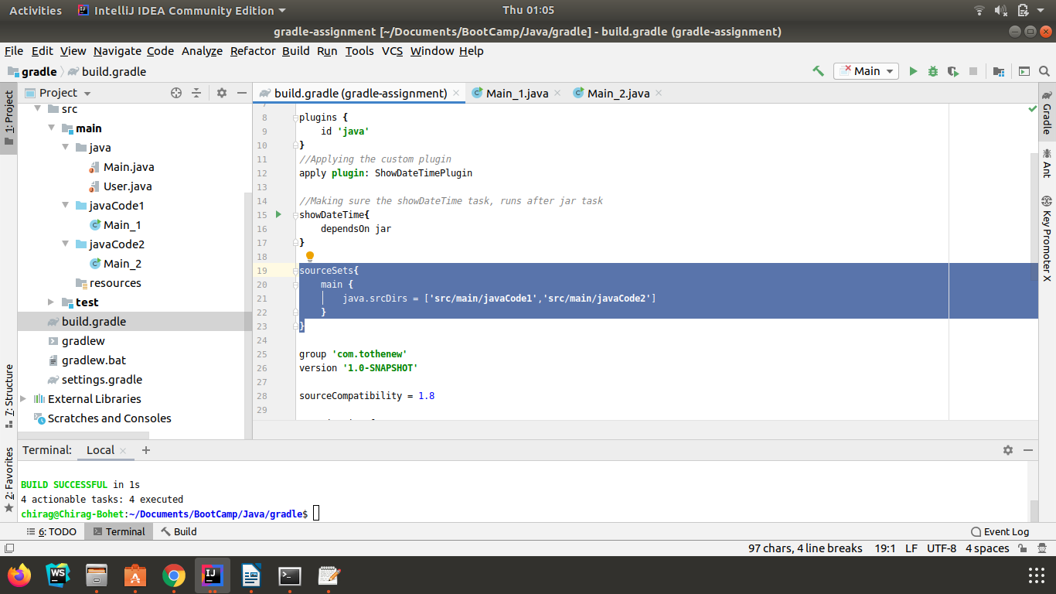
Output of : jar tf gradle-assignment-1.0-SNAPSHOT.jar

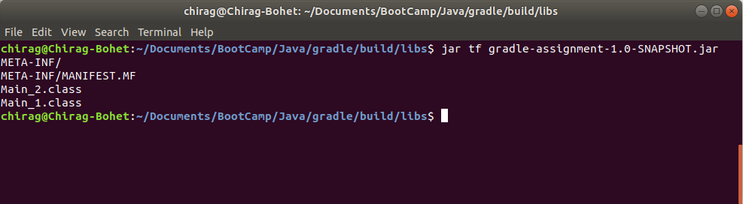

7) Override the Gradle Wrapper task to install a different version of gradle. Make sure that the task written in Q4 also executes with it.

build.gradle

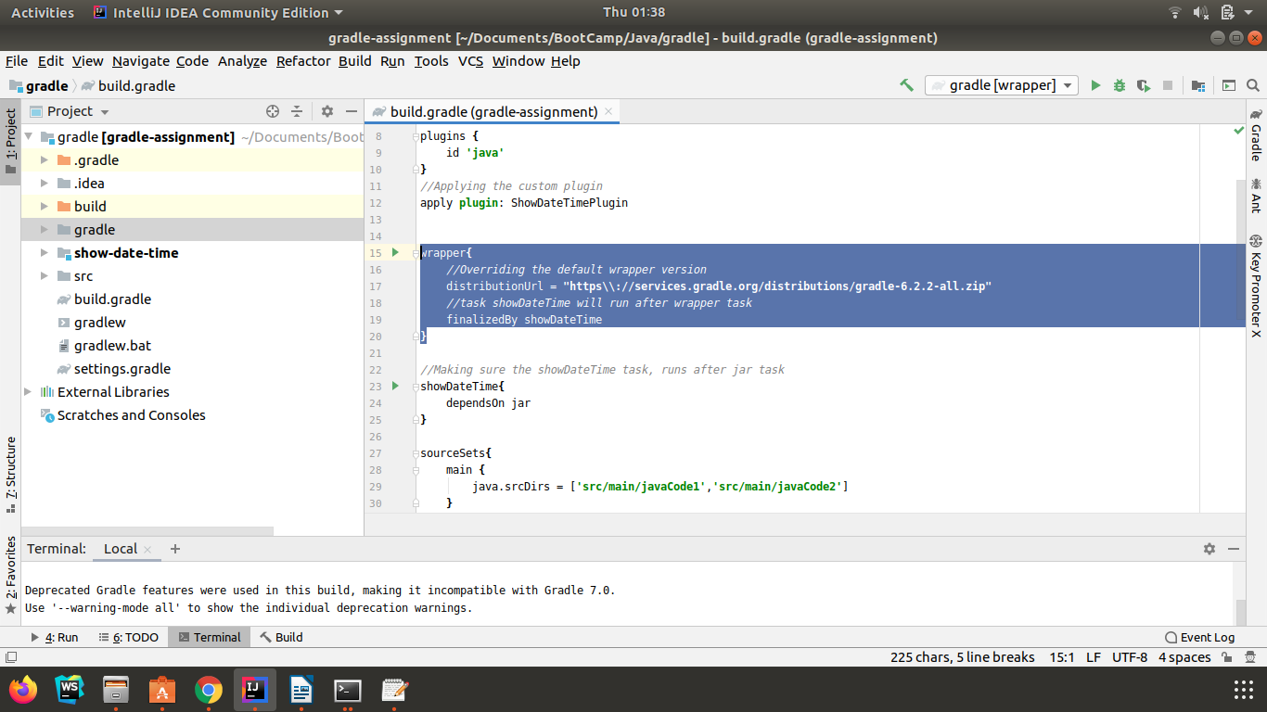
output of : gradle wrapper --console verbose

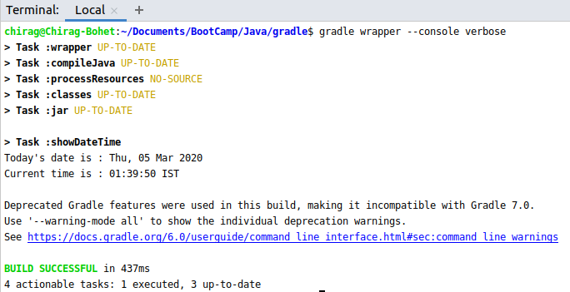

8) Run the gradle profile command and attach the resulting files.

Profiling output can be seen at this link :
https://github.com/chiragbohet/ttn-java-bootcamp/tree/gradle/gradle/profile

