Initial screen(Desktop version) for submitting image of damaged vehicle while raising FNOL. User need to upload image of vehicle by clicking Select Image button.

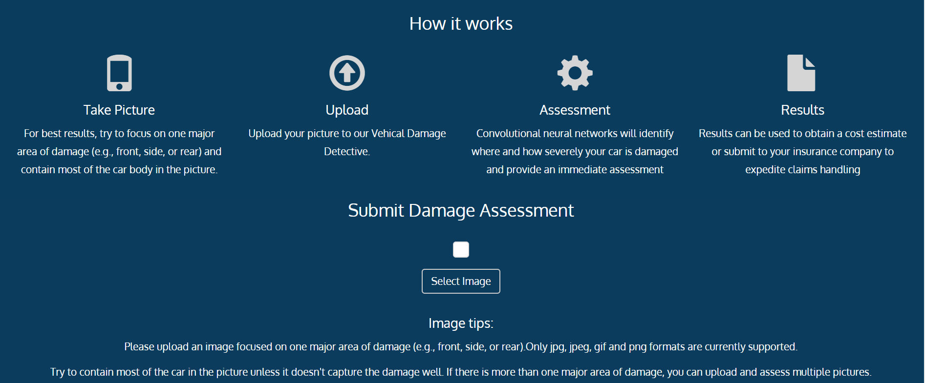

User upload image of car and click on submit button.

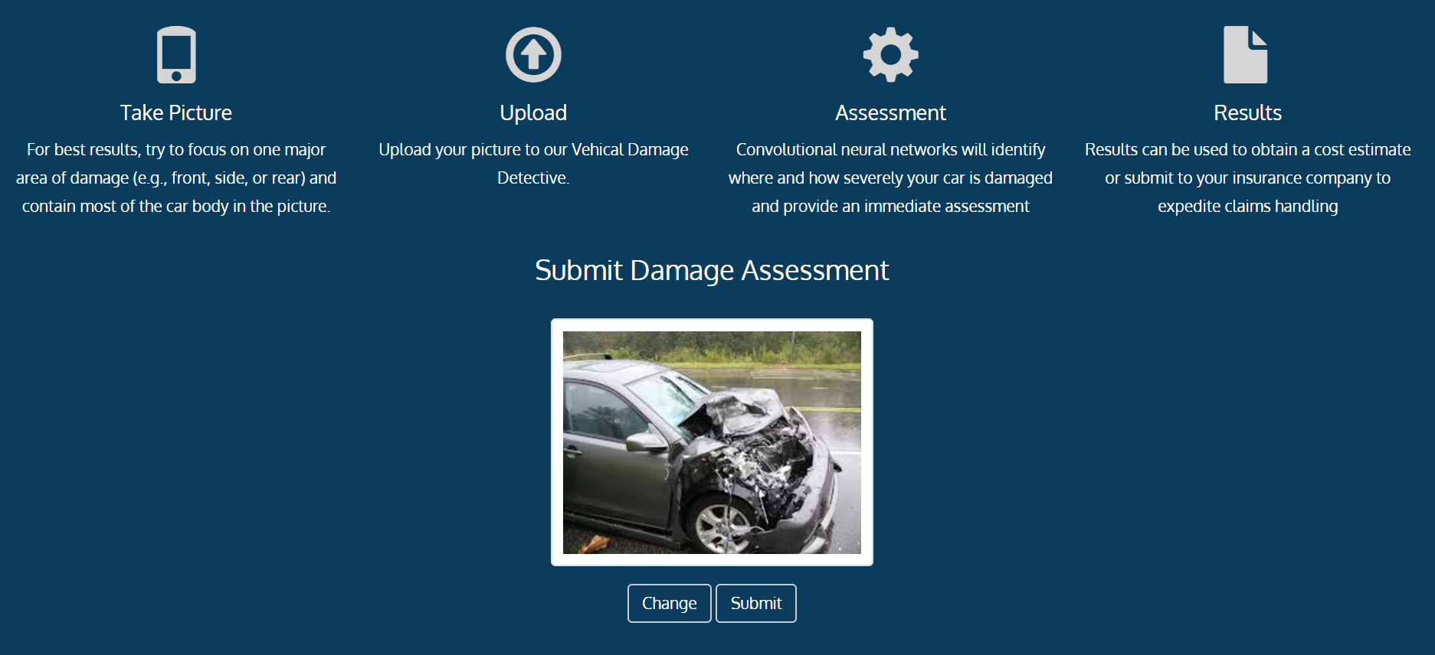

System automatically detect damage, its location and severity

