Orcathon 2026: Flagship Platform & App Specification
An Awwwards-Caliber Product Showcase, Dynamic PWA Ecosystem & Hackathon Pitch Engine
Project Target | Orcathon 2026 Final Problem Statement Solution
Design Inspiration Benchmark | Oryzo AI (Awwwards SOTY Benchmark by Lusion)
Architecture Model | Dual-Engine: Next.js 16 Web Showcase + Offline-Ready Mobile PWA
Authentication & Access | Clerk Authentication + Supabase Postgres Database (Guest, User, Judge Roles)

1. Executive Summary & Core Objective
This specification establishes the end-to-end design and system architecture for the Orcathon 2026 final project. Rather than treating the hackathon submission as an ordinary static landing page or basic mobile prototype, this architecture introduces a unified triple-threat asset:
1. Flagship Presentation Surface: A luxury, high-craft editorial landing page inspired by Oryzo AI (Lusion), replacing generic AI tropes with studio lighting, CAD vector calipers, and dynamic UI viewports.
2. Functional Production Application: A production-grade web application equipped with Clerk authentication, Supabase Postgres persistence, and full Progressive Web App (PWA) installability for standalone mobile usage.
3. Pitch & Video Generation Engine: A choreographed visual narrative designed to be screen-recorded directly for the 3-minute hackathon demo video, with keyboard-snapping slides for live judge pitch defense.
📌 Key Insight on Device Presentation
To prevent the website from appearing as a 'commercial for a smartphone,' the 3D phone is NOT a static hardware hero. Instead, it serves as the dynamic Mobile Companion HUD that syncs with floating Desktop Website Panes. The hero of the website is 100% the product solution built for the announced problem statement.

2. Visual Reference Analysis: The Oryzo Benchmark
Oryzo AI (oryzo.ai), developed by creative agency Lusion, represents the global benchmark for high-craft interactive 3D web design. Our technical analysis of Oryzo deconstructs why it feels so captivating and how we apply its lessons to Orcathon:
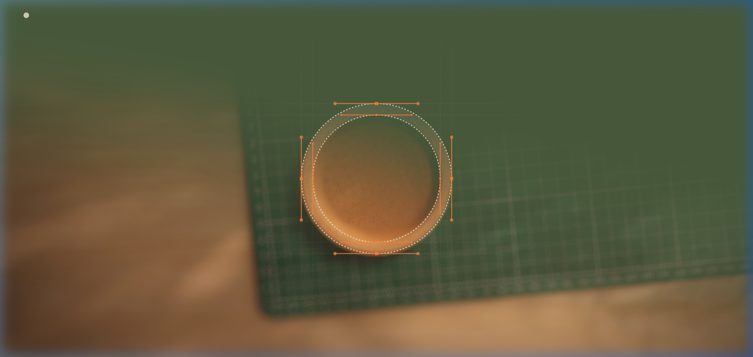
Figure: Oryzo AI Hero: Precision CAD vector handles, bounding boxes, and warm directional studio lighting.

Deconstructed Visual Mechanics
• Anti-Slop Palette: Deep obsidian base (#08090D) paired with warm sand/cream (#FFEDD6) typography, eliminating radioactive neon glows.
• Typographic Rhythm: Clean grotesque and editorial serifs paired with monospace metrics for telemetry readouts.
• CAD & Engineering Overlays: Subtle crosshair reticles, dimension callouts (e.g., 6.1" Super Retina XDR), dashed alignment guides, and formula annotations.
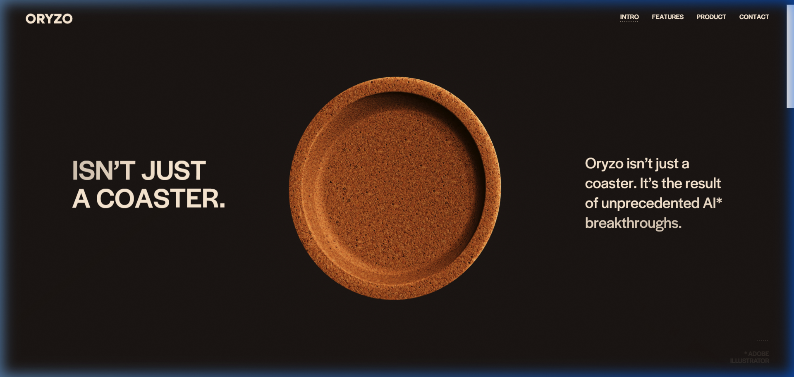
Figure: Oryzo AI Scroll Parallax: Smooth momentum-driven camera positioning and high-contrast editorial hierarchy.

3. Choreographed Website Experience: Act-by-Act Breakdown
As judges and visitors scroll through the landing page, the page moves through six cinematic narrative acts:

Act 1: The Core Solution Hook (Hero)
The visitor lands on a studio-lit scene. A floating viewport (mobile companion or glass monolith) appears in the center, framed by CAD crosshairs and dimensional bounding lines. A prominent 'Sign In / Launch App' CTA sits in the navbar alongside an interactive 'Live Demo' trigger.

Act 2: The Expanding Website Panes (Desktop Web App)
As the user scrolls, the central device glides smoothly to the right flank. Simultaneously, a floating, high-resolution Desktop Browser Pane unfolds from the center, revealing the core desktop interface of the problem-statement solution.
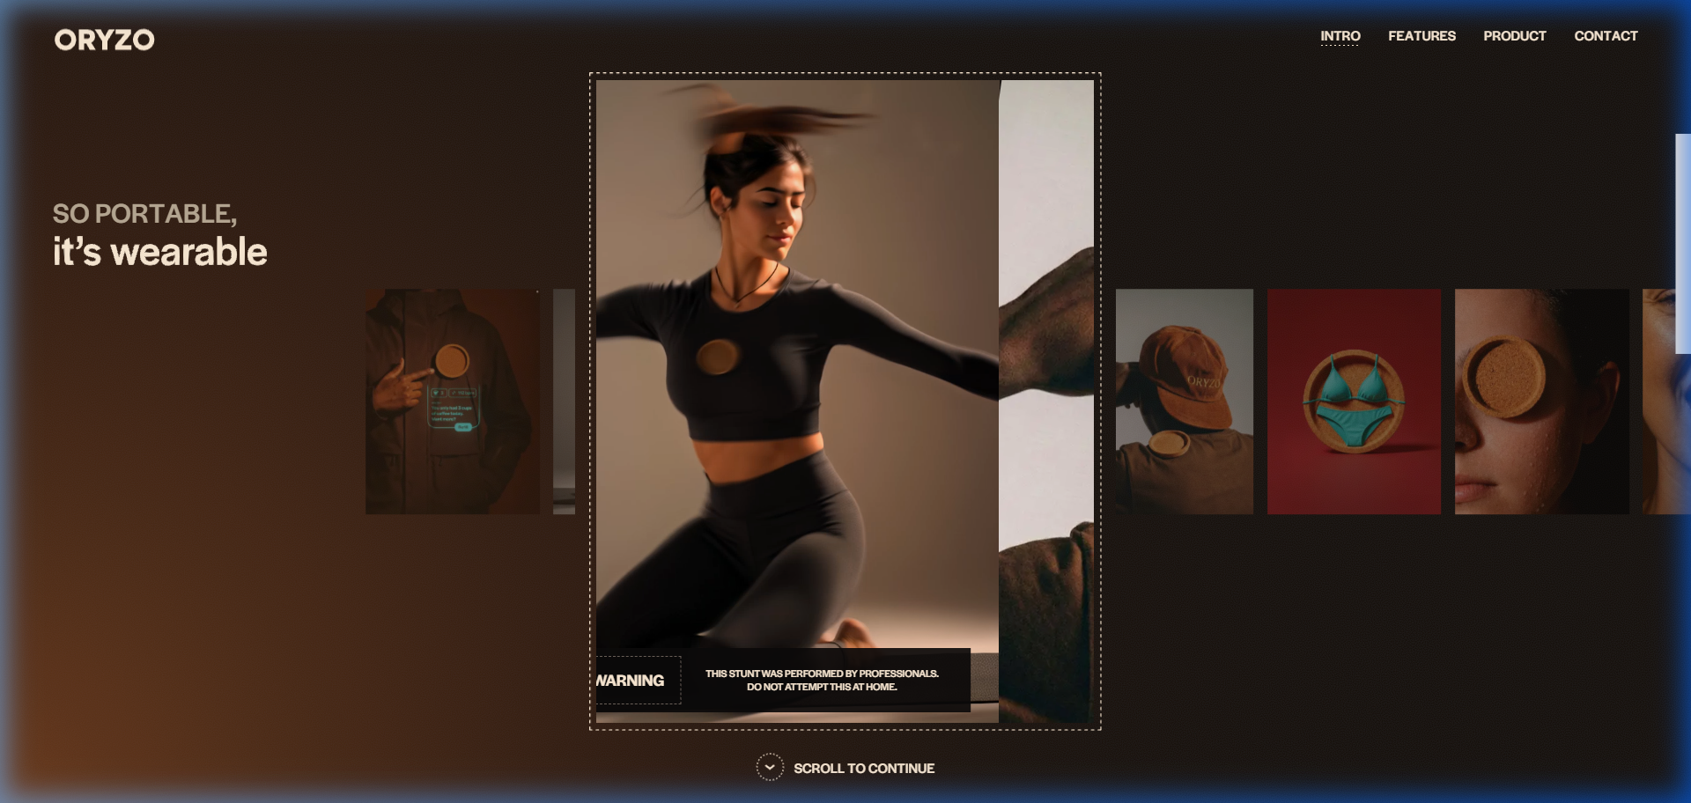
Figure: Oryzo Editorial Carousel: Modular card layout showcasing real-world use-cases, warnings, and feature proofs.

Act 3: Cross-Platform Ecosystem (Desktop + Mobile Sync)
The desktop pane and mobile companion align side-by-side. An interactive action taken on the desktop pane (e.g., dispatching an AI task or submitting a record) reflects in real-time on the mobile phone screen, proving full cross-platform synchronization.

Act 4: The 'Smart Flip' Telemetry Pane
Inspired by Oryzo's interactive craft workbench and message flip, users can click an 'Inspect Architecture' button. The device flips 180° in 3D space, revealing the underlying engine: live database queries (Drizzle ORM), Supabase connection health, and Redis cache hit ratios.
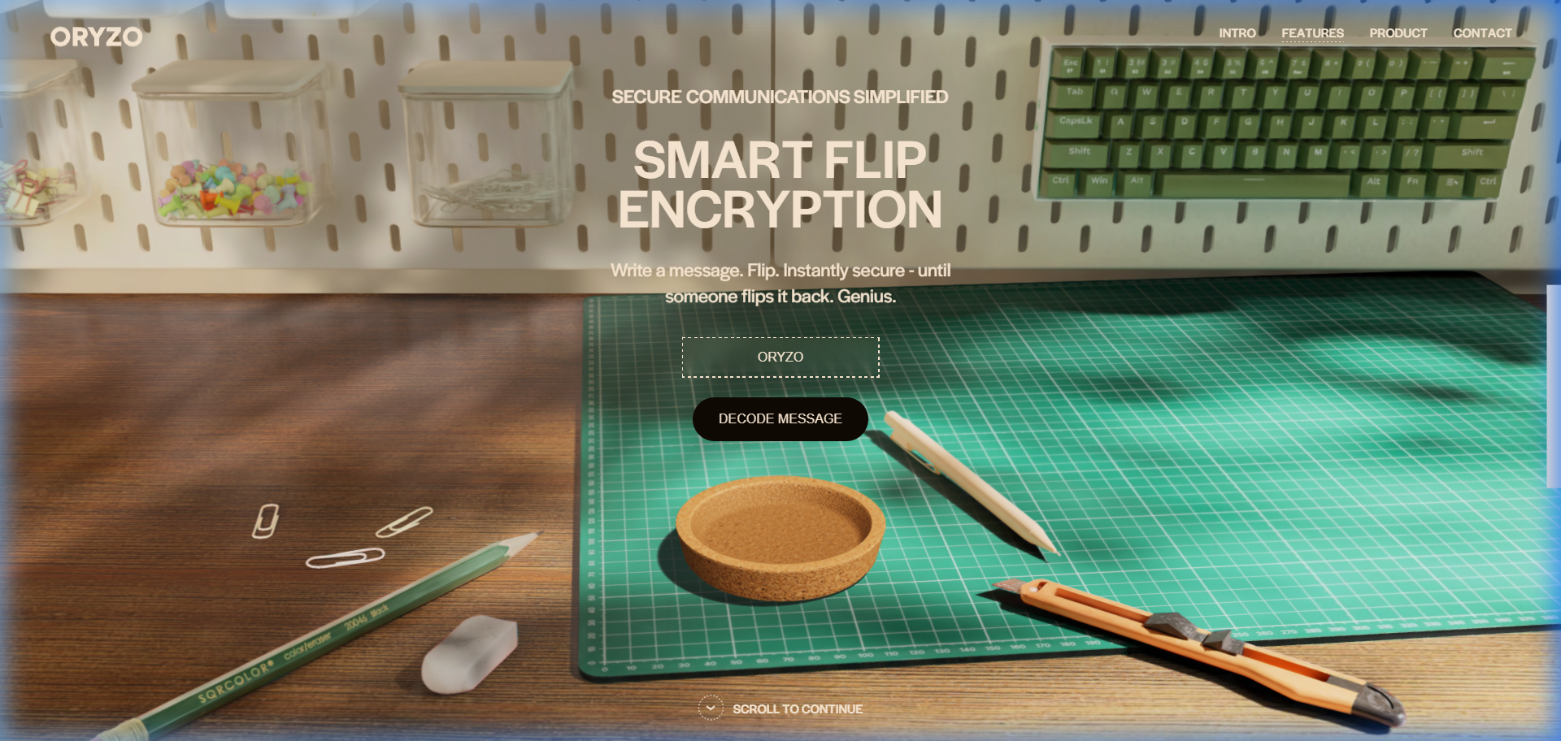
Figure: Oryzo Physical Flip Interaction: Tangible workbench scene with real-time 180-degree flip trigger.

Act 5: Technical Blueprints & Mathematical Validation
Technical validation matters deeply to judges. This section features SVG engineering schematics, algorithmic formulas (e.g., latency reduction curves, ranking weights), and interactive code snippets explaining the core algorithm.
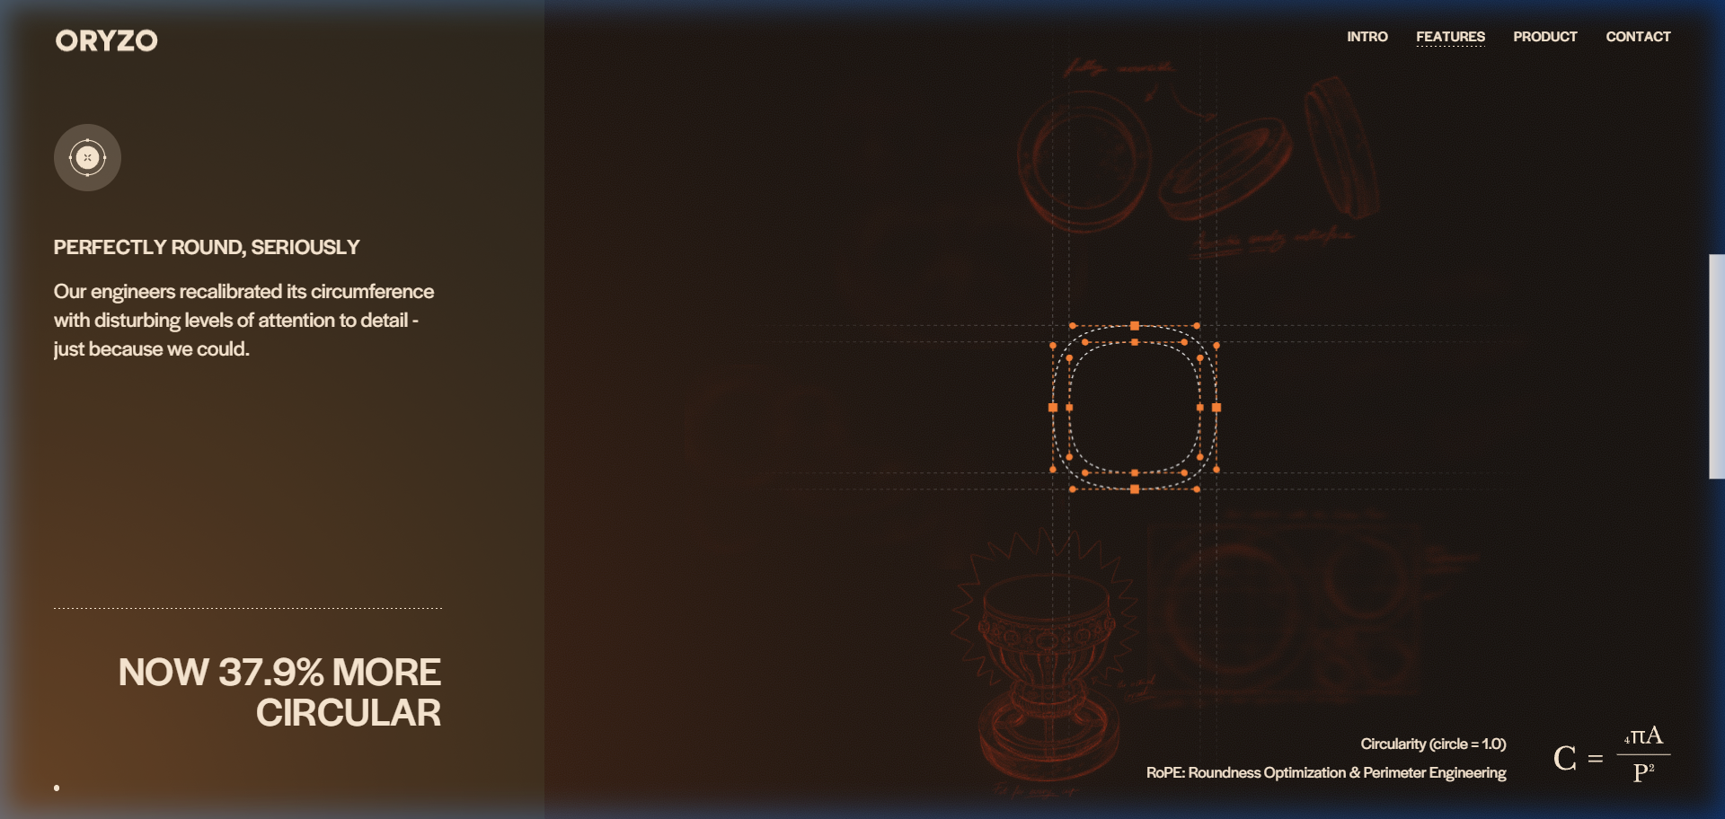
Figure: Oryzo Technical Schematics: Formulaic equations, blueprint vector lines, and technical calipers.

4. Functional Application & PWA Specification
The project is not merely a marketing facade; it houses a complete, functional software application ready for immediate user sign-in and mobile installation.

Authentication & Role Governance
• Guest Sandbox Mode: Instant one-click guest preview so judges can evaluate the app immediately without signup friction.
• Authenticated User Session: Powered by Clerk Authentication, supporting Google, GitHub, and email/password sign-in with user profile syncing.
• Judge & Admin Telemetry HUD: Dedicated toggle enabling judges to inspect raw database states, rate-limit consumption, and background task logs.

Progressive Web App (PWA) Architecture
• Web App Manifest (manifest.json): Configured with 'display: standalone', custom app icons (192px and 512px), background color '#08090D', and theme color '#08090D' for seamless full-screen mobile integration without browser chrome.
• Service Worker & Caching: Static UI bundles are aggressively cached via Cache-First strategies, while dynamic problem data uses Stale-While-Revalidate with IndexedDB local fallbacks.
• Install Prompt: An unobtrusive, elegant toast prompts mobile users: 'Install Orcathon Companion to Home Screen'.

5. Pitch Video & Presentation Engine
One of the greatest competitive advantages of this architecture is its dual role as a video generator and pitch deck:
📌 Instant Hackathon Demo Video
By opening the website in browser full-screen and scrolling at an even pace with a screen recorder, the site creates a cinematic product launch video. The smooth 3D transitions and camera choreography look like a multi-thousand-dollar studio render, requiring zero post-production editing.

• Built-In Slide Deck Mode: A keyboard listener (Arrow Right / Spacebar) snaps the viewport between the 6 distinct narrative acts.
• Live Interactive Defense: You can pitch to judges live from the live Vercel URL, demonstrating that your pitch deck IS the live software itself.

6. Technical Stack Summary
Layer | Technology | Role & Justification
Framework | Next.js 16 + React 19 | App Router, Turbopack, Server Actions
3D & Motion | Three.js + R3F + GSAP | PBR lighting, device choreography, scroll timeline
Authentication | Clerk Next.js v7 | Production sign-in, session tokens, user metadata
Database / ORM | Supabase + Drizzle ORM | PostgreSQL pool, type-safe schema, JSONB support
Rate Limiter / Cache | Upstash Redis | Sliding-window API security, real-time counter

7. Execution Readiness Protocol
When the problem statement is released, the following 3-step rapid deployment sequence will be executed:
Step 1 (Problem Ingestion): Extract the core user persona, primary pain point, and success metrics from the released prompt.
Step 2 (Schema & App Logic): Inject the problem statement into the App Router routes (/app and /api) and populate the live desktop/mobile viewports.
Step 3 (Deployment & Video): Deploy instantly to Vercel via GitHub CI/CD, verify mobile PWA install, and record the 3-minute pitch video directly from the live URL.

