Orcathon 2026: Master Engineering & Agent Specification
Granular Architecture, Pixel-Perfect UI Wireframes, Responsive Protocols, Backend Schemas, and Vercel Deployment Blueprint
⚠️ MANDATORY AGENT DIRECTIVE: ALL SPECIFICATIONS ARE SUBJECT TO CHANGE
CRITICAL: Everything documented in this specification — including database tables, API payloads, UI views, problem categories, device screens, copy, and features — is a modular architectural foundation and is STRICTLY SUBJECT TO CHANGE based on the officially released hackathon problem statement.
All coding agents (Antigravity, Cursor, Claude Code) must maintain the underlying engineering stack (Next.js 16 + Three.js + Clerk + Supabase + Drizzle + Upstash + PWA + Vercel) while completely adapting domain models, mockups, copy, and endpoints to solve the released problem statement.

1. Architecture Overview (Subject to Problem Statement Domain)
The Orcathon platform establishes a production-ready template that can be instantly customized once the problem statement drops. It unifies three core capabilities:
1. Flagship Presentation Layer: A cinematic landing page inspired by Oryzo AI (Lusion), featuring CAD vector overlays and floating application viewports (Content subject to problem statement).
2. Functional Production Application: A functional Next.js 16 + React 19 application backed by Clerk Auth, Supabase PostgreSQL, Drizzle ORM, and an offline-ready Progressive Web App (PWA) (App logic subject to problem statement).
3. Video & Pitch Deck Engine: A scroll-driven narrative designed to be screen-recorded for the 3-minute hackathon demo video and navigated via keyboard for live judging defense (Narrative subject to problem statement).

2. Exact Pixel-Perfect UI Design & Blueprint Schematics (Layouts Non-Negotiable)
The following exact dimensions, layout grids, and component hierarchies govern all routes. Coding agents must adhere to these exact structures:

2.1 Global Sticky Navigation Bar (src/components/navbar.tsx)
• Dimensions & Container: Fixed top-0, height 64px (h-16), z-index 50, max-w-7xl mx-auto px-6.
• Backdrop: bg-[#08090d]/80 backdrop-blur-md border-b border-[rgba(255,237,214,0.08)].
• Left: Orcathon 2026 Wordmark with amber dot; Center: Pill navigation items ([Overview], [Solution], [Telemetry], [Specs]); Right: Live edge latency badge (14ms edge) and 'Launch App ->' pill CTA.

2.2 Act 1: Hero Viewport (src/components/hero/index.tsx)
• Top Sub-bar: Left: 'ENGINEERED FOR REAL-WORLD STAKES. BUILT FOR SCALE.'; Right: Live 48:00:00 Countdown Pill.
• Main Title: RESOLVING THE UNRESOLVED. (Outfit 900, text-white/text-[#ffedd6], 72px desktop / 36px mobile).
• CAD Vector Bounding Box: Dashed lines, corner crosshairs (+), coordinate markers ([X: +142.10, Y: -89.44]).
• Center Stage: 3D floating phone/device model with dynamic screen UI tilting to mouse coordinates.

2.3 Act 2: Expanding Desktop Browser Pane (src/components/panes/DesktopAppPane.tsx)
• Window Shell: max-w-6xl mx-auto, aspect-[16/10], rounded-2xl border border-[rgba(255,237,214,0.12)] bg-[#0d0f17] shadow-2xl.
• Titlebar (h-10): Red/Yellow/Green window dots, center URL pill (https://orcathon.app/dashboard), and 'TLS 1.3 | HTTP/3' badge.
• Main Workspace: Left sidebar rail (200px) with 3-card metric grid ([Impact], [Latency: 12ms], [Verification Hash: #8F3A]).

2.4 Act 4: The 'Smart Flip' Telemetry Workbench (src/components/telemetry/FlipWorkbench.tsx)
• Background: Dark green cutting mat (#0d1a12) with 20px grid lines (#183324) and SVG craft accessories.
• Flip Trigger: Central pill button ('Flip to Telemetry Engine'). Rotates the device 180 degrees.
• Backface Engine: Live Drizzle ORM query terminal, Supabase pooler ping gauge, and Upstash Redis rate counter.

2.5 Act 5: Technical Blueprints & Mathematical Validation
• Left: Mathematical formulation SVG box (C = 4*pi*A / P^2) and algorithmic latency decay curve.
• Right: Multi-tab code inspector (schema.ts, route.ts, worker.ts) with line numbers and copy buttons.

2.6 Act 6: Editorial Bento Carousel & Act 7 Minimalist Footer
• Carousel: Horizontal snap scroll with Magazine Cover (Issue No. 00124), 48h Warning Card, and 5-Star Testimonial.
• Footer: Bold headline ('IF WE CAN SOLVE THIS PROBLEM, IMAGINE WHAT WE CAN BUILD NEXT.'), newsletter input, and uptime dot.

3. Visual Benchmark Analysis (The Oryzo Reference)
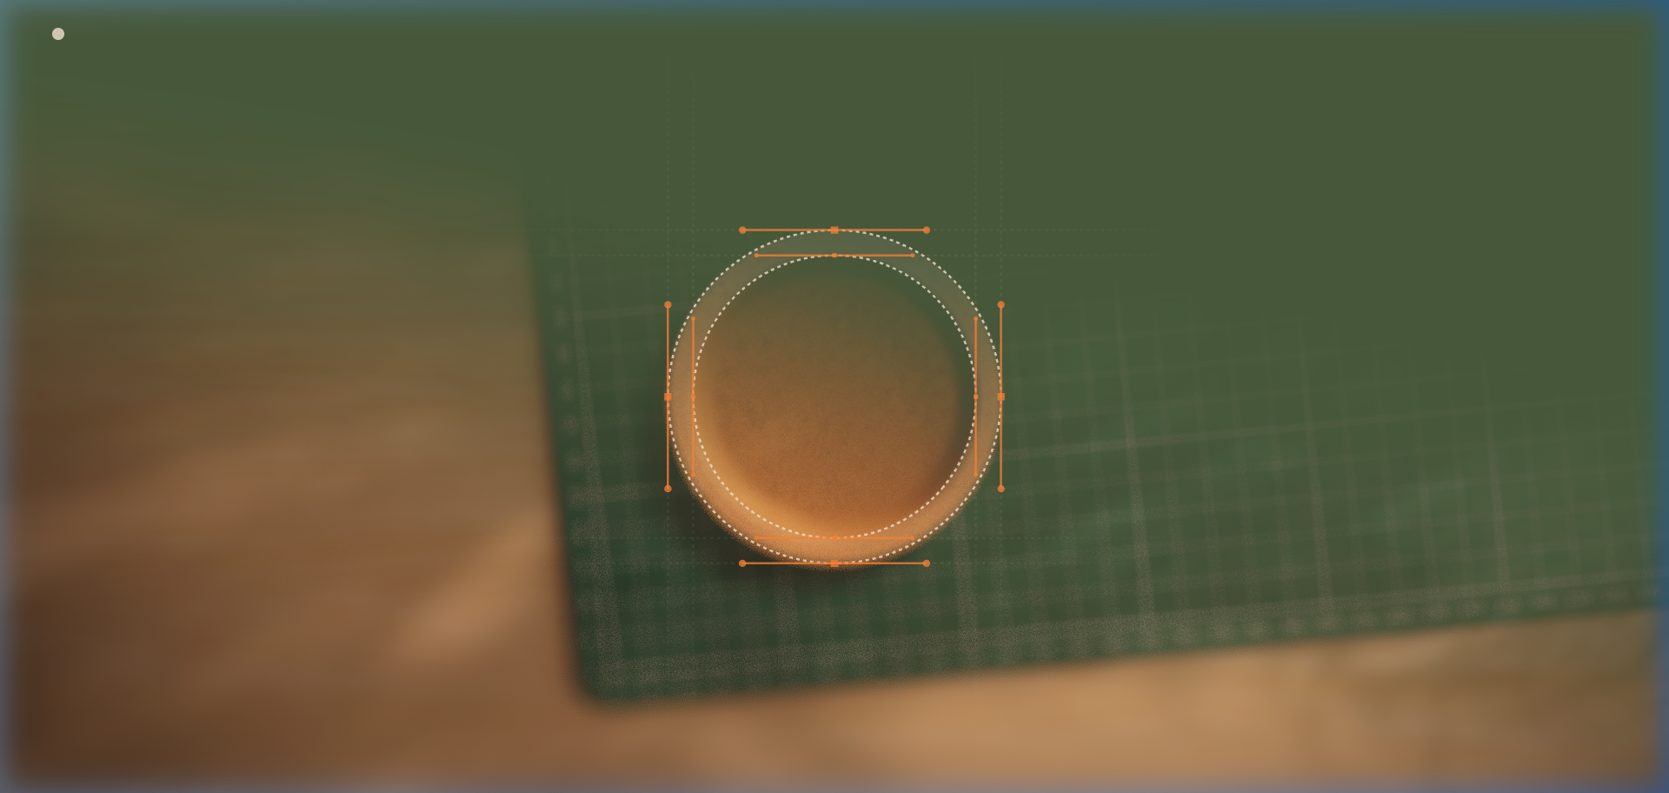
Visual Reference: Oryzo Hero: Precision CAD vector bounding boxes, coordinate calipers, and warm studio lighting (Style reference only; content subject to problem statement).
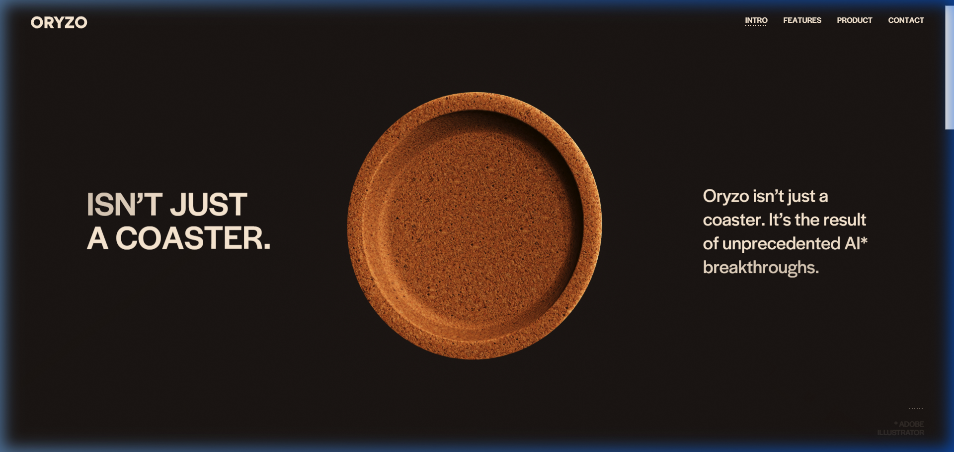
Visual Reference: Oryzo Scroll Parallax: Smooth momentum scroll with high-contrast editorial typography and anti-slop dark palette.

4. Design Tokens & Component Styling Standard (Branding Subject to Problem Statement)
Core design tokens are defined in src/app/globals.css. The accent colors can be fine-tuned to match the released problem statement domain:
Token Name | Base Value / Hex | Usage Rule (Subject to Problem Statement)
--background | #08090D | Deep pitch noir base for all pages
--cream-accent | #FFEDD6 | Oryzo signature vanilla cream (adaptable to brand)
--surface-card | rgba(18, 20, 29, 0.70) | Translucent frosted card surface with backdrop blur
--border-subtle | rgba(255, 237, 214, 0.08) | Fine 1px hair-line borders for CAD grids
--border-prominent | rgba(255, 237, 214, 0.18) | Hover and active focus states on buttons and inputs

5. Mobile Phone Responsiveness & Touch Optimization (App Screens Subject to Change)
The entire application must operate flawlessly on smartphones (iOS Safari and Android Chrome):
• Dynamic Viewport Units (min-h-dvh): The root layout utilizes dynamic viewport height units to prevent iOS address bars from clipping content.
• Notch & Home Bar Insets: Safe-area-inset-top and safe-area-inset-bottom are enforced on all sticky headers, floating navbars, and bottom bars.
• 3D Canvas Mobile Fallback: On mobile screens (<640px), the 3D WebGL engine automatically clamps devicePixelRatio to 1.0, disables post-processing passes, and uses passive touch gestures to ensure zero stutter and 60fps lock.
• Responsive Panes: Side-by-side desktop viewports seamlessly stack into an intuitive single-column scroll with sticky category tabs.

6. Backend Specifications & Database Architecture (Schemas Strictly Subject to Change)
The backend is powered by Next.js 16 App Router serverless functions, Supabase PostgreSQL, Drizzle ORM, and Upstash Redis. NOTE: All table models and API routes are modular placeholders and MUST be updated to represent the exact entities required by the problem statement.

6.1 Drizzle Schema Template (src/db/schema.ts — Subject to Change)
// TEMPLATE TABLE: Update fields to match the entities of the released problem statement
import { pgTable, serial, text, integer, timestamp, jsonb } from "drizzle-orm/pg-core";
export const problemSignals = pgTable("problem_signals", {
id: serial("id").primaryKey(),
title: text("title").notNull(),
category: text("category").notNull().default("general"), // Dynamic: health, civic, ai, fintech, etc.
status: text("status").notNull().default("open"), // Dynamic: open, processing, resolved
impactScore: integer("impact_score").notNull().default(3), // 1-5 scale
notes: text("notes"),
evidenceMetadata: jsonb("evidence_metadata").$type<{
reportedBy?: string;
metrics?: Record<string, any>;
customPayload?: Record<string, any>; // Adaptable to problem statement specifics
}>().default({}),
createdAt: timestamp("created_at").defaultNow().notNull(),
});

6.2 Serverless Connection Pooling
In src/db/index.ts, connections use the Supabase Transaction Pooler (port 6543) with pgbouncer=true. This prevents connection saturation when judges access the Vercel serverless deployment simultaneously.

6.3 Rate Limiting & Edge Caching (src/lib/redis.ts)
Powered by Upstash Redis REST. Uses sliding-window rate limiting (10 requests / 10s per client IP) to protect public API endpoints against spam while returning cached signal data instantly.

6.4 Complete API Route Matrix (Operations Subject to Change)
Endpoint | Method | Security | Function & Status
/api/health | GET | Public | Returns system status and Node runtime version (Fixed)
/api/db-check | GET | Public | Executes real SELECT query against Supabase Postgres (Fixed)
/api/redis-check | GET | Public | Pings Upstash Redis and tests rate limit counter (Fixed)
/api/signals | GET | Cached | Returns list of records (SUBJECT TO CHANGE TO PROBLEM STATEMENT)
/api/signals | POST | Rate-Guarded | Inserts verified solution record (SUBJECT TO CHANGE TO PROBLEM STATEMENT)

7. Authentication & User Roles (Roles Subject to Problem Statement)
• Guest Sandbox Mode: Instant access to /app?demo=true so judges can evaluate the app without creating accounts.
• Authenticated User: Standard Clerk modal supporting GitHub, Google, and email authentication.
• User Roles (Subject to Change): Roles (e.g. Student/Teacher, Doctor/Patient, Buyer/Seller) will be assigned based on the problem statement.

8. Progressive Web App (PWA) Implementation (Icons & Names Subject to Change)
• Manifest Location: public/manifest.json configured with standalone display and #08090D theme.
• Dynamic App Icons (Subject to Change): Once the final problem statement is selected, 192px and 512px icons will be placed into public/icons/.
• Service Worker: Cache-first for UI components; Network-first for dynamic API data with offline fallback.

9. Vercel Zero-Fail Deployment Protocol
The repository is configured for automated Vercel CI/CD deployment:
• Build Verification: npm run build has been pre-validated and generates zero compile or TypeScript errors.
• Environment Variables: Set DATABASE_URL, NEXT_PUBLIC_SUPABASE_URL, NEXT_PUBLIC_CLERK_PUBLISHABLE_KEY, CLERK_SECRET_KEY, UPSTASH_REDIS_REST_URL, and UPSTASH_REDIS_REST_TOKEN in Vercel project settings.
• Push-to-Deploy: Every git commit pushed to branch main triggers instant production builds on Vercel.

