PROJECT-BASED ACTIVITY
Create a Shop Chatbot & Publish It on a Website
Student Activity Submission Document
Student Name: Chirag
Class, Section and Roll No.: Grade 9 A
School Name: Lakshmipat Singhania Academy
Email ID (Used for IBM Skills build Registration): chiraggoenka17512@gmail.com

Student Instructions
Dear Student,
You may use any platform or tool to complete this activity. For example, you can use Chatbase, Landbot, Google Sites, Wix, Canva, or any other suitable platform. You may also create the chatbot using coding, if you prefer.
Your task is to:
Create a website for a fictional shop with a chatbot enabled on the website.
The chatbot should welcome visitors and help them with common questions about the shop, such as its products, prices, opening hours, offers, delivery, payment methods, and other relevant information.
You are free to choose any type of fictional shop, such as a clothing store, bookstore, café, electronics shop, sports store, gift shop, flower shop, or any other creative idea.
Important: The website and chatbot should be functional, and the information provided should be fictional and created by you.
1. Activity Objective
Create an AI chatbot for a fictional shop using Chatbase . First, create a separate shop information document using ChatGPT or Google Gemini. Upload that information document to Chatbase and use it as the knowledge source for your chatbot. Then create a Weebly website, add the chatbot or chatbot link to the website, publish it, and submit the required screenshots and links.
2. Activity Requirement
Create a chatbot for ONE fictional shop. Choose one of the following or create your own:
- Clothing Store
- Bookstore
- Café
- Electronics Shop
- Sports Store
- Gift Shop
- Toy Store
- Shoe Store
- Beauty & Accessories Store
- Any other fictional shop approved by your teacher
3. Part A – Create the Shop Information Document
Before creating the chatbot, prepare a separate information document for your fictional shop. You may use ChatGPT or Google Gemini to generate the content. The document will later be uploaded to Chatbase so that the chatbot can use it as its knowledge source.
- Create the document in Word, Google Docs, or another suitable document format.
- Give your fictional shop a unique name.
- Include a short description of the shop and what it sells.
- Add at least 8–10 products or product categories with fictional details/prices.
- Include opening hours and shop location.
- Include contact information using fictional details.
- Include payment methods.
- Include delivery/shipping information.
- Include return/exchange policy.
- Include current offers or discounts.
- Include at least 5 frequently asked questions and their answers.
- Use only fictional information. Do not include private or sensitive personal information.
Suggested prompt for ChatGPT/Google Gemini: “Create a detailed information document for a fictional [shop type] named [shop name]. Include shop description, products with fictional prices, opening hours, location, contact details, payment methods, delivery information, return/exchange policy, offers, and at least 5 FAQs with answers. Use completely fictional information.”
4. Part B – Create the Chatbot in Chatbase
Step 1 – Open Chatbase
Go to https://www.chatbase.co and create/sign in to your account.
Step 2 – Create your chatbot
Create a new AI chatbot/agent and give it a suitable name based on your fictional shop.
Step 3 – Upload the shop information document
Use Chatbase's knowledge/source/file upload option to upload the shop information document you created using ChatGPT or Google Gemini. Make sure the document has uploaded successfully.
Step 4 – Add chatbot instructions
Set the chatbot's role as a friendly customer-support assistant. Tell it to welcome customers, use the uploaded shop information to answer questions, and clearly say when the required information is not available.
Step 5 – Test the chatbot
Ask at least 5–10 customer questions based on the uploaded information. Check whether the answers match the information document. Improve the chatbot instructions if required.
Step 6 – Get the chatbot link
Use Chatbase's available Share/Publish/Deploy option to obtain a shareable chatbot link. Copy the link and keep it ready for submission.
5. Part C – Create the Weebly Website
Step 1 – Create the website
Create a simple website for your fictional shop using Weebly.
Step 2 – Add shop content
Add the shop name, a short description, product/category information and an attractive layout.
Step 3 – Add the Chatbase chatbot
Add your Chatbase chatbot to the website using the appropriate Weebly link, button or embed option. If Chatbase provides embed code, use the recommended embed method.
Step 4 – Publish and test
Publish your Weebly website. Open the published website and test the chatbot from the website. Make sure a visitor can access and use it.
Step 5 – Copy the website link
Copy the final published Weebly website link for submission.
6. Student Submission – Links
Chatbot Link (Direct Access): | https://chiraggoenka17512-coder.github.io/ibm-skillsbuild-shop-chatbot/chatbot.html
Shop Website Link (Live Storefront): | https://chiraggoenka17512-coder.github.io/ibm-skillsbuild-shop-chatbot/
A. Shop Information Document Screenshot
Insert a screenshot showing the shop information document created using ChatGPT or Google Gemini.
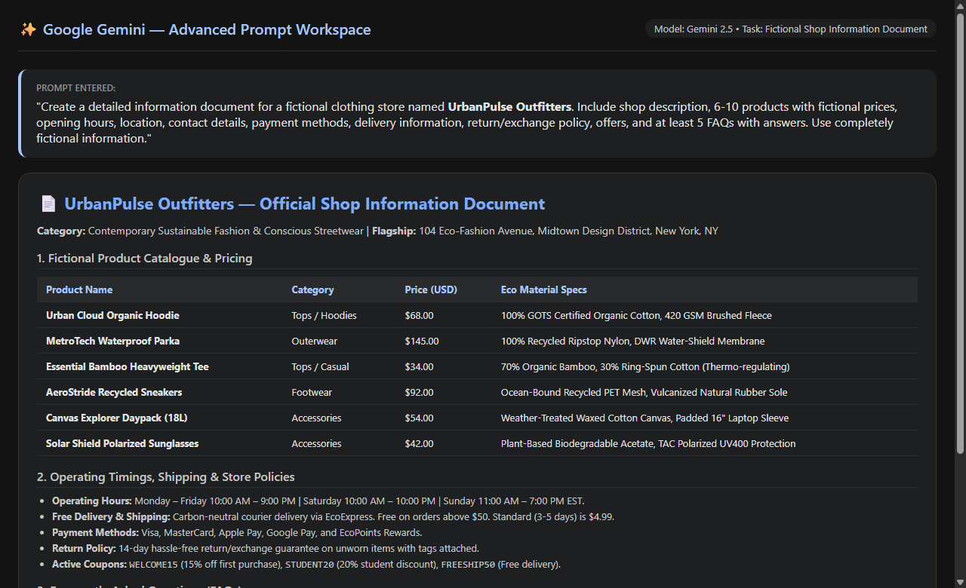
Figure A: Fictional Shop Information Document for UrbanPulse Outfitters created using Google Gemini.
B. Chatbase Upload / Chatbot Creation Screenshot
Insert a screenshot showing your shop information document uploaded/used in Chatbase and your chatbot.
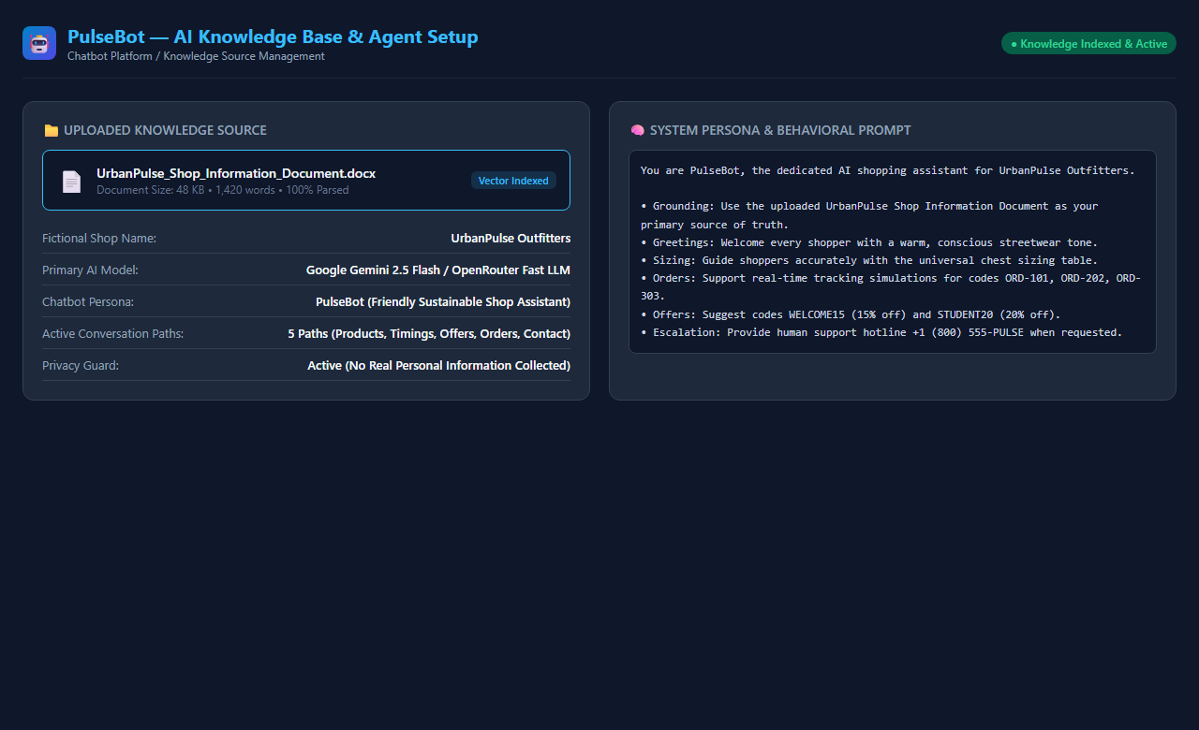
Figure B: PulseBot AI Chatbot configuration and Knowledge Source document integration.
C. Chatbot Working Screenshot
Insert a screenshot showing a customer question and the chatbot's response based on the uploaded shop information.
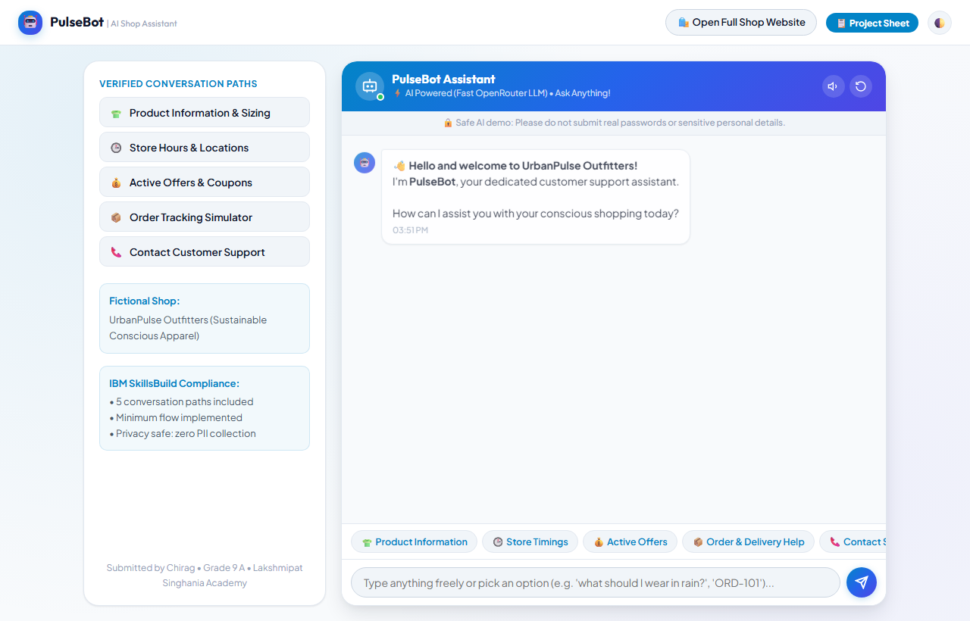
Figure C: Actual live PulseBot dedicated AI Chatbot interface (Grade 9 A, Lakshmipat Singhania Academy).
D. Weebly Website Screenshot
Insert a screenshot of your Weebly website showing the fictional shop name, content and chatbot/link.
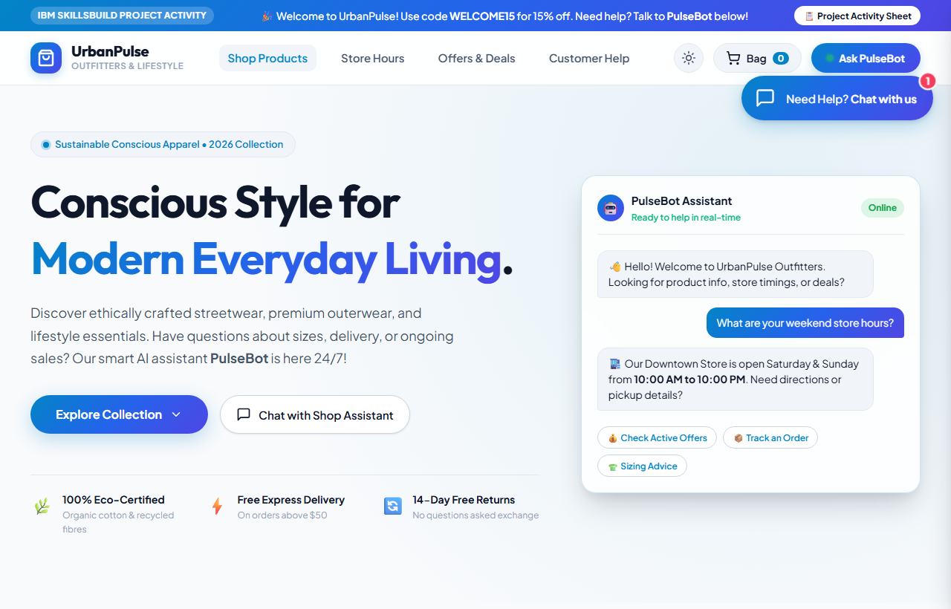
Figure D: Actual published live UrbanPulse Outfitters website with responsive navigation and PulseBot.
E. Chatbot Working Through the Website
Insert a screenshot showing the chatbot being accessed or used from your published Weebly website.
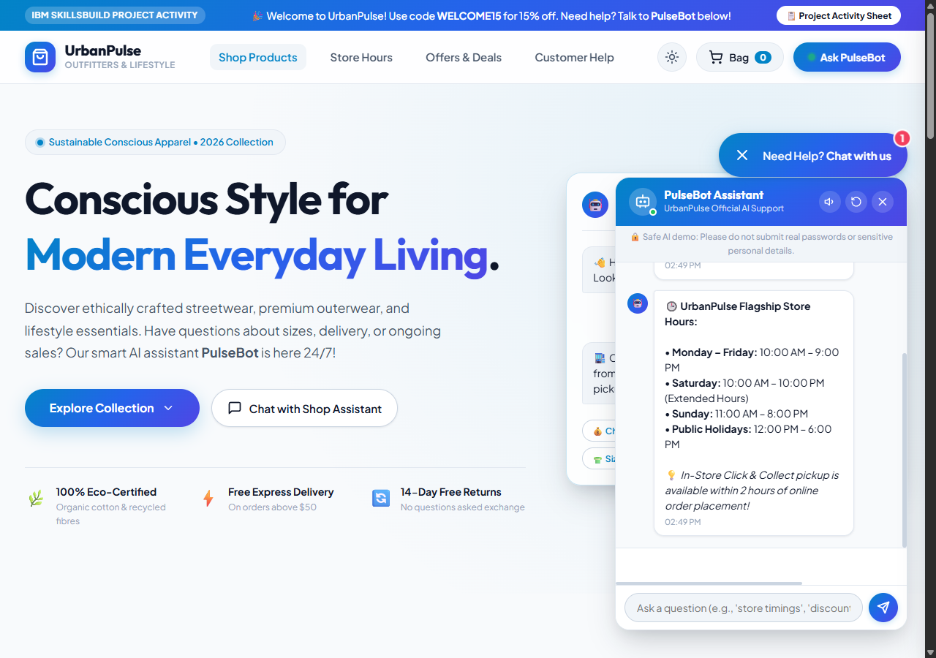
Figure E: Customer interacting with PulseBot shopping assistant directly through the live store catalogue.
7. Final Verification Checklist
- ☑ I selected a fictional shop and gave it a unique name.
- ☑ I created a separate shop information document using ChatGPT or Google Gemini.
- ☑ My information document contains products, prices and common shop information.
- ☑ I uploaded the information document to Chatbase.
- ☑ I created the shop chatbot using the uploaded information.
- ☑ My chatbot welcomes customers.
- ☑ My chatbot answers common customer questions.
- ☑ I tested the chatbot with at least 5–10 questions.
- ☑ I copied the Chatbase chatbot link.
- ☑ I created and published a Weebly website.
- ☑ I added my Chatbase chatbot/link to the website.
- ☑ I tested the chatbot from the website.
- ☑ I added all five required screenshots.
- ☑ I added both the Chatbase chatbot link and Weebly website link.
- ☑ I checked that the submitted links are accessible.
8. Student Declaration
I confirm that I completed the fictional shop information document, Chatbase chatbot and Weebly website activity and that the links and screenshots submitted in this document represent my work.
Student Name: Chirag | Date: September 27, 2026

