VIBELENS EXPERIENCE ARCHITECTURE
Design Direction, Narrative Comparison & Hackathon Feasibility Analysis
―――――――――――――――――――――――――――――――――――――――――――――――――――――――

1. Executive Summary & Core Conflict
Vibe coding has democratized software creation: anyone can prompt an AI and have an entire functional application built in an afternoon. However, after 24 to 48 hours, every creator faces the 'Vibe Coding Hangover'—the realization that they are operating a complex, opaque system whose internal wiring, dependencies, and security vulnerabilities they cannot see or verify.
This evaluation analyzes two distinct storytelling architectures for VibeLens. Both reject generic software dashboards in favor of a cohesive narrative, but they anchor that story in two completely different emotional worlds:
Dimension | Direction A: The Optical Diagnostic Lens | Direction B: The House the AI Built
Core Metaphor | The Optician's Diagnostic Lens & 24h Day-in-the-Life | The Architectural Cutaway House & Homeowner Walkthrough
Emotional Tone | Precision craft, technical clarity, diagnostic relief | Warm, intimate, accessible, empowering, human ownership
Core Tagline | "Build with the velocity of AI. Keep the clarity of a master." | "You built it in an afternoon. Now see what you built."
Audience Bridge | Visual scrollytelling + CAD telemetry chips | [Plain] vs [Show me the code] live bilingual toggle
Target Users | Engineers, tech-fluent vibe coders, DevSecOps juries | Universal: Non-coders (bakery owners, students) + Elite devs
Visual DNA | Obsidian dark (#060608), glass refraction, knurled metal dials | Warm amber lamplight at dusk, 3D cutaway rooms, code as texture

2. Direction A: The 24-Hour Builder & Optical Lens
Direction A structures the interface around the chronological journey of a software builder over a 24-hour cycle. It focuses on the physical workspace, the emotional descent into late-night alert fatigue, and the arrival of a physical precision optical lens that wipes away simulated noise.
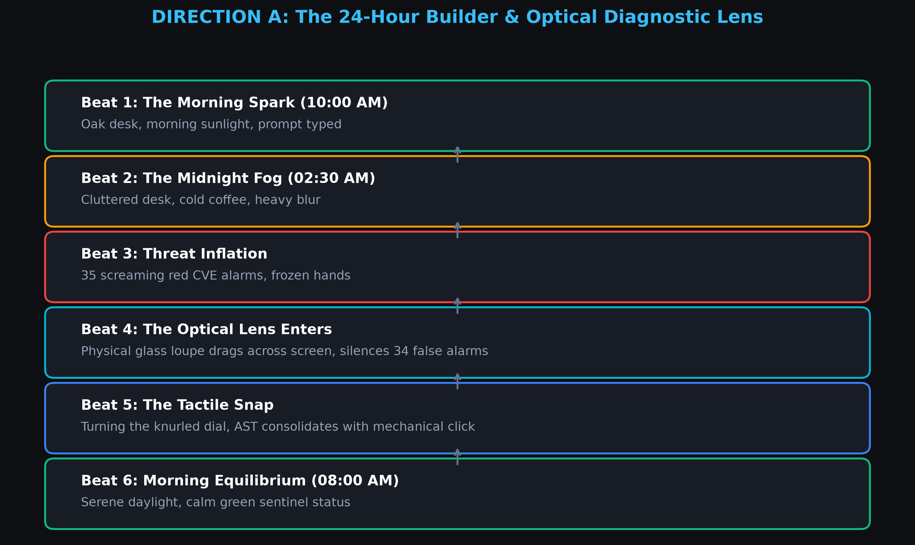
Figure 1: Direction A Process Flowchart — The 24-Hour Builder Journey & Diagnostic Lens.

Beat-by-Beat Narrative Breakdown (Direction A):
- Beat 1: The Morning Spark (10:00 AM): A sunlit oak desk, fresh coffee, effortless typing. The user feels invincible as the AI generates code in seconds.
- Beat 2: The Midnight Fog (02:30 AM): Cool monitor glow, empty energy drink, cluttered notes. The AI has hallucinated duplicates and context window chokes.
- Beat 3: Threat Inflation: 35 red warning triangles screaming in Dependabot. The builder is paralyzed, fearing the entire architecture is broken.
- Beat 4: The Optical Lens Enters: An interactive circular optical glass loupe slides into view. Looking through it, 34 false smoke alarms dissipate like dust motes.
- Beat 5: The Tactile Snap: A knurled metal dial turns with a mechanical click. The duplicate functions consolidate into one canonical utility with a 40% token drop.
- Beat 6: Morning Equilibrium (08:00 AM): Warm sunrise returns. The desk is clean. VibeWatcher sentinel quietly guards the codebase.

3. Direction B: The House the AI Built for You
Direction B drops the medical and technical diagnostic metaphors entirely in favor of a universal human experience: living in a house whose hidden wiring, pipes, and locks you didn't build. It transforms VibeLens from an intimidating auditor into a friendly guide walking you through your own home.
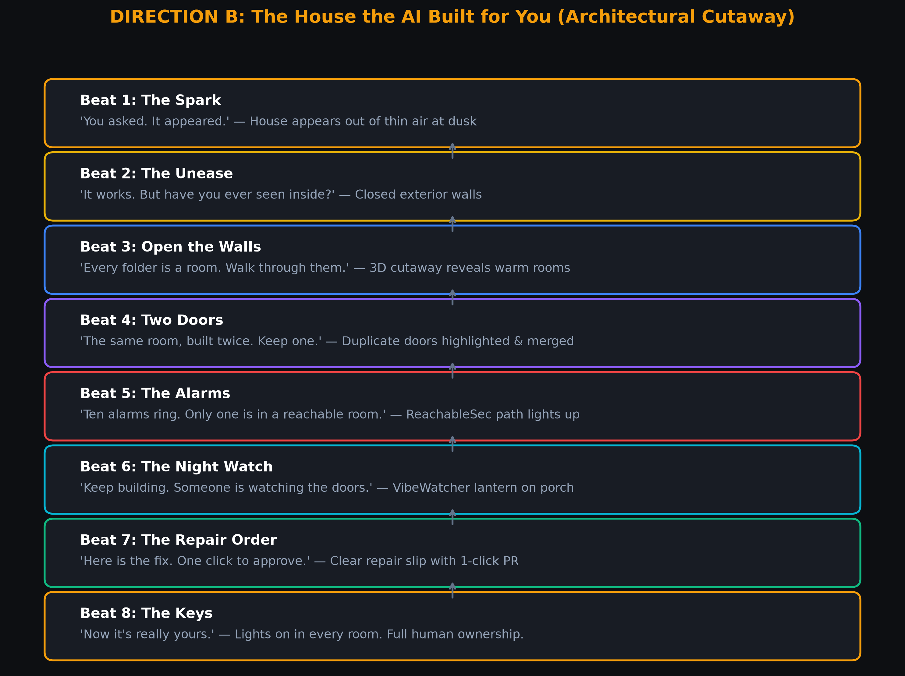
Figure 2: Direction B Process Flowchart — The House the AI Built for You.

The Dual-Audience Rosetta Stone: [Plain] vs [Show me the code]
The standout innovation of Direction B is its interactive bilingual toggle situated persistently in the navigation header. It preserves the exact same visual narrative while dynamically rewriting the copywriting:
Beat | Feature / Mechanism | [Plain] Audience Copy | [Show me the code] Technical Copy
1. The Spark | Hero Onboarding | "You asked. It appeared." | "You prompted. It shipped."
2. The Unease | Hero Scroll Descent | "It works. But have you ever seen inside?" | "Works on my machine. Reviewed by nobody."
3. Open Walls | 3D Cutaway Galaxy | "Every folder is a room. Walk through them." | "Live AST call-graph: folders, routes, imports."
4. Two Doors | De-Slop Engine | "The same room, built twice. Keep one." | "AST clone deduplication & CSS pruning."
5. The Alarms | ReachableSec SAST | "Ten alarms ring. Only one is in a room a stranger can reach." | "CVEs filtered by call-path reachability (88.6% silenced)."
6. Night Watch | VibeWatcher CLI | "Keep building. Someone is watching the doors." | "1Hz background file sentinel streaming AST diffs."
7. Repair Slip | 1-Click PR Generator | "Here's the fix. One click to approve." | "380-token context shrink & test-gated GitHub PR."
8. The Keys | Call to Action | "Now it's really yours." | "Own your repository with 100% confidence."

4. Hackathon Feasibility Analysis & The 3.5-Hour Cheat Code
A critical question for Prasunex Innovathon: Is building Direction B realistic within the hackathon time constraints, or is an architectural 3D cutaway a dangerous scope trap?

Where Direction B Fails (The Dangerous Naive Route):
- Procedural Room Generation: Writing an algorithm that dynamically models a custom 3D room for every folder in arbitrary GitHub repositories is a multi-week engineering project. It introduces mesh bugs, camera clipping, and severe performance degradation.
- Custom 3D Shaders & Rigging: Attempting to animate 'peeling walls' via custom WebGL vertex shaders in Three.js drains 20+ hours of debugging math rather than polishing the core security engine.
- Heavy Blender Assets: Baking custom lighting textures into massive 80MB GLTF files leads to browser stutter during live jury judging.

The Hackathon Cheat Code (Building Direction B in 3.5 Hours):
Winning hackathon teams do not build custom architectural engines. They achieve the same visual fidelity through three pragmatic shortcuts:
- The Universal 4-Zone Model: Every web application maps cleanly to the same 4 physical house zones: Front Porch = Public API Routes; Living Room = UI Components; Basement = Database & Storage; Lockbox = Auth & Security. Scanning any repository simply illuminates the relevant pre-mapped zone rather than generating infinite rooms.
- Pre-Baked Spline.design or 2.5D Layered SVG: Use a free, polished isometric cutaway house from Spline.design. It embeds natively into Next.js via <Spline scene='...' /> in 10 minutes, handling smooth camera pans and lighting without writing WebGL shaders.
- The 15-Minute Bilingual React Toggle: The [Plain] vs [Show me the code] toggle is 100% simple React client state (useState). It requires 20 lines of code, yet delivers an enormous psychological impact during pitch judging.
Criteria | Direction A (Lens & Desk) | Direction B (Hard 3D Way) | Direction B (Cheat Code)
Time to Build | ~4 to 6 Hours | 25+ Hours (Dangerous) | ~3.5 Hours (Achievable)
Technical Risk | Medium (Node graph math) | Very High (Shader bugs) | Low (Spline / Layered SVG)
Pitch Memorability | 8.5 / 10 (Sleek tech tool) | 10 / 10 | 10 / 10 (Emotional Standout)
Jury Comprehension | 7.5 / 10 (Engineers get it) | 10 / 10 | 10 / 10 (Instant Aha! Moment)

5. Final Strategic Recommendation
For Prasunex Innovathon 2026, the optimal strategy is to commit to Direction B using the 3.5-Hour Cheat Code. It elevates VibeLens from a dry CLI utility into a memorable, emotionally resonant product story while keeping engineering execution tightly bounded and risk-free.

